**Kathmandu University**

**Department of Computer Science and Engineering**

**Dhulikhel, Kavre**



**A Project Proposal**

**On**

**COVID Mapping**

**[Code No: COMP 207]**

**(For the partial fulfillment of 2nd Year/2nd Semester in Computer Science)**

**Submitted by:**

**Bigen Aryal (77)**

**Bikramaditya Prasad Subedi (75)**

**Milan Dhamala (73)**

**Rajeshwor Niroula (71)**

**Usta Adhikari (68)**

**Submitted to:**

**Mr. Nabin Ghimire**

**Department of Computer Science and Engineering**

**Submission Date: 10th July, 2020**

Date: 10th July, 2020

To

The Project Supervisor,

Department of Computer Science

Kathmandu University

**Subject: Cover Letter for proposal approval**

Dear Sir,

This project proposal has been submitted for your review entitled “**COVID Mapping**” for the partial fulfillment of **COMP 207** course. It contains a group project to be submitted under the directions and monitoring of a supervisor. Within this document, you will find basic introduction, objectives, methodology and expected outcome from the proposed work (Listed in detail in table of content section).

We hope for your keen review and future assistance in this work along with the approval.

Sincerely,

Bigen Aryal (77)

Bikramaditya Prasad Subedi (75)

Milan Dhamala (73)

Rajeshwor Niroula (71)

Usta Adhikari (68)

Abstract

Not to mention, we are facing a global crisis due to a virus never known to the human mankind before. As the world is seeking to find a cure, we as a responsible citizen have been urged to stay home as we watch the counter increase every day. Given the circumstances of our country dealing with COVID, keeping track of the ongoing cases is a matter of life and death to the community or the whole country. Thus, staying updated on the go might help prevent you from possibly reaching places that has been known to have been infected so we came up with an idea of building a web app that basically keeps track of the COVID cases in a provincial manner. A choropleth map with a legend shows you the infection rates on your screen where we plan to serve datas from authentic sources allowing user to be visually informed of the infected zones which will help you take precautions before you plan your short trip or even go for a grocery. We will be using Python for building the backend and handling the source code. Meanwhile, folium will be used to visualize data that has been manipulated in Python using an interactive leaflet map enabling both the binding of data to a map for choropleth visualizations as well as passing rich vector/raster/HTML visualizations as a marker on the map. As for the database, MySQL features are enough for our simple database plan.

**Keywords:** COVID, MySQL, HTML

Table of Contents:

Title Page No.

Abstract……………………………………………………………………………………….…..…I

Acronyms…………………………………………………………………………………………...V

Chapter 1: Introduction………………………………………………………………………...….1-2

* 1. Background………………………………………………………………………………...…1
  2. Objectives……………………………………………………………………………….….....1
  3. Motivation and Significance…………………………………………………………..............2

Chapter 2: Related Works/Existing Works……………………………………………………..……3

Chapter 3: Procedure and Methods……………………………………………………………..........4

Chapter 4: System Requirement Specification……………………………………………………....6

4.1 Software Specification………………………………………………………………..……….6

4.2 Hardware Specification………………………………………………………………......…....6

Chapter 5: Project Planning and Scheduling……………………………………………………...…7

References……………………………………………………………………………………………8

List of Figure

FigurePage No.

Fig 3.1: Workflow Diagram………………………………………………………………………….5

**List of Table**

**Table Page No.**

Table 5.1: Gantt Chart……………………………………………………………………………….7

Acronyms

**HTML**: Hypertext Markup Language

**CSS**: Cascading Style Sheets

**MySQL:** Database using Structured Query Language

**COVID:** Corona Virus Disease

**SARS:** Severe Acute Respiratory Syndrome

Chapter 1: Introduction

Project COVID Mapping is a web map used for keeping track of ongoing cases of COVID in a provincial manner. Our project is intended to display COVID-19 cases on a choropleth map from a database where the database is fed with datas from official sources. A simple UI will let users know about the stats of all the provinces on an Open Street map.

# 1.1: Background

COVID-19 has been proven to be different from the viral epidemics from the past in a few ways: it is more widespread than Severe Acute Respiratory Syndrome (SARS), more infectious than seasonal influenza and has killed more people than Ebola. As of early June, more than a million coronavirus cases were reported around the world. There have been more than 80,000 deaths reported so far, with Italy, the United States and Spain reporting the highest number. And the pandemic has yet to hit its stride in most low and middle-income countries, like Nepal, where it could cause much more damage. As the number of COVID cases soar, citizens need more reliable platform to know accurate and precise data in a sequential form.

COVID Mapping can be a platform for people to get well-organized data on the ongoing cases. Across the world, government and health authorities are working together to find solutions to the ongoing pandemic, to protect people and get society back up and running. Software developers are contributing by crafting technical tools to help combat the virus and save lives. However, a straightforward manifesto is missing for the population to get error-free facts about the count of COVID infections. So, we as a responsible computer science student, want to contribute to society to fight against this global pandemic by building an easy and simple web map with legend showing us the infection rates on our screen from authentic sources giving precise data count of infected so that it would keep people updated of their surrounding and more or less know about places to avoid in general.

# 1.2. Objectives

* An all in one platform to display recorded cases
* Precise and Accurate data in provincial manner
* Helps in the Data Analysis of COVID-19
* User friendly navigation

# 1.3. Motivation and Significance

The recent trend of coronavirus has been harsh on our country and lockdown has affected day to day life and is slowing down the global economy. The virus seems to have erupted into every district affecting thousands of peoples, who are either sick are or being killed due to the spread. Since coronavirus can be transmitted through close proximity with the affected individuals, it is very important to know the red zones of coronavirus, and avoid proximity to these zones. This has made us realize there are no current services offering a visual representation of the cases nationwide. Comparing and contrasting our project idea with existing popular services offering global view of the cases, we as a team concluded that our project can make a typical citizen visualize and understand the affected regions through a choropleth map.

To minimize the spread individuals are expected to self-isolate and stay away from the infected areas, and to do so we have to have an idea about the infected zones. This is basically the motivation behind our project.

Chapter 2: Related Works/Existing Works

Web mapping dates back to 1996 with an online mapping service known as ‘MapQuest’. Since then, several tech giants namely Google and Yahoo have come online with mapping services. In addition to interactive maps with zooming and recentering functions some services offer topographical maps, satellite imagery, weather and climate maps, demographic maps, disease mapping and traffic information.

1. HousingMaps: HousingMaps was the very first Google Maps mashup created even before the Google Maps API. It overlaid Craigslist apartment and housing listings on a map, for some major US cities plus London.
2. Worldometer: Worldometer is a provider of global COVID-19 statistics around the world with data collected from official reports, directly from Government’s communication channels or indirectly through local media sources when deemed reliable.
3. World Migration Map: Based on the data from UN Population Division, this map shows estimated net migration i.e. inflows minus outflows by origin and destination country.
4. OpenCelliD: OpenCelliD works towards creating an open cellular dataset that is driven and inspired by the community. From locating devices to understanding network coverage patterns; it enables so by providing convenient access to the data via an API and data dumps.
5. Flightradar24: Flightradar24 is a flight tracker that shows live air traffic from around the world combining data from various sources including ADS-B, MLAT and radar data. The ADS-B, MLAT and radar data is aggregated together with schedule and flight status data from airlines and airports to create a unique flight tracking experience.

Chapter 3: Procedure and Methods

For completion of our website we have created certain procedure which we will be following strictly. They are:

1. Study and research: Firstly, we have planned to do some research related to front-end and backend development needed for our project by visiting similar kind of websites, by consulting with seniors and teachers.
2. Front-end Development: Front End part i.e.; Visual parts of website is the first thing that will be noticed by user and is responsible for having first impression on a user. So, we will be making our website attractive and user-friendly using HTML, CSS, Bootstrap and leaflet.
3. Back-end Development: Back End part is the backbone of our website. Without it our website will not work functionally. We will be doing backend programming with the help of Python and MySQL, where MySQL is used for designing database and Folium will perform Visualization tasks and fetching data from database, generate web-page content, and Django sending and receiving requests.
4. Testing and Debugging: It is not 100 percent sure that our website will be built as perfect as we have desired. There can be some syntactical and logical errors. Our website might not be as user friendly we have expected. So, we will be performing tests and debugging to solve it. Also, we will allow a few of our friends to use our website and we will be taking their opinions so that we can improve our front-end part.
5. Documentation: After completion of our above listed task, we will prepare work report and present our project.

User/admin uses Django to add/remove data from MySQL

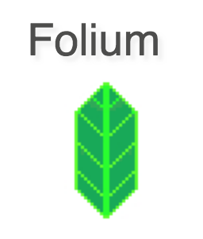

Django fetches data points from the database and feeds it to folium.



Django acts as an intermediary between user and database.

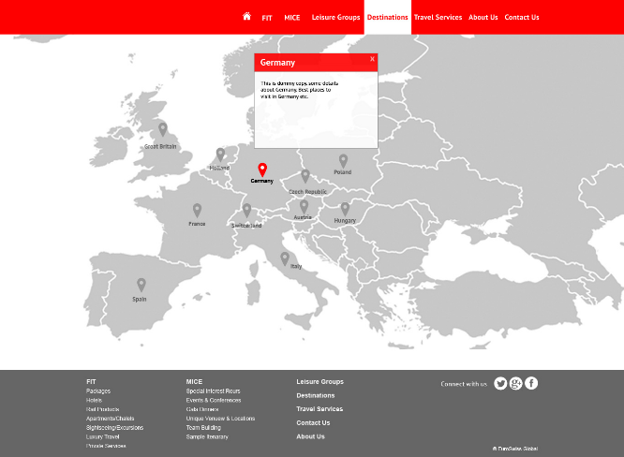



The choropleth map using folium is updated via Django fetching data from the database.

Database is manually updated through an inbuilt panel from the homepage by admins.

**Workflow Diagram** i

Chapter 4: System Requirement Specification

# 4.1 Software Specification

4.1.1 Front End Tools:Bootstrap, HTML, CSS, Leaflet

4.1.2 Back End Tools:Python and it’s web development framework (Django)

4.1.3 Database:MySQL

4.1.4 IDE:PyCharm

4.1.5 Browsers:Chrome, Microsoft Edge

# 4.2 Hardware Specification

Since the website will be simplistic, sophisticated hardware is not required. Any modern PC capable of running a modern OS should suffice.

Chapter 5: Project Planning and Scheduling

The work breakdown and time in weeks required to complete the specific task are shown as in the Gantt chart below: -

|  |  |  |  |  |  |  |  |  |  |  |  |  |
| --- | --- | --- | --- | --- | --- | --- | --- | --- | --- | --- | --- | --- |
| **Task** | 1 | 2 | 3 | 4 | 5 | 6 | 7 | 8 | 9 | 10 | 11 | 12 |
| Research and study |  |  |  |  |  |  |  |  |  |  |  |  |
| Graphic Designing |  |  |  |  |  |  |  |  |  |  |  |  |
| Core Programming |  |  |  |  |  |  |  |  |  |  |  |  |
| Program testing |  |  |  |  |  |  |  |  |  |  |  |  |
| Documentation |  |  |  |  |  |  |  |  |  |  |  |  |

Table 5.1: Gantt Chart

**Tasks**:

1. Research and Study
2. Graphic Designing
3. Core Programming
4. Program Testing
5. Documentation

# References

Common, C. (n.d.). *Open Knowledge Nepal*. Retrieved from http://localboundries.oknp.org/.

NYT. (n.d.). *New york Times*. Retrieved from https://www.nytimes.com/interactive/2020/world/coronavirus-maps.html?auth=login-google1tap&login=google1tap.

Worldometer. (n.d.). *Worldometer*. Retrieved from https://www.worldometers.info/coronavirus/.

younginnovations. (n.d.). *Github*. Retrieved from https://github.com/younginnovations/nepal-locallevel-map.