**Kathmandu University**

**Department of Computer Science and Engineering**

**Dhulikhel, Kavre**



**A Project Report**

**on**

**“GhumGham”**

**[Code No: ENGG 102]**

**(For partial fulfillment of ENGG 102 I/II in Computer Science)**

**Submitted by**

Suniti Sainju(40)

Subodh Bhandari(66)

Usta Adhikari(68)

Ashwin Shrestha(69)

**Submitted to :**

**Department of Computer Science and Engineering**

**Submission Date: July 25, 2019**

**Bonafide Certificate**

**This project work titled as**

**“GhumGham”**

**has beeen submitted to the Department of Computer Science and Engineering**

**for the partial fulfillment of ENGG 102 as a 1st year 2nd semester project.**

**This project work is the bonafide work of**

**“Suniti Sainju, Subodh Bhandari, Usta Adhikari and Ashwin Shrestha”**

**who carried out the project work under my supervision.**

**Project Supervisor**

**________________________**

**Name: Satyendra Lohani**

**Academic Designation:**

**Project Coordinator**

**_________________________**

**Name : Denny**

**Academic Designation:**

**Project Evaluators**

**________________________ ________________________**

**Abstract**

This report has been sketched in order to meet the demands of course ENGG 102 proposed by the Department of Computer Science and Engineering, Kathmandu University.

As per the ENGG 102 project, we have been successful in developing a desktop application “GhumGham”. Anyone who is willing to travel beautiful places of Nepal or simply get information about places, can use this application as they may face lots of problems even for deciding the destination. Also many tourists may face problems on finding the suitable travel agencies and the places to roam around their selected destinations. This application aims to ease the process of finding the appropriate destinations for traveling inside Nepal. We have completed the project by the use of C++ (Qt Framework). The tourist can find key features about the different tourism places in Nepal such as information about travel agencies,climate, hotels, other geographical information and the map of the selected place. The system will surely help to promote tourism places of Nepal all around the globe . The system will prove to be useful for both tourists and the travel agencies. We have developed the application that can surely be commercialized in the future.

*Keyword : Tourism*

**Table of Content**

Abstract.…………..…………………………………………………….… i

List of Figures.…………………………………………………….…….… iii

Abbreviations…………………….……………………………….…….… iv

1. Introduction…………………………………………………….… 1
   1. Background………….…………………………..………….… 1
   2. Objective……….…………………………..………….……… 1
   3. Motivation and Significances…………………..………….… 1
2. Related Works………………...………………………….……….… 3
3. Design and Implementation..………..………………………….… 4

3.1 System Requirement Specification……………………….. 6

1. Discussion on the Achievements…. ……………………………… 7
2. Conclusion and Recommendation..…………………………….…. 8
   1. Limitation………………………………………………………8
   2. Future Enhancement……………………………………………8

References………………………………….…………………………. 9

Appendix……………………………………………………………… 10

**List of Figures**

3.1 Flow Diagram…………………………………………………………. 4

5.1 Gantt Chart…………..………………………………………………… 8

A.1 Home Screen…………………………………………………………… 10

A.2 Map Screen………………………………………………..…………… 11

A.2 Use of search button…..…………………………………..…………… 12

A.3 Kathmandu Screen………………………………………………..……. 13

**Abbreviations**

PC : Personal Computer

CPU : Central Processing Unit

RAM : Random Access Memory

OS : Operating System

**Chapter 1: Introduction**

**1.1 Background**

Nepal is a country of wonderful places filled with natural beauty. But due to lack of technical advancement tourists are unaware about those places and thus tourism industry of Nepal is flourishing like never before. The development process of Nepal would have been easier if we can attract a lot of tourist by awaring them about the beauty the country holds.

There are very few trust worthy agencies that actually guides the tourist. Although some companies have tried to work for the betterment of this field but still they haven’t been successful in providing better service. Not only foreigners but we Nepalese ourselves are unknown about many places that needs to be recognized. So, for development and enhancement of tourism in Nepal there is an urgent need of a solution.

In developed countries, there has been vast technological advancement in this field. Travelers can know about a place by just one click. They have no problem at all in attracting tourist and letting them know about places of their country. But in our case, still a lot of technological development has to be done so that it would be much easier for everyone to explore the nation.

**1.2 Objectives**

The main goals of our project have been listed below:

* To make the tourism places of Nepal easily accessible to the tourists
* To promote the tourism industry of Nepal globally
* To show the distance between source and destination and also recommend places nearby
* To enhance our C++ programming skills

**1.3 Motivation and Significances**

In this digital era, the job of paper works has been replaced by memory drives. Same should be applied in the case of tourism field. This project has been designed to meet the requirements of technology in tourism industry. Through this application, the tourists will be able to access information about every beautiful places inside Nepal. Also, the frauds in the tourism industry can be greatly reduced as the tourists visiting any places of Nepal can start their journey knowing every features like climate, location, distance, available hotels and travel agencies.

The existing online portals do not give much information about the tourism places of Nepal. They do not provide enough information so that one can travel even on their own without any third party help like travel agencies. Even some travel agencies providing their services in Nepal are providing some portals but they are more business oriented than information oriented. Thus by creating an application that could provide better information could surely lead tourism industry of Nepal to another level.

**Chapter 2: Related Works**

We researched and collected data from various website similar to ours. Some of the existing websites are listed below:

**1. Google Maps**

Multinational company goggle has given the facility to the tourists by providing details of various tourism places all over the world by launching Google Maps. Tourists can easily find out the details of places with a simple search. But, it doesn’t provides enough details and some places in remote areas of Nepal are not included. {1}

**2. lonelyplanet.com**

It is the website which provides proper details of the cities. Although the website has provided enough details of the famous places but still lacks the details of some places which deserve to be visited. {2}

**3.Welcome Nepal Tours and Travel Pvt. Ltd**

The website of this organization has provided enough details of almost all the places of Nepal but it has been unable to include map. {3}

These apps and websites have failed to provide all the essential informations of the tourism places in Nepal. Each of these websites do not give clear data on the famous and backwarded areas which may have been famous in their own locality but not Nationally/Internatonally.

**Chapter 3: Design and Implementation**

We first planned and created an algorithm based on our other routines and so as to complete the project in time. Firstly, we did some research about what we need to build so that it will not only remain as a project but also be commercialized and decided to build this application GhumGham. Then, we wrote the proposal and after acceptance we started to build this application. We first learned C++ and started collecting data side by side. Then we began coding and created a pretty good application and solved its flaws.

We implemented Waterfall model of software development during the development of this application. The following flowchart represents the procedure implemented :

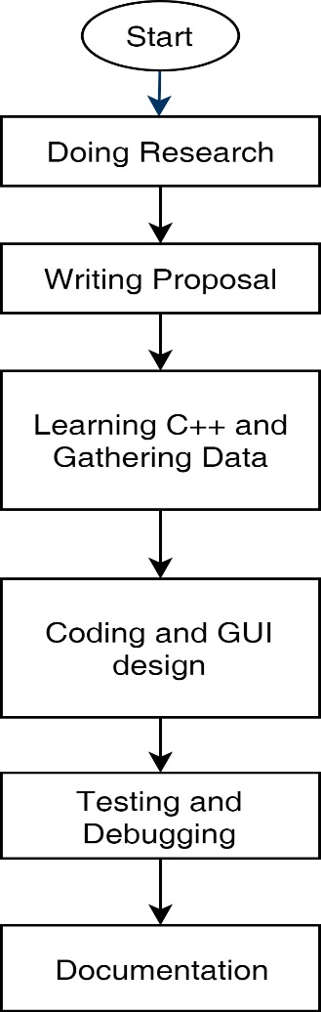

Fig: 3.1 Flow Diagram

The application “GhumGham” is very much user friendly and easier to use. The use-case diagram of the application is as below :

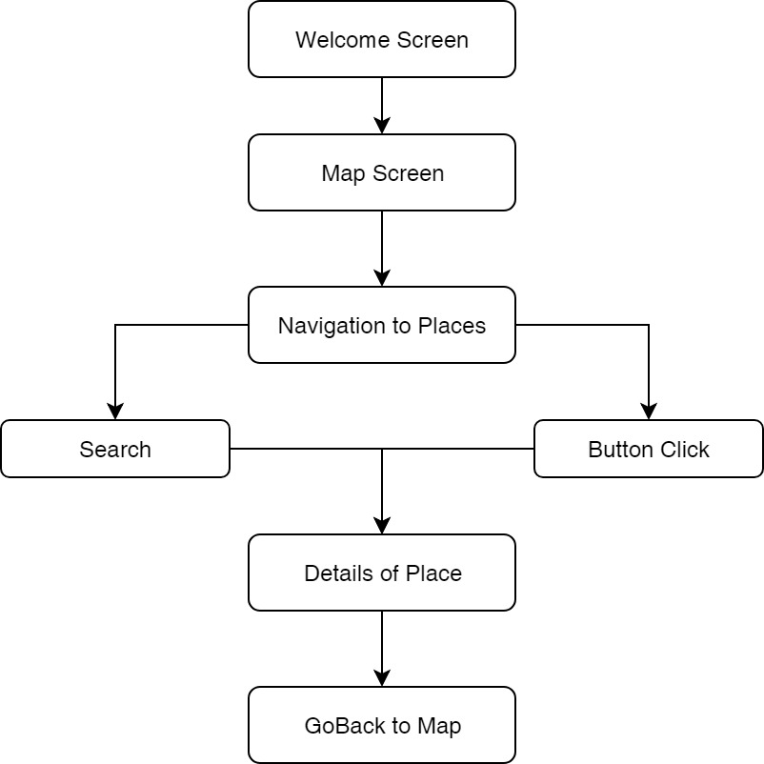

Fig 3.2 Use Case Diagram

**Gantt Chart**

The work breakdown and time required for the completion of the specific task is summarized as below:

|  |  |  |  |  |  |  |
| --- | --- | --- | --- | --- | --- | --- |
|  |  |  |  |  |  |  |
| Research |  |  |  |  |  |  |
| Proposal |  |  |  |  |  |  |
| Learning C++ |  |  |  |  |  |  |
| Coding and GUI |  |  |  |  |  |  |
| Testing and Debugging |  |  |  |  |  |  |
| Final Report |  |  |  |  |  |  |

Work Accomplished Days

Fig : 5.1 Gantt Chart

**3.1 System Requirement Specification**

**3.1.1 Software Specification**

**Tools Used :** C++ (Qt Framework), Qt Creator

**3.1.2 Hardware Specification**

**Compatibility:** Compatible with all modern PCs

**Chapter 4: Discussion on the Achievements**

Developing a complete application from scratch in this short span of time was a very challenging task but we still managed to create it. We were able to achieve almost all the objectives that we initially proposed. We created an application that displays all the details of the tourism places in Nepal along with the names of hotels and travel agencies providing services in those places. Overall, we have a pretty good final application which will be very useful to the tourists.

**Features:**

The various features available on the application GhumGham are:

1. Easy access to the details of the tourism places in Nepal.
2. Information of various travel hotels providing services at that place.
3. Browse and search main tourism places of Nepal.
4. Recommending other beautiful placesnear main tourism site.

**Chapter 5: Conclusion**

In this short span of time we have been able to collect all the required data of the tourism places in Nepal and build an application. Building this project has been a great team work and every members have contributed to the fullest for the creation of the “GhumGham”. The guidance and support from our supervisor helped us to build the project. This project have all the capabilities to be commercialized not only being confined as a semester project.

**5.1 Limitations**

* There are tons of tourism places in Nepal but since its a semester project we couldn’t cover all the places.
* User interface seems traditional.

**5.2 Future Enhancement**

This is a complete project but bringing in the real world is a tough task as it has high standards and better competing apps. So for the future enhancement we have thought of including all the tourism places in Nepal, using query languages like MySQL for storing the data as it will make this application more accessible and developing a better user interface for more attraction and ease.

**References**

1. [*www.maps.google.com*](http://www.maps.google.com/)
2. [*www.lonelyplanet.com*](http://www.lonelyplanet.com/)
3. [*www.welcomenepaltreks.com*](http://www.welcomenepaltreks.com/)
4. [*www.udemy.com*](http://www.udemy.com/)
5. C++ Qt Programming Retrieved May 18,2018, from

*https://youtube.com/playlist?llist=PL2D1942A4688E9D63*

1. Kanetkar, Y.(2002). *Let Us C++,* New Delhi : BPB Publishing
2. Pozrikidis, C.(2007). *Introduction to C++ Programming and Graphics*,

Berlin : Springer Science and Business Media

**Appendix**

Fig: A.1 Home Screen

Fig: A.2 Map Screen

Fig A.3 Use of search button

Fig: A.3 Kathmandu Screen