**Kathmandu University**

**Department of Computer Science and Engineering**

**Dhulikhel, Kavre**



**A Project Proposal**

**On**

**Breakfast Scoop**

**[Code No: COMP 207]**

**(For the partial fulfillment of 2nd Year/ 2nd Semester in Computer Science)**

**Submitted by:**

**Usta Adhikari (68)**

**Rajeshwor Niroula (71)**

**Milan Dhamala (73)**

**Bikramaditya Prasad Subedi (75)**

**Submitted to:**

**Mr. Samir Tamrakar**

**Department of Computer Science and Engineering**

**Submission Date: 12th November, 2019**

**Cover Letter**

November 12, 2019

Respected Sir,

This proposal has been submitted for the partial fulfillment of the COMP 206 course, which consists of a group project to be submitted under the directions and monitoring of a supervisor. Following are the topics covered under this proposal.

- Introduction to our project………………………….

- Requirements……………………………………….

- System Description and Work Breakdown…………

Thank you for giving us this opportunity.

Sincerely,

Usta Adhikari (68)

Rajeshwor Niroula (71)

Milan Dhamala (73)

Bikramaditya Prasad Subedi (7)

**Abstract**

Scrappy focuses on creating subtle product comparing tool which allows for easier product purchases saving enormous comparison and purchasing times. Our project is a web application based tool with an objective of providing simpler way of browsing products from several online marketplace. In scrappy, we scrap information about products such as images, prices, etc. These information will be organized in pages making product easier to compare.

**Keywords:** Web Application, Scrap

**Table of Contents:**

**Title Page No.**

Abstract……………………………………………………………………………………….…..…I

Acronyms…………………………………………………………………………………………...V

Chapter 1: Introduction………………………………………………………………………...….1-2

* 1. Background………………………………………………………………………………...…1
  2. Objectives……………………………………………………………………………….….....1
  3. Motivation and Significance…………………………………………………………..............2

Chapter 2: Related Works/Existing Works……………………………………………………..…3-4

Chapter 3: Procedure and Methods……………………………………………………………......5-6

Chapter 4: System Requirement Specification……………………………………………………....7

4.1 Software Specification………………………………………………………………..……….7

4.2 Hardware Specification………………………………………………………………......…....7

Chapter 5: Project Planning and Scheduling……………………………………………………...…8

References……………………………………………………………………………………………9

**List of Figure**

**Figure Page No.**

Fig 3.1: Layout of the Website……………………………………………………………………….5

Fig 3.2: Workflow Diagram………………………………………………………………………….6

**List of Table**

**Table Page No.**

Table 5.1: Gantt Chart………………………………………………………………………………..8

**Acronyms**

**HTML**: Hypertext Markup Language

**CSS**: Cascading Style Sheets

**JS:** Java Script

**PC**: Personal Computer

**AI**: Artificial Intelligence

**Chapter 1: Introduction**

Project Scrappy is a web tool used for extracting data from websites. Basically, web scrapping typically refers to automated processes implemented using a bot or web crawler. This form of extracted datasets can be used for later retrieval or analysis.

**1.1: Background**

If we observe todays online market system, there are too many online shopping platforms and from site to site prices for even the same product varies making it difficult to find the best price so an easy product comparing website feels very much needed. Even though we can find plenty of web scrappers for sites like amazon and eBay there aren’t any user friendly product comparing websites in the local market. Therefore, people tend to seek multiple sources and opinions before they jump into buying any products. As a result, people have to scour through multiple online marketplaces just to get hold onto a single product. With the objective to simplify this problem, our project Scrappy will strive to accumulate multiple products from multiple sources on a single screen, served in a single platter to devour.

Scrappy is a web-based product scraping tool, where each user can visit the site and type the desired keyword and get the keyword related products listings from multiple sources on a single screen. It not only, will provide product option but also decrease unnecessary time we have to spend on internet to get the right product pricing. With the global reach in mind, our project will scrap national and international products that will increase the inclusivity of information in the site which will not only be limited to local products but also cover international outreaches.

**1.2. Objectives**

* An all in one platform for price analysis and product purchase
* Market analysis at scale
* Increase inclusivity of information
* User intuitive web design

**1.3 Motivation and Significance**

Websites like Hagglezon, Trivago, Flightscanner, Expedia etc. was our motivation for our project. Hagglezon compares amazon products, prices throughout most of the European countries that helps customers to compare prices of the same amazon service throughout several European countries. Similarly, Trivago displays prices of hotel rooms in certain destination that allows you to pick hotel on your budget. Thus, we decided to design a web-application that allows customers to compare prices from multiple sites.

**Chapter 2: Related Works/Existing Works**

News in general can be defined as the information about the things that is happening around you. It is a piece of diverse information related to various fields which keeps one updated and enlightens one with the political, economic, social and technical information. Considering back our years, we are no longer bound to television broadcast and newspaper for information.

Ever since the birth of World Wide Web, it has been the frontier for information exchange and circulation of media. In recent years, news has grown to take on more forms. People retrieve their information via different websites, social media, tweets, etc. These bits of information via different sources entwined with their own views and opinions may affect one’s own opinion and judgements. Since the news on a local or global scale may affect the lives of people directly or indirectly, it is important for the news to be delivered from credible sources.

A person at a time is only able to know and get their hands on a handful of information. Often a lot of that is going around the world is unfamiliar to a person as the news sources that s/he is associated with cannot cover everything that is going around the world. Some snippets of information and news are bound to be lost. To provide timely up to date news compared to traditional news websites, services like Microsoft News, Google News does provide some level of services.

Microsoft News keeps people informed across the web, phone and PC, using long-tested approach of curating news via publishing partnerships, human editors, and AI, working with more than a thousand premium publishers and more than 3,000 brands in all major global markets – like USA Today, The New York Times, FOX News, The Washington Post, and many more- to aggregate the best news, videos, photos, and other content and deliver it, for free, to people all over the word. (About Us: Msn , 2018)

Another relatively unknown website called “Karma Reader” is also working on a similar goal. Karma Reader was created to provide timely up to date news to those who are used to traditional websites like CNN, Fox News or even the Drudge Report. Reddit provides an excellent source of news, but it’s not easily accessible. Karma Reader brings the best of Reddit’s news to one page in an easy to navigate format. (The Karma Reader, 2019)

Our “Breakfast Scoop” will work like a news-hub. It won’t create its own news articles but will act as a hosting site for different news articles from different sources through web scraping and storing them in database and later hosting it. A user is thus able to get their hands-on different news articles from different credible sources all under a single roof.

**Chapter 3: Procedure and Methods**

For completion of our website we have created certain procedure which we will be following strictly. They are:

1. Study and research- Firstly, we have planned to do some research related to front-end and backend development needed for our project by visiting similar kind of websites, by consulting with seniors and teachers.
2. Front-end Development: Front End part i.e.; Visual parts of website is the first thing that will be noticed by user and is responsible for having first impression on a user. So, we will be making our website attractive and user-friendly using HTML, CSS, Bootstrap.
3. Back-end Development: Back End part is the backbone of our website. Without it our website will not function as needed. We will be doing backend programming with the help of Java and MySQL, where MySQL is used for designing database and Java will perform web-scraping tasks and store the collected data on database, generate web-page content, or send and receive request.
4. Testing and Debugging: There can be some syntactical and logical errors. Our website might not be as user friendly as we expected. So, we will be performing tests and debugging to improve it.
5. Documentation: After completion of our above listed task, we will prepare work report and present our project.

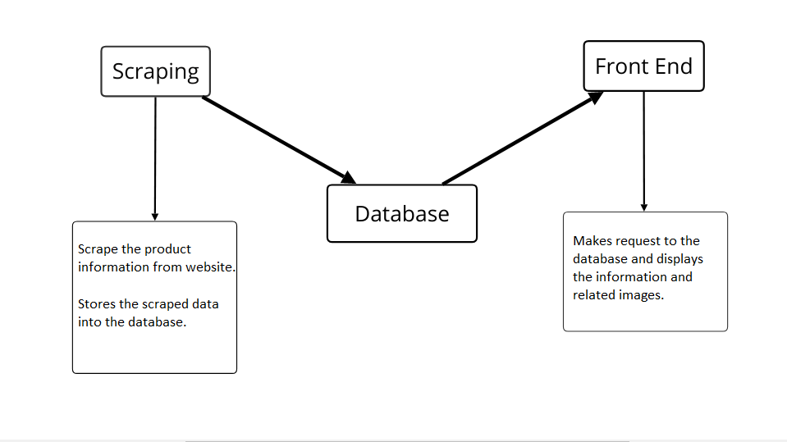

**Fig 3.2: Workflow Diagram**

**Chapter 4: System Requirement Specification**

**4.1 Software Specification**

**4.1.1 Front End Tools:** HTML, CSS, Bootstrap

**4.1.2 Back End Tools:** Java web scraping and web development libraries

**4.1.3 Database:** MySQL

**4.1.4 IDE:** IntelliJ IDEA

**4.1.5 Browsers:** Chrome, Microsoft Edge

**4.2 Hardware Specification**

Since the website will be simplistic, sophisticated hardware is not required. Any modern PC capable of running a modern OS should suffice.

**Chapter 5: Project Planning and Scheduling**

The work breakdown and time in weeks required to complete the specific task are shown as in the Gantt chart below: -

|  |  |  |  |  |  |  |  |  |  |  |  |  |
| --- | --- | --- | --- | --- | --- | --- | --- | --- | --- | --- | --- | --- |
| **Task** | 1 | 2 | 3 | 4 | 5 | 6 | 7 | 8 | 9 | 10 | 11 | 12 |
| Research and study |  |  |  |  |  |  |  |  |  |  |  |  |
| Graphic Designing |  |  |  |  |  |  |  |  |  |  |  |  |
| Core Programming |  |  |  |  |  |  |  |  |  |  |  |  |
| Program testing |  |  |  |  |  |  |  |  |  |  |  |  |
| Documentation |  |  |  |  |  |  |  |  |  |  |  |  |

Table 5.1: Gantt Chart

**Tasks**:

1. Research and Study
2. Graphic Designing
3. Core Programming
4. Program Testing
5. Documentation

# References

(2019). Retrieved from The Karma Reader: http://www.karmareader.com/

*About Us: Msn* . (2018, 07 09). Retrieved from msn : https://www.msn.com/en-us/news/us/about-us/ar-BBN0NAK