Kathmandu University
Department of Computer Science and Engineering
Dhulikhel, Kavre

A Project Proposal
On
Scrappy
[Code No: COMP 207]
(For the partial fulfillment of 2nd Year/ 1st Semester in Computer Science)

Submitted by:
Usta Adhikari (68)
Rajeshwor Niroula (71)
Milan Dhamala (73)
Bikramaditya Prasad Subedi (75)

Submitted to:
Mr. Samir Tamrakar
Department of Computer Science and Engineering

Submission Date: 12th November, 2019

Cover Letter

November 12, 2019

Respected Sir,

This proposal has been submitted for the partial fulfillment of the COMP 206 course, which consists of a group project to be submitted under the directions and monitoring of a supervisor. Following are the topics covered under this proposal.

- Introduction to our project………………………….
- Requirements……………………………………….
- System Description and Work Breakdown…………

Thank you for giving us this opportunity.

Sincerely,
Usta Adhikari (68)
Rajeshwor Niroula (71)
Milan Dhamala (73)
Bikramaditya Prasad Subedi (7)

Abstract

Scrappy focuses on creating subtle product comparing tool which allows for easier product purchases saving enormous comparison and purchasing times. Our project is a web application based tool with an objective of providing simpler way of browsing products from several online marketplace. In scrappy, we scrap information about products such as images, prices, etc. These information will be organized in pages making product easier to compare.

Keywords: Web Application, Scrap

Table of Contents:
Title Page No.
Abstract……………………………………………………………………………………….…..…I
Acronyms…………………………………………………………………………………………...V
Chapter 1: Introduction………………………………………………………………………...….1-2
1.1 Background………………………………………………………………………………1
1.2 Objectives………………………………………………………………………………...1
1.3 Motivation and Significance………………………...………………………….........…...2
Chapter 2: Related Works/Existing Works……………………………………………………..…...3
Chapter 3: Procedure and Methods………………………………………………………………....4
Chapter 4: System Requirement Specification…………………………………………………...6
4.1 Software Specification………………………………………………………………..………6
4.2 Hardware Specification………………………………………………………………......…...6
Chapter 5: Project Planning and Scheduling……………………………………………………...…7
References…………………………………………………………………………………………...8

List of Figure
Figure Page No.
Fig 3.1: Workflow Diagram………………………………………………………………………….5

List of Table
Table Page No.
Table 5.1: Gantt Chart………………………………………………………………………………..7

Acronyms

HTML: Hypertext Markup Language
CSS: Cascading Style Sheets
JS: Java Script
PC: Personal Computer
AI: Artificial Intelligence

Chapter 1: Introduction
Project Scrappy is a web tool used for extracting data from websites. Basically, web scrapping typically refers to automated processes implemented using a bot or web crawler. This form of extracted datasets can be used for later retrieval or analysis.

1.1: Background
If we observe todays online market system, there are too many online shopping platforms and from site to site prices for even the same product varies making it difficult to find the best price so an easy product comparing website feels very much needed. Even though we can find plenty of web scrappers for sites like amazon and eBay there aren’t any user friendly product comparing websites in the local market. Therefore, people tend to seek multiple sources and opinions before they jump into buying any products. As a result, people have to scour through multiple online marketplaces just to get hold onto a single product. With the objective to simplify this problem, our project Scrappy will strive to accumulate multiple products from multiple sources on a single screen, served in a single platter to devour.

Scrappy is a web-based product scraping tool, where each user can visit the site and type the desired keyword and get the keyword related products listings from multiple sources on a single screen. It not only, will provide product option but also decrease unnecessary time we have to spend on internet to get the right product pricing. With the global reach in mind, our project will scrap national and international products that will increase the inclusivity of information in the site which will not only be limited to local products but also cover international outreaches.
1.2. Objectives
- An all in one platform for price analysis and product purchase
- Market analysis at scale
- Increase inclusivity of information
- User intuitive web design

1.3 Motivation and Significance

Websites like Hagglezon, Trivago, Flightscanner, Expedia etc. was our motivation for our project. Hagglezon compares amazon products, prices throughout most of the European countries that helps customers to compare prices of the same amazon service throughout several European countries. Similarly, Trivago displays prices of hotel rooms in certain destination that allows you to pick hotel on your budget. Thus, we decided to design a web-application that allows customers to compare prices from multiple sites.

Chapter 2: Related Works/Existing Works

Chapter 3: Procedure and Methods
For completion of our website we have created certain procedure which we will be following strictly. They are:
- Study and research- Firstly, we have planned to do some research related to front-end and back-end development needed for our project by visiting similar kind of websites, by consulting with seniors and teachers.

- Front-end Development: Front End part i.e.; Visual parts of website is the first thing that will be noticed by user and is responsible for having first impression on a user. So, we will be making our website attractive and user-friendly using HTML, CSS, Bootstrap.

- Back-end Development: Back End part is the backbone of our website. Without it our website will not function as needed. We will be doing backend programming with the help of Java and MySQL, where MySQL is used for designing database and Java will perform web-scraping tasks and store the collected data on database, generate web-page content, or send and receive request.

- Testing and Debugging: There can be some syntactical and logical errors. Our website might not be as user friendly as we expected. So, we will be performing tests and debugging to improve it.

- Documentation: After completion of our above listed task, we will prepare work report and present our project.

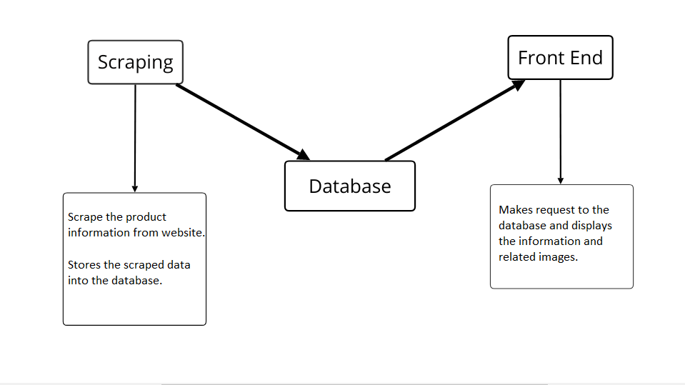Fig 3.2: Workflow Diagram

Chapter 4: System Requirement Specification
4.1 Software Specification
4.1.1 Front End Tools: HTML, CSS, Bootstrap
4.1.2 Back End Tools: Java web scraping and web development libraries
4.1.3 Database: MySQL
4.1.4 IDE: IntelliJ IDEA
4.1.5 Browsers: Chrome, Microsoft Edge

4.2 Hardware Specification
Since the website will be simplistic, sophisticated hardware is not required. Any modern PC capable of running a modern OS should suffice.

Chapter 5: Project Planning and Scheduling
The work breakdown and time in weeks required to complete the specific task are shown as in the Gantt chart below: -

Task | 1 | 2 | 3 | 4 | 5 | 6 | 7 | 8 | 9 | 10 | 11 | 12
Research and study
Graphic Designing
Core Programming
Program testing
Documentation
Table 5.1: Gantt Chart

Tasks:
- Research and Study
- Graphic Designing
- Core Programming
- Program Testing
- Documentation

References
(2019). Retrieved from The Karma Reader: http://www.karmareader.com/

About Us: Msn . (2018, 07 09). Retrieved from msn : https://www.msn.com/en-us/news/us/about-us/ar-BBN0NAK

