Kathmandu University
Department of Computer Science and Engineering
Dhulikhel, Kavre

A Project Proposal
On
Breakfast Scoop
[Code No: COMP 207]
(For the partial fulfillment of 2nd Year/ 2nd Semester in Computer Science)

Submitted by:
Utsav Darlami (14)
Babin Joshi (19)
Gyanas Luitel (27)
Niraj Tamang (47)

Submitted to:
Mr. Nabin Ghimire
Department of Computer Science and Engineering

Submission Date: 19th April, 2019

Cover Letter

April 19,2019

Respected Sir,

This proposal has been submitted for the partial fulfillment of the COMP 207 course, which consists of a group project to be submitted under the directions and monitoring of a supervisor. Following are the topics covered under this proposal.

- Introduction to our project………………………….
- Requirements……………………………………….
- System Description and Work Breakdown…………

Thank you for giving us this opportunity.

Sincerely,
Utsav Darlami (14)
Babin Joshi (19)
Gyanas Luitel (27)
Niraj Tamang (47)

Abstract

Breakfast Scoop is a web application project with an objective of providing simpler and more intuitive news delivery system. The newspaper industry is on a decline and with the changing technology and our dependency on it to get our daily news, we often find ourselves amongst the false information vortex nor the right information is any easier to find. Our project “Breakfast Scoop”, is an effort to calm the ripple of news that we get on the oceanic Internet, manage the floating pieces of information and provide a systematic sanctuary which can eventually act as a survival island where you get what you need.
The project itself is engraved with an idea of Pinterest like dashboard system, where any user can get the top news of the day on a desired topic. Therefore, Breakfast Scoop is a project to organize the news on the internet by delivering the needed information only but rather in a minimal and organized way.

Keywords: Web Application, Technology, Internet

Table of Contents:
Title Page No.
Abstract……………………………………………………………………………………….…..…I
Acronyms…………………………………………………………………………………………...V
Chapter 1: Introduction………………………………………………………………………...….1-2
  - Background………………………………………………………………………………...…1
  - Objectives……………………………………………………………………………….….....1
  - Motivation and Significance…………………………………………………………..............2
Chapter 2: Related Works/Existing Works……………………………………………………..…3-4
Chapter 3: Procedure and Methods……………………………………………………………......5-6
Chapter 4: System Requirement Specification……………………………………………………....7
4.1 Software Specification………………………………………………………………..……….7
4.2 Hardware Specification………………………………………………………………......…....7
Chapter 5: Project Planning and Scheduling……………………………………………………...…8
References……………………………………………………………………………………………9

List of Figure
Figure Page No.
Fig 3.1: Layout of the Website……………………………………………………………………….5
Fig 3.2: Workflow Diagram………………………………………………………………………….6

List of Table
Table Page No.
Table 5.1: Gantt Chart………………………………………………………………………………..8

Acronyms

HTML: Hypertext Markup Language
CSS: Cascading Style Sheets
JS: Java Script
PC: Personal Computer
AI: Artificial Intelligence

Chapter 1: Introduction
Project Breakfast Scoop will focus on creating a systematic news delivery platform with the purpose of providing readers the news they desire from the nooks and corner of the internet, pieced together on a single screen.

1.1: Background
If we observe today’s news media conundrum, or flip any news channel, somewhere along the delivery, certain hints of biasedness can be sensed. Left, right, liberal or conservative. However, news was never supposed to be delivered with any hidden agenda or message, but it also seems impossible to eliminate the biasedness due to various reasons. Therefore, people tend to seek multiple sources and opinions, to build more reality, that the news is true for all parties. As a result, we scour through multiple news websites to re-read the same news. With the objective to simplify this problem, our project Breakfast Scoop will strive to accumulate multiple news headlines from multiple sources on a single screen, served in a single platter to devour.

Breakfast Scoop is a web-based news delivering platform, where each user can visit the site and type the desired keyword and get the keyword related news from the multiple news sources on a single screen. It not only, will provide news option but also decrease unnecessary time we have to spend on internet to get the right article of news. With the global reach in mind, our project will scrap national to international news from around the globe that will increase the inclusivity of information in the site which will not only be limited to local happenings but cover international outreaches

1.2. Objectives
- An all in one platform for news/happenings around the globe.
- Provide multiple news option for readers to consume
- Increase inclusivity of information
- Provide current news about major events around the world.
- Provide news filtering

1.3 Motivation and Significance
E-Kantipur is recognized as the most prominent online news portal in the country but in the recent Notre Dame Church burning incident, it seemed like all side of the story was not covered. Similarly, the local news portal on which many people might have relied on might not provide holistic information which create a need to browse more and more articles. It is a hassle to do so. And to do such in vast spectrum of internet is like trying to find a needle in a haystack.
Thus, to provide readers with multiple news sources on different topics within a same inclusive platform, Breakfast Scoop is proposed. It is not only a motivation to create such a platform, but the necessity of time itself.

Chapter 2: Related Works/Existing Works

Web scraping is used in a variety of digital businesses that rely on data harvesting. Legitimate use cases include: Search engine bots crawling a site, analyzing its content and then ranking it. We researched and collected some data on other application that work on similar principle. Some existing programs are listed below:

Web Scraping 2.0
Web Scraping 2.0 is a web application that turns any website to an API. This scraper works even when the website updates.

ParseHub
Another relatively unknown website called “ParseHub” also works on a similar goal. It is also an free scrapper that turns websites to API or spreadsheet.

Trivago
Trivago also compares 200+ booking website and gives best deal to customers.

Chapter 3: Procedure and Methods
For completion of our website we have created certain procedure which we will be following strictly. They are:
- Study and research- Firstly, we have planned to do some research related to front-end and backend development needed for our project by visiting similar kind of websites, by consulting with seniors and teachers.

- Front-end Development: Front End part i.e.; Visual parts of website is the first thing that will be noticed by user and is responsible for having first impression on a user. So, we will be making our website attractive and user-friendly using HTML, CSS, Bootstrap and JavaScript.

- Back-end Development: Back End part is the backbone of our website. Without it our website will not work functionally. We will be doing backend programming with the help of Python and MongoDB, where MongoDB is used for designing database and Python will perform web-scraping tasks and store the collected data on database, generate web-page content, or send and receive request.

- Testing and Debugging: It is not 100 percent sure that our website will be built as perfect as we have desired. There can be some syntactical and logical errors. Our website might not be as user friendly we have expected. So, we will be performing tests and debugging to solve it. Also, we will allow a few of our friends to use our website and we will be taking their opinions so that we can improve our front-end part.

- Documentation: After completion of our above listed task, we will prepare work report and present our project.

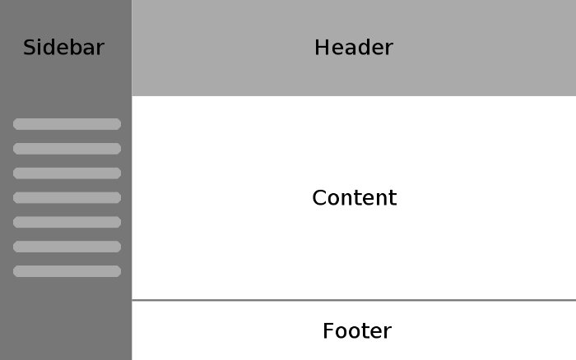
Fig 3.1: Layout of the Website

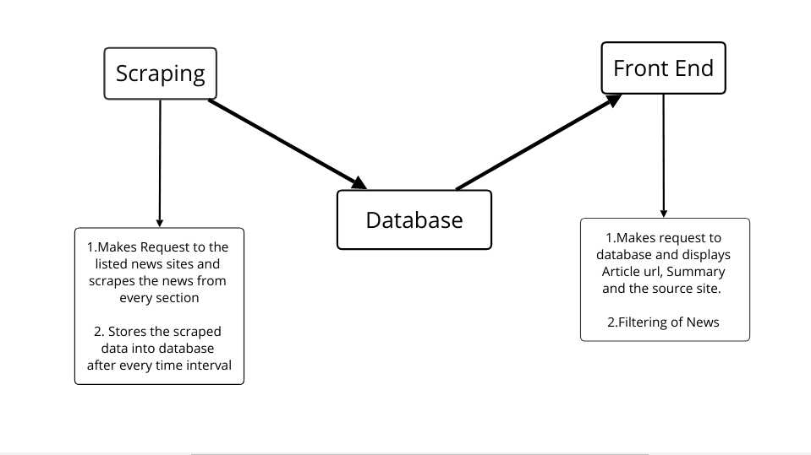
Fig 3.2: Workflow Diagram

Chapter 4: System Requirement Specification
4.1 Software Specification
4.1.1 Front End Tools: HTML, CSS, JavaScript
4.1.2 Back End Tools: Python web scraping and web development libraries
4.1.3 Database: MongoDB
4.1.4 Text Editor: VS Code
4.1.5 Browsers: IE 8 above, Safari 9 above, Firefox 46 above, Chrome 47 above

4.2 Hardware Specification
Since the website will be simplistic, sophisticated hardware is not required. Any modern PC capable of running a modern OS should suffice.

Chapter 5: Project Planning and Scheduling
The work breakdown and time in weeks required to complete the specific task are shown as in the Gantt chart below: -

Task | 1 | 2 | 3 | 4 | 5 | 6 | 7 | 8 | 9 | 10 | 11 | 12
Research and study
Graphic Designing
Core Programming
Program testing
Documentation
Table 5.1: Gantt Chart

Tasks:
- Research and Study
- Graphic Designing
- Core Programming
- Program Testing
- Documentation

References
(2019). Retrieved from The Karma Reader: http://www.karmareader.com/

About Us: Msn . (2018, 07 09). Retrieved from msn : https://www.msn.com/en-us/news/us/about-us/ar-BBN0NAK

