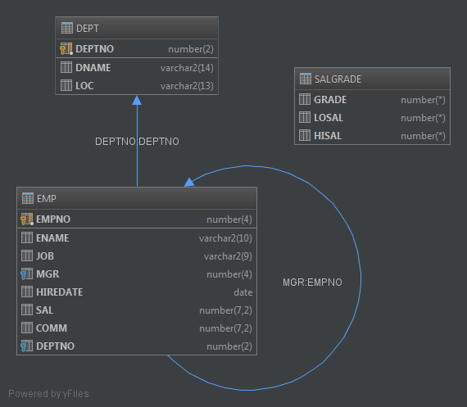

**Tables Used in the Course**

Three main tables will be used in this course. These are:

* EMP table, which gives details of all the employees
* DEPT table, which gives details of all the departments
* SALGRADE table, which gives details of salaries for various grades

The structure and data for all the tables is given in Appendix B.

**EMP data:**

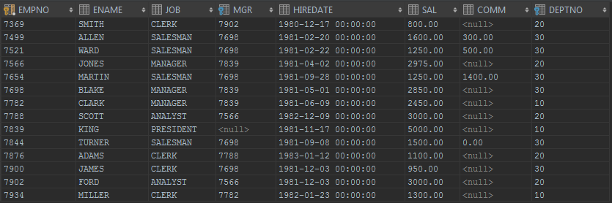

**DEPT data:**

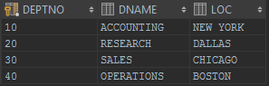

**SALGRADE data:**

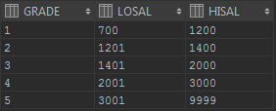

1. Create a query to display the name and salary of employees earning more than $2850.

|  |  |
| --- | --- |
| **ENAME** | **SAL** |
| KING | 5000 |
| JONES | 2975 |
| FORD | 3000 |
| SCOTT | 3000 |

2. Create a query to display the employee name and department number for employee number 7566.

|  |  |
| --- | --- |
| **ENAME** | **DEPTNO** |
| JONES | 20 |

3. Create a query to display the name and salary for all employees whose salary is not in the  
range of $1500 and $2850.

|  |  |
| --- | --- |
| **ENAME** | **SAL** |
| KING | 5000 |
| JONES | 2975 |
| MARTIN | 1250 |
| JAMES | 950 |
| WARD | 1250 |
| FORD | 3000 |
| SMITH | 800 |
| SCOTT | 3000 |
| ADAMS | 1100 |
| MILLER | 1300 |

4. Display the employee name, job and start date of employees hired between February 20, 1981, and May 1, 1981. Order the query in ascending order of start date.

|  |  |  |
| --- | --- | --- |
| **ENAME** | **JOB** | **HIREDATE** |
| ALLEN | SALESMAN | 1981-02-20 |
| WARD | SALESMAN | 1981-02-22 |
| JONES | MANAGER | 1981-04-02 |
| BLAKE | MANAGER | 1981-05-01 |

5. Display the employee name and department number of all employees in departments 10 and 30 in alphabetical order by name.

|  |  |
| --- | --- |
| **ENAME** | **DEPTNO** |
| ALLEN | 30 |
| WARD | 30 |
| MARTIN | 30 |
| BLAKE | 30 |
| CLARK | 10 |
| KING | 10 |
| TURNER | 30 |
| JAMES | 30 |
| MILLER | 10 |

6. Display list the name and salary of employees who earn more than $1500 and are in department 10 or 30. Label the columns Employee and Monthly Salary, respectively.

|  |  |
| --- | --- |
| **Employee** | **Monthly Salary** |
| ALLEN | 1600 |
| BLAKE | 2850 |
| CLARK | 2450 |
| KING | 5000 |

7. Display the name and hire date of every employee who was hired in 1982.

|  |  |
| --- | --- |
| **ENAME** | **HIREDATE** |
| SCOTT | 1982-12-09 |
| MILLER | 1982-01-23 |

8. Display the name and job title of employees who do not have a manager.

|  |  |
| --- | --- |
| **ENAME** | **JOB** |
| KING | PRESIDENT |

9. Display the name, salary, and commission for all employees who earn commissions. Sort the data in descending order of salary and commissions (commission within salary).

|  |  |  |
| --- | --- | --- |
| **ENAME** | **SAL** | **COMM** |
| ALLEN | 1600 | 300 |
| TURNER | 1500 | 0 |
| MARTIN | 1250 | 1400 |
| WARD | 1250 | 500 |

10. Display the names of all employees where the third letter of their name is an A.

|  |
| --- |
| **ENAME** |
| BLAKE |
| CLARK |
| ADAMS |

11. Display the name of all employees that have two Ls in their name and are in department 30 or their manager is 7782.

|  |
| --- |
| **ENAME** |
| ALLAN |
| MILLER |

12. Display the name, job, and salary for all employees whose job is Clerk or Analyst and their salary is not equal to $1000, $3000, or $5000.

|  |  |  |
| --- | --- | --- |
| **ENAME** | **JOB** | **SAL** |
| SMITH | CLERK | 800 |
| ADAMS | CLERK | 1100 |
| JAMES | CLERK | 950 |
| MILLER | CLERK | 1300 |

13. Display the name, salary, and commission for all employees whose commission amount is greater than their salary increased by 10%.

|  |  |  |
| --- | --- | --- |
| **ENAME** | **SAL** | **COMM** |
| MARTIN | 1250 | 1400 |