Assignment 1: Draw your Home Network Topology and explain how you are accessing the RPS Lab environment.
Network Topology in which all the devices or nodes are physically connected to a central node such as a router,switch,
or hub.
A switch can also be utilised as a central device instead of hub.
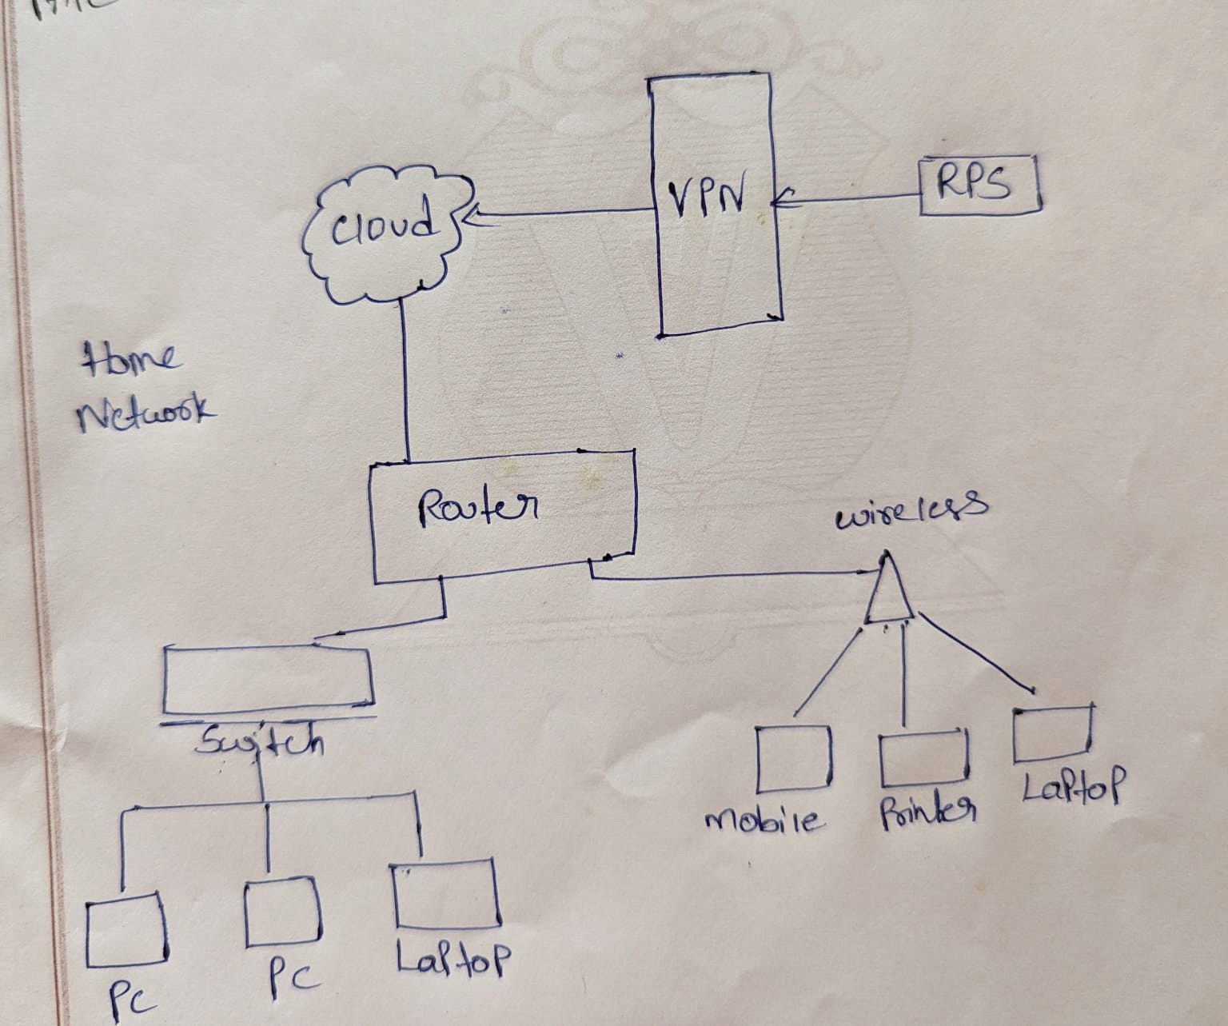
Assignment 2: Identify a real-world application for both parallel computing and networked systems.
Explain how these technologies are used and why they are important in that context.

Weather forecasting is a prime example of a real-world application that relies heavily on both
parallel computing and networked systems. Let's delve into how these technologies work together:

1. Networked Systems:
Data Collection: A vast network of weather stations, satellites, radar systems, and buoys spread
across the globe continuously gathers atmospheric data like temperature, pressure, humidity,
and wind speed.
Data Sharing: This data is transmitted over communication networks to central processing
centers. Networked systems ensure the efficient and timely flow of this critical information.
2. Parallel Computing:
Massive Datasets: Weather forecasting models involve complex calculations using enormous
datasets. Parallel computing comes into play here.
Breaking Down the Work: The data is divided and distributed across multiple processors
within a supercomputer or a network of computers working together. Each processor
performs calculations on a portion of the data simultaneously.
Faster Simulations: This parallel processing significantly reduces the time required to run
weather simulations, allowing for quicker and more up-to-date forecasts.
Importance of This Combination:

Accuracy: The faster processing speeds enabled by parallel computing allow for more complex
and detailed simulations, leading to more accurate forecasts.
Timeliness: Timely weather information is crucial for various sectors like agriculture, aviation,
and disaster preparedness. Networked systems ensure the rapid collection and processing of
data, enabling real-time forecasts.
Scalability: As weather data collection continues to grow, networked systems and parallel
computing can be scaled up by adding more processing power or data collection points to handle the
increasing demands.
In conclusion, weather forecasting exemplifies the power of combining networked systems and
parallel computing. Networked systems ensure the collection and sharing of vast amounts of data,
while parallel computing allows for the rapid processing of this data to generate accurate and
timely weather forecasts. This fusion of technologies plays a vital role in our everyday lives and
various critical industries.

