Assignment 1: Create an infographic illustrating the Test-Driven Development (TDD) process.
Highlight steps like writing tests before code, benefits such as bug reduction, and how it fosters software reliability.
The Test-Driven Development (TDD) Process
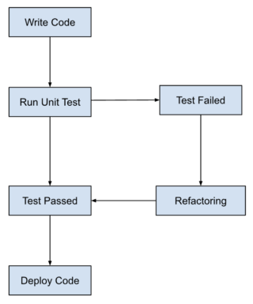

Write Failing Tests (Test First):
Depict a programmer writing code for an automated test.
Show the test initially failing (marked with an "X").
Code to Make Tests Pass (Just Enough):
Show the programmer carefully coding to fulfill the failing test requirements.
Refactor (Clean Up): The programmer reviewing and improving the code for better readability and maintainability.
Benefits:
Reduced Bugs:
On the side of the infographic, showcase a magnifying glass finding and eliminating bugs (represented as insects).
Improved Code Quality:
Depict a code snippet with clean structure and clear comments.
Reliable Software:
Show the completed castle/building structure standing strong (representing reliable software built using TDD).

Assignment 2: Produce a comparative infographic of TDD, BDD, and FDD methodologies. Illustrate their unique approaches,
benefits, and suitability for different software development contexts. Use visuals to enhance understanding.

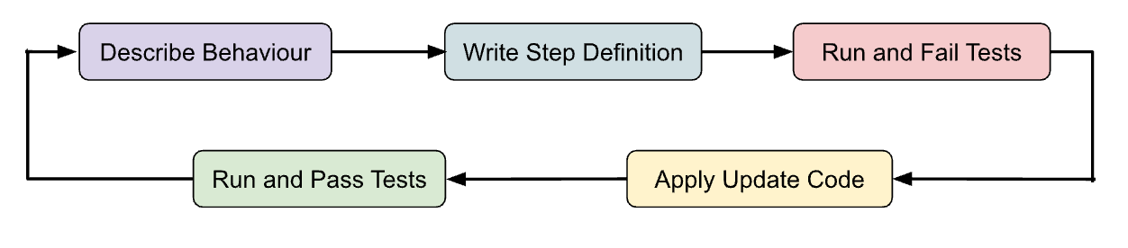
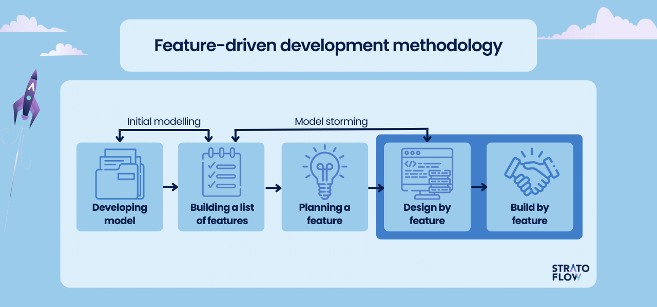

Test-Driven Development (TDD):
Approach: Write failing tests before writing code.
Benefits:
Bug Reduction
Reliability
Suitable Context: Agile environments with iterative development.
Behavior-Driven Development (BDD):
Approach: Define behavior using natural language specifications.
Benefits:
Improved Communication
Alignment with Business Goals
Suitable Context: Complex projects with diverse stakeholder requirements.
Feature-Driven Development (FDD):
Approach: Focus on delivering specific features in short cycles.
Benefits:
Scalability
Clear Progress Tracking
Suitable Context: Projects with clear, predefined requirements.

Introduction:
Brief explanation of each methodology: Test-Driven Development (TDD), Behavior-Driven Development (BDD), and Feature-Driven Development (FDD).
TDD (Test-Driven Development):
Approach:
Illustration of a developer writing a failing test before writing code.
Caption: "Write failing tests before writing code to define functionality."
Benefits:
Bug Reduction:
Illustration showing bugs caught early in the development process.
Caption: "Identify and fix bugs early, reducing overall development time."
Reliability:
Illustration of a sturdy bridge representing reliable software.
Caption: "Build reliable software with a comprehensive test suite."
Suitable Context:
Illustration of a small project with frequent code changes.
Caption: "Ideal for agile environments with iterative development."
BDD (Behavior-Driven Development):
Approach:
Illustration of collaboration between developers, testers, and stakeholders to define behavior using natural language.
Caption: "Define behavior using natural language specifications."
Benefits:
Improved Communication:
Illustration of a conversation bubble connecting stakeholders and developers.
Caption: "Enhanced communication between stakeholders and development teams."
Alignment with Business Goals:
Illustration of a target symbolizing alignment with business objectives.
Caption: "Ensure software development aligns with business objectives."
Suitable Context:
Illustration of a large project with multiple stakeholders.
Caption: "Well-suited for complex projects with diverse stakeholder requirements."
FDD (Feature-Driven Development):
Approach:
Illustration of breaking down development into manageable feature sets.
Caption: "Focus on delivering specific features in short cycles."
Benefits:
Scalability:
Illustration showing the growth of features over time.
Caption: "Easily scale development to accommodate project growth."
Clear Progress Tracking:
Illustration of a progress bar indicating completion of features.
Caption: "Track progress by focusing on feature completion."
Suitable Context:
Illustration of a project with a well-defined scope and timeline.
Caption: "Ideal for projects with clear, predefined requirements."
Conclusion:
Summarize the unique approaches, benefits, and suitability of each methodology.
Encourage consideration of project requirements and team dynamics when choosing a methodology.

