**Lab Manual 4**



Session: 2021 – 2024

**Submitted by:**

Uswa Arif

1. CS-77

**Supervised by:**

   Ms. Aroosh Fatima

Department of Computer Science

**University of Engineering and Technology**

**Lahore Pakistan**

**Lab Tasks**

**Task 1:**

**Command:**  Ping

**Description:**

A ping command is used in computer networks to check the availability of network that can our network can reach other computer’s network. By giving the IP addresses to routers, if the signal becomes green then it means there is availability of the network we are trying to reach.

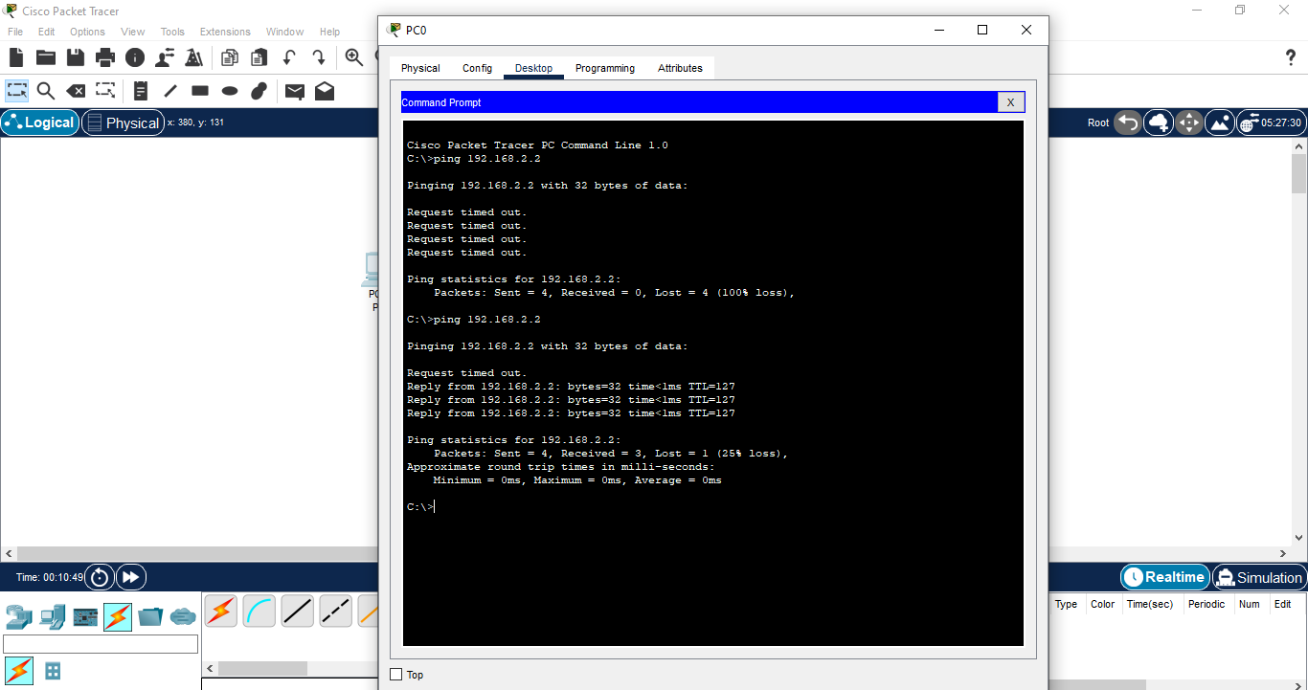

**Task 2:**

**Command:**  Enable

**Description:**

Enable command in Computer Networks enables the device to perform many other command of specific network devices that we are enabling in CLI. As, we are enabling the Router in Router’s CLI. We can reach many other command of router by enabling it like **show ip, show version, show users, show hosts** etc.

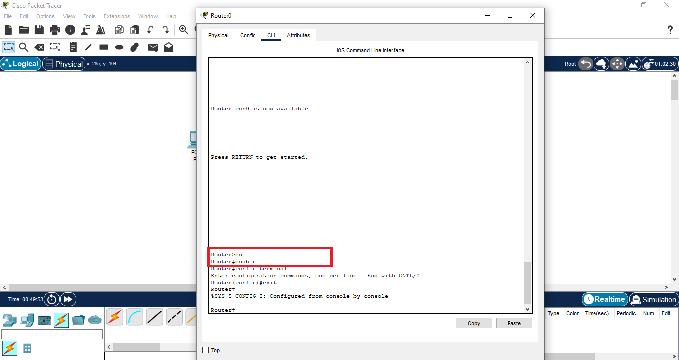

**Task 3:**

**Command:**  Configure Terminal

**Description:**

The configure command is used after we enable any network device. After that, write configure terminal command in CLI and now we can access all the features like host-name, passwords and IP domain of devices. We can change host-name, passwords of the devices.

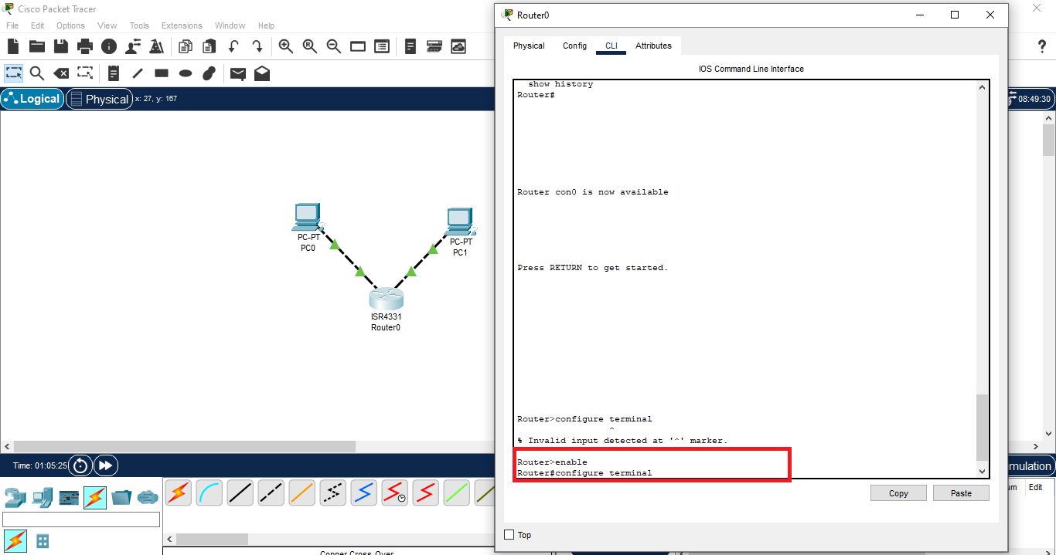

**Task 4:**

**Command:**  Host Name

**Description:**

Host Name command is used after enabling the router device in CLI and, then after the command configure terminal, we write host-name and the name we want to give for host name. This will changes the name of host to name given by us.

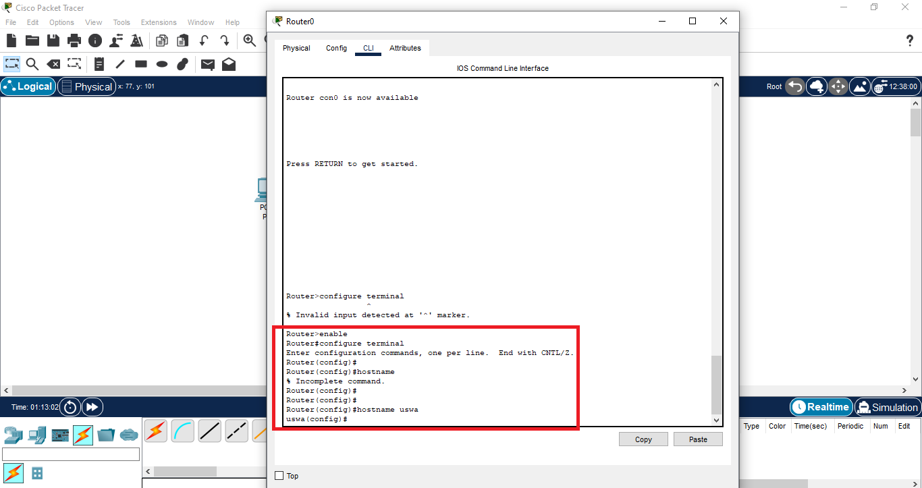

**Task 5:**

**Command:**  Shut down

**Description:**

Shutdown command is used to close the computer. First, lookup the computer you want to close by giving command **show interfaces**. This command is given after exiting the **configure terminal** command. Show interfaces command prompts all computers connected to ports. Select the computer connected to port. After that, write the **configure terminal**  command, then write **interface computer_port_name** command and then write **shutdown command**. This will shut down that computer by showing you on the screen.

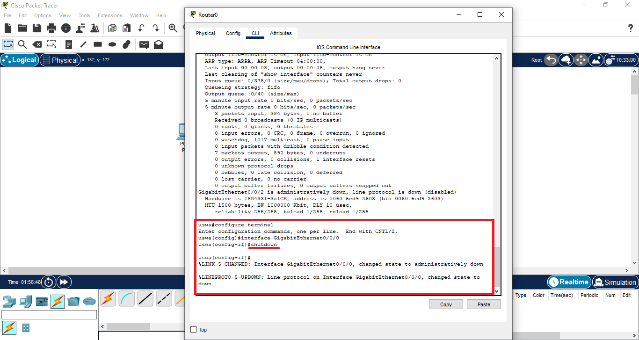

**Task 6:**

**Command:**  Exit

**Description:**

Exit command in Computer Networks is used to close the access of specific network device like router, we are using. Using this command, closes the configure terminal of router.

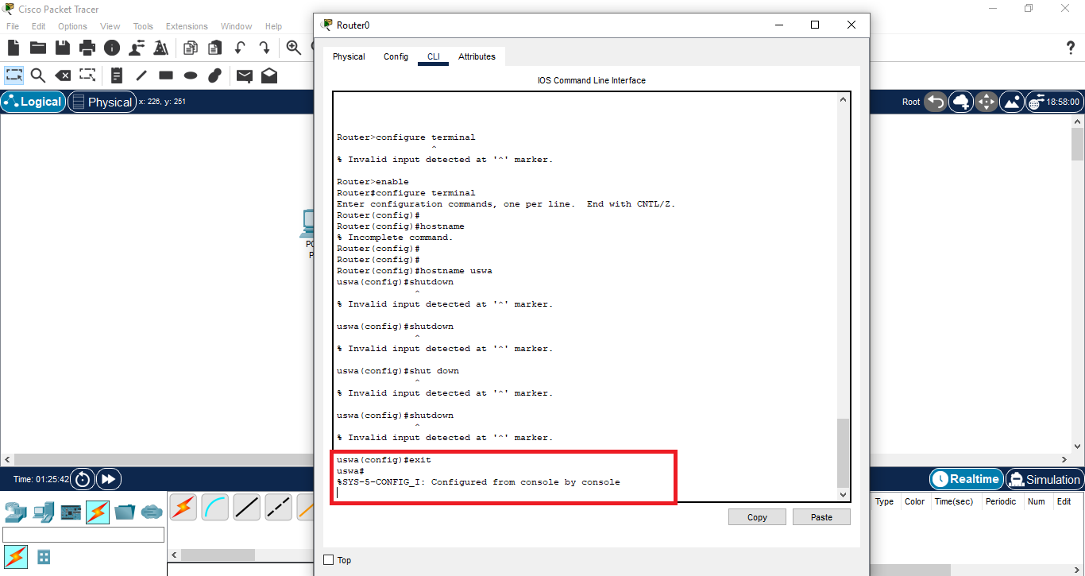

**Task 7:**

**Command:**  Write Memory

**Description:**

Write memory command is used when we have done making all the changes to the connected device that we have enabled. This command will save all the changes like changing host-name, password, shut down the computer etc. that we have made to router.

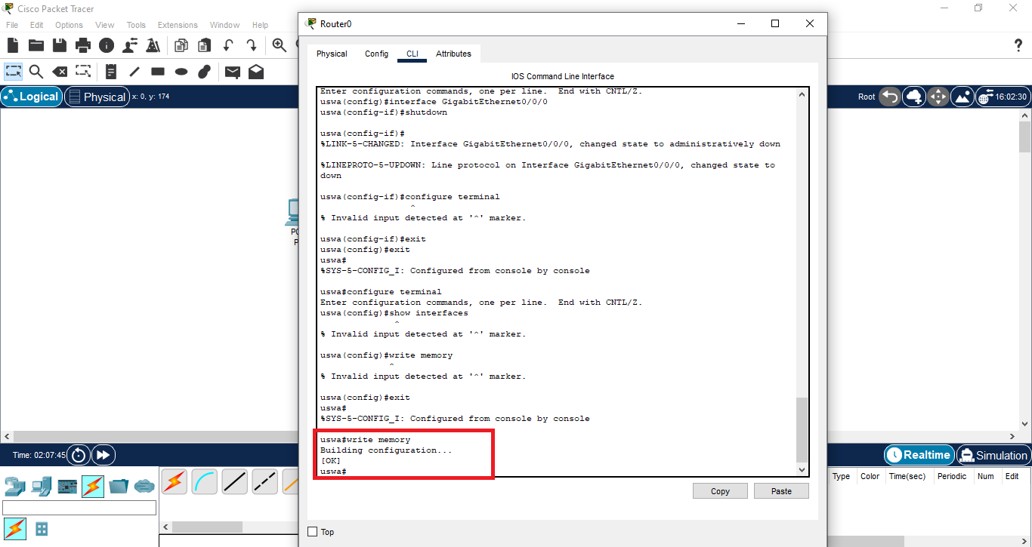

**Task 8:**

#### **Command:** show ip interface brief

**Description:**

This command shows all the interfaces that are available in Routers like their IP addresses and status. This command is written after exiting the configure terminal command. This will shows the interfaces that are connected are shutdown or not, their IP addresses, status and protocols etc.

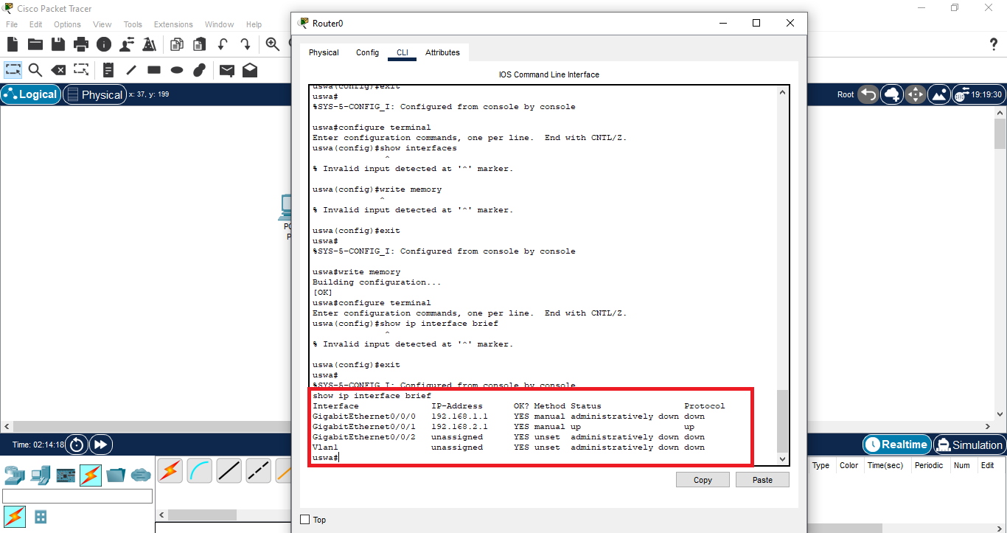

**Task 9:**

#### **Command:** write erase

**Description:**

**Write Erase** command in Computer Networks is used if we want to remove all the changes that we have made a connected device like router and the changes we save by using command **Write Memory.** This will remove all saved changes and reset the device to its default.

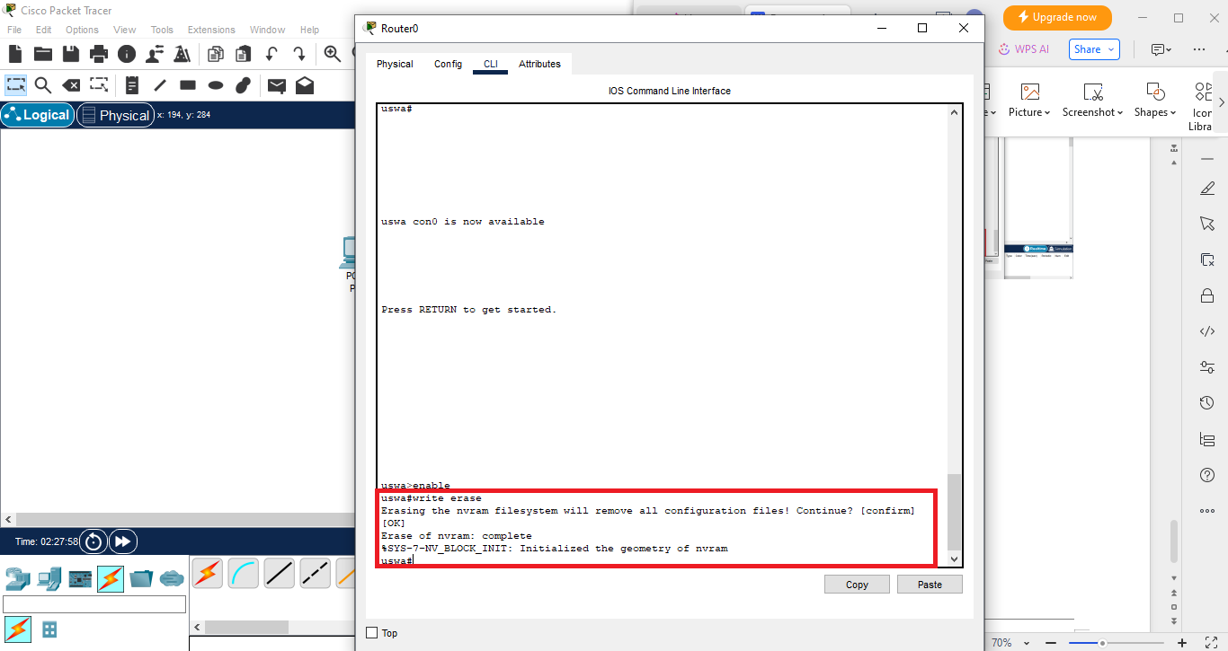

**Task 10:**

#### **Command:** no shut down

**Description:**

No-Shutdown command is used to open the computer that are closed. First, lookup the computer you want to open by giving command **show interfaces**. This command is given after exiting the **configure terminal** command. Show interfaces command prompts all computers connected to ports. Select the computer connected to port. After that, write the **configure terminal**  command, then write **interface computer_port_name** command and then write **no shutdown command**. This will opens that computer by showing you on the screen.

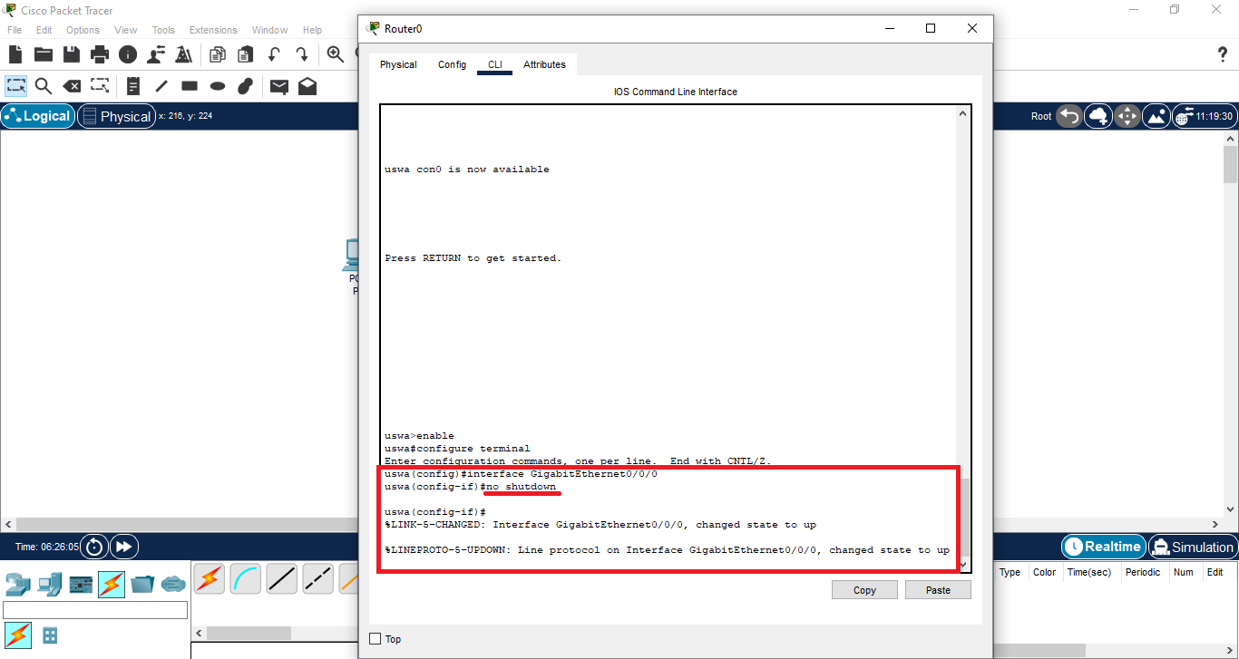

**Task 11:**

#### **Command:** interface fastethernet/number

**Description:**

**Interface interface_name** command is used to where we want to use the configurations of an interface/port through which devices are connected. For example, we want to shut down the device, this command is used.

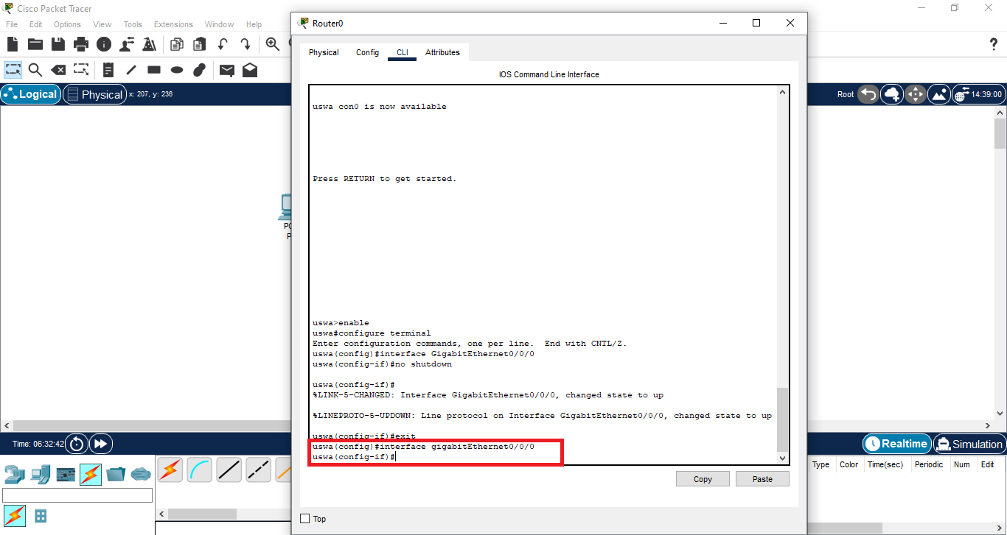

**Task 12:**

#### **Command:** reload

**Description:**

**Reload command** is used to restart the device that we have enabled in CLI. As we have enabled router device, this command will restart the this device.

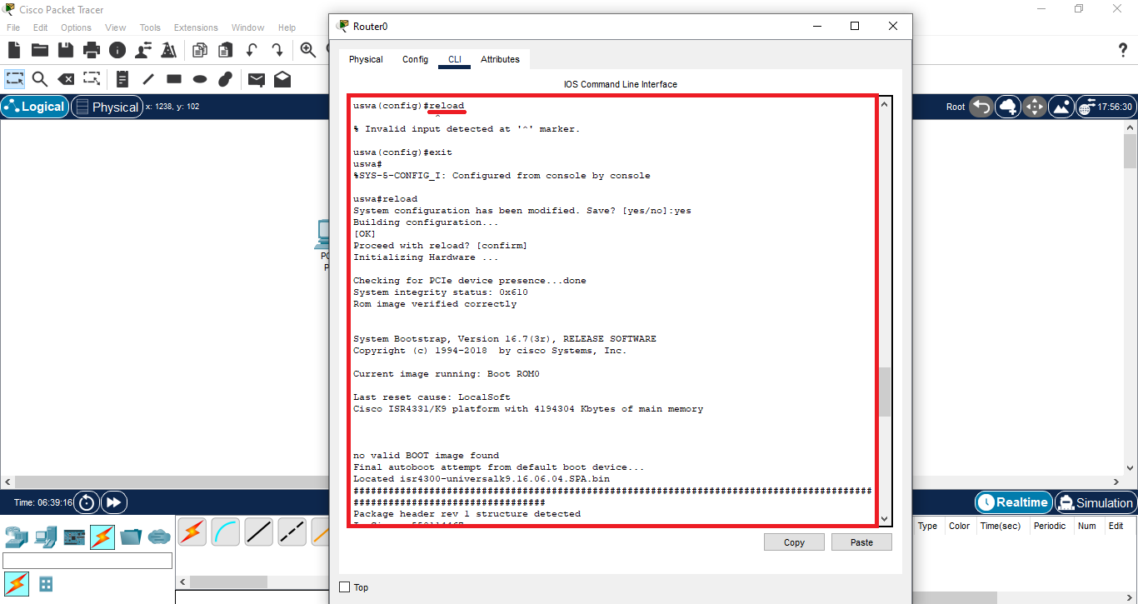

**Task 13:**

#### **Command:** show ip interface interface_name

Interface_name: FastEthernet/gigabitEthernet0/0/0

**Description:**

This command is used to lookout the IP address of the interface.

This command is written after **exiting** the configure **terminal command.** This command also gives information about IP address given to interface.

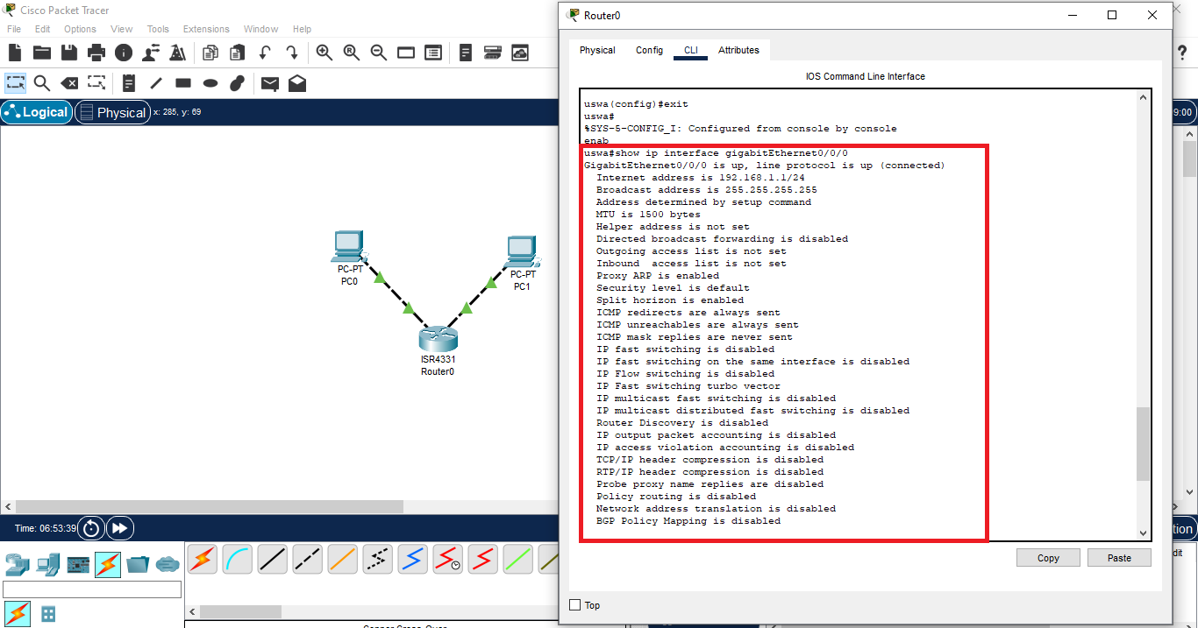

**Task 14:**

#### **Command:** show history

**Description:**

Show History command is used to keep the history of the commands that we have used before. This command gives all the commands that have used on specific enabled device.

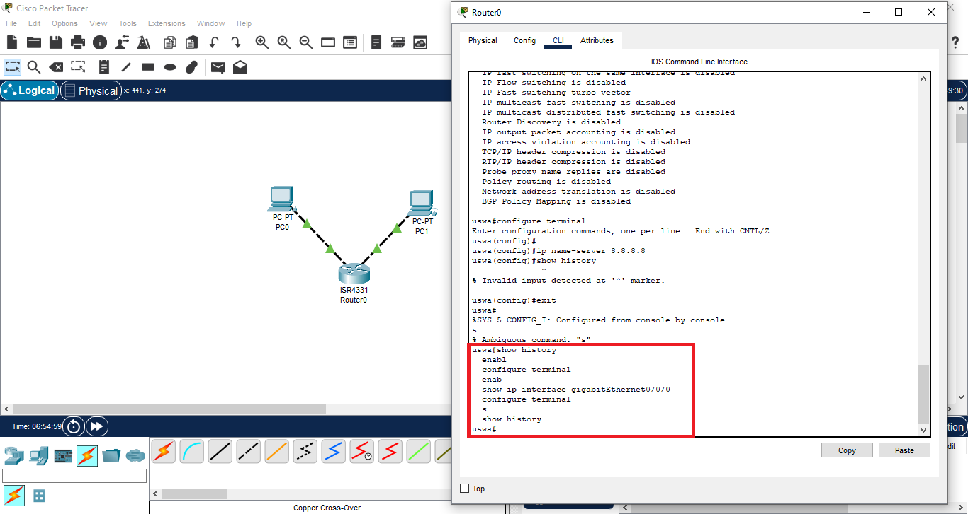

**Task 15:**

#### **Command:** show running-config

**Description:**

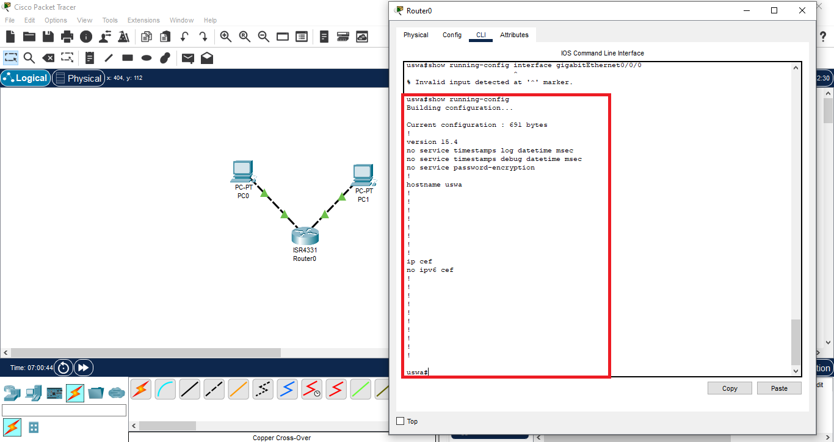

**Task 16:**

#### **Command:** show users

**Description:**

**Show users command** is used to show the users that are connected to devices like routers. This command prompts all the users.

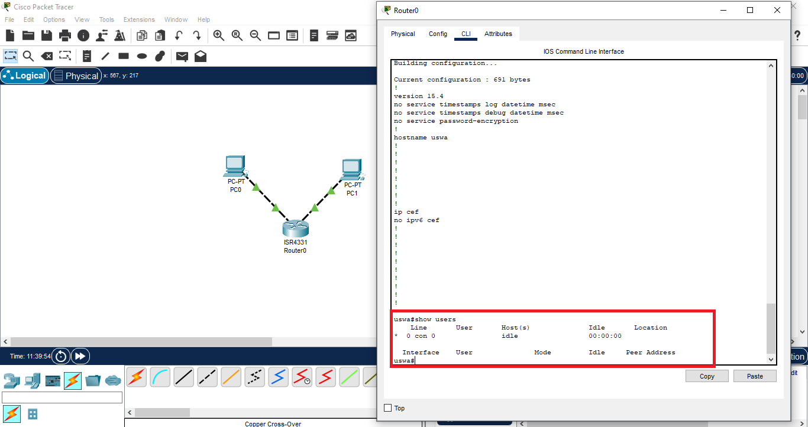

**Task 17:**

#### **Command:** disable

**Description:**

**Disable command** is used to exit or disable the **enable mode** that is enabled for any device like routers. This command jump back to user mode.

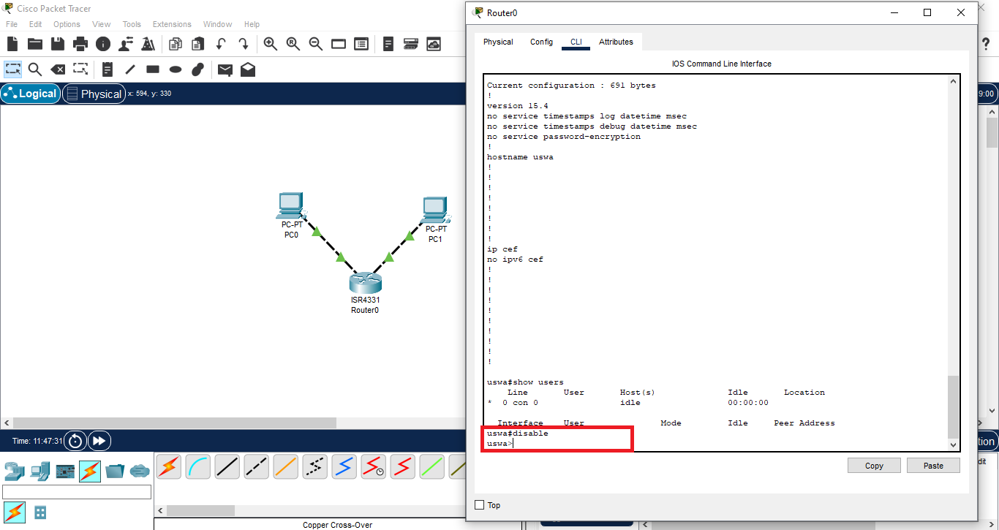

**Task 18:**

#### **Command:** show version

**Description:**

**Show Version** command is used to see the version of software that we are using. Also, this command gives the information about any connected device. It gives all information about software and devices that are used in software.

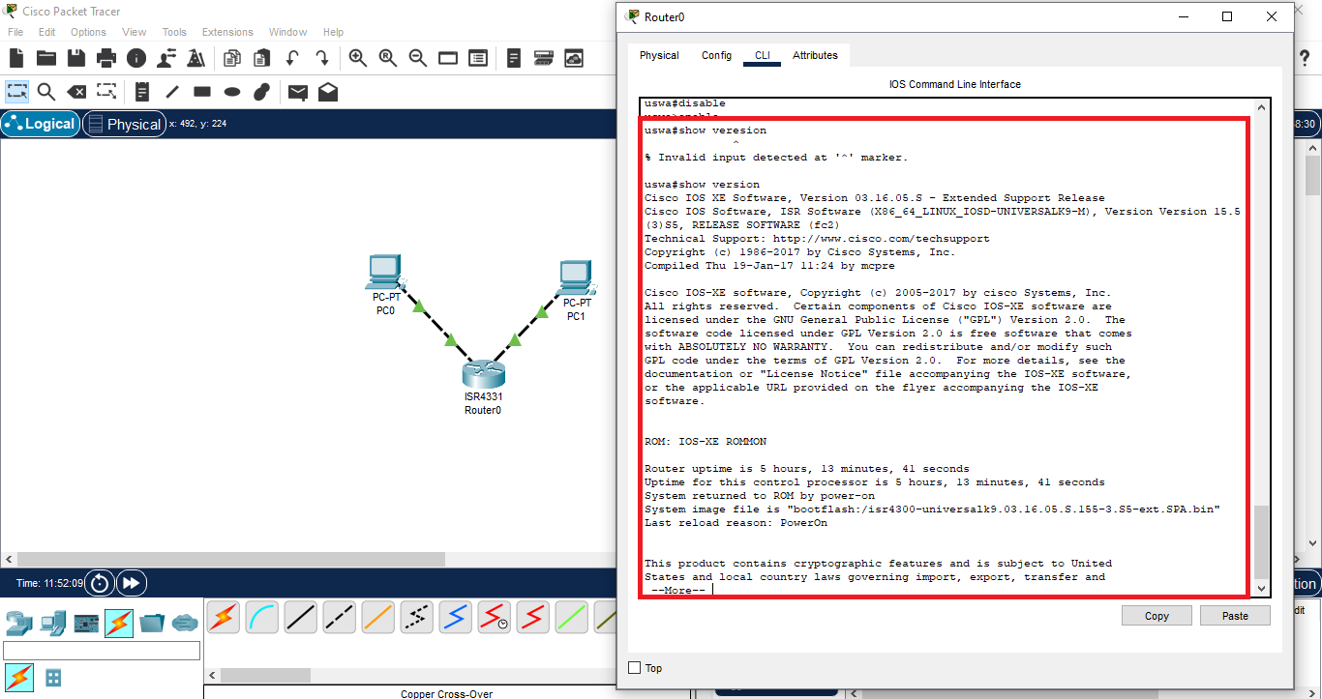

**Task 19:**

#### **Command:** description add_description

**Description:**

**Description command** is used to give description to any connected port/device. For using this command, you have to write **command configure termina**l, then you have to write the interface name for which you want to give description by using **command interface interface_name** as my interface_name is **gigabitEthernet0/0/0**. After that, you write the command **description add_description**.

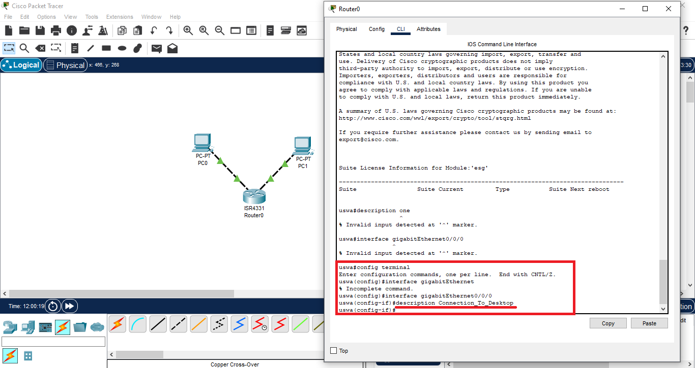

**Task 20:**

#### **Command:** show clock

**Description:**

This command shows the time that is on connected device that is enabled like router.

