**Lab Manual 6**

**Configurations of Router**



Session: 2021 – 2024

**Submitted by:**

Uswa Arif

1. CS-77

**Supervised by:**

   Ms. Aroosh Fatima

Department of Computer Science

**University of Engineering and Technology**

**Lahore Pakistan**

**Lab Tasks**

**Task 1:**

Choose a router in packet tracer. Name it with your registration # e.g., 2018-CS-XX. Set its Time and Date as today. Enable user mode and privileged mode passwords with your name.

1. Choose a router in packet tracer.

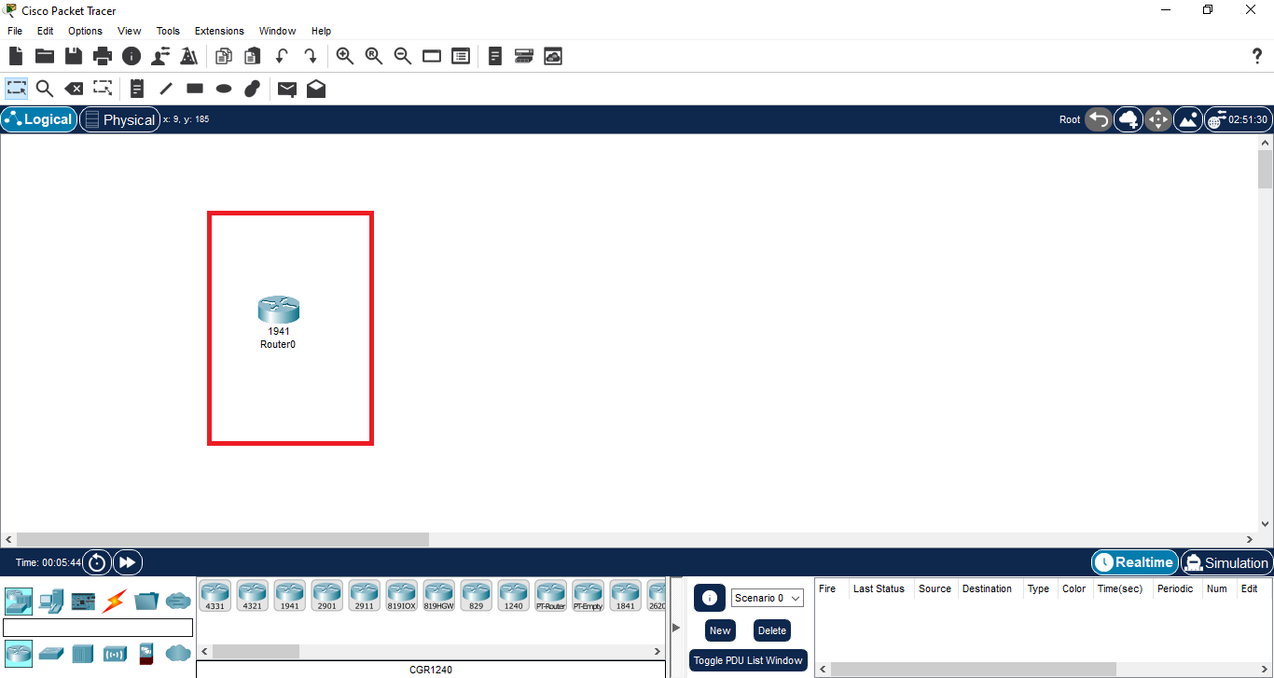

1. Name it with your registration # e.g., 2018-CS-XX.

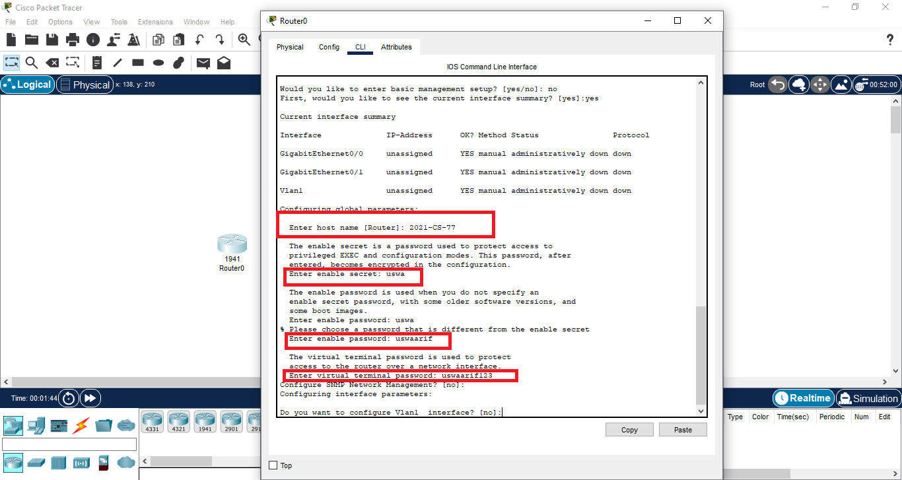

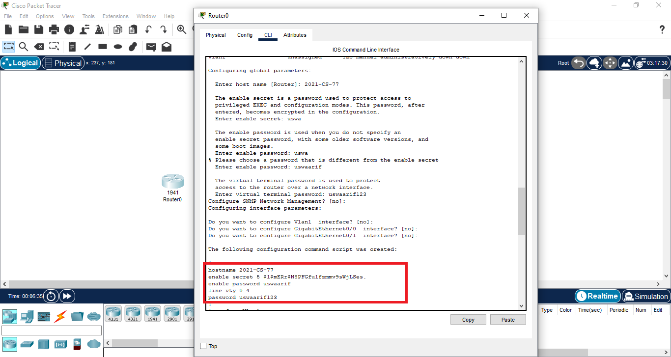

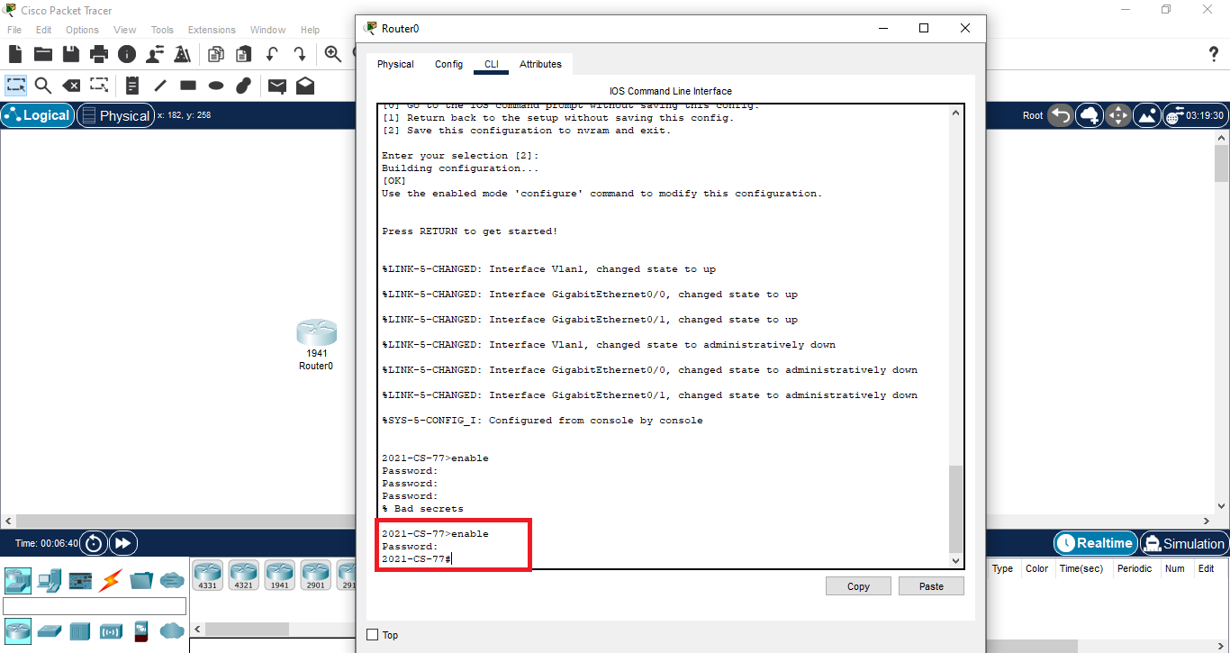

1. Set its Time and Date as today.

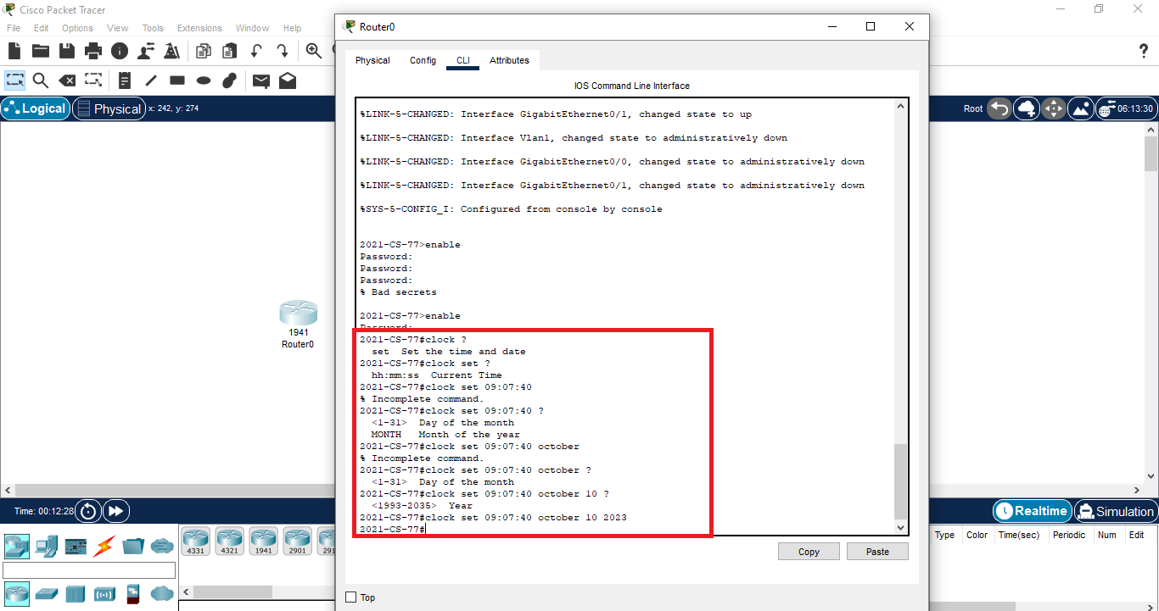

1. Enable user mode passwords with your name.

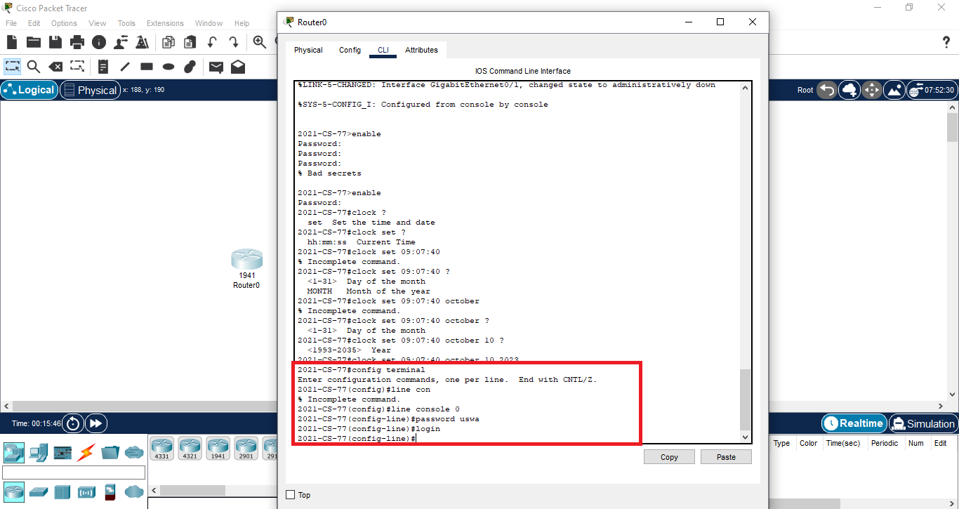

1. Enable privileged mode passwords with your name.

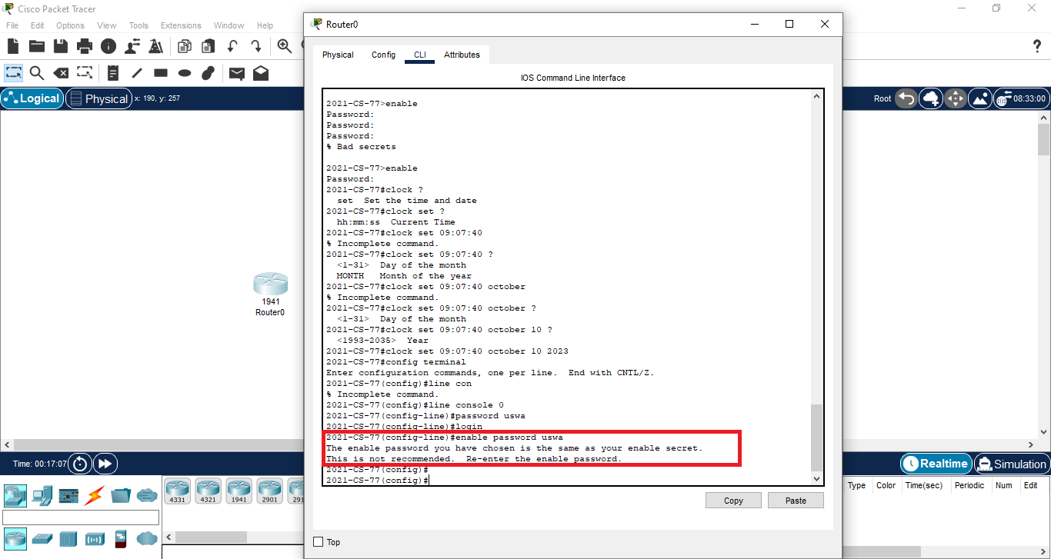

**Task 2:**

Design a network having one router, a switch and two PC’s as shown in the figure. Configure the router and also assign the Class B IP addresses to the PC’s and ping the default gateway. Also save the current configuration of the router.

1. Configure the router.

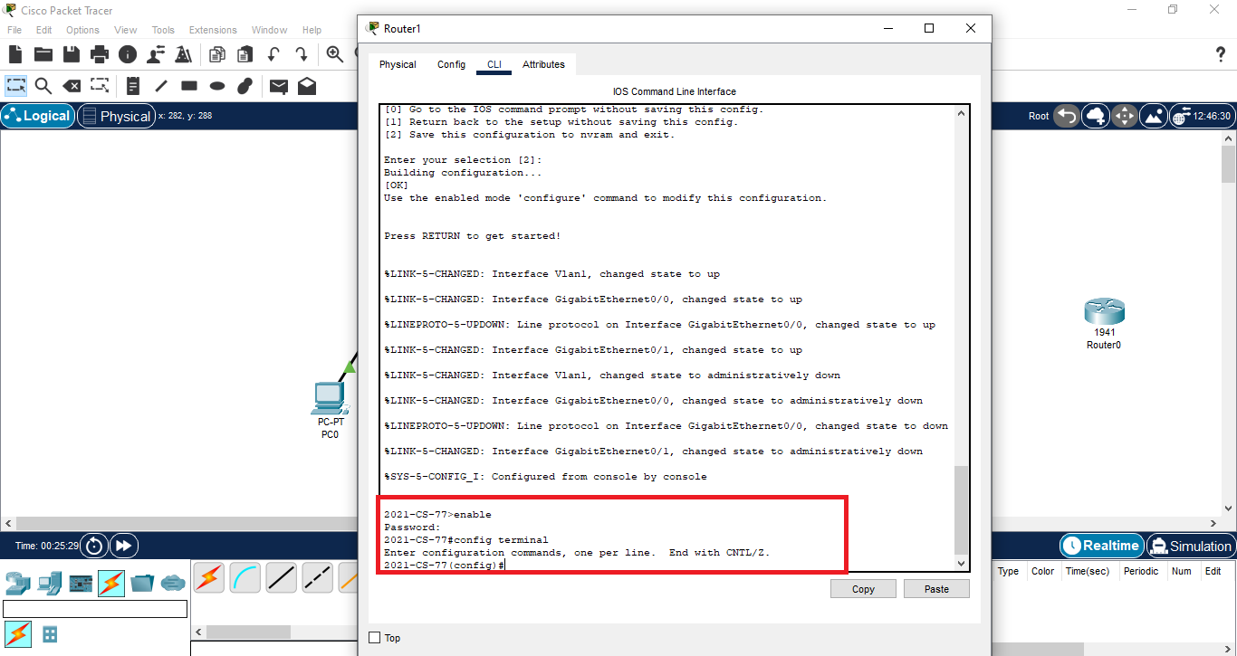

1. Also assign the Class B IP addresses to the PC’s.

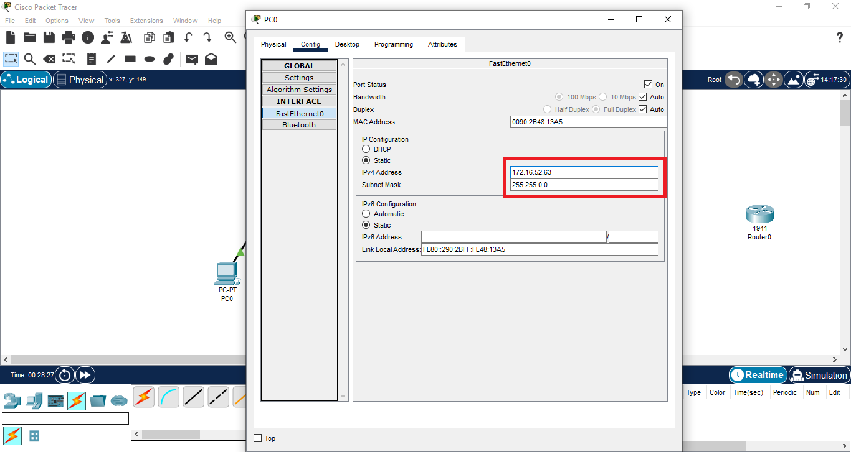

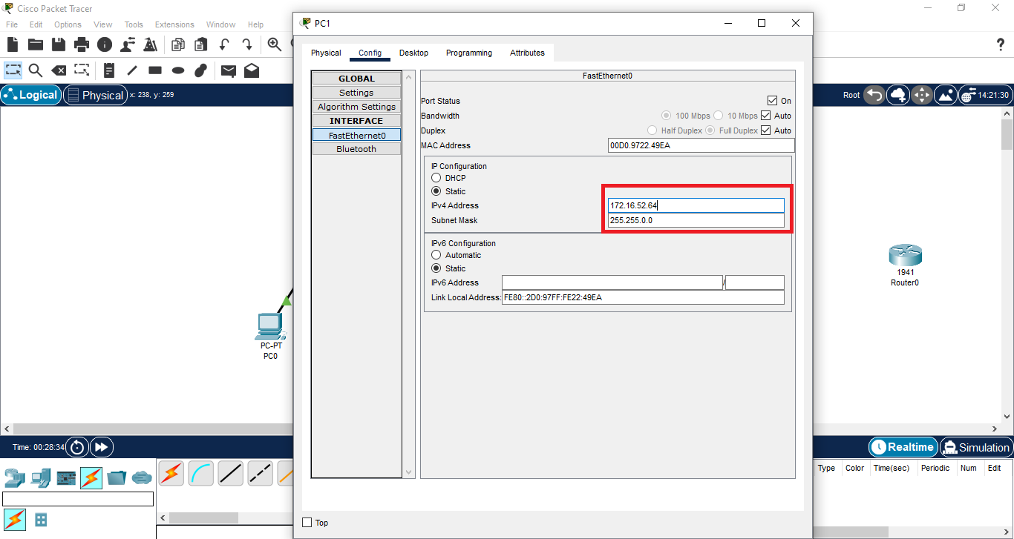

1. ping the default gateway.

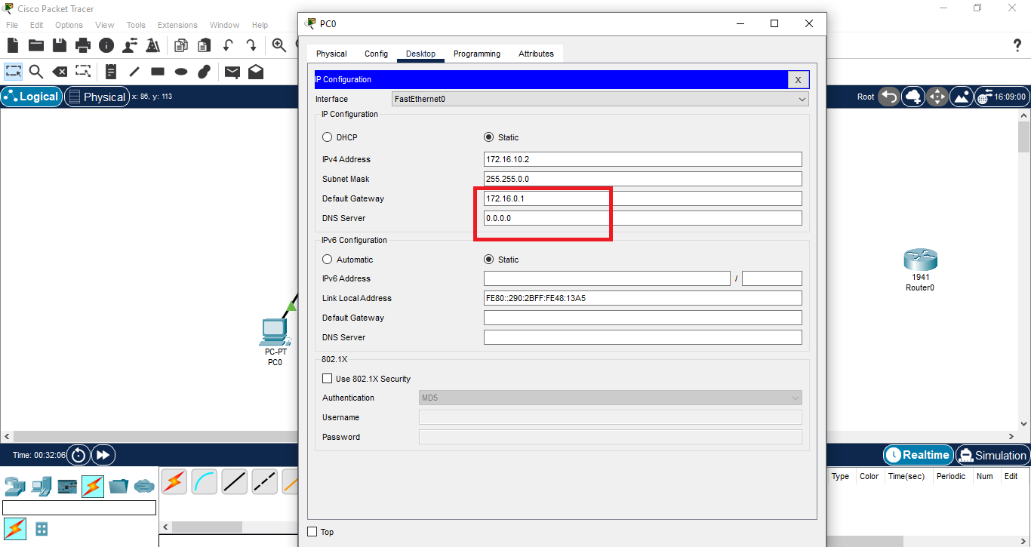

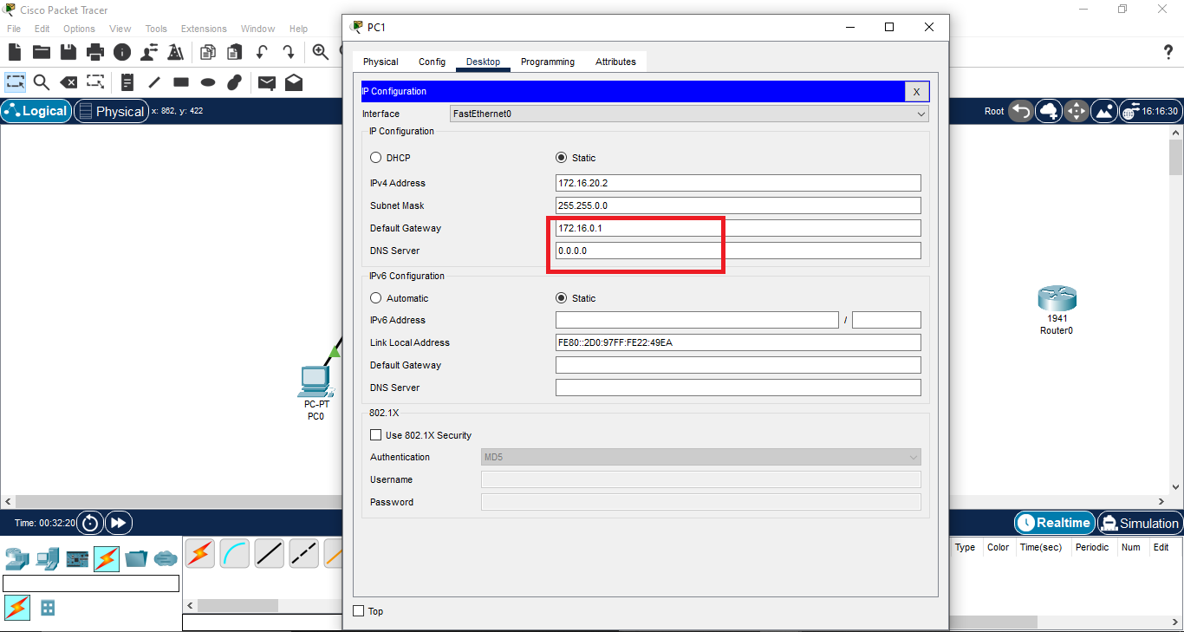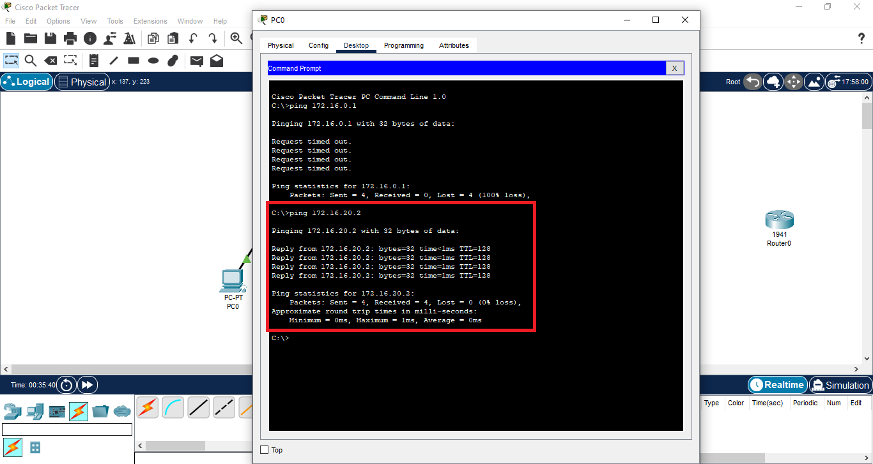

1. Also save the current configuration of the router.

