Advanced CSS with SASS
Assignment


Session: 2021 – 2024

Submitted by:
Uswa Arif
2021-CS-77

Submitted To:
Aatif Hussain

Department of Computer Science
University of Engineering and Technology
Lahore Pakistan
Introduction:
This is the Coffee Website Project. This project is a simple website for a coffee shop designed using HTML, CSS and Javascript.
Instructions:
To run this website in your system, you need to follow following instructions:
- Download the compressed zip file in your system.
- Extract the compressed file in one of the folders in your system.
- Open the project in VS-code.
- Install Live SASS Compiler in VS code and then after installing it, Open the settings by clicking on the gear icon in the bottom-left corner and selecting "Settings". Search for "live sass compiler config" and click on "Edit in settings.json". Add the following configuration:
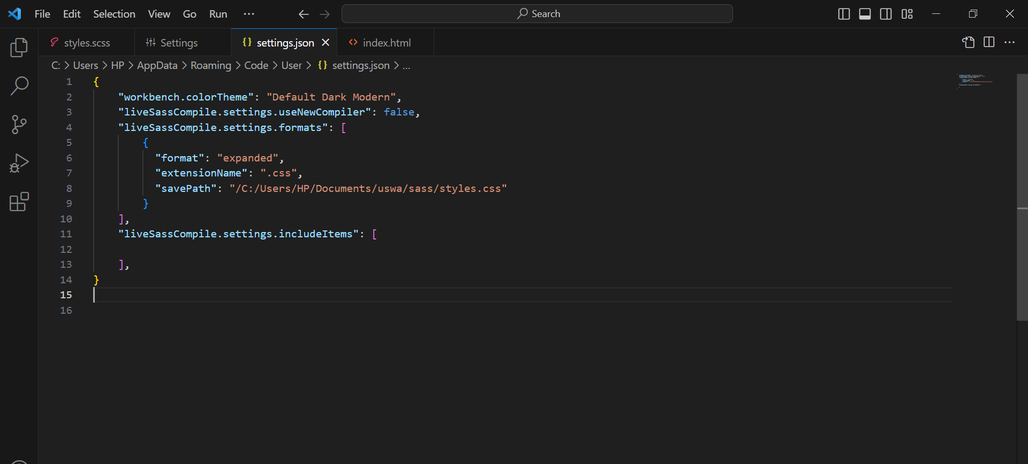

- Give the path of your directory in the savePath in the provided code.
- After editing this code, run the Live Sass Compiler in the terminal. But, first navigate the terminal to the directory in which the code is present and then write the following command to run the compiler.
“sass styles.scss styles.css”
- This command creates a styles.css file in the folder in which the other code is present.
- Then, open the index.html file in the browser and you will see the code is running.

