

**School of Computing**

**SRM IST, Kattankulathur – 603 203**

|  |  |
| --- | --- |
| **Title of Project** | INCREDIGREEN |
| **Name of the candidate** | Utkarsh Singh |
| **Register Numbers** | RA2011031010090 |
| **Date of Experiment** | 15/06/2022 |

**Aim**

To provide the details of architectural design/framework/implementation

< Provide the details of architectural design/framework/implementation with screenshots - Minimum three modules to be completed (excluding login page) use of software on their choice to implement>

Full documentation with the coding

**Architectural design used in our project:**

1. **Data flow architectures:**
   * This kind of architecture is used when input data to be transformed into output data through a series of computational manipulative components.
   * The figure represents pipe-and-filter architecture since it uses both pipe and filter and it has a set of components called filters connected by pipes.
   * Pipes are used to transmit data from one component to the next.
   * Each filter will work independently and is designed to take data input of a certain form and produces data output to the next filter of a specified form. The filters don’t require any knowledge of the working of neighboring filters.
   * If the data flow degenerates into a single line of transforms, then it is termed as batch sequential. This structure accepts the batch of data and then applies a series of sequential components to transform it.

**Software used:**

Vs code

**Preferred languages:**

Html,css,javascript

**Main screen**

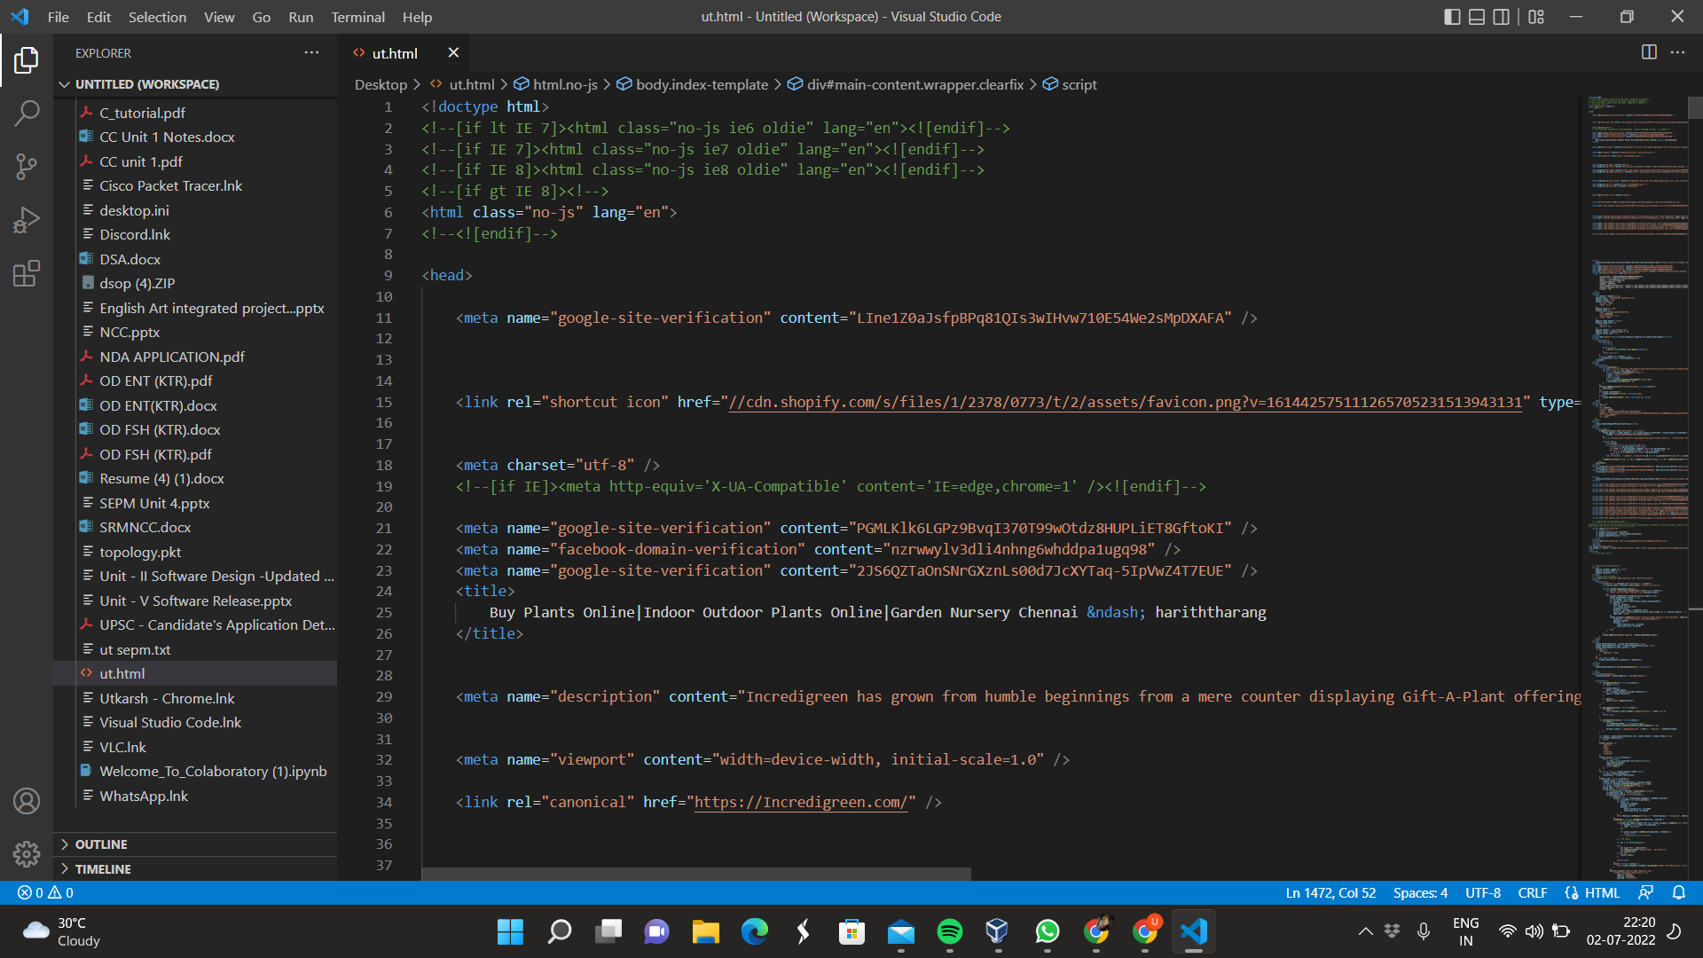

**Collections of plants and pots:**

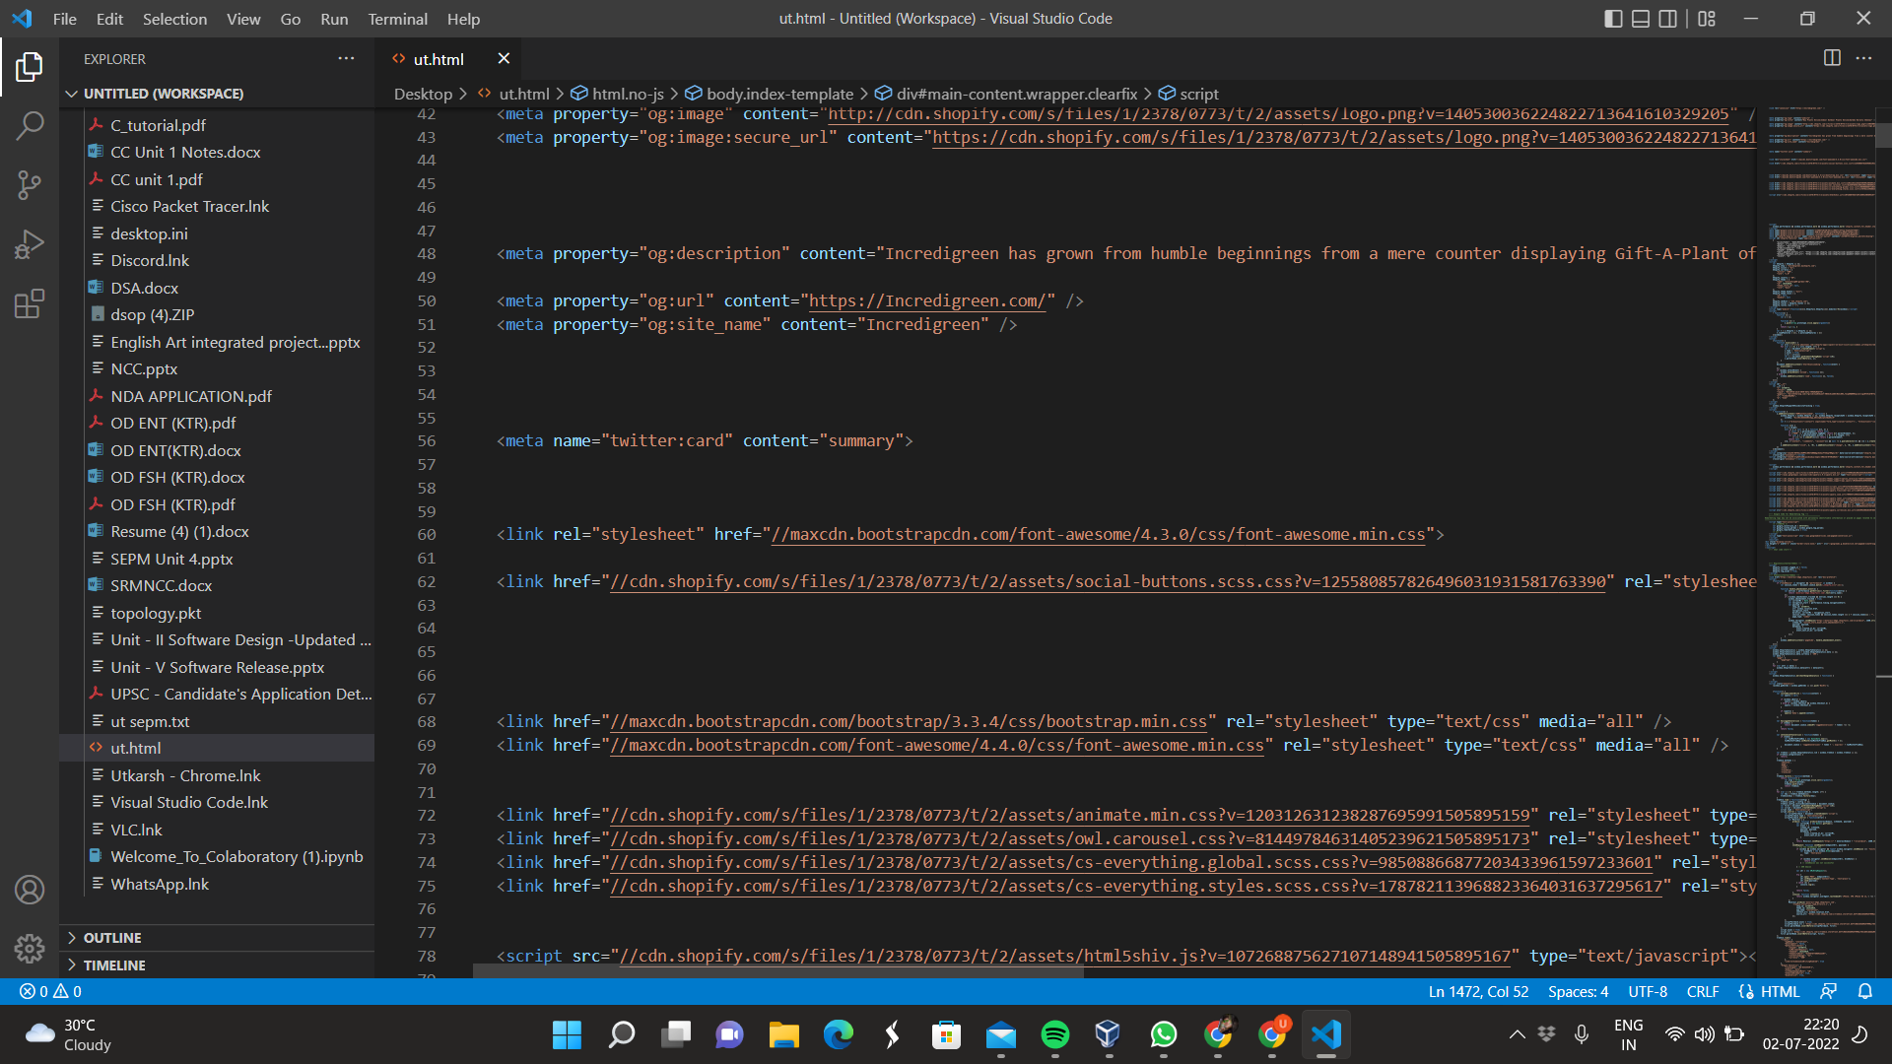

**Services:**

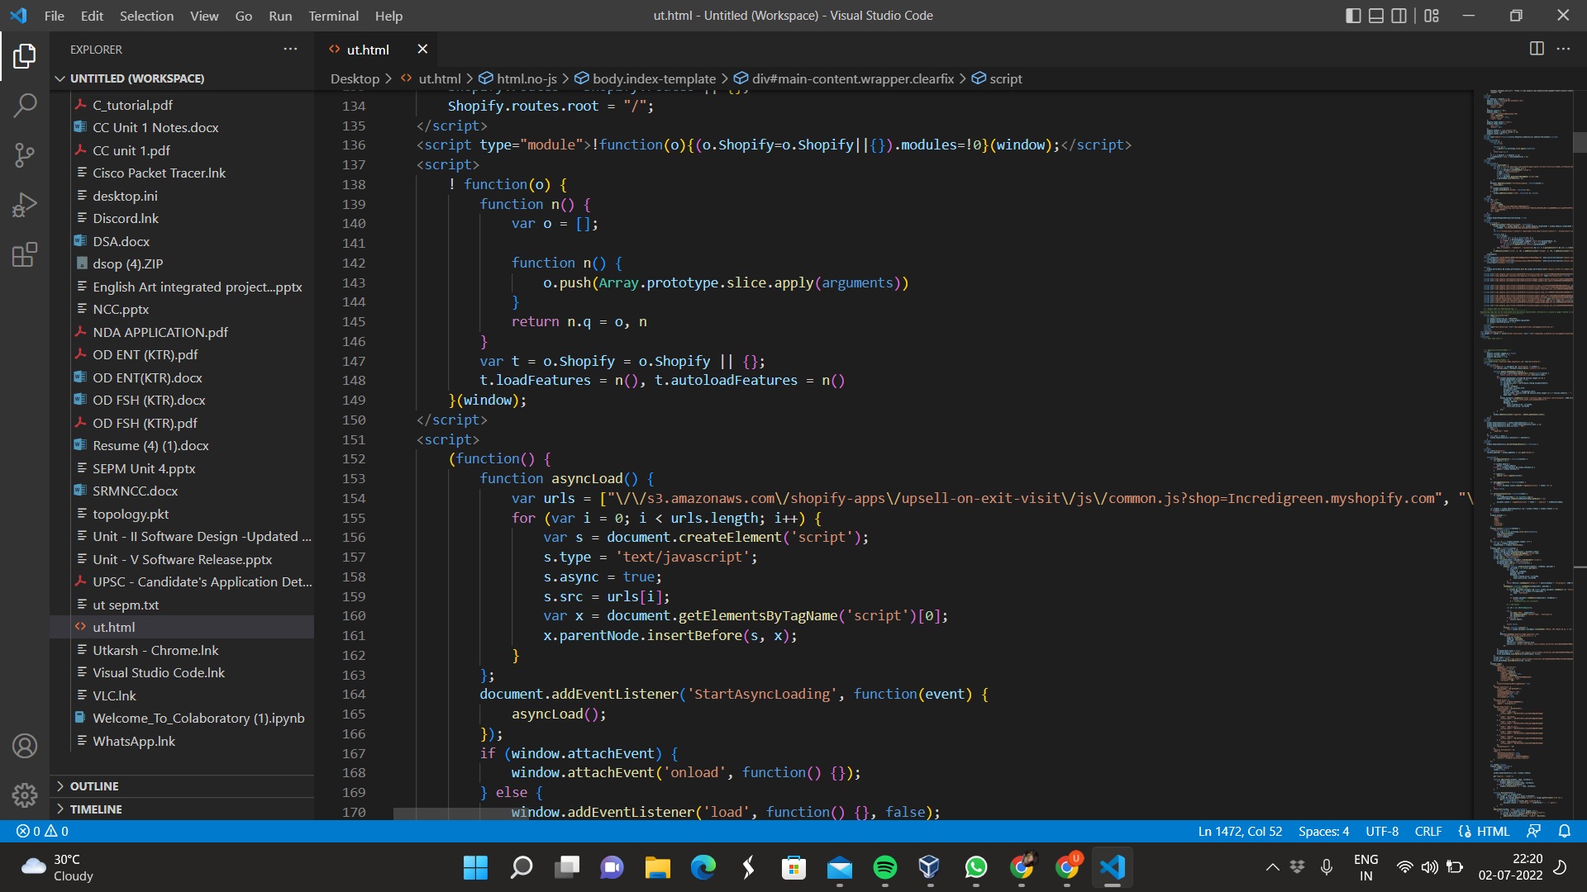

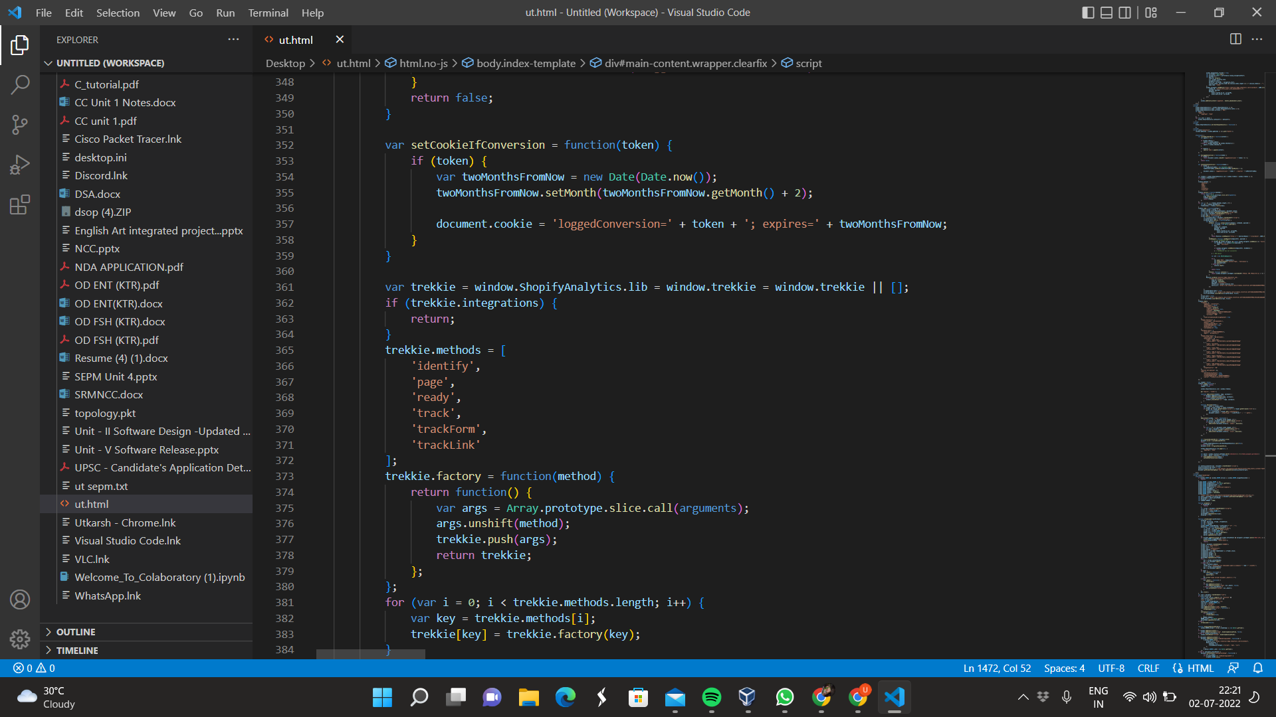

**Links to contact and connect:**

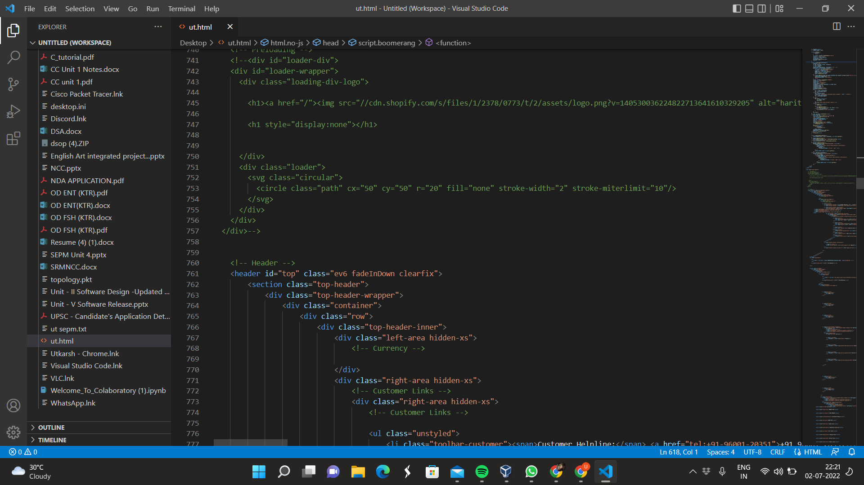



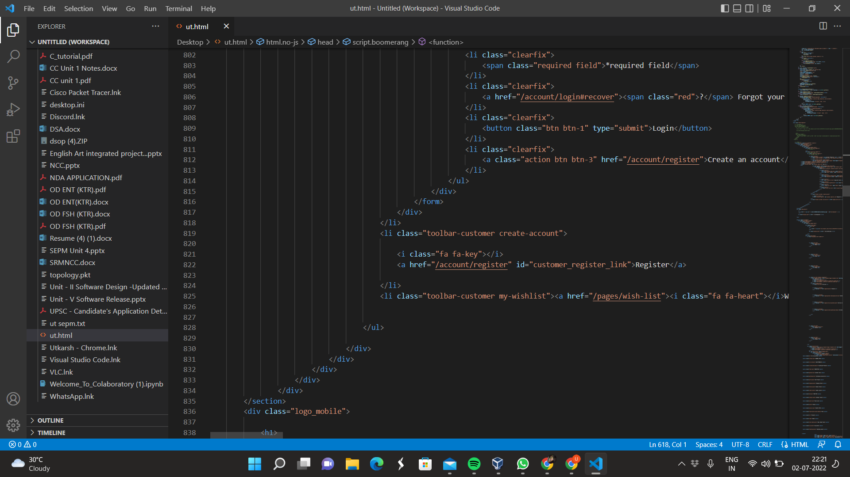

**Output of Website**

**Main screen:**

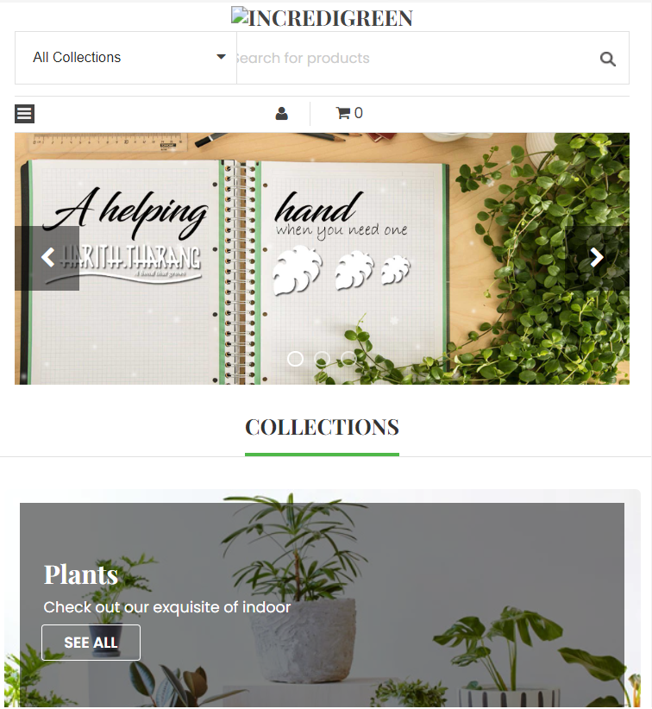

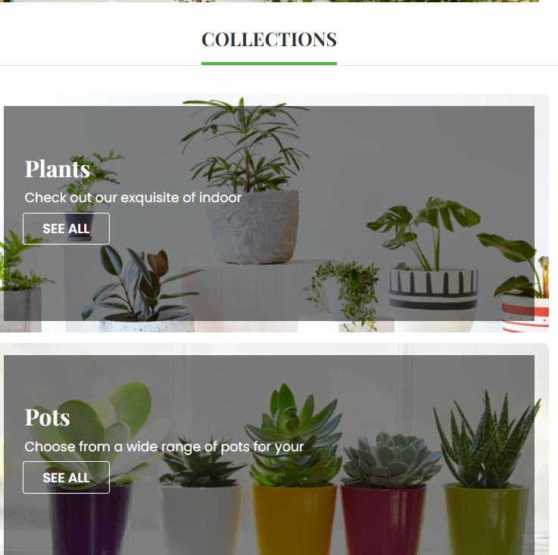

**Services and offers:**



**Links to connect:**



Result:

Thus, the details of architectural design/framework/implementation along with the screenshots were provided.