CS 6460: Artificial Intelligence
HW1
Spring 2025

Points are listed by each problem.
Submission: Submit completed homework as a PDF file. Handwritten work or phots of handwritten work must be neat and legible.

- It is a training day for a swarm of robotic miners in a hazardous environment. Each of the k miners starts in its own assigned start location s_{i} in a large maze of size M × N, meaning M columns and N rows. Each miner’s goal is to return to its own dumpsite stationed at location g_{i}. Along the way the miners must gather all chucks of Strontium 90 (think Pacman dots) in the maze.

At each time step, all k miners move one unit to any open adjacent square. The only legal actions are Up, Down, Left, or Right. It is illegal for a miner to wait in a square, attempt to move into a wall, or attempt to occupy the same square as another miner. To set a record, the miners must find an optimal collective solution.
  - (3 pts) Define a minimal state space representation for this problem.
  - (3 pts) How large is the state space?

- Consider the search graph shown below. S is the start state and G is the goal state. All edges are bidirectional.

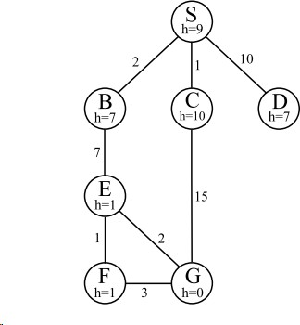

For each of the following search strategies, give the path that would be returned, or write none if no path will be returned. If there are any ties, assume alphabetical tiebreaking--nodes for states earlier in the alphabet are expanded first in the case of ties.
- (3 pt) Depth-first graph search

- (3 pt) Breadth-first graph search

- (3 pt) Uniform cost graph search

- (3 pt) Greedy graph search

- (3 pt) A* graph search
- (3pts) List the major characteristics of each search in the table below.

Search | Main Characteristics
BFS
DFS
UCS
Greedy
A*

- (3pts) When would an uninformed search outperform a smarter search?

