Points: Please see the points for each problem.
Submission: Submit completed homework as a PDF file. Handwritten work or phots of handwritten work must be neat and legible.

Q1. [8 pts] Bayes’ Nets Representation
CS 6460: Artificial Intelligence
HW3

Graph Structure: Conditional Independence
Consider the Bayes’ net given below.
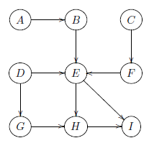

Recall:
X ⊥⊥Y reads as “X is independent of Y”, and
X ⊥⊥Y |{Z, W } reads as “X is independent of Y given Z and W .”
For each expression, circle to indicate whether it is True or False. 1 point each.
(i) True False
It is guaranteed that A ⊥⊥ B
(ii) True False
It is guaranteed that A ⊥⊥ C
(iii) True False
It is guaranteed that A ⊥⊥ D | E
(iv) True False
It is guaranteed that A ⊥⊥ I | E
(v) True False
It is guaranteed that B ⊥⊥ C | I
(vi) True False
It is guaranteed that F ⊥⊥ A | H
(vii) True False
It is guaranteed that D ⊥⊥ I | {E, G}
(viii) True False
It is guaranteed that C ⊥⊥ H | G

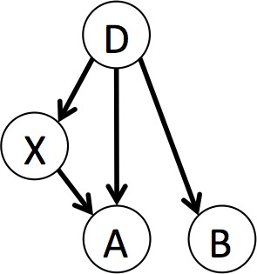
Q2. Bayes’ Net Reasoning
P (X|D)
+d | +x | 0.7
+d | −x | 0.3
−d | +x | 0.8
−d | −x | 0.2

P (A|D, X)
+d | +x | +a | 0.9
+d | +x | −a | 0.1
+d | −x | +a | 0.8
+d | −x | −a | 0.2
−d | +x | +a | 0.6
−d | +x | −a | 0.4
−d | −x | +a | 0.1
−d | −x | −a | 0.9

P (D)
+d | 0.1
−d | 0.9

P (B|D)
+d | +b | 0.7
+d | −b | 0.3
−d | +b | 0.5
−d | −b | 0.5

(a) [3 pts] What is the probability of having disease D and getting a positive result on test A?
P (+d, +a) =
(b) [3 pts] What is the probability of not having disease D and getting a positive result on test A?
P (−d, +a) =
(c) [3 pts] What is the probability of having disease D given a positive result on test A?
P (+d| + a) =
(d) [3 pts] What is the probability of having disease D given a positive result on test B?
P (+d| + b) =

