# out=variable doesn't change much

# float32 is about twice as fast as float64

# casting='no' is no faster

# order='C' is no faster

# numpy.matmul with scipy.linalg.blas.sgemm(...) is faster for 64, not for 32

# changing order 'F' or 'C', some improvement, but not significant..

Np.array.flags: <https://stackoverflow.com/questions/19839539/how-to-get-faster-code-than-numpy-dot-for-matrix-multiplication>

<https://docs.scipy.org/doc/scipy/reference/generated/scipy.linalg.get_blas_funcs.html>

<https://numpy.org/doc/stable/reference/generated/numpy.matmul.html#numpy.matmul>

<https://numpy.org/doc/stable/reference/ufuncs.html#ufuncs-kwargs>

<https://docs.scipy.org/doc/scipy/reference/generated/scipy.linalg.blas.sgemm.html>

<https://stackoverflow.com/questions/9000164/how-to-check-blas-lapack-linkage-in-numpy-and-scipy>

<https://github.com/numpy/numpy/blob/main/numpy/distutils/system_info.py>

<https://github.com/numpy/numpy/blob/main/site.cfg.example>

Python3.4

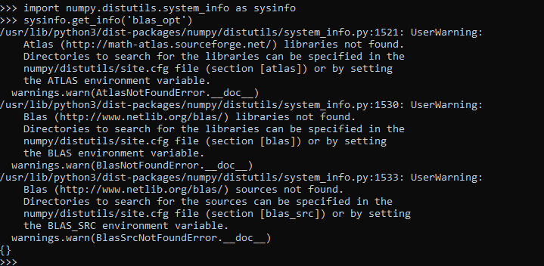

Python3.7

