

**Technical Innovations in**

**Autonomous Robotics**

**Vehicle Design**

**Exploring Neural Network Applications:**

**Advancing RC Car Platform Development**

**WRO 2024**

**Future Engineers**

**Team**

**Driver US**

**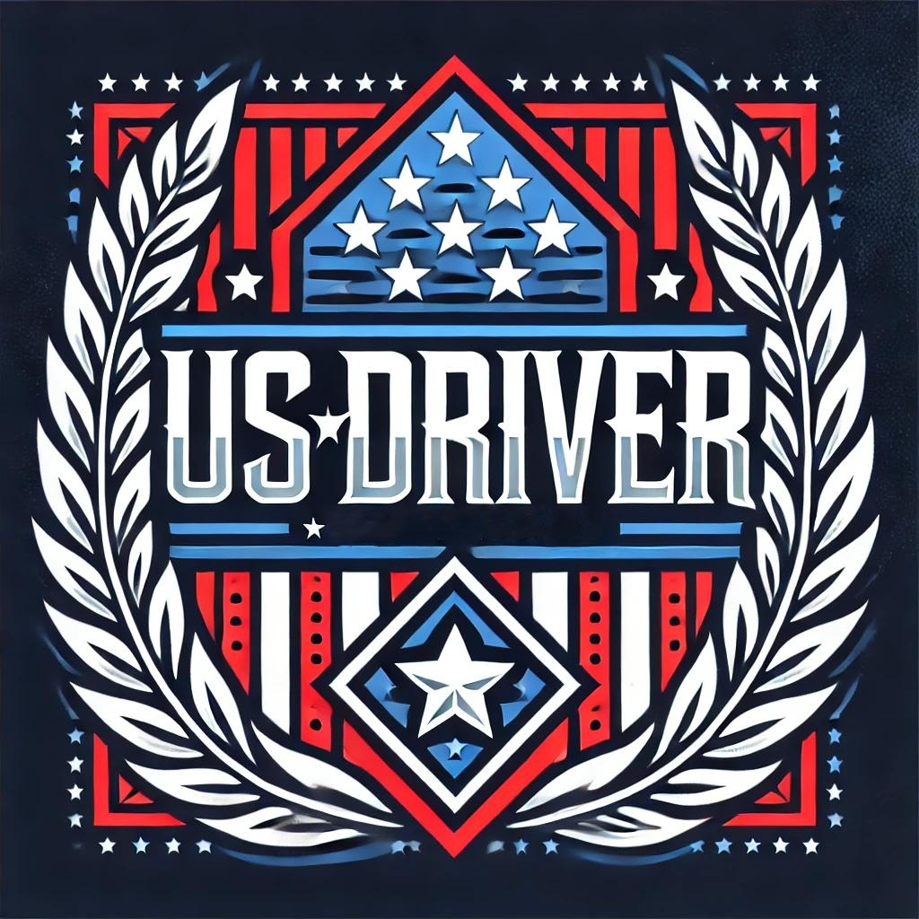**

**Nov 07-17, 2024**

**Table of Contents**

1. **Team Presentation**

* Coach
* Team Members:

1. **Summary of the Project Ideas**

* Executive Summary
* Technical Solution Design
* Integrated Technical Solution Framework

1. **Project Detail Solution Analysis**

* Mobility Management
* Power and Sense Management
* Obstacle Management
* Software and Coding
* Challenges and Solutions

1. **Conclusion**

* Achievements and future directions

1. **References**

* Technical documents and academic paper

**Team Presentation**

**Coach:**

Fei Guo

**Team Members:**

William Wu

Yangxuezhe Sun

Jiarui Hu



**William Wu:** 10th-grade student skilled in programming and vehicle design, handling assembly and PWM for precise speed and steering.

**Yangxuezhe Sun:** 11th-grade student specializing in

AI algorithm integration, ensuring real-time AI performance in complex track conditions.



**Jiarui Hu: 1**2th-grade student focused on AI optimization and 3D modeling, simulating stable AI adaptability before real-world testin

**Summary of the Project Ideas**

#### **Executive Summary**

The 2024 WRO Future Engineers competition challenges participants to design and develop fully autonomous vehicles capable of dynamic obstacle avoidance, precise navigation, and accurate parking in simulated real-world scenarios. Our team, Driver US, employs a cutting-edge approach that combines AI-driven technologies with robust hardware engineering. By utilizing convolutional neural networks (CNNs) and integrating these models into Raspberry Pi-based systems, we achieved a seamless blend of artificial intelligence and robotics. This solution ensures real-time decision-making, precise maneuvering, and reliable performance on complex tracks.

#### **Technical Solution Design**

***Design of LEGO Robot and RC car Vehicle Structure:***

Our technical approach focuses on modularity and adaptability. The vehicle's hardware is built upon a highly durable RC car chassis, enhanced with custom LEGO structures for component mounting. A Raspberry Pi 4 serves as the central processing unit, executing AI models for path planning and obstacle avoidance. The software architecture, built on TensorFlow, employs data-driven learning for predictive and adaptive navigation. This modular design allows for flexible adjustments during testing, ensuring compatibility with varying track conditions.

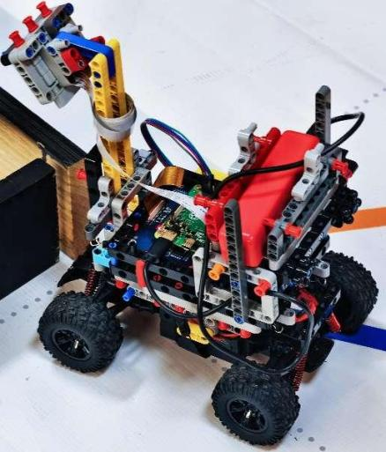

（这里需要各个角度五张图）

#### **Integrated Technical Solution Framework *The integrated framework combines AI, hardware engineering, and real-time control systems. It features:***

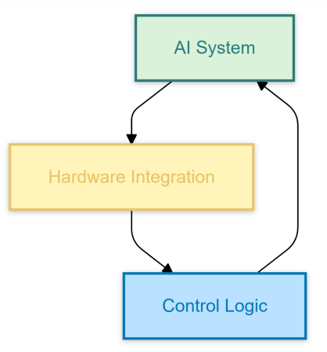

* **AI System**: A CNN model trained on extensive image and sensor data.
* **Hardware Integration**: A gyroscope and high-resolution camera linked to the Raspberry Pi for real-time feedback.
* **Control Logic**: Adaptive algorithms for dynamic speed and steering adjustments.

This framework supports efficient collaboration between all components, ensuring seamless operation in dynamic environments.

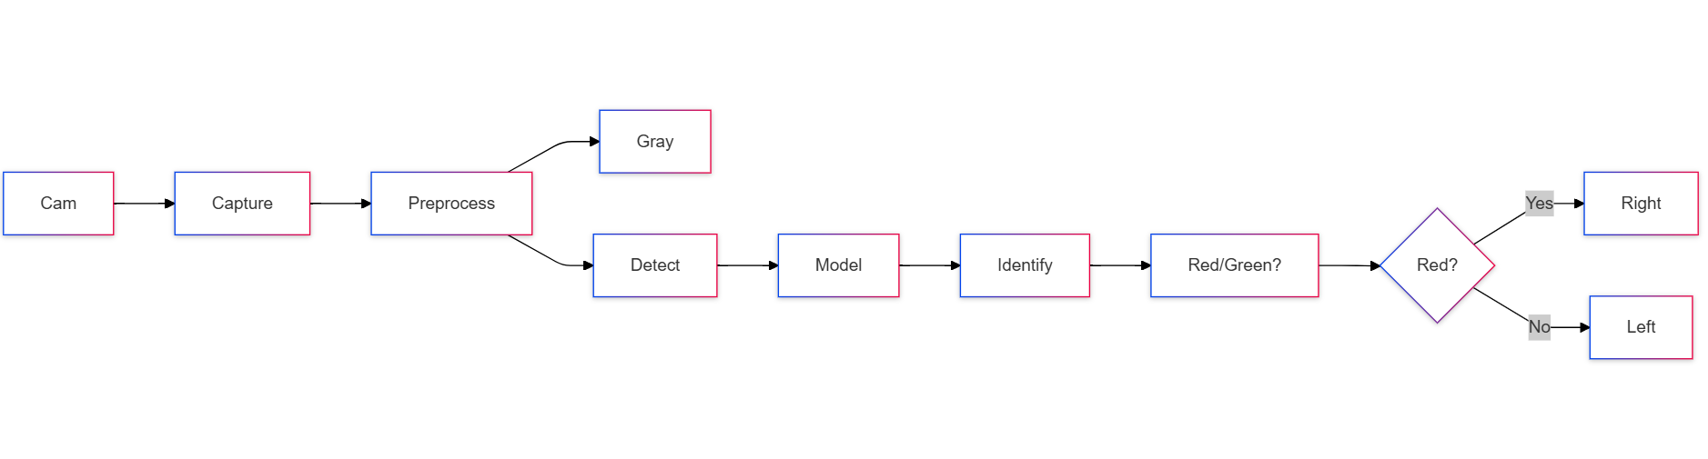

**Project Detail Solution Analysis**

**Mobility Management**

***The mobility management of our autonomous RC vehicle focuses on integrating high-precision hardware and optimized algorithms to ensure smooth navigation and agility. The vehicle's chassis is based on the robust Bezgar RC platform, chosen for its durability and ability to handle dynamic track conditions. Key mobility features include:***

1. Chassis Design:

- Reinforced with customized LEGO mounting structures to house sensors and processing units securely.

- Adjusted suspension system to improve stability on uneven surfaces.

2. Steering and Speed Control:

- Implemented PWM (Pulse Width Modulation) to control motor speed and steering precision.

- Dynamic adjustments to speed ensure optimal performance under varying track layouts.

**Power and Sense Management**

***Effective power management and accurate sensing capabilities are critical to the performance of the vehicle. Key components and features include:***

1. Power System Design:

- Utilized a high-capacity rechargeable lithium battery to ensure uninterrupted operation during extended runs.

- Power distribution managed via Raspberry Pi GPIO pins to optimize energy efficiency.

2. Sensor Integration:

- Integrated Raspberry Pi Camera v2 for high-resolution image capture.

- Deployed the WT901 gyroscope for real-time orientation monitoring and IMU data collection.

- Sensor fusion algorithms ensure synchronized data from multiple sources, improving decision-making accuracy.

**Obstacle Management**

***Obstacle management is achieved through a combination of hardware sensing and AI-driven algorithms. This ensures real-time detection and avoidance of obstacles on the track. Key aspects include:***

1. Real-Time Obstacle Detection:

- Utilized TensorFlow-based CNN models to detect and classify obstacles in real-time.

- Detection accuracy is enhanced by preprocessing images (grayscale conversion and normalization).

2. Obstacle Avoidance Logic:

- Implemented adaptive path-planning algorithms that calculate alternative routes dynamically.

- Integrated gyroscope data to maintain stability while executing avoidance maneuvers.

**Software and Coding**

***The software architecture leverages a modular and scalable design to handle complex tasks, including path planning, image processing, and real-time decision-making. Key features include:***

1. Path Planning:

- CNN models trained using TensorFlow predict optimal paths based on input from the camera.

- Developed fallback logic to handle incomplete data or unexpected obstacles.

2. Image Processing:

- Preprocessing pipeline converts images to grayscale and normalizes them for CNN input.

- TensorFlow models identify relevant track features and obstacles with high accuracy.

3. Codebase:

- Modularized Python scripts ensure maintainability and scalability.

- Model training and testing conducted in a Miniconda3 environment for compatibility.

**Challenges and Solutions**

1. Camera Burnout:

- Challenge: The Raspberry Pi Camera module was damaged during prolonged testing due to overheating and excessive power draw.

- Solution: Implemented a heat dissipation mechanism using passive cooling elements and a voltage regulator to stabilize the power supply.

2. Speed Instability at High Velocity:

- Challenge: The vehicle became unstable during high-speed runs, leading to loss of control.

- Solution: Adjusted the vehicle's center of gravity by redistributing hardware components and fine-tuned motor control using gyroscope feedback.

3. Issues with Training Data Output Algorithm:

- Challenge: The initial output from the CNN model produced inconsistent predictions, especially in dynamic lighting conditions.

- Solution: Improved the algorithm by normalizing training data and incorporating data augmentation techniques such as varying brightness and adding noise.

**Conclusion**

**Achievements**

***The participation in the 2024 WRO Future Engineers competition has allowed our team, Driver US, to achieve significant technical and developmental milestones:***

1. Integration of AI and Robotics:

- Successfully combined Convolutional Neural Networks (CNNs) with real-time control systems to enable precise navigation, obstacle avoidance, and autonomous parking on a dynamic track.

1. Innovative Hardware and Software Design:

- Developed a modular and robust RC vehicle platform that integrates high-precision sensors (Raspberry Pi Camera v2 and WT901 gyroscope) with scalable software architecture for adaptive performance.

1. Problem-Solving Expertise:

- Overcame critical challenges such as camera burnout, speed instability, and algorithm inefficiencies through systematic engineering approaches, enhancing both technical and collaborative capabilities.

**Future Directions**

***Building on the foundation laid by this project, the following directions are identified for further exploration and enhancement:***

1. Advanced Sensing Systems:

- Incorporate LiDAR or advanced stereo vision systems to improve spatial awareness and precision.

1. Enhanced AI Algorithms:

- Explore deep reinforcement learning models to enhance decision-making in dynamic and complex environments.

1. Improved Energy Management:

- Develop more efficient power systems, including dynamic power allocation strategies to extend operational runtime.

1. Simulation and Testing:

- Utilize advanced simulation environments to train and validate models under diverse track conditions.

### ****References****

**Github:**

https://github.com/Utcassyxz/USA-Future-Engineers---DriverUS

Raspberry Pi Camera Guide: Guide to integrate high-resolution cameras in embedded systems.  
Link: [https://picamera.readthedocs.io](https://picamera.readthedocs.io" \t "_new)

**Academic Papers:**

"Deep Learning for Autonomous Driving: State-of-the-Art and Future Directions"

"Sensor Fusion in Autonomous Systems: Methods and Applications"

**Technical Guides:**

- WT901 Gyroscope User Manual

- Raspberry Pi GPIO Configuration Guide

Donkey car：

https://www.donkeycar.com/

release-1.13/index.html

Tensorﬂow: <https://www.tensorﬂow.or>



**—-Thank You —-**