

**ANNAI VAILANKANNI**

**ARTS & SCIENCE COLLEGE,**

**THANJAVUR – 613 007.**

**STAFF PROFILE as on 30-June-2021**

Batch

(if any)

Passport size Photo

|  |  |  |  |  |  |  |  |  |  |  |  |  |  |  |  |  |  |
| --- | --- | --- | --- | --- | --- | --- | --- | --- | --- | --- | --- | --- | --- | --- | --- | --- | --- |
|  | Employee’s ID | | : | **F21BC004** | | | | | | | | | | | | | |
|  | Department Name | | : | **Computer Science** | | | | | | | | | | | | | |
|  | Name of the Staff | | : | **UTHAMAN. V** | | | | | | | | | | | | | |
|  | Qualification | | : | **MCA., M.Phil., SET., (Ph.D.)** | | | | | | | | | | | | | |
|  | Designation | | : | **ASSISTANT PROFESSOR** | | | | | | | | | | | | | |
|  | Father’s/Guardian Name | | : | VISWANATHAN.R | | | | | | | | | | | | | |
|  | Spouse Name | | : | SUBHALAKSHMI.C | | | | | | | | | | | | | |
|  | Aadhaar No.(Optional) | | : | **974882588608** | | | | | | | | | | | | | |
|  | PAN No. (Optional) | | : | **ACSPU1613M** | | | | | | | | | | | | | |
|  | Academic Qualification | | : | **Annexure – 1** | | | | | | | | | | | | | |
| **Progamme** | **Degree & Subject** | **College** | | | | | **University** | | | | **Year** | | **Mode of Study** | | **% / Grade** | |
| Ph.D | Computer Science | Adaikalamatha College, Thanajavur | | | | | Bharathidasan University | | | | 2021(Registration) | | Part time | | Pursuing | |
| NET | **--** | **--** | | | | | **--** | | | | **--** | | **--** | | **--** | |
| SET | Computer Science & Applications | -- | | | | | Mother Terasa University | | | | 2016 | | -- | | **--** | |
| M. Phil | Computer Science | PRIST University | | | | | PRIST University | | | | 2015 | | Regular | | 7.84 CGPA | |
| PG | MCA,  Computer Applications | Shanmugha College Of Engineering,Thanjavur | | | | | Bharathidasan University | | | | 2003 | | Regular | | 70.63 | |
| UG | B.Sc,  Maths | Avvm Sri Pushpam College,Poondi | | | | | Bharathidasan University | | | | 2000 | | Regular | | 70.23 | |
| Others | **--** | **--** | | | | | **--** | | | | **--** | | **--** | | **--** | |
|  | Qualification Approved Faculty by the University | | : | Yes  **Annexure – 2** | | | | | | | | | | | | | |
|  | M.Phil Research Advisor | | : | No  **Annexure – 3** | | | | | | | | | | | | | |
|  | Ph.D Research Advisor | | : | No  **Annexure – 4** | | | | | | | | | | | | | |
|  | Ph.D Thesis Tilte | | : | -- | | | | | | | | | | | | | |
|  | Area of Research Interest (Max. 4) | | : | Wireless Sensor Networks  Big data Analytics  Machine Learning | | | | | | | | | | | | | |
|  | Date of Birth & Age | | : | 07 / 07 / 1980 & 41 Yrs Old | | | | | | | | | | | | | |
|  | Religion | | : | Hindu | | | | | | | | | | | | | |
|  | Community | | : | MBC | | | | | | | | | | | | | |
|  | Caste (Optional) | | : | *Sozhia Chetty* | | | | | | | | | | | | | |
|  | Date of Joining (AVASC) | | : | 21/ 06 / 2017 | | | | | | | | | | | | | |
|  | Details of outside Teaching / Research / Industry Experience | | : | 12 Years 8 Months  ***\*(Service Certificate Mandatory)*** **Annexure – 5** | | | | | | | | | | | | | |
|  | Total Service (*includes AVASC Service)* | | : | 16 Years 9 Months (*Till Date*)  ***\*(Service Certificate Mandatory)*** [Only Teaching Service] | | | | | | | | | | | | | |
|  | Total Teaching Experience in completed years | | : | UG | 6 | PG | | | 1 | | M.Phil | | 1 | | Ph. D | | -- |
|  | Residential Address | | : | 1849, Jamal Hussain Nagar, 4th Street, N. K. Road, Thanjavur-613006 | | | | | | | | | | | | | |
| Mobile No. (whatsapp) | | : | 9789902280 Another Number : 6380186143 | | | | | | | | | | | | | |
| E-Mail Address | | : | uthaman@avasctnj.edu.in | | | | | | | | | | | | | |
|  | Whether FDP’s/ Course / Training Programme’s Attended, if yes, furnish details | | : | **Yes** **Annexure – 6** | | | | | | | | | | | | | |
|  | No. of Papers Published in Journals with ISSN | | : | **7** **Annexure – 11** | | | | | | | | | | | | | |
|  | No. of. M.Phil. Scholars Guided | | : | Completed | | | 2 | | | Ongoing | | __ | | **Annexure – 17** | | | |

***Signature of the Staff***

# Annexure – 1

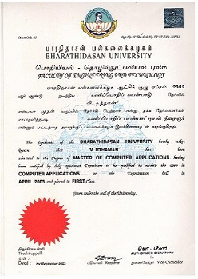

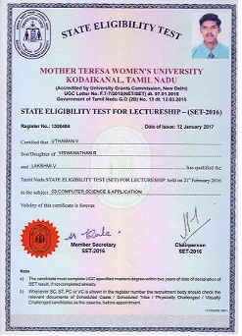

# Annexure – 2

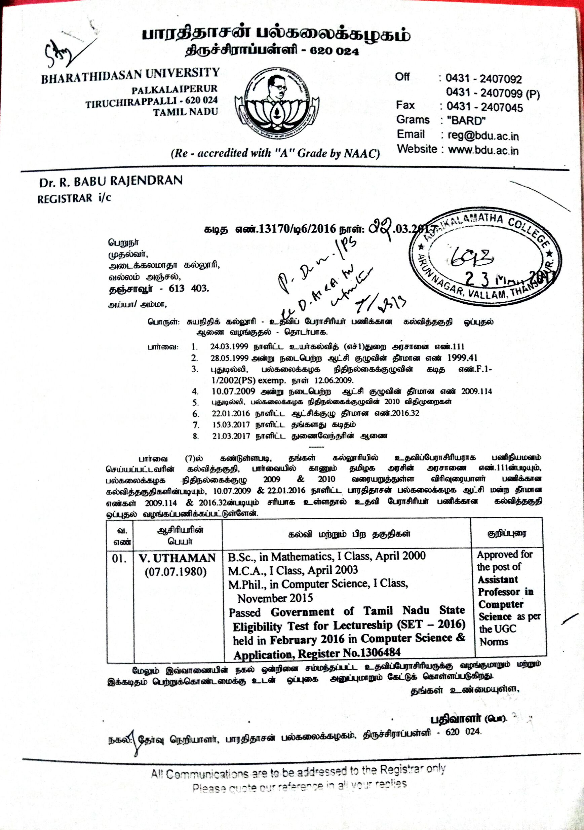

|  |  |  |  |  |  |  |
| --- | --- | --- | --- | --- | --- | --- |
| S.No | Designation | Institution / Organization | Date of Joining | Date of Relieving | No. of Yrs & Months | Roles & Responsibilities |
| 1 | Assistant Professor | Annai Vailankanni Arts and Science College, Thanajvur | 21.06.2017 | Till | 4y&1m | Teaching, Counselling of students, participation in departmental committee work |
| 2 | Lecturer | Adaikalamatha College, Vallam | 15.07.2015 | 27.04.2017 | 1y&9m | Lectures to the students, Observe and evaluate student’s performance |
| 3 | Lecturer | CCMR Polytechnic College, Thanjavur | 15.06.2010 | 06.05.2015 | 4y&11m | Lectures to the students, Observe and evaluate student’s performance |
| 4 | Faculty & Project Coordinator | SRM Infotech, Thanjavur | 02.12.2009 | 31.05.2010 | 0y&6m | Teaching, Developing & coordinating mini projects |
| 5 | Software Engineer | Dart Innovations, Chennai | 02.03.2009 | 13.11.2009 | 0y&8m | Writing, Designing& Testing codes |
| 6 | Software Engineer | Egalax Technologies, Chennai | 02.07.2007 | 02.09.2008 | 1y&2m | Writing, Designing& Testing codes |
| 7 | Software Engineer | Wipro Technologies | 20.11.2006 | 07.06.2007 | 0y&7m | Monitoring & Error handling of jobs |
| 8 | Medical Insurance Processor | CBS Exports | 14.07.2003 | 07.08.2006 | 3y&1m | Processing Medical Insurance Claim forms |

# Annexure – 6

|  |  |  |  |  |  |  |
| --- | --- | --- | --- | --- | --- | --- |
| S.No | FDP / Programme / Course Name | Organized By | Start Date | End Date | No. of Days | Outcome |
| 1 | Optimising ICT Tools for Effective Writing of Research Paper | IQAC,Annai Vailankanni Arts and Science College | 09/10/2021 | 09/10/2021 | 1 | Learnt various ICT tools and their utilization |
| 1 | Introduction to Angular JS (Online FDP) | ICT Academy | 24/05/2021 | 28/05/2021 | 5 | Got Knowledge with client-side Java Script frameworks |
| 2 | Artificial Intelligence Online course | Sri Krishna Adithya College of Arts and Science, Coimbatore | 15.05.2020 | 15.05.2020 | 1 | Understood the concepts of AI |

# Annexure – 7

|  |  |  |  |  |  |  |
| --- | --- | --- | --- | --- | --- | --- |
| S.No | Event Name | Organized By | Start Date | End Date | No. of Days | Outcome |
| 1 | Trends in STEMEM (Online Webinar) | Annai College of Arts & Science, kumbakonam | 14.06.2021 | 18.06.2021 | 5 |  |
| 2 | Overview of Research methodology | Annai Vailankanni Arts&Science College, Thanjavur | 15.06.2020 | 15.06.2020 | 1 |  |
| 3 | A Machine Learning approach for Power Management (Online Webinar) | Sathyabama Institute of Science and Technology, Chennai | 06.06.2020 | 06.06.2020 | 1 |  |
| 4 | Build Your own Regression model in Machine Learning | MLR Institute of Technology, Hydreabad | 06.06.2020 | 06.06.2020 | 1 |  |
| 5 | MQTT Protocols Demonstration and Hands-on (online Webinar) | Anurag University, Hyderabad | 04.06.2020 | 04.06.2020 | 1 |  |
| 6 | An Overview of Machine Learning (Webinar) | Annai Vailankanni Arts&Science College, Thanjavur | 04.06.2020 | 04.06.2020 | 1 |  |
| 7 | Building An IOT Cloud for Healthcare Applications (Online Webinar) | Anna Adarsh College for Women in association with Pantech Solutions | 30.05.2020 | 30.05.2020 | 1 |  |
| 8 | How to earn Passive income from Stock market? (Online workshop) | Nehru Institute of Information Technology and Management, Coimbatore | 25.05.2020 | 26.05.2020 | 2 |  |
| 9 | Survival Strategies for Business After Covid 19 (International Webinar) | MaruduPandiyar College, Thanjavur | 20.05.2020 | 20.05.2020 | 1 |  |
| 10 | Simple Application Creation on Different Platforms using Multi-tier Architecture (online Workshop) | Nehru Institute of Information Technology and Management, Coimbatore | 18.05.2020 | 22.05.2020 | 5 |  |
| 11 | Knowledge Gained through the Challenging Exercises of NAAC: Success Story | St Joseph’s College (Autonomous), IQAC, Tiruchirappalli | 15.05.2020 | 15.05.2020 | 1 |  |
| 12 | How to Conduct Online Class to Students (Online Webinar) | Atal Incubation Centre Pondicherry Engineering College Foundation | 08.04.2020 | O8.04.2020 | 1 |  |

# 

|  |  |  |  |  |  |  |  |  |
| --- | --- | --- | --- | --- | --- | --- | --- | --- |
| S.No | Paper Title | Author(s) Details  *(Order wise - As printed in Paper)* | Journal Name (Mention the Index) | Page No. (from) | Page No.  (to) | ISSN No | DOI  Link | Date of Publish |
| 1. | Attribute Based Encryption in Wireless Sensor Networks | 1. V.Bhuvaneshwari 2. V.Uthaman | Journal of Xidian University | 1 | 10 | 1001-  2400 | https://doi.org/10.37896/jxu14.6/001 | June 2020 |
| 2. | Ornamental Security of structure using visual cryptography | 1. V. Rajeswari   2. V. Uthaman | Journal of Xidian University | 2910 | 2913 | 1001-  2400 | https://doi.org/10.37896/jxu14.6/338 | June 2020 |
| 3. | Enhanced Security of system using visual cryptography | 1. V. Rajeswari   2. V. Uthaman | IJIREEICE | 1 | 5 | 2321-  2004 | 10.17148/IJIREEICE.2019.7801 | August 2019 |
| 4. | Security scheme Wireless Sensor Network using Cryptography Scheme | 1.V.Bhuvaneshwari  2. V.Uthaman | IJIREEICE | 21 | 26 | 2321-  2004 | 10.17148/IJIREEICE.2019.7803 | August 2019 |
| 5. | Scrutiny on Cloud computing Preservation and Architectonics in Prevailing Orientation | 1. M.Merlin Asuntha 2. A.Stenila 3. S.Rajesh Kumar 4. V.Uthaman | IJETCSE | 6 | 9 | 0976  -  1353 |  | November 2017 |
| 6. | Energy aware Load Balancing of parallel mining of frequent sequences using LB scheme | V.Uthaman | IJCSE | 116 | 120 | 2347-  2693 | https://doi.org/10.26438/ijcse/v5i8.115120 | 30 August 2017 |
| 7. | A Brief survey of Secrecy Productive Data Mining(SPDM) | V.Uthaman | IJARCSSE | 138 | 141 | 2277- 128X | 10.23956/ijarcsse/V7I8/0131 | August 2017 |

# 