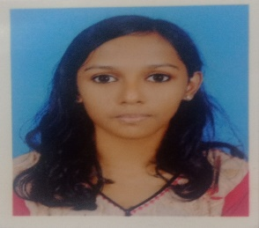

**UTHARA V**

**Curriculum vitae**

**PERSONAL DETAILS**

BIRTH : DECEMBER 15, 2001

ADDRESS : THAZHE VAROL(HO),POOVADAN GATE,

VADAKARA

PHONE : 9188866082

**EDUCATION**

**BSC COMPUTER SCIENCE 2020-2023**

UNIVERSITY OF CALICUT

CO-OPERATIVE ARTS AND SCIENCE COLLEGE , KURIKILLAD,

VADAKARA

**PLUS-TWO**

JNM GHSS PUTHUPPANAM ,VADAKARA

**SSLC**

ST.ANTONY’S GIRLS HIGH SCHOOL ,VADAKARA

**SKILLS**

CREATIVE THINKING

RESPONSIBILITY

DECISION MAKING

POSITIVITY

**REFERENCES**

AVAILABLE UPON REQUEST