**Project Report**

**Project Title:**

**LAPTOP REQUEST CATALOG ITEM**

**Duration:** 30 Days

**Name :** Uthayan U

**Abstract:**

The Laptop Request Catalog Item project is designed to automate and simplify the process of requesting laptops within an organization using the ServiceNow platform. The traditional method was manual, time-consuming, and lacked real-time tracking. This project introduces a dynamic catalog form where employees can easily request laptops with additional accessories if required. The system dynamically displays fields based on user input and automatically tracks each request with a unique Request ID. This automation enhances efficiency, reduces approval delays, and improves overall IT asset management.

**Problem Statement:**

Employees often face difficulties in requesting laptops due to the manual process, which leads to errors, incomplete information, and delayed approvals. There is no centralized way to track requests or ensure data accuracy. To overcome this, a ServiceNow-based catalog item must be created that provides a user-friendly, dynamic, and automated laptop request process, with proper tracking and visibility.

**Objectives:**

1. To create an automated and dynamic Service Catalog item for laptop requests.

2. To implement UI Policies for controlling field visibility and behavior based on user selections.

3. To include a UI Action that allows users to reset or clear the form easily.

4. To track each request using a unique Request Number (REQ ID) for governance.

5. To export and deploy the catalog item through Update Sets for migration and version control.

6. To test and verify the functionality through simulated user submissions.

**Methodology:**

1. Requirement Analysis: Understanding the workflow for laptop requests and identifying required fields such as laptop model, justification, accessories, and quantity.

2. Catalog Item Creation: Developed a new Service Catalog item named “Laptop Request” using ServiceNow’s Catalog Builder.

3. UI Policy Implementation: Configured rules to dynamically show or hide accessory details when users select additional accessories.

4. UI Action Creation: Added a “Reset Form” button for clearing all fields and restoring defaults.

5. Workflow Integration: Linked the form to ServiceNow’s request management module for automatic request number generation and tracking.

6. Update Set Export: Saved configurations to an update set for deployment in other instances.

7. Testing and Validation: Submitted test requests to ensure dynamic fields, workflow, and delivery tracking function as expected.

**Modules Involved:**

1. Service Catalog Item:

- Main form for users to request laptops.

- Includes fields like Laptop Model, Justification, Quantity, and Accessories.

2. UI Policy:

- Controls the visibility of additional fields when specific options are selected.

- Ensures data accuracy and improves user experience.

3. UI Action:

- Adds a button to reset or clear form inputs.

- Improves usability by allowing quick restarts of the request process.

4. Export Update Set:

- Captures all configurations for migration or deployment on another ServiceNow instance.

5. Login to Another Instance:

- Used for verifying the update set import and confirming cross-instance compatibility.

6. Testing:

- Submitted sample requests and validated that Request Numbers are generated correctly (e.g., REQ0010001).

- Verified the delivery date and workflow completion.

**Result:**

The project successfully automated the laptop request process using ServiceNow. The form dynamically responds to user inputs, ensuring accurate data collection. Each request generates a unique tracking number, and submission confirmation messages are displayed. The system provides visibility into the order status, approval process, and estimated delivery dates. This implementation improves IT efficiency, eliminates manual paperwork, and speeds up the laptop allocation process.

* Form before submission

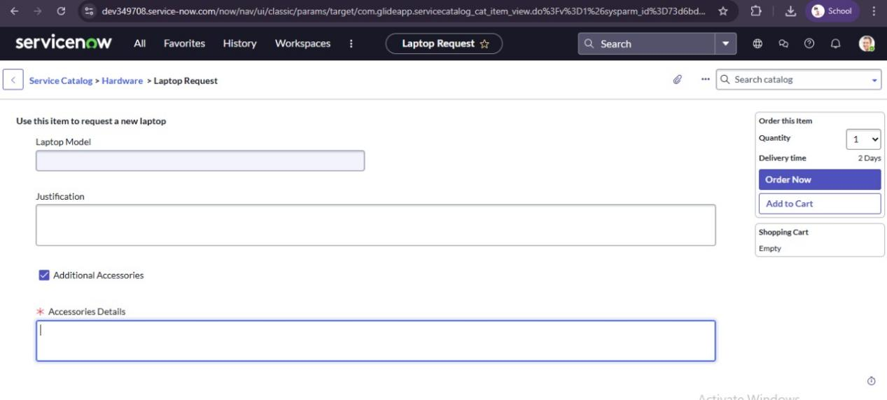

* Form with dynamic fields

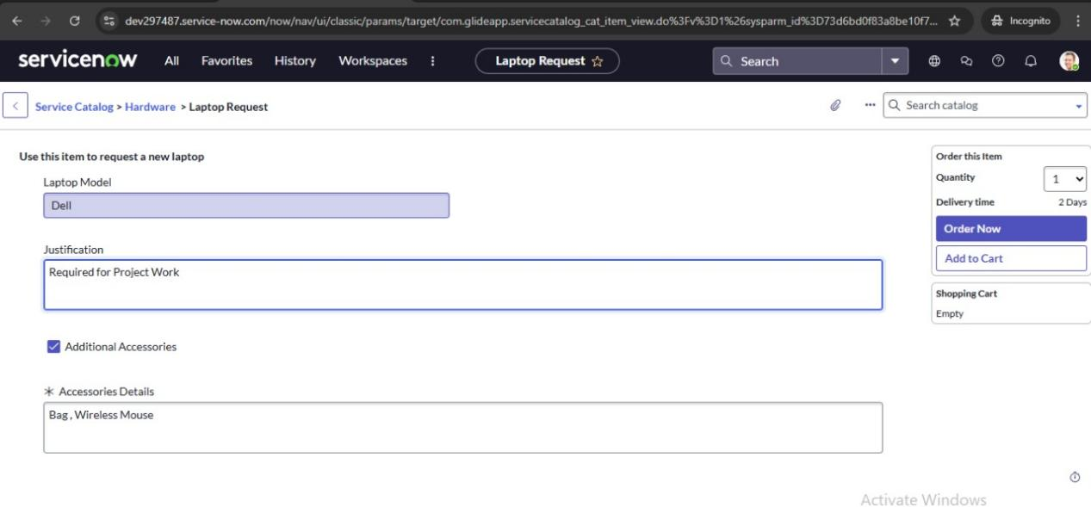

* Confirmation page

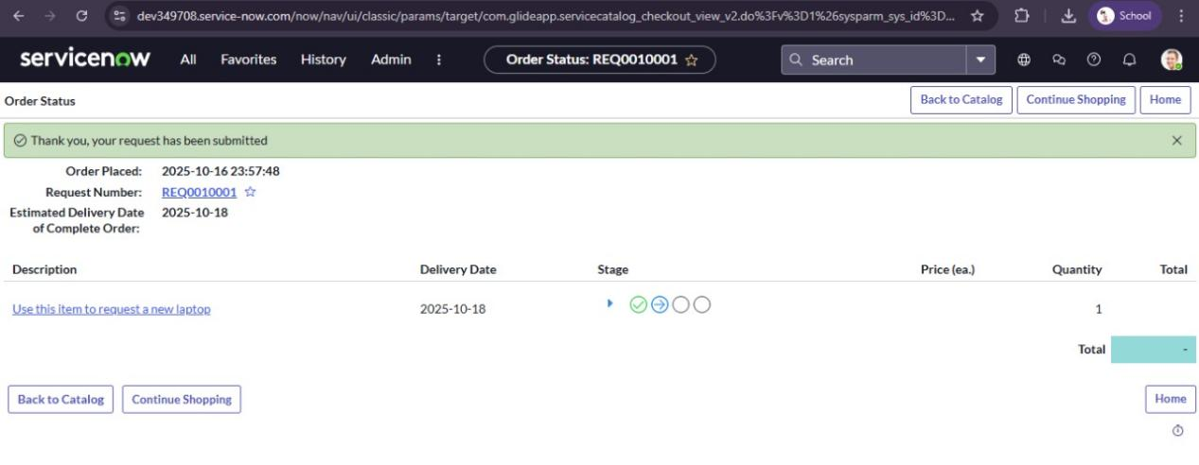

**Conclusion:**

The Laptop Request Catalog Item project achieved its goal of streamlining laptop procurement for employees. By using ServiceNow’s Catalog Builder, UI Policies, and UI Actions, the project created a fully functional, user-friendly, and automated request system. The form’s dynamic behavior enhances usability and ensures accurate data entry, while the automated workflow improves tracking and governance.

**Future Enhancement:**

1. Integrate with the Asset Management module for automatic inventory updates.

2. Add email notifications for approval and delivery status.

3. Implement a multi-level approval workflow (manager to IT admin).

4. Create an analytics dashboard to visualize request statistics.

5. Extend the catalog for other IT assets like monitors and accessories.

**References:**

1. ServiceNow Product Documentation — https://docs.servicenow.com

2. ServiceNow Developer Portal — https://developer.servicenow.com

3. IT Service Management Fundamentals, ServiceNow Training Materials

4. Internal project guidelines provided by ITUP Kid Hub