**18CSC303 DATABASE DESIGN**

NAME: UTHAYARAHAVAN M S

ROLL_NO: CB.SC.I5DAS21065

**________________________________________________________**

**DESCRIPTION: MyStore-Ultimate Application and shopping store**

The MyStore – Welcome to MyStore, your one-stop destination for all your shopping needs! Discover a world of books, movies, products, courses, restaurants, and more, all in one convenient app. Whether you're a bookworm, a movie enthusiast, a tech geek, a foodie, or someone looking to enhance your skills, MyStore has something for everyone.

|  |  |
| --- | --- |
| OPERATIONS | ADDITIONAL INFORMATION |
| ADD | MODIFY |
| DELETE | MODIFY |
| SEARCH | SELECT |
| DISPLAY | SELECT |

1. MODIFICATION: Modify user data as the data

|  |  |
| --- | --- |
| operations | Additional info |
| add | Insert into table name |
| delete | Delete from table name |
| search | Select from table name |
| display | Select * from table name |

Form names and description:

|  |  |  |  |
| --- | --- | --- | --- |
| name | type | Table related information | operations |
| category | Master form | User category | Delete, search, display, add |
| user | transaction | User table |  |

**REPORT:**

**Features:**

MyStore is designed to cater to various interests and needs, making it a versatile application:

**Wide Variety of Products:** The app hosts an extensive collection of books, movies, products, courses, and restaurants, ensuring there's something for every user.

**Entertainment and Learning:** Users can indulge in their favorite books and movies, as well as educational applications.

**Seamless Shopping Experience:** MyStore provides an easy and secure checkout process for purchasing products, ensuring a hassle-free shopping experience.

**Personalized Recommendations:** The app offers personalized recommendations based on user preferences, helping users discover new content and products.

**Transaction Tracking:** Users can track their transactions, making it convenient to manage and review past purchases.

**Social Engagement:** The app encourages community engagement by connecting users through social media channels, sharing updates, and special offers.

**User Experience:**

**The app prioritizes user experience by offering:**

**User-Friendly Interface:** A simple and intuitive interface that allows users to navigate effortlessly.

**Personalization:** Customized content recommendations based on user behavior and preferences.

**Easy Checkout:** A streamlined checkout process with secure payment options.

**Transaction History:** Access to a detailed history of past transactions for easy reference.

**Quick Search:** Efficient search functionality to find specific products, courses, or restaurants.

**Conclusion:**

The MyStore - Ultimate Shopping Hub app offers a unique and holistic experience, combining shopping, entertainment, and learning. Its user-friendly design, diverse offerings, and potential for growth position it as a valuable platform for users seeking convenience, engagement, and personalization.

**Table: users**

| **Column** | **Data Type** | **Constraints** |
| --- | --- | --- |
| user_id | INT | PRIMARY KEY |
| username | VARCHAR(50) | NOT NULL |
| email | VARCHAR(100) | UNIQUE |
| password | VARCHAR(100) | NOT NULL |
| registration_date | DATE | CHECK (registration_date <= CURRENT_DATE) |
| last_login | TIMESTAMP |  |

**Table: master_books**

| **Column** | **Data Type** | **Constraints** |
| --- | --- | --- |
| book_id | INT | PRIMARY KEY |
| book_title | VARCHAR(100) | NOT NULL |
| author | VARCHAR(100) |  |
| publication_date | DATE |  |
| genre | VARCHAR(50) |  |
| price | DECIMAL(10, 2) | CHECK (price >= 0) |

**Table: master_movies**

| **Column** | **Data Type** | **Constraints** |
| --- | --- | --- |
| movie_id | INT | PRIMARY KEY |
| movie_title | VARCHAR(100) | NOT NULL |
| director | VARCHAR(100) |  |
| release_date | DATE |  |
| genre | VARCHAR(50) |  |
| price | DECIMAL(10, 2) | CHECK (price >= 0) |

**Table: master_products**

| **Column** | **Data Type** | **Constraints** |
| --- | --- | --- |
| product_id | INT | PRIMARY KEY |
| product_name | VARCHAR(100) | NOT NULL |
| brand | VARCHAR(100) |  |
| manufacture_date | DATE |  |
| category | VARCHAR(50) |  |
| price | DECIMAL(10, 2) | CHECK (price >= 0) |

**Table: master_courses**

| **Column** | **Data Type** | **Constraints** |
| --- | --- | --- |
| course_id | INT | PRIMARY KEY |
| course_name | VARCHAR(100) | NOT NULL |
| instructor | VARCHAR(100) |  |
| start_date | DATE |  |
| category | VARCHAR(50) |  |
| price | DECIMAL(10, 2) | CHECK (price >= 0) |

**Table: master_restaurants**

| **Column** | **Data Type** | **Constraints** |
| --- | --- | --- |
| restaurant_id | INT | PRIMARY KEY |
| restaurant_name | VARCHAR(100) | NOT NULL |
| cuisine | VARCHAR(100) |  |
| opening_date | DATE |  |
| rating | DECIMAL(3, 2) | CHECK (rating >= 0 AND rating <= 5) |
| price_range | VARCHAR(20) |  |

**Table: transactions_books**

| **Column** | **Data Type** | **Constraints** |
| --- | --- | --- |
| transaction_id | INT | PRIMARY KEY |
| user_id | INT |  |
| book_id | INT |  |
| transaction_date | DATE |  |
| purchase_price | DECIMAL(10, 2) | CHECK (purchase_price >= 0) |
| timestamp | TIMESTAMP | DEFAULT CURRENT_TIMESTAMP |
| FOREIGN KEY (user_id) REFERENCES users(user_id) |  |  |
| FOREIGN KEY (book_id) REFERENCES master_books(book_id) |  |  |

**Table: transactions_movies**

|  |  |  |
| --- | --- | --- |
| **column** | **Data Type** | **Constraints** |
| transaction_id | INT | PRIMARY KEY |
| user_id | INT |  |
| movie_id | INT |  |
| transaction_date | DATE |  |
| purchase_price | DECIMAL(10, 2) | CHECK (purchase_price >= 0) |
| timestamp | TIMESTAMP | DEFAULT CURRENT_TIMESTAMP |
| FOREIGN KEY (user_id) REFERENCES users(user_id) |  |  |
| FOREIGN KEY (movie_id) REFERENCES master_movies(movie_id) |  |  |

**Table: transactions_products**

| **Column** | **Data Type** | **Constraints** |
| --- | --- | --- |
| transaction_id | INT | PRIMARY KEY |
| user_id | INT |  |
| product_id | INT |  |
| transaction_date | DATE |  |
| purchase_price | DECIMAL(10, 2) | CHECK (purchase_price >= 0) |
| Timestamp | TIMESTAMP | DEFAULT CURRENT_TIMESTAMP |
| FOREIGN KEY (user_id) REFERENCES users(user_id) |  |  |
| FOREIGN KEY (product_id) REFERENCES master_products(product_id) |  |  |

**Table: transactions_courses**

| **Column** | **Data Type** | **Constraints** |
| --- | --- | --- |
| transaction_id | INT | PRIMARY KEY |
| user_id | INT |  |
| course_id | INT |  |
| transaction_date | DATE |  |
| purchase_price | DECIMAL(10, 2) | CHECK (purchase_price >= 0) |
| Timestamp | TIMESTAMP | DEFAULT CURRENT_TIMESTAMP |
| FOREIGN KEY (user_id) REFERENCES users(user_id) |  |  |
| FOREIGN KEY (course_id) REFERENCES master_courses(course_id) |  |  |

**Table: transactions_restaurants**

| **Column** | **Data Type** | **Constraints** |
| --- | --- | --- |
| transaction_id | INT | PRIMARY KEY |
| user_id | INT |  |
| restaurant_id | INT |  |
| transaction_date | DATE |  |
| total_bill | DECIMAL(10, 2) | CHECK (total_bill >= 0) |
| Timestamp | TIMESTAMP | DEFAULT CURRENT_TIMESTAMP |
| FOREIGN KEY (user_id) REFERENCES users(user_id) |  |  |
| FOREIGN KEY (restaurant_id) REFERENCES master_restaurants(restaurant_id) |  |  |

**Table: transactions_miscellaneous**

| **Column** | **Data Type** | **Constraints** |
| --- | --- | --- |
| transaction_id | INT | PRIMARY KEY |
| user_id | INT |  |
| Description | TEXT |  |
| transaction_date | DATE |  |
| Amount | DECIMAL(10, 2) | CHECK (amount >= 0) |
| Timestamp | TIMESTAMP | DEFAULT CURRENT_TIMESTAMP |
| FOREIGN KEY (user_id) REFERENCES users(user_id) |  |  |

**Inserted values:**

**Table: users**

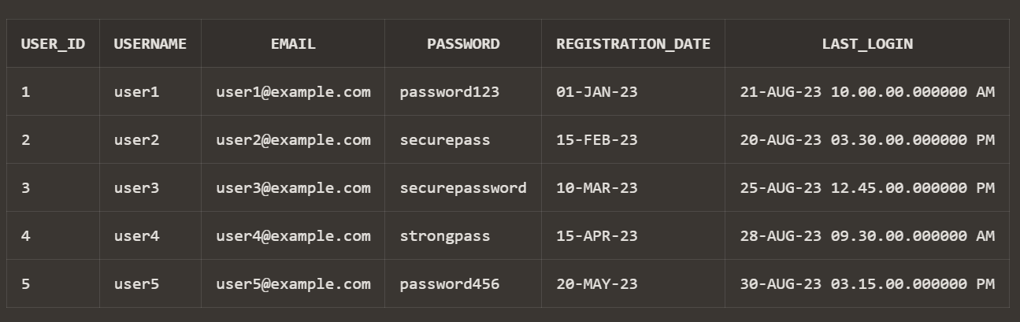

**Table: master_books**

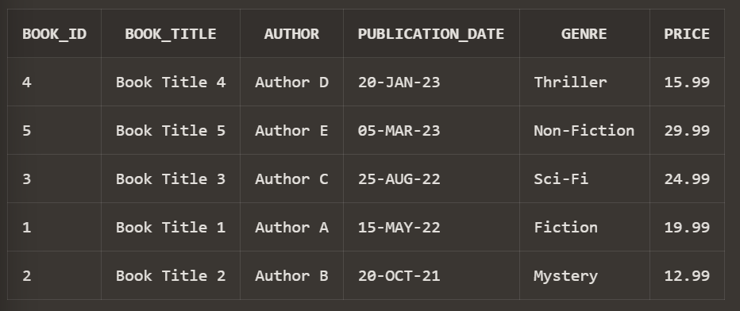

**Table: master_movies**

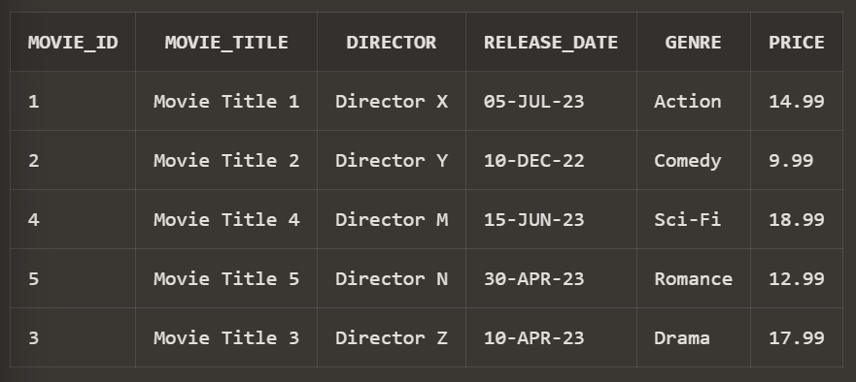

**Table: master_products** 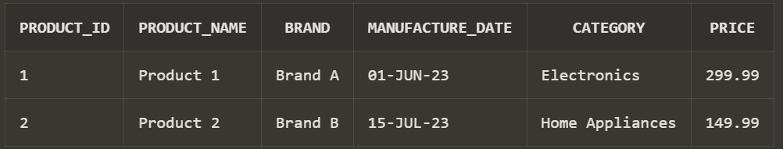

**Table: master_courses**

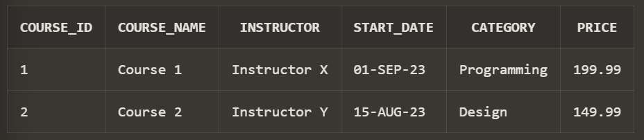

**Table: master_restaurants**

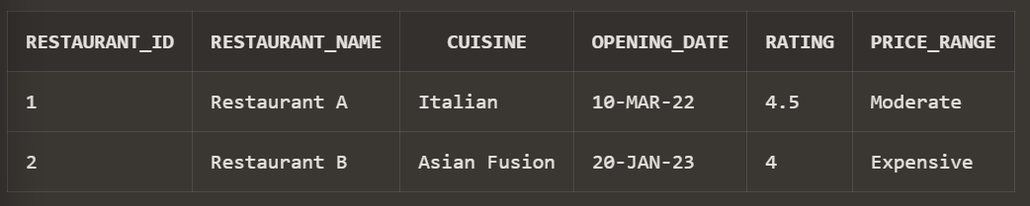

**Table: transactions_books**

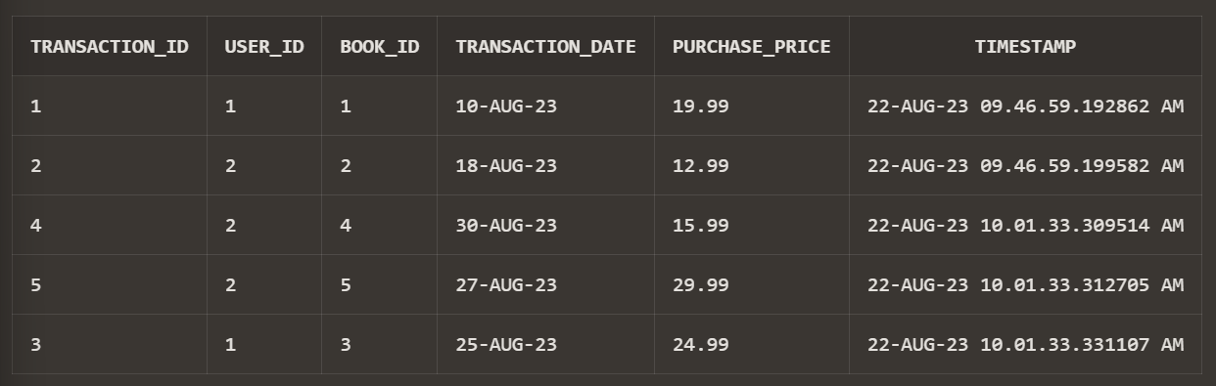

**Table: transactions_movies**

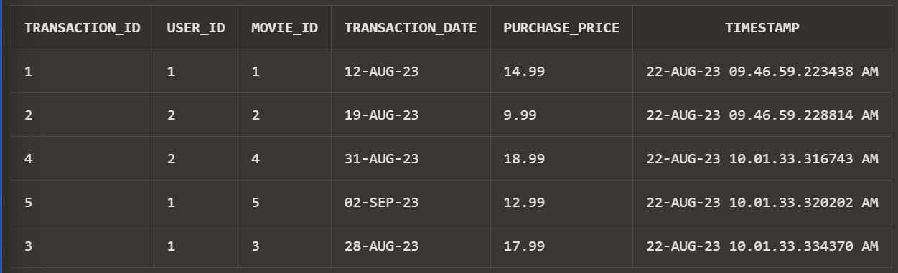

**Table: transactions_products**

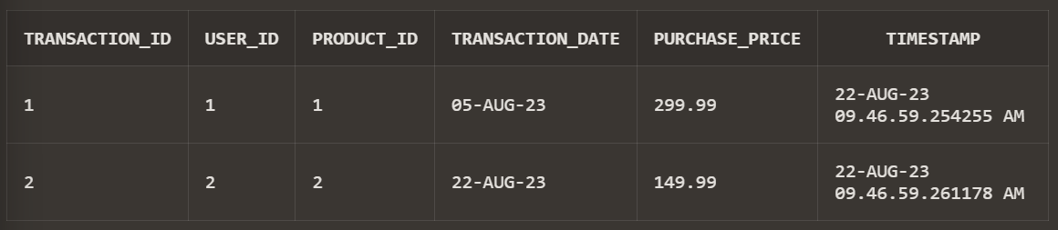

**Table: transactions_courses**

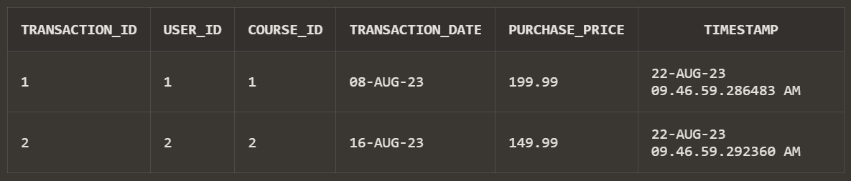

**Table: transactions_restaurants**

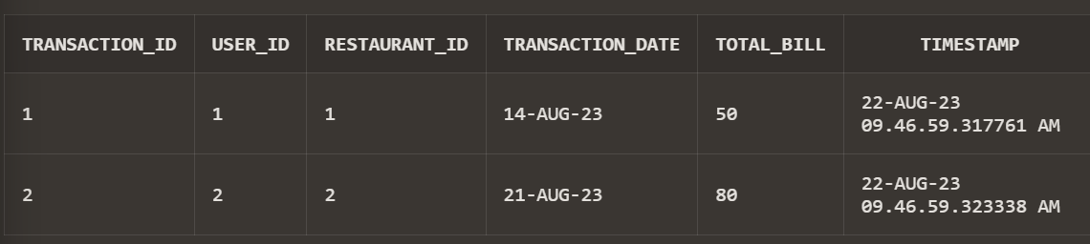

**Table: transactions_miscellaneous**

