**18CSC303 DATABASE DESIGN**

NAME: UTHAYARAHAVAN M S

ROLL_NO: CB.SC.I5DAS21065

**­__________________________________________________**

**Table Creation:**

**--Create users Table**

CREATE TABLE users (

user_id NUMBER PRIMARY KEY,

username VARCHAR2(50) NOT NULL,

email VARCHAR2(100) UNIQUE,

password VARCHAR2(100) NOT NULL,

registration_date DATE,

last_login TIMESTAMP

);

**-- Create master_books Table**

CREATE TABLE master_books (

book_id NUMBER PRIMARY KEY,

book_title VARCHAR2(100) NOT NULL,

author VARCHAR2(100),

publication_date DATE,

genre VARCHAR2(50),

price NUMBER(10, 2),

CONSTRAINT chk_price_books CHECK (price >= 0)

);

**-- Create master_movies Table**

CREATE TABLE master_movies (

movie_id NUMBER PRIMARY KEY,

movie_title VARCHAR2(100) NOT NULL,

director VARCHAR2(100),

release_date DATE,

genre VARCHAR2(50),

price NUMBER(10, 2),

CONSTRAINT chk_price_movies CHECK (price >= 0)

);

**--Create master_products Table**

CREATE TABLE master_products (

product_id NUMBER PRIMARY KEY,

product_name VARCHAR2(100) NOT NULL,

brand VARCHAR2(100),

manufacture_date DATE,

category VARCHAR2(50),

price NUMBER(10, 2),

CONSTRAINT chk_product_price CHECK (price >= 0)

);

**--Create master_courses Table**

CREATE TABLE master_courses (

course_id NUMBER PRIMARY KEY,

course_name VARCHAR2(100) NOT NULL,

instructor VARCHAR2(100),

start_date DATE,

category VARCHAR2(50),

price NUMBER(10, 2),

CONSTRAINT chk_courses_price CHECK (price >= 0)

);

**--Create master_restaurants Table**

CREATE TABLE master_restaurants (

restaurant_id NUMBER PRIMARY KEY,

restaurant_name VARCHAR2(100) NOT NULL,

cuisine VARCHAR2(100),

opening_date DATE,

rating NUMBER(3, 2),

price_range VARCHAR2(20),

CONSTRAINT chk_rating CHECK (rating >= 0 AND rating <= 5)

);

**-- Create transactions_books Table**

CREATE TABLE transactions_books (

transaction_id NUMBER PRIMARY KEY,

user_id NUMBER,

book_id NUMBER,

transaction_date DATE,

purchase_price NUMBER(10, 2),

timestamp TIMESTAMP DEFAULT CURRENT_TIMESTAMP,

CONSTRAINT fk_user_books FOREIGN KEY (user_id) REFERENCES users(user_id),

CONSTRAINT fk_book_books FOREIGN KEY (book_id) REFERENCES master_books(book_id),

CONSTRAINT chk_purchase_price_books CHECK (purchase_price >= 0)

);

**-- Create transactions_movies Table**

CREATE TABLE transactions_movies (

transaction_id NUMBER PRIMARY KEY,

user_id NUMBER,

movie_id NUMBER,

transaction_date DATE,

purchase_price NUMBER(10, 2),

timestamp TIMESTAMP DEFAULT CURRENT_TIMESTAMP,

CONSTRAINT fk_user_movies FOREIGN KEY (user_id) REFERENCES users(user_id),

CONSTRAINT fk_movie_movies FOREIGN KEY (movie_id) REFERENCES master_movies(movie_id),

CONSTRAINT chk_purchase_price_movies CHECK (purchase_price >= 0)

);

**-- Create transactions_products Table**

CREATE TABLE transactions_products (

transaction_id NUMBER PRIMARY KEY,

user_id NUMBER,

product_id NUMBER,

transaction_date DATE,

purchase_price NUMBER(10, 2),

timestamp TIMESTAMP DEFAULT CURRENT_TIMESTAMP,

CONSTRAINT fk_user_products FOREIGN KEY (user_id) REFERENCES users(user_id),

CONSTRAINT fk_product_products FOREIGN KEY (product_id) REFERENCES master_products(product_id),

CONSTRAINT chk_purchase_price_products CHECK (purchase_price >= 0)

);

**-- Create transactions_courses Table**

CREATE TABLE transactions_courses (

transaction_id NUMBER PRIMARY KEY,

user_id NUMBER,

course_id NUMBER,

transaction_date DATE,

purchase_price NUMBER(10, 2),

timestamp TIMESTAMP DEFAULT CURRENT_TIMESTAMP,

CONSTRAINT fk_user_courses FOREIGN KEY (user_id) REFERENCES users(user_id),

CONSTRAINT fk_course_courses FOREIGN KEY (course_id) REFERENCES master_courses(course_id),

CONSTRAINT chk_purchase_price_courses CHECK (purchase_price >= 0)

);

**-- Create transactions_restaurants Table**

CREATE TABLE transactions_restaurants (

transaction_id NUMBER PRIMARY KEY,

user_id NUMBER,

restaurant_id NUMBER,

transaction_date DATE,

total_bill NUMBER(10, 2),

timestamp TIMESTAMP DEFAULT CURRENT_TIMESTAMP,

CONSTRAINT fk_user_restaurants FOREIGN KEY (user_id) REFERENCES users(user_id),

CONSTRAINT fk_restaurant_restaurants FOREIGN KEY (restaurant_id) REFERENCES master_restaurants(restaurant_id),

CONSTRAINT chk_total_bill CHECK (total_bill >= 0)

);

**-- Create transactions_miscellaneous Table**

CREATE TABLE transactions_miscellaneous (

transaction_id NUMBER PRIMARY KEY,

user_id NUMBER,

description VARCHAR2(4000),

transaction_date DATE,

amount NUMBER(10, 2),

timestamp TIMESTAMP DEFAULT CURRENT_TIMESTAMP,

CONSTRAINT fk_user_miscellaneous FOREIGN KEY (user_id) REFERENCES users(user_id),

CONSTRAINT chk_amount CHECK (amount >= 0));

**Insertion:**

**-- Insert values into users table**

INSERT INTO users (user_id, username, email, password, registration_date, last_login)

VALUES

(1, 'user1', 'user1@example.com', 'password123', to_date('2023-01-01','yyyy-mm-dd'), timestamp'2023-08-21 10:00:00');

INSERT INTO users (user_id, username, email, password, registration_date, last_login)

VALUES(2, 'user2', 'user2@example.com', 'securepass', to_date('2023-02-15','yyyy-mm-dd'), timestamp'2023-08-20 15:30:00');

-- Insert more values into users table

INSERT INTO users (user_id, username, email, password, registration_date, last_login)

VALUES

(3, 'user3', 'user3@example.com', 'securepassword', TO_DATE('2023-03-10', 'YYYY-MM-DD'), TO_TIMESTAMP('2023-08-25 12:45:00', 'YYYY-MM-DD HH24:MI:SS'));

INSERT INTO users (user_id, username, email, password, registration_date, last_login)

VALUES

(4, 'user4', 'user4@example.com', 'strongpass', TO_DATE('2023-04-15', 'YYYY-MM-DD'), TO_TIMESTAMP('2023-08-28 09:30:00', 'YYYY-MM-DD HH24:MI:SS'));

INSERT INTO users (user_id, username, email, password, registration_date, last_login)

VALUES

(5, 'user5', 'user5@example.com', 'password456', TO_DATE('2023-05-20', 'YYYY-MM-DD'), TO_TIMESTAMP('2023-08-30 15:15:00', 'YYYY-MM-DD HH24:MI:SS'));

**-- Insert values into master_books table**

INSERT INTO master_books (book_id, book_title, author, publication_date, genre, price)

VALUES

(1, 'Book Title 1', 'Author A', to_date('2022-05-15','yyyy-mm-dd'), 'Fiction', 19.99);

INSERT INTO master_books (book_id, book_title, author, publication_date, genre, price)

VALUES(2, 'Book Title 2', 'Author B', to_date('2021-10-20','yyyy-mm-dd'), 'Mystery', 12.99);

INSERT INTO master_books (book_id, book_title, author, publication_date, genre, price)

VALUES

(3, 'Book Title 3', 'Author C', TO_DATE('2022-08-25', 'YYYY-MM-DD'), 'Sci-Fi', 24.99);

INSERT INTO master_books (book_id, book_title, author, publication_date, genre, price)

VALUES

(4, 'Book Title 4', 'Author D', TO_DATE('2023-01-20', 'YYYY-MM-DD'), 'Thriller', 15.99);

INSERT INTO master_books (book_id, book_title, author, publication_date, genre, price)

VALUES

(5, 'Book Title 5', 'Author E', TO_DATE('2023-03-05', 'YYYY-MM-DD'), 'Non-Fiction', 29.99);

**-- Insert values into master_movies table**

INSERT INTO master_movies (movie_id, movie_title, director, release_date, genre, price)

VALUES

(1, 'Movie Title 1', 'Director X', TO_DATE('2023-07-05', 'YYYY-MM-DD'), 'Action', 14.99);

INSERT INTO master_movies (movie_id, movie_title, director, release_date, genre, price)

VALUES

(2, 'Movie Title 2', 'Director Y', TO_DATE('2022-12-10', 'YYYY-MM-DD'), 'Comedy', 9.99);

INSERT INTO master_movies (movie_id, movie_title, director, release_date, genre, price)

VALUES

(3, 'Movie Title 3', 'Director Z', TO_DATE('2023-04-10', 'YYYY-MM-DD'), 'Drama', 17.99);

INSERT INTO master_movies (movie_id, movie_title, director, release_date, genre, price)

VALUES

(4, 'Movie Title 4', 'Director M', TO_DATE('2023-06-15', 'YYYY-MM-DD'), 'Sci-Fi', 18.99);

INSERT INTO master_movies (movie_id, movie_title, director, release_date, genre, price)

VALUES

(5, 'Movie Title 5', 'Director N', TO_DATE('2023-04-30', 'YYYY-MM-DD'), 'Romance', 12.99);

**-- Insert values into master_products table**

INSERT INTO master_products (product_id, product_name, brand, manufacture_date, category, price)

VALUES

(1, 'Product 1', 'Brand A', TO_DATE('2023-06-01', 'YYYY-MM-DD'), 'Electronics', 299.99);

INSERT INTO master_products (product_id, product_name, brand, manufacture_date, category, price)

VALUES

(2, 'Product 2', 'Brand B', TO_DATE('2023-07-15', 'YYYY-MM-DD'), 'Home Appliances', 149.99);

INSERT INTO master_products (product_id, product_name, brand, manufacture_date, category, price)

VALUES

(3, 'Product 3', 'Brand C', TO_DATE('2023-08-10', 'YYYY-MM-DD'), 'Clothing', 49.99);

INSERT INTO master_products (product_id, product_name, brand, manufacture_date, category, price)

VALUES

(4, 'Product 4', 'Brand D', TO_DATE('2023-07-20', 'YYYY-MM-DD'), 'Beauty', 29.99);

INSERT INTO master_products (product_id, product_name, brand, manufacture_date, category, price)

VALUES

(5, 'Product 5', 'Brand E', TO_DATE('2023-08-05', 'YYYY-MM-DD'), 'Electronics', 199.99);

**-- Insert values into master_courses table**

INSERT INTO master_courses (course_id, course_name, instructor, start_date, category, price)

VALUES

(1, 'Course 1', 'Instructor X', TO_DATE('2023-09-01', 'YYYY-MM-DD'), 'Programming', 199.99);

INSERT INTO master_courses (course_id, course_name, instructor, start_date, category, price)

VALUES

(2, 'Course 2', 'Instructor Y', TO_DATE('2023-08-15', 'YYYY-MM-DD'), 'Design', 149.99);

INSERT INTO master_courses (course_id, course_name, instructor, start_date, category, price)

VALUES

(3, 'Course 3', 'Instructor Z', TO_DATE('2023-09-10', 'YYYY-MM-DD'), 'Language', 99.99);

INSERT INTO master_courses (course_id, course_name, instructor, start_date, category, price)

VALUES

(4, 'Course 4', 'Instructor W', TO_DATE('2023-08-15', 'YYYY-MM-DD'), 'Music', 79.99);

INSERT INTO master_courses (course_id, course_name, instructor, start_date, category, price)

VALUES

(5, 'Course 5', 'Instructor X', TO_DATE('2023-07-20', 'YYYY-MM-DD'), 'Fitness', 149.99);

**-- Insert values into master_restaurants table**

INSERT INTO master_restaurants (restaurant_id, restaurant_name, cuisine, opening_date, rating, price_range)

VALUES (1, 'Restaurant A', 'Italian', TO_DATE('2022-03-10', 'YYYY-MM-DD'), 4.5, 'Moderate');

INSERT INTO master_restaurants (restaurant_id, restaurant_name, cuisine, opening_date, rating, price_range)

VALUES

(2, 'Restaurant B', 'Asian Fusion', TO_DATE('2023-01-20', 'YYYY-MM-DD'), 4.0, 'Expensive');

INSERT INTO master_restaurants (restaurant_id, restaurant_name, cuisine, opening_date, rating, price_range)

VALUES

(3, 'Restaurant C', 'Mexican', TO_DATE('2023-06-10', 'YYYY-MM-DD'), 4.2, 'Moderate');

INSERT INTO master_restaurants (restaurant_id, restaurant_name, cuisine, opening_date, rating, price_range)

VALUES

(4, 'Restaurant D', 'Indian', TO_DATE('2023-05-15', 'YYYY-MM-DD'), 4.5, 'Expensive');

INSERT INTO master_restaurants (restaurant_id, restaurant_name, cuisine, opening_date, rating, price_range)

VALUES

(5, 'Restaurant E', 'Japanese', TO_DATE('2023-07-01', 'YYYY-MM-DD'), 4.0, 'Moderate');

**-- Insert values into transactions_books table**

INSERT INTO transactions_books (transaction_id, user_id, book_id, transaction_date, purchase_price)

VALUES

(1, 1, 1, TO_DATE('2023-08-10', 'YYYY-MM-DD'), 19.99);

INSERT INTO transactions_books (transaction_id, user_id, book_id, transaction_date, purchase_price)

VALUES

(2, 2, 2, TO_DATE('2023-08-18', 'YYYY-MM-DD'), 12.99);

-- Insert additional values into transactions_books table

INSERT INTO transactions_books (transaction_id, user_id, book_id, transaction_date, purchase_price)

VALUES

(3, 1, 3, TO_DATE('2023-08-25', 'YYYY-MM-DD'), 24.99);

INSERT INTO transactions_books (transaction_id, user_id, book_id, transaction_date, purchase_price)

VALUES

(4, 2, 4, TO_DATE('2023-08-30', 'YYYY-MM-DD'), 15.99);

INSERT INTO transactions_books (transaction_id, user_id, book_id, transaction_date, purchase_price)

VALUES

(5, 2, 5, TO_DATE('2023-08-27', 'YYYY-MM-DD'), 29.99);

**-- Insert values into transactions_movies table**

INSERT INTO transactions_movies (transaction_id, user_id, movie_id, transaction_date, purchase_price)

VALUES

(1, 1, 1, TO_DATE('2023-08-12', 'YYYY-MM-DD'), 14.99);

INSERT INTO transactions_movies (transaction_id, user_id, movie_id, transaction_date, purchase_price)

VALUES

(2, 2, 2, TO_DATE('2023-08-19', 'YYYY-MM-DD'), 9.99);

INSERT INTO transactions_movies (transaction_id, user_id, movie_id, transaction_date, purchase_price)

VALUES

(3, 1, 3, TO_DATE('2023-08-28', 'YYYY-MM-DD'), 17.99);

INSERT INTO transactions_movies (transaction_id, user_id, movie_id, transaction_date, purchase_price)

VALUES

(4, 2, 4, TO_DATE('2023-08-31', 'YYYY-MM-DD'), 18.99);

INSERT INTO transactions_movies (transaction_id, user_id, movie_id, transaction_date, purchase_price)

VALUES

(5, 1, 5, TO_DATE('2023-09-02', 'YYYY-MM-DD'), 12.99);

**-- Insert values into transactions_products table**

INSERT INTO transactions_products (transaction_id, user_id, product_id, transaction_date, purchase_price)

VALUES

(1, 1, 1, TO_DATE('2023-08-05', 'YYYY-MM-DD'), 299.99);

INSERT INTO transactions_products (transaction_id, user_id, product_id, transaction_date, purchase_price)

VALUES

(2, 2, 2, TO_DATE('2023-08-22', 'YYYY-MM-DD'), 149.99);

INSERT INTO transactions_products (transaction_id, user_id, product_id, transaction_date, purchase_price)

VALUES

(3, 1, 3, TO_DATE('2023-08-10', 'YYYY-MM-DD'), 49.99);

INSERT INTO transactions_products (transaction_id, user_id, product_id, transaction_date, purchase_price)

VALUES

(4, 2, 4, TO_DATE('2023-08-22', 'YYYY-MM-DD'), 29.99);

INSERT INTO transactions_products (transaction_id, user_id, product_id, transaction_date, purchase_price)

VALUES

(5, 1, 5, TO_DATE('2023-08-15', 'YYYY-MM-DD'), 199.99);

**-- Insert values into transactions_courses table**

INSERT INTO transactions_courses (transaction_id, user_id, course_id, transaction_date, purchase_price)

VALUES

(1, 1, 1, TO_DATE('2023-08-08', 'YYYY-MM-DD'), 199.99);

INSERT INTO transactions_courses (transaction_id, user_id, course_id, transaction_date, purchase_price)

VALUES

(2, 2, 2, TO_DATE('2023-08-16', 'YYYY-MM-DD'), 149.99);

INSERT INTO transactions_courses (transaction_id, user_id, course_id, transaction_date, purchase_price)

VALUES

(3, 1, 3, TO_DATE('2023-08-08', 'YYYY-MM-DD'), 99.99);

INSERT INTO transactions_courses (transaction_id, user_id, course_id, transaction_date, purchase_price)

VALUES

(4, 2, 4, TO_DATE('2023-08-16', 'YYYY-MM-DD'), 79.99);

INSERT INTO transactions_courses (transaction_id, user_id, course_id, transaction_date, purchase_price)

VALUES

(5, 1, 5, TO_DATE('2023-08-12', 'YYYY-MM-DD'), 149.99);

**-- Insert values into transactions_restaurants table**

INSERT INTO transactions_restaurants (transaction_id, user_id, restaurant_id, transaction_date, total_bill)

VALUES

(1, 1, 1, TO_DATE('2023-08-14', 'YYYY-MM-DD'), 50.00);

INSERT INTO transactions_restaurants (transaction_id, user_id, restaurant_id, transaction_date, total_bill)

VALUES

(2, 2, 2, TO_DATE('2023-08-21', 'YYYY-MM-DD'), 80.00);

INSERT INTO transactions_restaurants (transaction_id, user_id, restaurant_id, transaction_date, total_bill)

VALUES

(3, 1, 3, TO_DATE('2023-08-14', 'YYYY-MM-DD'), 70.00);

INSERT INTO transactions_restaurants (transaction_id, user_id, restaurant_id, transaction_date, total_bill)

VALUES

(4, 2, 4, TO_DATE('2023-08-21', 'YYYY-MM-DD'), 100.00);

INSERT INTO transactions_restaurants (transaction_id, user_id, restaurant_id, transaction_date, total_bill)

VALUES

(5, 1, 5, TO_DATE('2023-08-18', 'YYYY-MM-DD'), 120.00);

**-- Insert values into transactions_miscellaneous table**

INSERT INTO transactions_miscellaneous (transaction_id, user_id, description, transaction_date, amount)

VALUES

(1, 1, 'Misc Item 1', TO_DATE('2023-08-17', 'YYYY-MM-DD'), 10.00);

INSERT INTO transactions_miscellaneous (transaction_id, user_id, description, transaction_date, amount)

VALUES

(2, 2, 'Misc Item 2', TO_DATE('2023-08-23', 'YYYY-MM-DD'), 15.00);

INSERT INTO transactions_miscellaneous (transaction_id, user_id, description, transaction_date, amount)

VALUES

(3, 1, 'Misc Item 3', TO_DATE('2023-08-17', 'YYYY-MM-DD'), 7.50);

INSERT INTO transactions_miscellaneous (transaction_id, user_id, description, transaction_date, amount)

VALUES

(4, 2, 'Misc Item 4', TO_DATE('2023-08-23', 'YYYY-MM-DD'), 12.25);

INSERT INTO transactions_miscellaneous (transaction_id, user_id, description, transaction_date, amount)

VALUES

(5, 1, 'Misc Item 5', TO_DATE('2023-08-20', 'YYYY-MM-DD'), 20.00);

**Adding new columns in user table for HTML form**

ALTER TABLE users

ADD first_name VARCHAR(50),

ADD last_name VARCHAR(50);

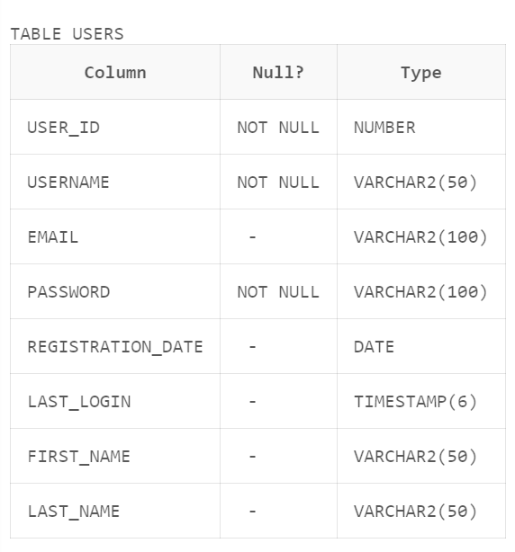

**Select**

**-- Retrieve all user data**

SELECT * FROM users;

**-- Retrieve books priced less than 15**

SELECT * FROM master_books WHERE price < 15;

**-- Retrieve transactions for user 1**

SELECT * FROM transactions_books WHERE user_id = 1;

**Describe**

**-- Describe the structure of the users table**

DESCRIBE users;

**-- Describe the structure of the master_books table**

DESCRIBE master_books;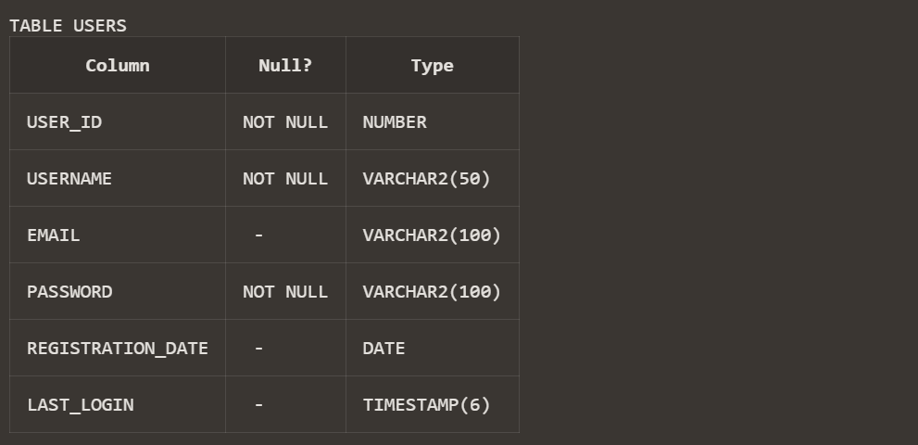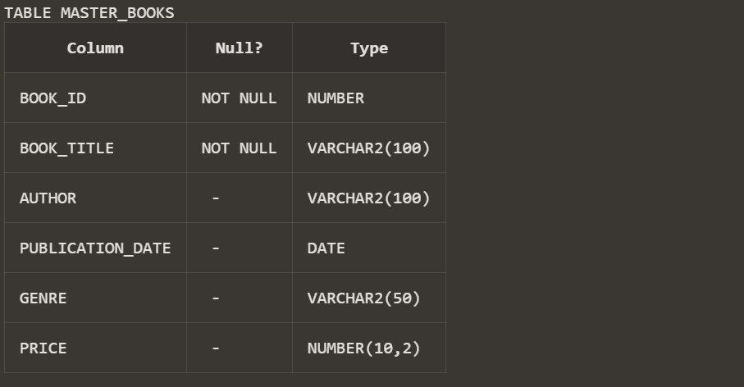

**Delete**

**-- Delete user with user_id 2**

DELETE FROM users WHERE user_id = 2;

**-- Delete a book with book_id 1**

DELETE FROM master_books WHERE book_id = 1;

**Alter**

**--- Add a new column 'is_active' to the users table**

ALTER TABLE users ADD is_active NUMBER(1) DEFAULT 1;

SELECT * FROM users;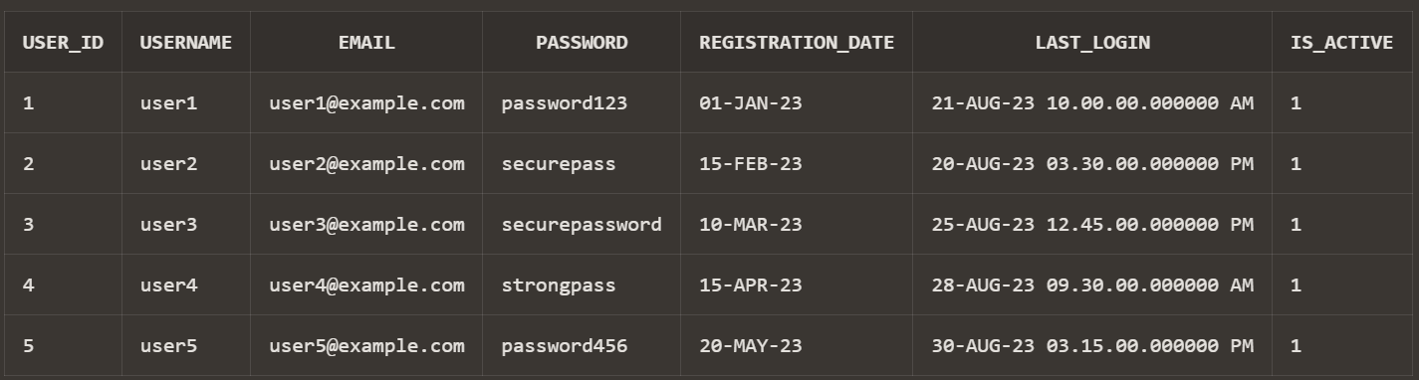

**-- Add a new column 'is_featured' to the master_books table**

ALTER TABLE master_books ADD is_featured NUMBER(1) DEFAULT 0;

SELECT * FROM master_books;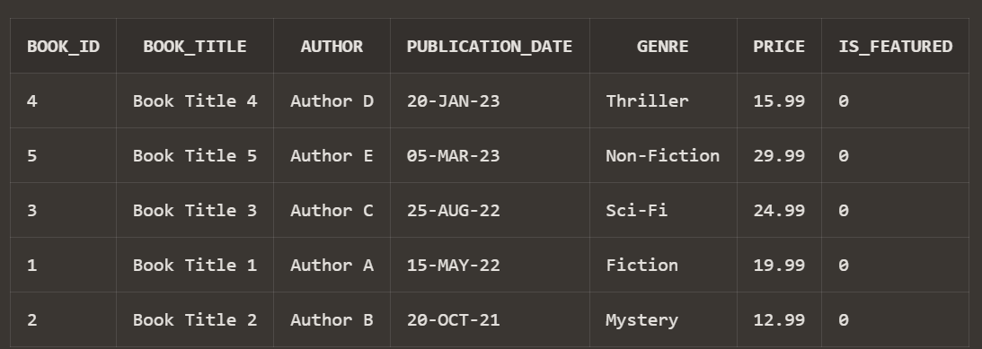

**Select with where clause**

**-- Retrieve user details for user_id 1**

SELECT * FROM users WHERE user_id = 1;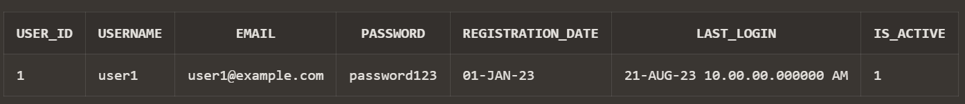

**-- Retrieve movies released after 2022-01-01**

SELECT * FROM master_movies WHERE release_date > TO_DATE('2022-01-01', 'YYYY-MM-DD');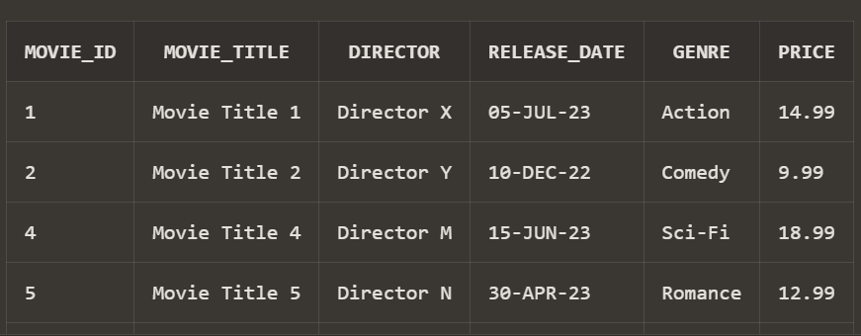

**Select with where clause on multiple tables**

**-- Retrieve transactions for user 1 along with book details**

SELECT tb.transaction_id, tb.transaction_date, tb.purchase_price, mb.book_title, mb.author

FROM transactions_books tb

JOIN master_books mb ON tb.book_id = mb.book_id

WHERE tb.user_id = 1;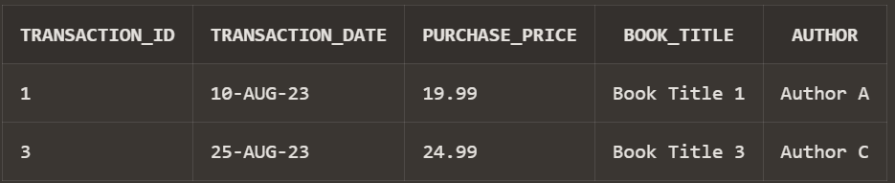

**Drop**

**-- Drop the transactions_miscellaneous table**

DROP TABLE transactions_miscellaneous;