Read the problem set. You may use any online programming reference, you may use an IDE, but you may not get help from any other person.

[https://docs.google.com/document/d/1_nsNz0nwI26F_BTONDGNOqnk2L47JlioIOVrY0g0EVA/edit?usp=sharing (Links to an external site.)](https://docs.google.com/document/d/1_nsNz0nwI26F_BTONDGNOqnk2L47JlioIOVrY0g0EVA/edit?usp=sharing)

Write the four programs, paste them together in a large text file with a suffix of .java or .txt.

You may not use a word processor. Your text must be readable by a programming editor. Upload the textfile before the deadline 5:40.

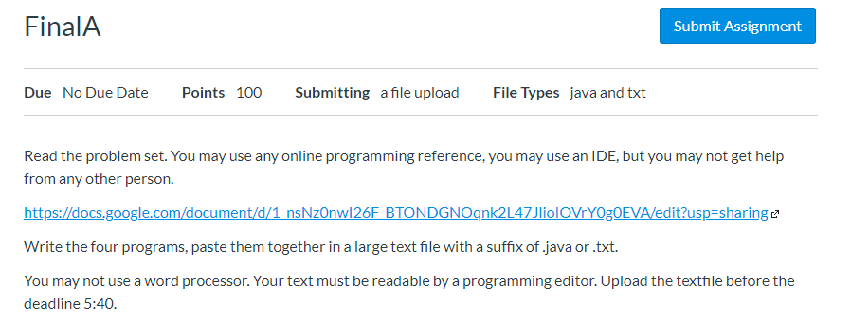

 EE-552_2020S Java Final A Name:_____________ Score: _______  
This test is open book, open notes. You may not get help from any person or ask for help.  
Write all the code. You may use an IDE if you wish or just type it in. Please try to make it neat if you can.  
When you are done, submit a single document in the final “homework”  
You have 2.5 hours. There are 4 problems. Good luck!

1. (25 points) Write a class PointList which
   1. reads in from a file a list of x,y points.
   2. Use Scanner to read in x,y points from a file (FileReader)
   3. create an ArrayList<Point> where you define class Point to have x,y.
   4. Remove any points that are not within 2 < x < 6 and 3 < y < 7.
   5. Calculate the mean (average) for x and y  
      For example, having read:  
      1.0 5.0  
      3.0 4.0   
      3.0 0.0  
      4.0 3.5  
        
      we remove the first point because x not within range.  
      second point stays  
      third point removed because y not in range  
      fourth point stays.  
      The resulting ArrayLIst has (3.0,4.0), (4.0, 3.5)  
        
      Compute the average and print out (3.5, 3.75)

2. (25 points) Write a sample window with a JButton and a JPanel using private variables like this:  
You must complete and make this code compile and run including all imports.  
Add an anonymous inner class implementing ActionListener so that when the button is pressed, it turns the JPanel p red. Note that the method to set any component’s color is setColor(Color c);  
  
  
public class MyWindow …  
  private JButton b;  
  private JPanel p;  
….

3. (25 points) Write a class Quiz that contains an ArrayList of Questions. There are two types of questions: Fillin the blank and Number.  
  
Fill in the blank questions look like:  
What is the title of your favorite book? ___________________________  
They contain the correct answer so that whatever the user types can be compared to the correct answer for grading. We will support only one correct answer.

Number questions look the same but the answer can be in a range and still be correct:  
What is 2 + 2? 4.02

close enough!

Printing a quiz should print out the name of the quiz and then print all the questions in it.  
Make the following main work:  
  
public class TestQuiz {  
  public static void main(String[] args) {  
    Quiz q = new Quiz(“Java”);  
    q.add(new FillInQuestion(“What is the best programming language?”,  
 “Java”);

    q.add(new NumberQuestion(“What is 2+2?””, 3.95, 4.05);  
    System.out.println(q); // print the quiz and all questions

4. (25 points) Turn the above class NumberQuestion into a Java Bean. Explain the rules of a Java Bean (very short) and implement attributes:  
  
Question (a string)

MinimumAnswer (double)

MaximumAnswer(double)