COMMON SENTENCE LEVEL PROBLEMS

# SENTENCE FRAGMENT

***While Sherlock waited.  
  
The detective Sherlock Holmes.  
With his fingertips together.  
Sherlock.***

Hansi's transcript content

# FUSED SENTENCE

***Sherlock Holmes waited Watson  
delayed his visit.***

Hansi's transcript content

# COMMA SPLICE

***Sherlock Holmes waited, Doctor  
Watson arrived eventually.***

Hansi's transcript content

# CORRECTED

***Sherlock Holmes waited, and  
Watson delayed his visit.  
  
Sherlock Holmes waited.  
Watson delayed his visit.***

Hansi's transcript content

# ‘AND-NESS’

***Constructing long sentences by stringing too many clauses  
together with ‘and’  
Proposals are to be submitted in duplicate, and enclosed ina  
sealed envelope, and endorsed with a reference number, and shall  
be lodged at the address below.***

Hansi's transcript content

# THE LISTLIKE SENTENCE

***‘The thing about a sentence with a listlike form is that there are a  
number of tiny points with independent bits of meaning that are  
set out in the sentence in a line so that the series of words and  
phrases reads like so many pieces of popcorn strung out ona  
string’. —  
  
From Linda Flower’s Problem-solving Strategies for Writing***

Hansi's transcript content

# ‘IS-NESS’

***Relies on parts of the ‘weak’ verb ‘to be’  
The intention of the tax office is to audit their records.  
  
This tyrant, whose sole name is a blister on our tongues, was once  
thought honest. (Macbeth by Shakespeare)***

Hansi's transcript content

***This chart shows the conjugation of the verb ‘to be’ in past and  
present tense. You can find itin your course reader.***

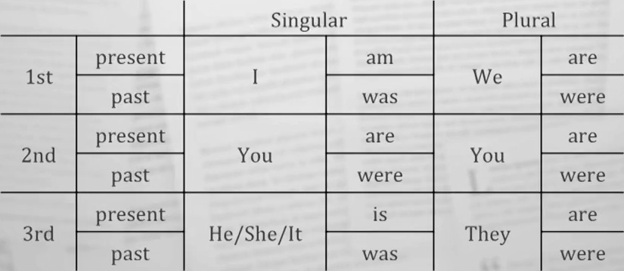

Hansi's transcript content

# -NESS’

***The word ‘of’ is used too frequently  
  
Our lack OF knowledge about local conditions precluded  
determination OF committee action effectiveness in fund  
allocation to those areas in greatest need OF assistance.***

Hansi's transcript content

***english - grammar - style***

Hansi's transcript content

***Ths UNivErsiny  
  
(Rm (Recents nace***

Hansi's transcript content