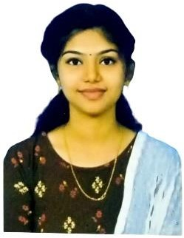Name :UTHRA

Photo

Figure 1Photo

**Mobile No :8825403733**

[Mail](mailto:dharshini143dharshini@gmail.com) **id :uthra1592004@gmail.com**

# OBJECTIVE

# Seeking an opportunity to use my knowledge and talent.

# SKILLS

# Problem solving

# Teamwork

# PERSONAL SKILLS

# Time management

# Active listening

# EDUCATION

|  |  |  |  |  |
| --- | --- | --- | --- | --- |
| Qualification | Institution | Board / University | Year of Passing | % of Marks / Grade |
| UG | S.T.Hindu College | ManonmaniamSundaranarUniversity | 2024 | 70.74 |
| HSC | Govt.High.School,Puthery | StateBoard | 2021 | 69.2 |
| SSLC | Govt.Hr.Sec.School,Vadasery | StateBoard | 2019 | 78.17 |

# ACADEMIC PROJECT

# Naanmudhalvan

# CERTIFICATIONS

# NULL

# PERSONAL DETAILS

# Date of Birth : 15.09.2004

# Gender :Female

# Marital Status : Unmarried

# Languages Known : Tamil,English

# Address for Communication : Tamil

# DECLARATION

# I hereby declared that the above said information are true to the best of my knowledge and belief.

# Place :Nagercoil

# Date : 19/09/2023

# Signature : Uthra.P

# 