KEGSENSE

Complete project guide
  - Two keg scales, temperature, history, Wi-Fi setup, OTA and Cloudflare Remote
ESP32 DevKit V1 + 2 x HX711 + 8 load cells + DS18B20
Firmware: KegSense 2.0.0-alpha | branch v2-refactor | commit 1c2145a
PURPOSE Build, wire, flash, configure, calibrate, operate, update and remotely monitor a complete KegSense installation. The pin map in section 4 matches the current schematic and firmware.

Prepared 17 August 2026

Contents
- 1. System overview
- 2. Parts, tools and safety
- 3. Load cells and HX711
- 4. Wiring and GPIO
- 5. Firmware and first flash
- 6. Wi-Fi and device setup
- 7. Calibration and keg setup
- 8. Daily operation and history
- 9. OTA update
- 10. Cloudflare Remote
- 11. Troubleshooting
- 12. Maintenance and acceptance test
- Appendix A. Wiring schematic
READ FIRST Load-cell signals are very small. Stable mechanics, a common ground, short signal wiring and correct cell orientation are as important as the software.

1. System overview
KegSense measures the total weight beneath one or two kegs and calculates the remaining contents in litres and percent. A DS18B20 monitors the kegerator temperature. The local web app provides setup and history, while the optional Cloudflare Remote service receives status over HTTPS.
Component | Purpose
ESP32 DevKit V1 | Reads sensors, stores settings and serves the local web interface.
Two HX711 modules | Amplify and digitise four load cells for each scale.
Eight 3-wire load cells | Four half-bridge cells form one complete scale platform.
DS18B20 module | Measures temperature through 1-Wire on GPIO 13.
Cloudflare Worker + D1 | Receives telemetry and serves the installable Remote app.

2. Parts, tools and safety
Qty | Part | Notes
1 | ESP32 DevKit V1, 30-pin | 4 MB flash recommended
2 | HX711 module | One per scale platform
8 | 3-wire load cell | Four identical cells per platform
1 | DS18B20 module | DATA, VCC and GND
1 | Stable 5 V USB supply | Use a data-capable cable for flashing
1 | Enclosure and wiring hardware | Strain relief, terminals and heat-shrink

- PC with USB and PlatformIO, esptool or a complete firmware image.
- Multimeter for continuity and 3.3 V/GND checks.
- Soldering and insulation tools where connectors are not used.
- Known 2-10 kg test mass.
- Phone or PC connected to 2.4 GHz Wi-Fi.
SAFETY Disconnect USB and power before moving wires. In this design the HX711 modules and DS18B20 are powered from 3.3 V. A short between 3.3 V and GND may damage the ESP32.

3. Load cells and HX711
Each platform uses four 3-wire half-bridge load cells. Mount them in the correct corners and in the same load direction. The schematic labels the positions Upper Left, Upper Right, Lower Left and Lower Right.
Scale | Cells | Positions
Scale 1 | B1-B4 | B1 upper left, B2 upper right, B3 lower left, B4 lower right
Scale 2 | B5-B8 | B5 upper left, B6 upper right, B7 lower left, B8 lower right

Connect the red, white and black load-cell leads exactly as shown in Appendix A. Wire colours can vary by manufacturer, so check the cell datasheet if the readings do not react as expected.
MECHANICAL CHECK The platform must move slightly without touching the frame, floor or refrigerator wall. Mechanical contact causes incorrect readings even when the electronics are wired correctly.

4. Wiring and GPIO
Function | ESP32 | Module pin
Scale 1 data / clock | GPIO 32 / GPIO 33 | HX711 DT / SCK
Scale 2 data / clock | GPIO 16 / GPIO 17 | HX711 DT / SCK
Temperature data | GPIO 13 | DS18B20 DATA
3.3 V supply | 3V3 | Both HX711 VCC and DS18B20 VCC
Common ground | GND | Both HX711 GND and DS18B20 GND

VERIFIED The updated PDF schematic and include/config.h on branch v2-refactor now use the same GPIO assignments.

- Check continuity between all ground points.
- Confirm there is no short circuit between 3.3 V and GND.
- Check DT/DOUT and SCK against the table above.
- Verify every load-cell corner against Appendix A.
- Connect USB only after all checks pass.

5. Firmware and first flash
- Connect the ESP32 to the PC using a USB data cable.
- Select the correct serial port, for example COM3.
- For a blank board, flash the bootloader, partition table and firmware image. A later OTA update uses only the application BIN.
- Open the serial monitor at 115200 baud and verify a stable boot.
PlatformIO setting | Value
Environment | esp32dev
Framework | Arduino
Monitor speed | 115200 baud
Upload speed | 921600 baud

FIRST BOOT Missing NVS key messages are normal on a new ESP32. They stop after configuration and calibration values have been saved.

6. Wi-Fi and device setup
- Join the KegSense-Setup network from a phone or PC.
- If the captive portal does not open, browse to http://192.168.4.1.
- Select the 2.4 GHz Wi-Fi network and enter its password.
- Choose one or two active kegs.
- Enable temperature, history and Cloudflare Remote as required.
- Save, reconnect to the home network and open http://kegsense.local.
Address | Use
http://kegsense.local | Stable local name using mDNS
Device IP address | Shown on the dashboard; use when mDNS is unavailable
/wifi | Change Wi-Fi, keg count and optional functions
/settings | Keg data, calibration, restart and OTA link

WI-FI ESP32 uses 2.4 GHz. If setup fails, use a separate 2.4 GHz SSID, disable client isolation and keep the phone or PC on the same LAN.

7. Calibration and keg setup

7.1 Calibrate a scale
- Open Settings from the dashboard.
- Remove everything from the platform and select Reset empty platform.
- Wait until the scale is ready for a known mass.
- Place the test mass, enter its weight in kg and start calibration.
- Wait for the new calibration factor to be saved.
- Remove and replace the mass to verify the result.
ACCURACY Use a test mass that loads all four cells through the platform. Do not place a small mass directly above one load cell.

7.2 Install a new keg
- Choose New keg on the correct dashboard card.
- Enter the keg or beer name.
- Enter the empty keg weight in kg.
- Enter the actual filled volume in litres.
- Confirm. Calibration is retained and today's history for that keg is reset.
Firmware defaults are 4.90 kg empty weight, 20.0 L volume and beer density 0.997 kg/L. Use the actual values for best accuracy.

8. Daily operation and history
- The dashboard shows total weight, estimated contents, litres, percent and today's consumption.
- Temperature is sampled about every five seconds when enabled.
- Consumption history is retained for up to 62 days.
- A large sudden weight loss is treated as a removed keg/platform, not a serving.
- Settings, zero points and history are stored in ESP32 NVS and survive restart.
Consumption is calculated from falling level. Drift and movement below about 0.20 L are filtered. Use New keg after cleaning, moving a platform or replacing a keg.

9. OTA update
- Download the correct KegSense application .bin file.
- Open http://kegsense.local/update.
- Sign in. The development default is admin / kegsense; change it in config.h before permanent deployment.
- Select the BIN file and start upload.
- Wait for completion and automatic restart.
- Never remove power while flash is being written. If restart does not occur after a confirmed update, press EN/RESET once.
OTA FAILURE A failed update retains the previous firmware. Restart the ESP32 and inspect the serial log before retrying. The BIN must fit the OTA partition.

10. Cloudflare Remote
Remote consists of a Cloudflare Worker, a D1 database and a PWA. The ESP32 sends outbound HTTPS telemetry about every 60 seconds. DEVICE_TOKEN protects device uploads; APP_TOKEN is used only by the Remote app.

10.1 Deploy the service
- Install Node.js and run npm install in the cloud directory.
- Run npx wrangler login.
- Create D1 with npx wrangler d1 create kegsense-remote.
- Copy the database ID into cloud/wrangler.jsonc.
- Create separate strong secrets with npx wrangler secret put DEVICE_TOKEN and npx wrangler secret put APP_TOKEN.
- Create the tables with npm run db:remote.
- Deploy with npm run deploy.

10.2 Configure KegSense
Field in /wifi | Value
Remote device ID | A unique name such as kegsense-home
Cloudflare Worker URL | https://<worker>.<subdomain>.workers.dev/api/telemetry
Remote device token | The same DEVICE_TOKEN stored as the Worker secret

SECRETS Cloudflare does not reveal a secret after it is stored. If DEVICE_TOKEN is lost, set a new value in Cloudflare and enter the same value in KegSense. Never use APP_TOKEN as the device token.

11. Troubleshooting
Symptom | Check / action
KegSense-Setup is missing | Restart; inspect serial output and saved Wi-Fi. Reset Wi-Fi/NVS if required.
kegsense.local does not open | Confirm same LAN and mDNS support; use the IP shown by the dashboard/router.
Weight is extreme or negative | Check bridge wiring, GPIO, zero point and recalibrate.
Scale is offline | Check HX711 3.3 V/GND and the DT/SCK pin map.
Temperature shows -- | Enable the function and check DS18B20 3.3 V/GND/DATA on GPIO 13.
History is empty | Enable history and wait for valid NTP time over Wi-Fi.
Remote does not update | Check HTTPS URL, device ID, DEVICE_TOKEN, Worker logs and HTTP status.
OTA fails | Check BIN size, Wi-Fi stability and serial log; use USB flashing if necessary.

12. Maintenance and acceptance test
- Keep platforms mechanically free and dry.
- Recheck zero and a known test mass periodically.
- Use strain relief and protect electronics from condensation.
- Archive the last working BIN and record the GPIO map.
- Rotate OTA passwords and Cloudflare tokens when ownership changes.
Test | Pass condition
Boot | No reset loop; dashboard opens through kegsense.local
Scale 1 and 2 | Known mass is within the chosen tolerance across each platform
Temperature | Stable and reasonable compared with a reference
Storage | Keg names, zero points and features survive restart
History | Consumption updates without counting a lifted keg as a serving
OTA | New BIN installs and the device returns automatically
Remote | Cloudflare app updates within about 1-2 minutes

Appendix A. Wiring schematic
Updated project schematic. The GPIO connections match section 4.
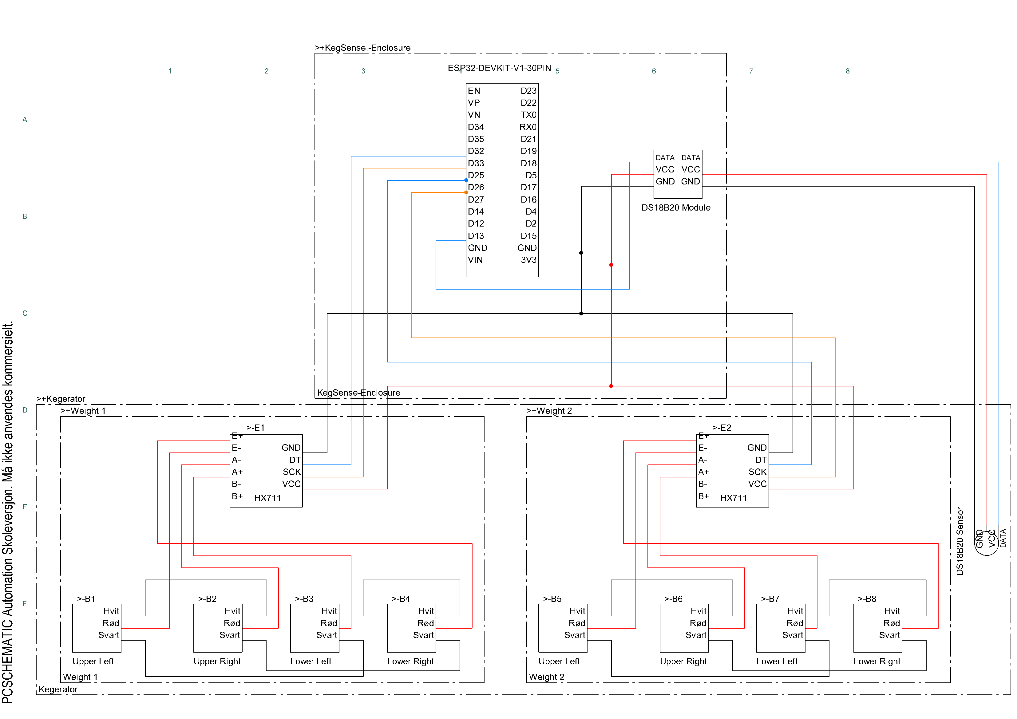
Figure A-1. KegSense wiring schematic.

