Звіт
Лабораторна робота 1
ОБ’ЄКТНО-ОРІЄНТОВАНЕ ПРОГРАМУВАННЯ
Большаков Андрій MIT-31
https://github.com/Utilka/OOP_labs_Univ
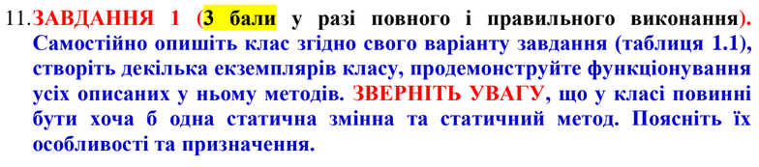
class Safe:
counter = 0
def __init__(self, password):
"""
create new instance of safe
increases safe counter
by default state is set to Open (True)
:type password: object
"""
self.password = password
self.opened_state = True
Safe.counter += 1
def open(self, password):
"""
open safe, change state to Open (True)
password argument must match password stored in safe's memory
:type password: object
"""
if (self.password == password):
self.opened_state = True
else:
raise Exception("cant open safe: incorrect password")
def close(self):
"""close safe, change state to Closed (False)"""
self.opened_state = False
def set_password(self, new_password):
"""
set new password for safe
will only work if this safe is opened
:type new_password: object
"""
if (self.opened_state == True):
self.password = new_password
else:
raise Exception("cant change password: safe is not opened")
@staticmethod
def beep():
"""this static method is here only for the sake of the assignment"""
return "beep-boop"
if __name__ == '__main__':
print(f"Safe.counter : {Safe.counter}")
safes = [Safe("123")]
print(f"Safe.counter : {Safe.counter}")
safes = safes + [Safe("1234"),Safe("12345")]
print(f"Safe.counter : {Safe.counter}")
safes[0].close()
print(f"Safe_0.opened_state : {safes[0].opened_state}")
print(f"Safe_2.opened_state : {safes[2].opened_state}")
safes[0].open("123")
print(f"Safe_0.opened_state : {safes[0].opened_state}")
safes[0].set_password("qwerty")
print(f"Safe_0.password : {safes[0].password}")
print(f"Safe_2.password : {safes[2].password}")

$ python3 main.py
Safe.counter : 0
Safe.counter : 1
Safe.counter : 3
Safe_0.opened_state : False
Safe_2.opened_state : True
Safe_0.opened_state : True
Safe_0.password : qwerty
Safe_2.password : 12345
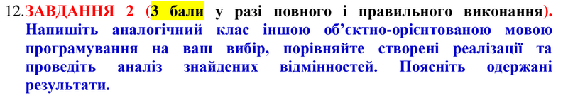
class Safe
attr_accessor :counter, :opened, :password
@@counter = 0
# create new instance of safe
# increases safe counter
# by default state is set to Open (True)
# @param [Object] password
def initialize(password)
@password = password
@opened = true
@@counter += 1
end
# open safe, change state to Open (True)
# password argument must match password stored in safe's memory
# @param [Object] password
def open(password)
if @password == password
@opened = true
else
raise StandardError.new("cant open safe: incorrect password")
end
end
# close safe, change state to Closed (False)
def close()
@opened = true
end
# set new password for safe
# will only work if this safe is opened
# @param [Object] new_password
def set_password(new_password)
if @opened
@password = new_password
else
raise StandardError.new("cant change password : safe is not opened")
end
end
# this static method is here only for the sake of the assignment
def self.beep()
"" "" ""
return "beep-boop"
end
def self.counter
@@counter
end
end
if __FILE__ == $0
puts("Safe.counter : #{Safe.counter}")
safes = [Safe.new("123")]
puts("Safe.counter : #{Safe.counter}")
safes = safes + [Safe.new("1234"), Safe.new("12345")]
puts("Safe.counter : #{Safe.counter}")
safes[0].close()
puts("Safe_0.opened_state : #{safes[0].opened}")
puts("Safe_2.opened_state : #{safes[2].opened}")
safes[0].open("123")
puts("Safe_0.opened_state : #{safes[0].opened}")
safes[0].set_password("qwerty")
puts("Safe_0.password : #{safes[0].password}")
puts("Safe_2.password : #{safes[2].password}")
end
$ ruby main.rb
Safe.counter : 0
Safe.counter : 1
Safe.counter : 3
Safe_0.opened_state : false
Safe_2.opened_state : true
Safe_0.opened_state : true
Safe_0.password : qwerty
Safe_2.password : 12345

