Звіт
Лабораторна робота 2
ОБ’ЄКТНО-ОРІЄНТОВАНЕ ПРОГРАМУВАННЯ
Большаков Андрій MIT-31
https://github.com/Utilka/OOP_labs_Univ

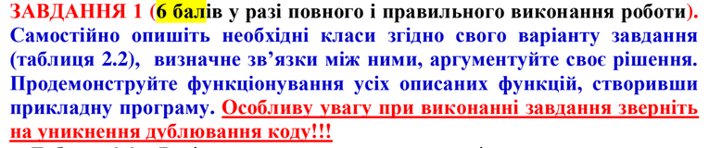
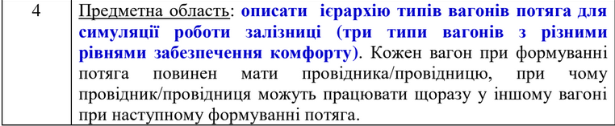
у нас есть 2 связи
связь между Train и PassengerCar,FreightCar агрегация
связь между RailroadsConductor и PassengerCar агрегация

class Car:
def __init__(self, wheel_width, width, height, length):
self.wheel_width = wheel_width
self.width = width
self.height = height
self.length = length
class PassengerCar(Car):
def __init__(self, wheel_width, width, height, length, passenger_count, railroads_conductor, ticket_price):
Car.__init__(self, wheel_width, width, height, length)
self.passenger_count = passenger_count
self.railroads_conductor = railroads_conductor
self.ticket_price = ticket_price
class CoupeCar(PassengerCar):
def __init__(self, railroads_conductor):
PassengerCar.__init__(self, 100, 120, 360, 6 * 360, 40, railroads_conductor, 50)
class EconomyCar(PassengerCar):
def __init__(self, railroads_conductor):
PassengerCar.__init__(self, 100, 60, 360, 6 * 360, 100, railroads_conductor, 20)
class FreightCar(Car):
def __init__(self, wheel_width, width, height, length, volume):
Car.__init__(self, wheel_width, width, height, length)
self.volume = volume
class RailroadsConductor:
def __init__(self, name):
self.name = name
class Train:
def __init__(self, name, engine, car_list):
Train._check_cars(car_list)
self.car_list = car_list
self.engine = engine
self.name = name
@staticmethod
def _check_cars(car_list):
car_target_wheel_width = car_list[0].wheel_width
for car in car_list:
if car_target_wheel_width != car.wheel_width:
raise Exception("Not all cars have same wheel_width")
def _check_departure_ready(self):
for car in self.car_list:
if isinstance(car, PassengerCar):
if not isinstance(car.railroads_conductor, RailroadsConductor):
raise Exception("Not all cars have railroads_conductor assigned")
def depart(self):
self._check_departure_ready()
print(f"Train {self.name} departed")
if __name__ == '__main__':
conductors = [RailroadsConductor("Kevin"), RailroadsConductor("Melanie")]
cars = [CoupeCar(conductors[0]), CoupeCar(conductors[1]), EconomyCar(conductors[1]), EconomyCar(conductors[1]),
FreightCar(100, 60, 360, 6 * 360, 1000)]
train = Train("Big Alice", "WHT", cars)
train.depart()
/usr/bin/python3.8 /home/utilka/Personal/productivity_stuff/univer/sem_6/OOP/OOP_labs_Univ/lab_2/main.py
Train Big Alice departed

Process finished with exit code 0

