**Data Integration with AVEVA PI System and CONNECT Data Services**

5 min read

Oct 31, 2024 2:00:00 PM

Welcome back to our [Data Storage Deep Dive Series](https://blog.softwaretoolbox.com/topic/data-storage-deep-dive), where we continue to explore innovative ways to integrate our industrial automation software solutions with enterprise-level historians. In one of our previous posts of this series, [Software Toolbox Helps You Fly Higher with Canary Historian](https://blog.softwaretoolbox.com/data-storage-deep-dive-solutions-with-canary-historian), we demonstrated how data from diverse sources could be collected using TOP Server, OmniServer and Cogent DataHub, and subsequently funneled into Canary Historian for advanced trend analysis.

Today, we’re shifting our focus to AVEVA PI System (formerly known as OSIsoft PI), a widely used data repository, and how it can be used alongside AVEVA CONNECT to gain even more value from your industrial data. This blog will showcase how you can leverage the Cogent DataHub to seamlessly integrate data into your PI System, and from there, to CONNECT Data Services, unlocking cloud-based capabilities such as visualization and advanced analytics options for your organization.

**Connecting Industrial Data to AVEVA PI Systems**

[Cogent DataHub](https://softwaretoolbox.com/datahub/opc-da-ua-ae-database-iot-excel-data-integration-middleware) stands out in the industrial landscape, offering robust, real-time, bi-directional communication between industrial networks and other systems. A key feature of Cogent DataHub is its [External Historian functionality](https://softwaretoolbox.com/datahub/historian-integration-to-aveva-osi-amazon-influx-rest-azure-apache), with connectors for Amazon Kinesis, AVEVA Historian, AVEVA Insight, Azure Event Hubs, InfluxDB, AVEVA PI and more. Using the RESTful PI Web API for our AVEVA PI connector simplifies real-time data transfer from industrial sources to the AVEVA PI system. This seamless and secure method allows for direct historical data storage without the need for intermediate steps or extra software.



Setting up this connection is easy. Simply select the OSIsoft PI (former name) as the Historian Type within the External Historian configuration, assign it a custom name (Label), and point it to the appropriate PI Web API URL. After specifying the name of the PI Data Server and configuring the necessary authentication, all you need to do is choose the point(s) to log. For our example we're using a slightly older installation of PI from 2018 (which showcases the backwards compatibility of our Historian Connector!), but you can do the same thing with the latest versions of PI as well.

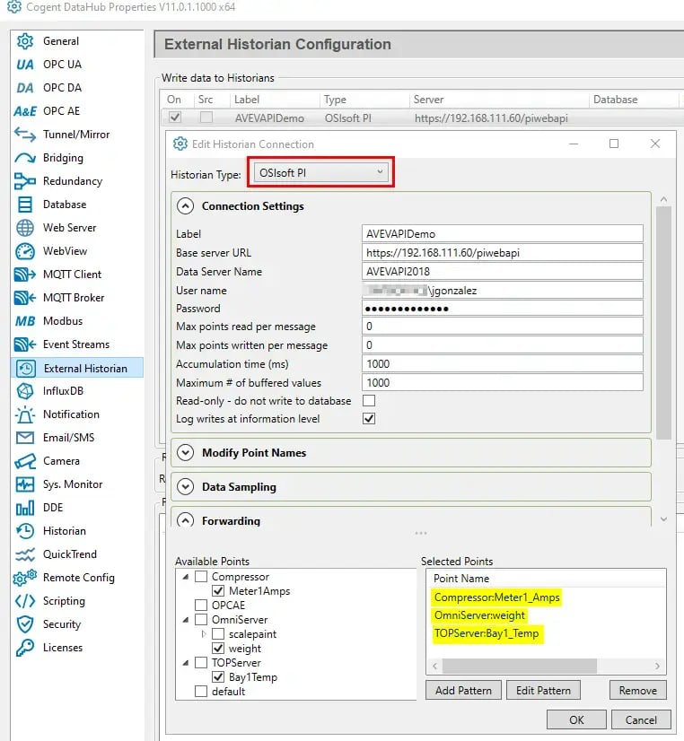

Once the configuration is applied and the connection has a “Running” status, the selected points are automatically created in the PI System. This eliminates the need to manually create PI points using the Point Builder in the PI System Management Tools (SMT). You can easily verify this by searching for the tags in the SMT Archive Editor, where the newly created tags will appear, ready to use.

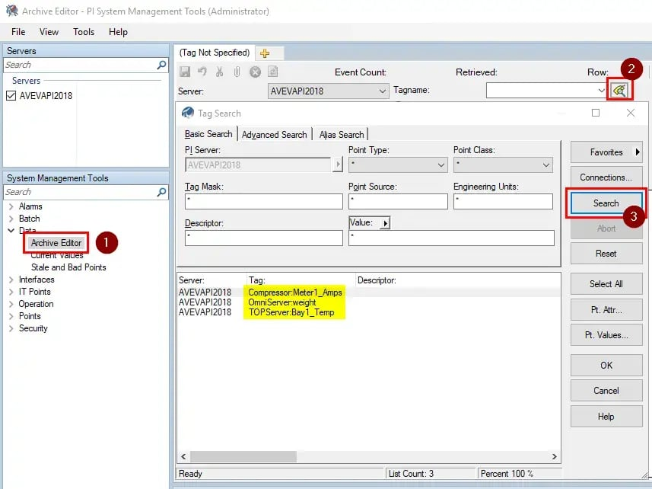

Finally, by selecting one of the tags, we can confirm it's being successfully logged and stored in the PI Data Archive from Cogent DataHub, ensuring real-time data is securely captured for historical analysis.

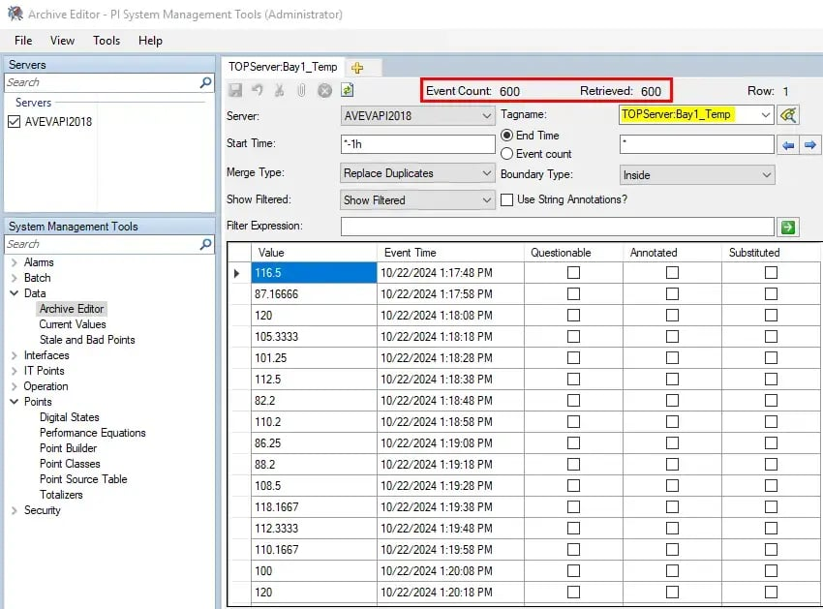

**Expanding Data Access with AVEVA CONNECT**

Storing data in the AVEVA PI Systems is just the beginning of realizing the full value of your industrial data. AVEVA CONNECT expands this by offering cloud-based tools for remote access, visualization and advanced analytics, enabling seamless data transfer via the PI to CONNECT Agent.

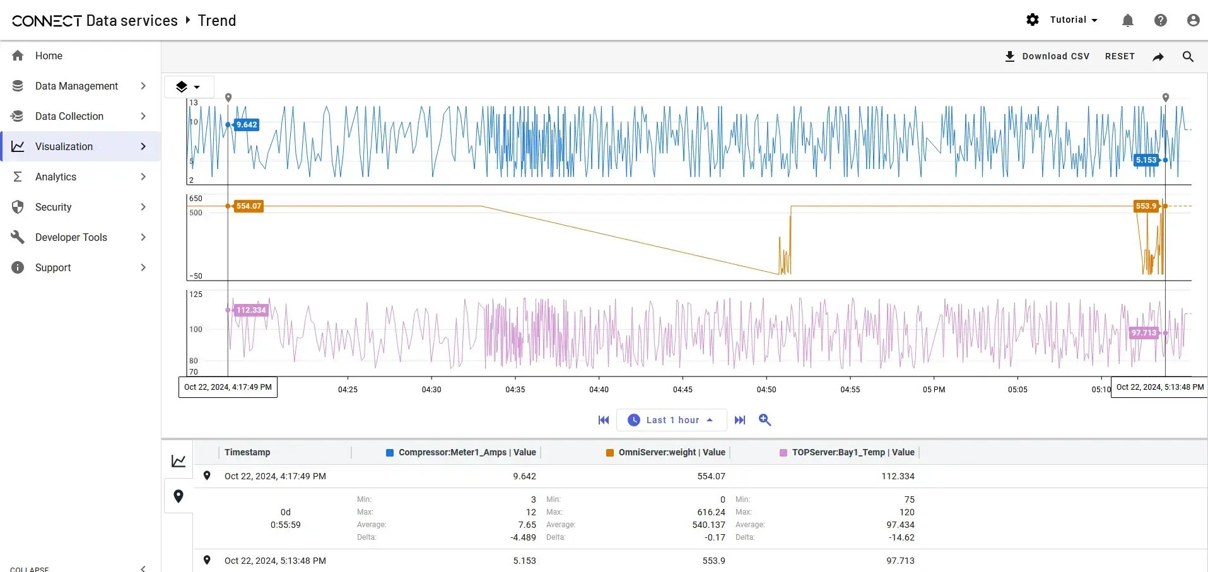

However, the true power of this setup rests with Cogent DataHub and its External Historian connector, which plays a critical role in streamlining data integration and delivering real-time data to PI Systems using the PI Web API.

DataHub ensures rapid data throughput of up to 20,000 writes per second with millisecond precision and guarantees data continuity with its built-in [Store-and-Forward capabilities](https://softwaretoolbox.com/datahub/store-forward-data-historian-logging-mqtt-iot), so no data is lost during network disruptions. Acting as an [OPC UA HDA server](https://products.softwaretoolbox.com/datahub/historian-integration-to-aveva-osi-amazon-influx-rest#opc-hda-client), DataHub also provides easy access to historical data for both immediate insights and long-term analysis.

When paired with [DataHub’s Tunneller feature](https://softwaretoolbox.com/datahub/secure-opc-da-ae-ua-ac-proxy-dmz-friendly-data-tunneling), this solution enables secure data transmission across networks without the need for VPNs or open firewall ports. Data is securely transferred through proxy servers and DMZs, ensuring reliable access across multiple locations while maintaining security.

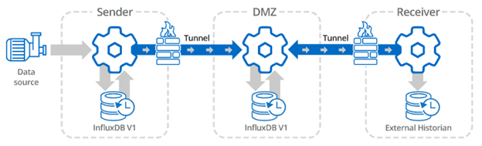

**Takeaway**

The integration of Cogent DataHub with AVEVA PI Systems and AVEVA CONNECT offers a powerful solution for managing and utilizing industrial data. By leveraging DataHub’s External Historian feature, real-time data from diverse sources can be securely logged into AVEVA PI Systems for long-term storage. This setup simplifies the process of transferring data by automating the creation of PI tags, ensuring seamless data flow without requiring complex manual configurations.

Additionally, AVEVA CONNECT extends the value of this data by enabling cloud-based visualization and advanced analytics, unlocking deeper insights and more accessible remote access. With features like the DataHub Tunneller for secure data transmission across networks, Cogent DataHub ensures that industrial data is reliably captured, stored and analyzed, providing a robust scalable solution for modern industrial operations.

At Software Toolbox, our mission is to provide solutions that are compatible and flexible, allowing you to extract maximum value from your existing and expanding infrastructure. If you have questions or need assistance with your data integration journey, our team is here to help.

[Contact us today](https://info.softwaretoolbox.com/ask-a-question) to start the conversation around how we can help you achieve your industrial automation business goals! Be sure to also [subscribe to our blog](https://info.softwaretoolbox.com/blog-subscribe) for future technical how-to's, video tutorials, and more!

Ready to get started securely pushing data to your External Historians with built-in Store and Forward? [Download Cogent DataHub today!](https://softwaretoolbox.com/datahub/free-trial)

Written by [John Gonzalez](https://blog.softwaretoolbox.com/author/john-gonzalez)