1. **Algorithm for Processing a Customer Order at a Restaurant**

1. Greet the customer

2. Explain the available menu

 3. Take the main dish order

4. Mention any special preferences the customer may have in the order

5. Proceed with the main order if the customer has no special preferences

6. Read the order to the customer to ensure it is correct

7. Proceed to generate the bill, which includes the price of the main dish and any add-ons

8. Give the customer a copy of the bill to review

9. Receive payment

10. Forward the order details to the kitchen

11. Hand over the order to the customer when it is ready

**1. Psuedocode for Processing a Customer Order at a Restaurant**

1. START
2. Print "GREETINGS" ,menu card
3. Input main order
4. Print "Do you want add-ons"
5. Input Yes/No
6. If Yes
7. Input addons
8. Else IF continue
9. Print "Your order is ", main order , addons
10. Process Bill
11. Print Bill
12. Input Cash
13. If Cash==Bill
14. Then Continue
15. ELSE Repeat Input Cash
16. Print wait time
17. Forward order to Kitchen
18. Output Order when ready
19. END

**1. Flowchart for Processing a Customer Order at a Restaurant**

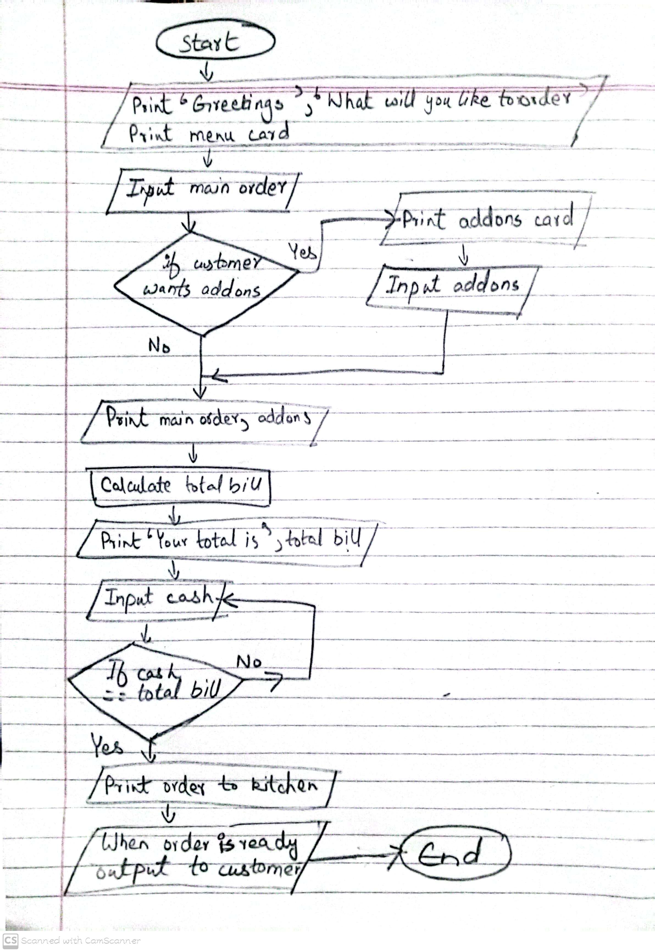

**2. ALGORITHM FOR DEPOSIT TRANSACTION REQUEST AT BANK**

1. START
2. greet customer
3. ask whether the customer wants to request for deposit
4. Input: Account Number and Deposit Amount
5. verify the account number
6. if valid then continue
7. else end
8. verify the deposit amount
9. if less than equals to zero then end
10. else continue
11. update account balance by adding the deposit amount to current balance
12. Print the receipt
13. Print deposit amount and new balance
14. END

**2. PSEUDOCODE FOR DEPOSIT TRANSACTION REQUEST AT BANK**

START

Print "enter valid account number and amount that you want to deposit."

Input account number, deposit amount

if account number is valid

if account number is invalid THEN

Print "Invalid Account"

END

if deposit amount is positive

if deposit amount <= 0 THEN

Print "Invalid Deposit Amount"

END

**2. FLOWCHART FOR DEPOSIT TRANSACTION REQUEST AT BANK**

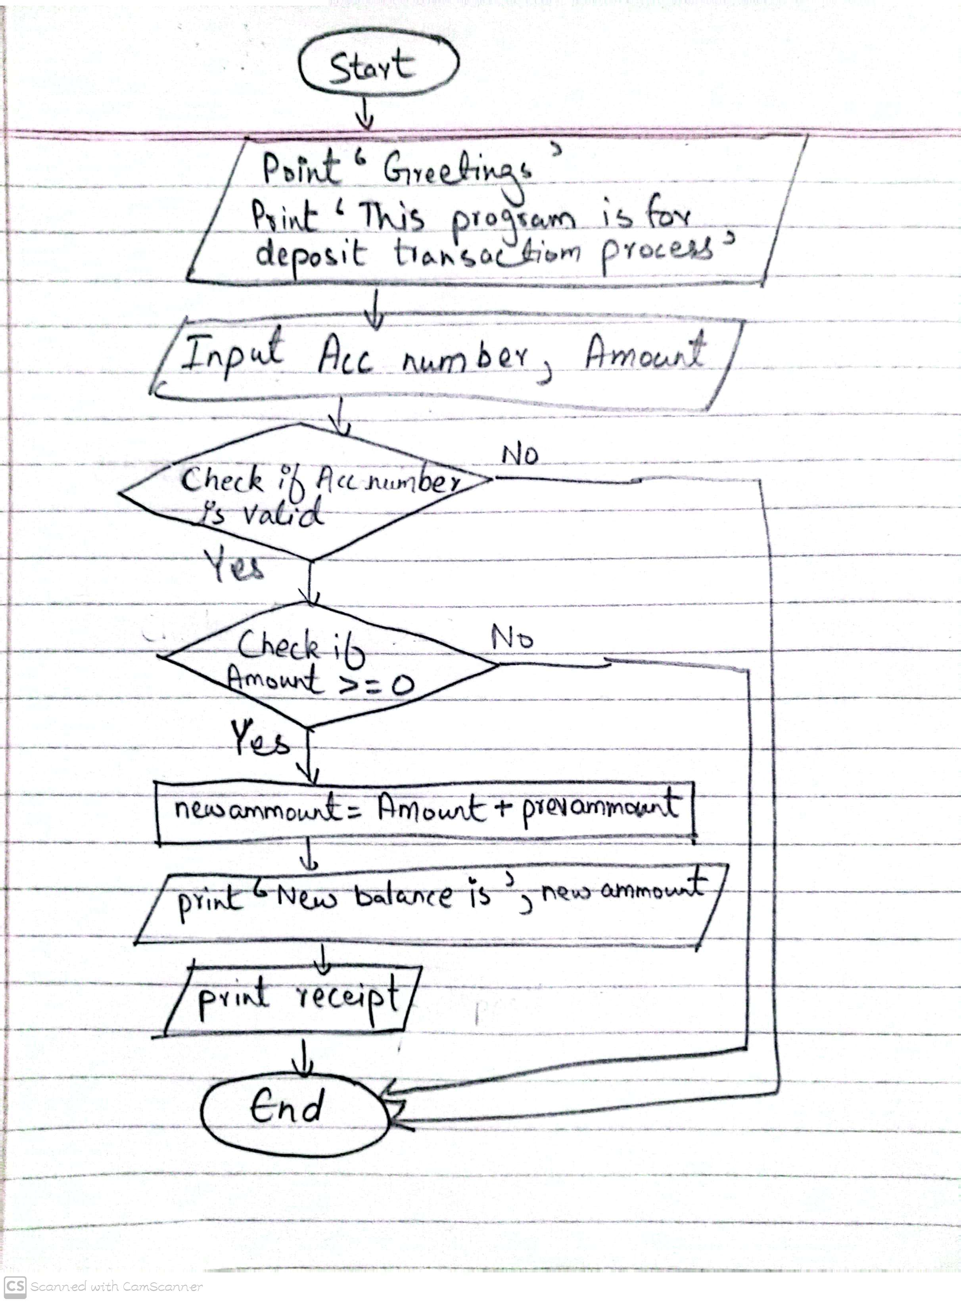

3. **PSEUDOCODE TO FIND GREATEST OF 3 NUMBERS**

START

INPUT num1, num2, num3

IF num1 > num2 THEN

IF num1 > num3 THEN

PRINT "num1 is the greatest"

ELSE

PRINT "num3 is the greatest"

ELSE

IF num2 > num3 THEN

PRINT "num2 is the greatest"

ELSE

PRINT "num3 is the greatest"

ENDIF

END

3. **ALGORITHM TO FIND GREATEST OF 3 NUMBERS**

START

Input 3 Numbers as three different variables

Compare Num 1 with Num2

If Num1 is greater then

Compare Num1 with Num3

If Num 1 is greater then

Output Num1 is Greatest

Else Compare Num 3 with Num2

If Num3 is greater then

Output Num3 is Greatest

Else Output Num2 is the greatest

END

3. **FLOWCHART TO FIND GREATEST OF 3 NUMBERS**

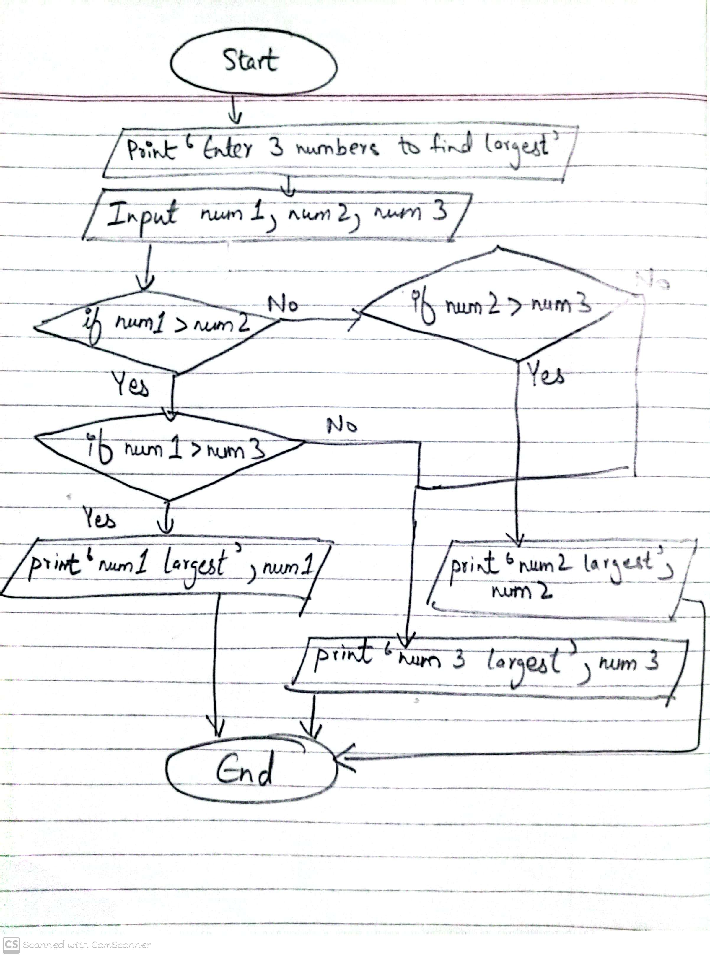

4. **ALGORITHM TO PRINT MONTH NAME FOR INPUT NUMBER**

START  
  
ask customer to input numbers between 1 to 12  
any number except it will lead to restart of program  
store input in variable month number   
then create 12 conditions of if loop  
to Print month name from Jan to Dec for subsequent month number from 1 to 12  
like if month number = to 1 Print January  
repeat the if conditon till December  
  
END

5. **PSEUDOCODE FOR SIMPLE PLUS MINUS**

START

Print "Enter the first number:"

Input num1

Print "Enter the second number:"

Input num2

Print "Enter the operator (+ or -):"

Input operator

IF operator == "+" THEN

Sum = num1 + num2

Print "The result of", num1, "+", num2, "is", sum

ELSE IF operator == "-" THEN

Left = num1 - num2

Print "The result of", num1, "-", num2, "is", Left

ELSE

Print "Invalid operator. Please enter + or -."

ENDIF

END

TO BE CONTINUED

6. **FLOW CHART OF CAR ASSEMBLING**

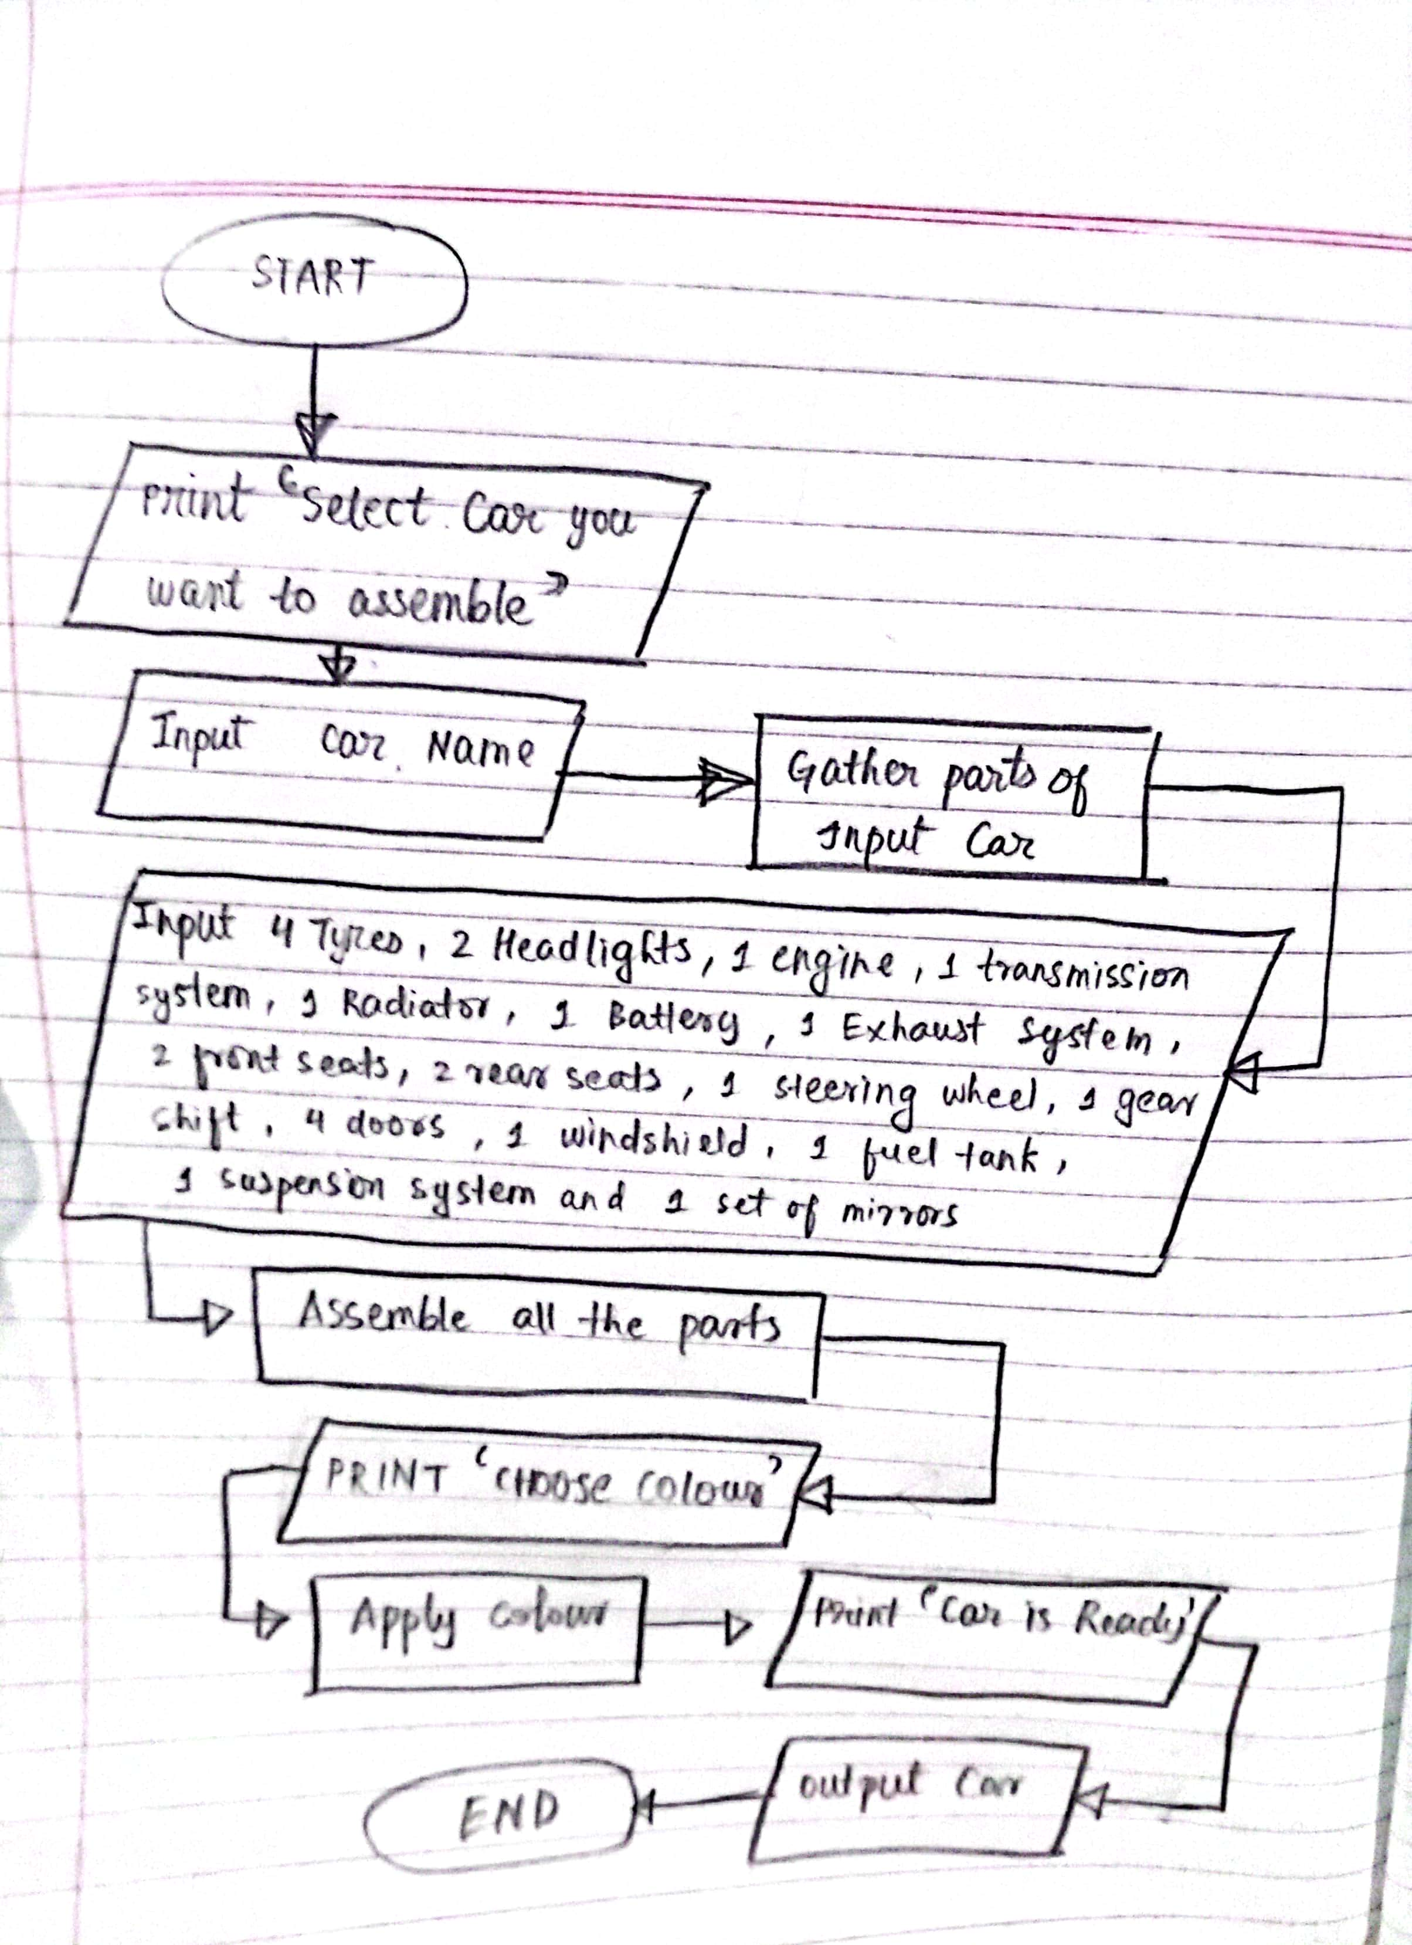

7. **ALGORITHM FOR SIMPLE CALCULATOR**

Start

Output enter num1 and num2

Take inputs for num1,num2

Output operators + , - , * , /

Input operator

End program if any other operator is input

If operator is +

Then ans = num1+num2

Print “ans is”, ans

If operator is -

Then ans = num1-num2

Print “ans is”, ans

If operator is *

Then ans = num1*num2

Print “ans is”, ans

If operator is /

Then ans = num1/num2

Print “ans is”, ans

END IF

End

9. **USE OF GITNORE**

We use .gitnore to remove or hide unnecessary files from our repository so that github cannot track those files like stops GitHub control over those files also it reduces the size of our repository , So that repository becomes more manageable and free from unwanted files.

**10. DIFFERENCE BETWEEN ALGORITHMS AND PSEUDOCODE**

Algorithm: An algorithm is a finite series of precise, step-by-step instructions to carry out a given operation or resolve a specific issue. It describes the logical steps that must be taken to arrive at the intended result.

Pseudocode: Pseudocode is a technique for creating algorithms that outline the stages in a logical, comprehensible manner by combining plain language with syntax resembling programming. By acting as a bridge between the algorithm and the actual code, it facilitates comprehension and allows for easier translation into programming languages.