Online Buzz Prediction on Twitter

Let's take a look on the data.

## NCD AI AS_NA BL NAC AS_NAC  
## 1 -0.2965941 -0.3183059 -0.3480090 -3.438032 -0.3055790 -0.3184644  
## 2 -0.2968246 -0.3187991 -0.3488366 -3.438032 -0.3058017 -0.3187956  
## 3 -0.2975161 -0.3202787 -0.3511123 -3.438032 -0.3064697 -0.3211135  
## 4 -0.2965941 -0.3183059 -0.3506986 -2.461761 -0.3055790 -0.3207823  
## 5 -0.2965941 -0.3183059 -0.3506986 -2.461761 -0.3055790 -0.3207823  
## CS AT NAO ADL NAD MNAD  
## 1 -3.491975 -0.7240877 -0.3289477 -0.7310262 -0.2970117 -0.2701534  
## 2 -3.491975 -0.7240877 -0.3292478 -0.7310262 -0.2972420 -0.2708395  
## 3 -3.491975 -0.7240877 -0.3301479 -0.7310262 -0.2979327 -0.2674093  
## 4 -2.509767 -0.5579229 -0.3289477 -0.5762051 -0.2970117 -0.2701534  
## 5 -2.509767 -0.5579229 -0.3289477 -0.5762051 -0.2970117 -0.2694674

## Multicollinearity Diagnostics

# Correlation matrix

## NCD AI AS_NA BL NAC AS_NAC  
## NCD 1.000000000 0.876236015 0.89758018 0.1192051 0.998569740 0.92298806  
## AI 0.876236015 1.000000000 0.89014213 0.1261385 0.876632001 0.79003421  
## AS_NA 0.897580184 0.890142133 1.00000000 0.1390026 0.903897369 0.94278881  
## BL 0.119205063 0.126138464 0.13900259 1.0000000 0.121554932 0.12629570  
## NAC 0.998569740 0.876632001 0.90389737 0.1215549 1.000000000 0.92595796  
## AS_NAC 0.922988061 0.790034209 0.94278881 0.1262957 0.925957963 1.00000000  
## CS 0.115929347 0.122998215 0.13594199 0.9938652 0.118781652 0.12352554  
## AT 0.011992586 0.019067626 0.02071662 0.1353892 0.015979654 0.01767762  
## NAO 0.948988382 0.955667590 0.94845748 0.1306123 0.953580007 0.87933906  
## ADL 0.003219328 0.009612417 0.01127623 0.1128369 0.008519014 0.01015258  
## NAD 0.999997908 0.876288000 0.89789521 0.1193148 0.998660489 0.92316402  
## CS AT NAO ADL NAD  
## NCD 0.1159293 0.01199259 0.948988382 0.003219328 0.999997908  
## AI 0.1229982 0.01906763 0.955667590 0.009612417 0.876288000  
## AS_NA 0.1359420 0.02071662 0.948457478 0.011276227 0.897895209  
## BL 0.9938652 0.13538920 0.130612277 0.112836862 0.119314832  
## NAC 0.1187817 0.01597965 0.953580007 0.008519014 0.998660489  
## AS_NAC 0.1235255 0.01767762 0.879339061 0.010152581 0.923164018  
## CS 1.0000000 0.17758982 0.127659030 0.161672297 0.116068425  
## AT 0.1775898 1.00000000 0.018570140 0.976031343 0.012136599  
## NAO 0.1276590 0.01857014 1.000000000 0.009599617 0.949212146  
## ADL 0.1616723 0.97603134 0.009599617 1.000000000 0.003393779  
## NAD 0.1160684 0.01213660 0.949212146 0.003393779 1.000000000

Most of the features are highly correlated. We can see that these features have a lot of common information. -NCD AI AS_NA NAC AS_NAC NAO NAD -CS BL -AT ADL

So,we need to eliminate features which donot add much variance to the data. For that,let's look at the VIF table as well.

## Variables VIF  
## 1 NCD 9.400885e+05  
## 2 AI 2.560414e+01  
## 3 AS_NA 1.774426e+02  
## 4 BL 9.598035e+01  
## 5 NAC 1.761030e+03  
## 6 AS_NAC 1.594218e+02  
## 7 CS 9.678539e+01  
## 8 AT 1.737452e+01  
## 9 NAO 2.909138e+02  
## 10 ADL 1.821024e+01  
## 11 NAD 1.001314e+06

An ideal VIF value is 1. So,any feature having vif value close to 1 is significant. A range of 1-5 for the VIF value is preferred. After 5, the feature is not considered significant. As we can see, our features lie nowhere near VIF value of 1.

So,this suggests that our features are highly correlated. And hence,we would have to run Principal Component Analysis on our data because neither correlation table nor VIF analysis is sufficient to differentiate between significant and insignificant features.

# PCA analysis

For PCA,data needs to be: scaled all numeric and without missing values

features <- train[-c(12)]  
prin_comp <- prcomp(features,scale. = T)  
prin_comp$x[1:5,]

## PC1 PC2 PC3 PC4 PC5 PC6  
## 1 -1.300026 4.061074 2.708136 -0.015378687 -0.025980288 -0.0004283566  
## 2 -1.300917 4.061007 2.708084 -0.015192968 -0.025574276 -0.0003792301  
## 3 -1.303957 4.060775 2.707907 -0.015251053 -0.023932738 -0.0008631072  
## 4 -1.157174 2.940816 1.882166 -0.006298887 -0.002266547 0.0010149047  
## 5 -1.157174 2.940816 1.882166 -0.006298887 -0.002266547 0.0010149047  
## PC7 PC8 PC9 PC10 PC11  
## 1 -0.04917162 0.0008117568 -0.01982261 0.002866512 3.591461e-05  
## 2 -0.04916839 0.0005789146 -0.01983245 0.002841919 3.604363e-05  
## 3 -0.04917318 0.0004874458 -0.01983983 0.002843028 3.627732e-05  
## 4 -0.04608215 -0.0002825231 -0.01755560 0.001265933 1.239030e-05  
## 5 -0.04608215 -0.0002825231 -0.01755560 0.001265933 1.239030e-05

dim(prin_comp$x)

## [1] 138861 11

Now,let’s plot the resultant principal components.

biplot(prin_comp,scale = 0)

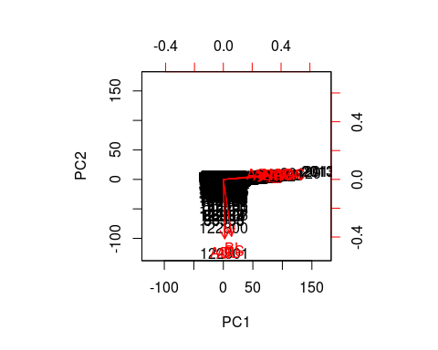 We can see that PC1 and PC2 both come from some features which are marked red. i.e. PC1 = a1x1 + a2x2 + a3x3 (say) and PC2 = b1x4 + b2x5 + b3x6 (say) Basically,PCA's are the resulatant of the correlated features.

Now,let's calculate the variance contribution of every principal component as we aim to find the components which explain the maximum variance. This is because, we want to retain as much information as possible using these components. So, higher is the explained variance, higher will be the information contained in those components.

std_dev <- prin_comp$sdev  
pr_var <- std_dev^2  
prop_varex <- (pr_var/sum(pr_var))*100  
prop_varex

## [1] 5.983751e+01 2.045092e+01 1.521456e+01 2.266109e+00 1.615689e+00  
## [6] 2.895581e-01 2.212197e-01 5.170297e-02 4.098495e-02 1.173542e-02  
## [11] 5.106242e-06

As we can see,PCA1 contributes app. 59% of the variance and hence is the most important feature. For more meaningful inference,we make a scree plot. A scree plot is used to access components or factors which explains the most of variability in the data. It represents values in descending order.

plot(prop_varex, xlab = "Principal Component",  
 ylab = "Proportion of Variance Explained",  
 type = "b")

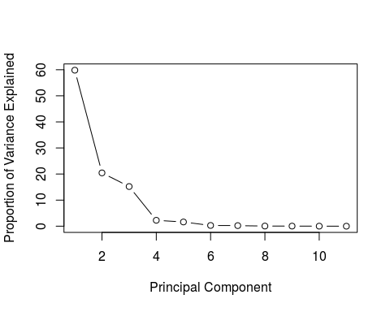

Here we can see that 6 components approximately 98% variance in the dataset. For the confirmation check,let's plot a cumulative variance plot.

plot(cumsum(prop_varex), xlab = "Principal Component",  
 ylab = "Cumulative Proportion of Variance Explained",  
 type = "b")

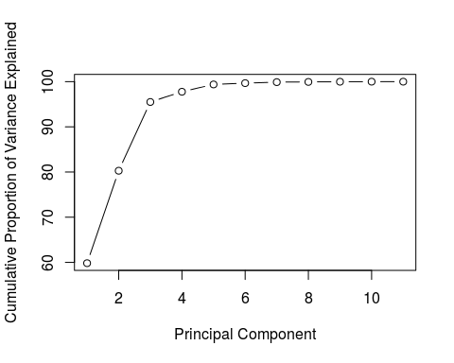

The graph clearly shows that we should select 6 features which explains almost 98% of the data. Hence,we will choose 6 variables from PC1 to PC6 for our model and continue further.

pca_data <- data.frame(prin_comp$x[,c(1:6)])  
pca_data$MNAD <- train$MNAD  
pca_data[1:5,]

## PC1 PC2 PC3 PC4 PC5 PC6  
## 1 -1.300026 4.061074 2.708136 -0.015378687 -0.025980288 -0.0004283566  
## 2 -1.300917 4.061007 2.708084 -0.015192968 -0.025574276 -0.0003792301  
## 3 -1.303957 4.060775 2.707907 -0.015251053 -0.023932738 -0.0008631072  
## 4 -1.157174 2.940816 1.882166 -0.006298887 -0.002266547 0.0010149047  
## 5 -1.157174 2.940816 1.882166 -0.006298887 -0.002266547 0.0010149047  
## MNAD  
## 1 -0.2701534  
## 2 -0.2708395  
## 3 -0.2674093  
## 4 -0.2701534  
## 5 -0.2694674

Now,our training data looks like above. Let's do the correlation and VIF analysis on this.

cor(pca_data[-c(7)])

## PC1 PC2 PC3 PC4 PC5  
## PC1 1.000000e+00 -1.957974e-17 -4.799278e-17 -2.214892e-15 2.239723e-15  
## PC2 -1.957974e-17 1.000000e+00 4.231617e-15 -5.402840e-17 3.604642e-16  
## PC3 -4.799278e-17 4.231617e-15 1.000000e+00 3.281163e-16 -4.279334e-16  
## PC4 -2.214892e-15 -5.402840e-17 3.281163e-16 1.000000e+00 -1.736649e-15  
## PC5 2.239723e-15 3.604642e-16 -4.279334e-16 -1.736649e-15 1.000000e+00  
## PC6 6.544796e-15 8.091517e-17 -6.454170e-16 8.597299e-16 1.035518e-15  
## PC6  
## PC1 6.544796e-15  
## PC2 8.091517e-17  
## PC3 -6.454170e-16  
## PC4 8.597299e-16  
## PC5 1.035518e-15  
## PC6 1.000000e+00

vif(pca_data[-c(7)])

## Variables VIF  
## 1 PC1 1.278656  
## 2 PC2 1.046930  
## 3 PC3 1.046625  
## 4 PC4 1.199276  
## 5 PC5 1.163193  
## 6 PC6 1.240137

As we can see, VIF values are close to 1 and correlation matrix also shows that features are independent. Now, our features are scaled and independent. Let's apply a regression model now.

## General multiple regression model

model=lm(MNAD~.,pca_data)  
summary(model)

##   
## Call:  
## lm(formula = MNAD ~ ., data = pca_data)  
##   
## Residuals:  
## Min 1Q Median 3Q Max   
## -42.059 -0.011 0.003 0.012 70.624   
##   
## Coefficients:  
## Estimate Std. Error t value Pr(>|t|)   
## (Intercept) 0.0141252 0.0011358 12.44 <2e-16 ***  
## PC1 0.3914790 0.0004427 884.31 <2e-16 ***  
## PC2 0.0409386 0.0007572 54.06 <2e-16 ***  
## PC3 0.0283823 0.0008779 32.33 <2e-16 ***  
## PC4 0.3241814 0.0022748 142.51 <2e-16 ***  
## PC5 0.2675612 0.0026941 99.31 <2e-16 ***  
## PC6 0.1291322 0.0063639 20.29 <2e-16 ***  
## ---  
## Signif. codes: 0 '***' 0.001 '**' 0.01 '*' 0.05 '.' 0.1 ' ' 1  
##   
## Residual standard error: 0.4232 on 138854 degrees of freedom  
## Multiple R-squared: 0.8547, Adjusted R-squared: 0.8547   
## F-statistic: 1.361e+05 on 6 and 138854 DF, p-value: < 2.2e-16

Here,we get an adjusted- R-square value of 0.8547 and all the features are significant as well. Now, our model seems good. But, we can still drop a variable to check if our model improves or not. For that,we can use methods of regression for propagating back-and-forth.

# METHODS OF REGRESSION

1.Forward Selection Method 2.Backward Elimination Method 3.Stepwise Method

For our analysis,we have considered Backward elimination method.

bmodel <- step(model, direction = "backward", trace=TRUE )

## Start: AIC=-238788.8  
## MNAD ~ PC1 + PC2 + PC3 + PC4 + PC5 + PC6  
##   
## Df Sum of Sq RSS AIC  
## <none> 24872 -238789  
## - PC6 1 74 24946 -238380  
## - PC3 1 187 25059 -237750  
## - PC2 1 524 25396 -235898  
## - PC5 1 1767 26639 -229262  
## - PC4 1 3638 28510 -219836  
## - PC1 1 140075 164947 23917

summary(bmodel)

##   
## Call:  
## lm(formula = MNAD ~ PC1 + PC2 + PC3 + PC4 + PC5 + PC6, data = pca_data)  
##   
## Residuals:  
## Min 1Q Median 3Q Max   
## -42.059 -0.011 0.003 0.012 70.624   
##   
## Coefficients:  
## Estimate Std. Error t value Pr(>|t|)   
## (Intercept) 0.0141252 0.0011358 12.44 <2e-16 ***  
## PC1 0.3914790 0.0004427 884.31 <2e-16 ***  
## PC2 0.0409386 0.0007572 54.06 <2e-16 ***  
## PC3 0.0283823 0.0008779 32.33 <2e-16 ***  
## PC4 0.3241814 0.0022748 142.51 <2e-16 ***  
## PC5 0.2675612 0.0026941 99.31 <2e-16 ***  
## PC6 0.1291322 0.0063639 20.29 <2e-16 ***  
## ---  
## Signif. codes: 0 '***' 0.001 '**' 0.01 '*' 0.05 '.' 0.1 ' ' 1  
##   
## Residual standard error: 0.4232 on 138854 degrees of freedom  
## Multiple R-squared: 0.8547, Adjusted R-squared: 0.8547   
## F-statistic: 1.361e+05 on 6 and 138854 DF, p-value: < 2.2e-16

As we can see,no features are rejected in the steps of backward-elimination method. Thus,we can conclude that our model will include all of the 6 variables. Now,let's take a look at the coefficients and confidence intervals of the features.

# Coefficients

## (Intercept) PC1 PC2 PC3 PC4 PC5   
## 0.01412517 0.39147901 0.04093860 0.02838228 0.32418139 0.26756121   
## PC6   
## 0.12913215

# Confidence Intervals

## 2.5 % 97.5 %  
## (Intercept) 0.01189910 0.01635124  
## PC1 0.39061133 0.39234668  
## PC2 0.03945442 0.04242279  
## PC3 0.02666154 0.03010301  
## PC4 0.31972273 0.32864004  
## PC5 0.26228083 0.27284159  
## PC6 0.11665900 0.14160531

As we can see,all the coefficients lie in the confidence interval.

Hence,our equation is # MNAD = 0.39147901*PC1 + 0.04093860*  PC2 + 0.02838228 * PC3 + 0.32418139 * PC4 + 0.26756121 * PC5 + 0.12913215 * PC6 + 0.01412517

Now,let's get to the prediction part. For prediction,we should not use PCA on train and test separately as their variance is unequal which will result in different vector directions. Also,we should not combine the training and test set as we donot want our test set to be used in model building. What we can do is use predict function as shown below.

pc_data_test <- predict(prin_comp,test[-c(12)])  
pc_data_test <- as.data.frame(pc_data_test)  
pc_data_test <- pc_data_test[c(1:6)]  
pc_data_test[1:5,]

## PC1 PC2 PC3 PC4 PC5  
## 138862 -0.9242058 -1.743193 4.503665 0.041880943 0.032483780  
## 138863 -1.1546048 2.941014 1.882318 -0.006670066 -0.003252062  
## 138864 -1.1546048 2.941014 1.882318 -0.006670066 -0.003252062  
## 138865 -1.3027098 4.060876 2.707984 -0.015703194 -0.023869805  
## 138866 -1.1587390 2.940685 1.882066 -0.005417740 -0.002812011  
## PC6  
## 138862 0.0115703087  
## 138863 0.0012153638  
## 138864 0.0012153638  
## 138865 -0.0006873007  
## 138866 0.0008238042

Now,let's predict on the above dataset.

pc_data_test$predicted_MNAD <- predict(model,pc_data_test)  
pc_data_test$MNAD <- test$MNAD  
pc_data_test$residuals <- pc_data_test$MNAD-pc_data_test$predicted_MNAD  
pc_data_test[1:5,7:9]

## predicted_MNAD MNAD residuals  
## 138862 -0.2674591 -0.2708395 -0.003380369  
## 138863 -0.2669284 -0.2708395 -0.003911097  
## 138864 -0.2669284 -0.2701534 -0.003225066  
## 138865 -0.2643190 -0.2701534 -0.005834383  
## 138866 -0.2680943 -0.2701534 -0.002059159

We can see that residuals are very less which explains the accuracy of our model. But,we have to do residual analysis for more accurate results. Let's calculate the variance of residuals.

Se_sq <- sum((pc_data_test$residuals)^2)  
n <- nrow(test)  
p <- 7  
var_res <- Se_sq/(n-p)  
std_res <- sqrt(var_res)  
std_res

## [1] 0.2261814

Now,let's do Standardized Residual Analysis.

pc_data_test$stand_residuals <- pc_data_test$residuals/std_res  
mean(pc_data_test$stand_residuals)

## [1] 0.005919984

var(pc_data_test$stand_residuals)

## [1] 0.9998641

We can see that mean is close to 0 and variance is close to 1. Let's plot them.

plot(pc_data_test$stand_residuals,main = 'Standardized Residuals plot',  
 xlab='Observation no.',ylab = 'residuals')  
abline(h=5,untf = FALSE)  
abline(h=-5,untf = FALSE)

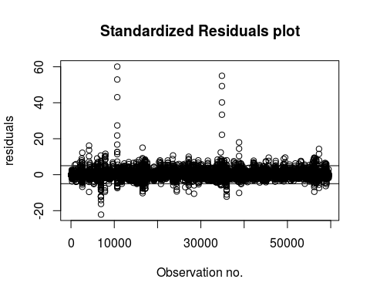

Now,we can say that a large standaradized residual(>5,say) potentially indicates an outlier.

qqnorm(pc_data_test$stand_residuals,  
 ylab="Residuals",  
 xlab="Normal Scores",main="Normal Q-Q plot")   
qqline(pc_data_test$stand_residuals)

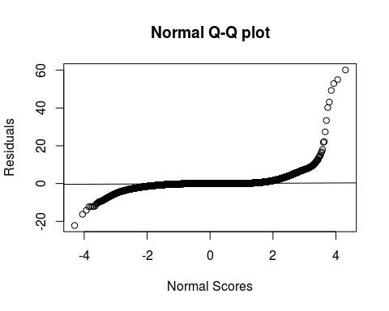

Now,let's plot normal probability plot.

y <- (as.numeric(rownames(pc_data_test))-0.5)/nrow(pc_data_test)  
x <- sort(pc_data_test$stand_residuals,decreasing = FALSE)  
plot(x,y,  
 xlab = 'Standardized residuals',  
 ylab = 'Probability')

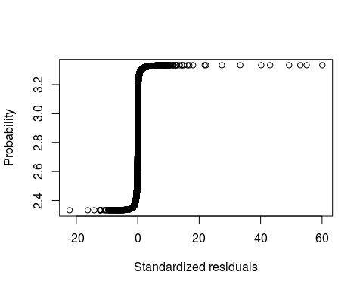 This plot is not ideal as it contains a lot of outliers. Let's take a closer look.

plot(x,y,  
 xlab = 'Standardized residuals',  
 ylab = 'Probability',  
 xlim = c(-1,1))

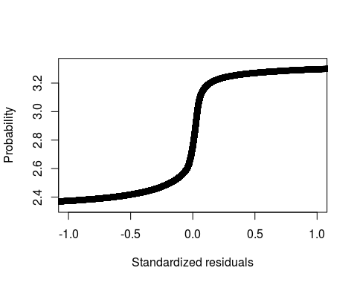 This suggests a light-tailed distribution.