**EC204**

**Digital System Design Lab**

**Lab – 7**

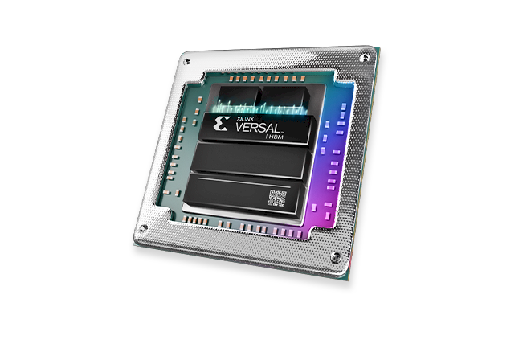

**Utkarsh R Mahajan**

**201EC164**

1] **Decade Counter** - Model a synchronous up/down decade counter with asynchronous reset. The counter is rising edge triggered.

If the **load** = 1, the data **data_in** is loaded into the counter.

If the **counter_on**=**counter_up**=1, the counter is incremented, the Terminal carry output TC=1 when the counter is in state 9.

If the **counter_on**=1 and **counter_up**=0, the counter is decremented, the Terminal carry output **TC**=1 when the counter is in state 0.

-> Verilog code for the counter:

*module* decadeCounter(input counter_up,

input load,

input resetn,

input counter_on,

input clk,

input [3:0] data_in,

output reg [3:0] count,

output reg TC);

always@(negedge resetn, posedge clk)

begin

    if(load) count <= data_in;

    else if(!resetn) begin TC<= 0; count <= 0; end

    else if(counter_on) begin

        if(counter_up) begin

        if(count<9) count <= count + 1;

        else count <= 0;

        if(count==9) TC <=1;

        else TC<=0;

        end else begin

        if(count>0) count <= count - 1;

        else count <= 9;

        if(count==0) TC <=1;

        else TC<=0;

        end

    end

end

*endmodule*

Verilog code for the testbench:

*module* testbench_1();

integer i;

reg clk, counter_on, resetn, load, counter_up;

reg [3:0] data_in;

wire [3:0] count;

wire TC;

decadeCounter d1(counter_up,

load, resetn, counter_on,

clk, data_in, count, TC);

initial

begin

    resetn=1;

    load=0; data_in =4'b1000;

    counter_on=1; counter_up =1;

    for( i=0; i<5; i=i+1)begin

    clk =1; #20; clk =0; #20;

    end

    load =1;

    clk =1; #20; clk =0; #20; load =0;

    counter_up =0;

    for( i=0; i<5; i=i+1)begin

    clk =1; #20; clk =0; #20;

    end

end

*endmodule*

Full Screenshot:

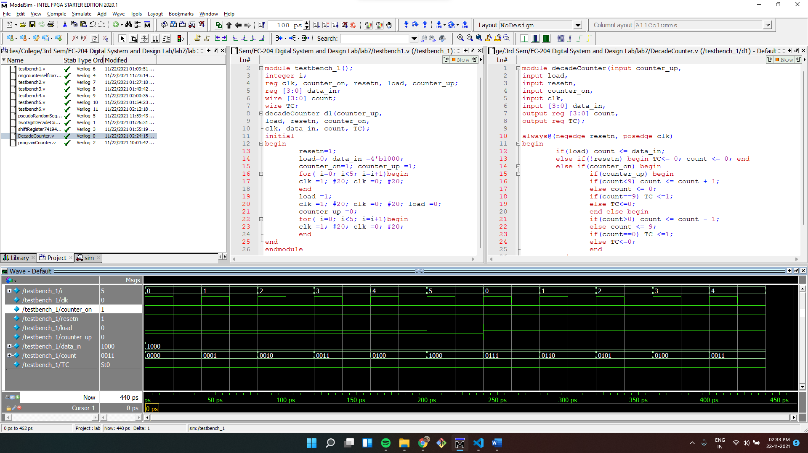

Wave:

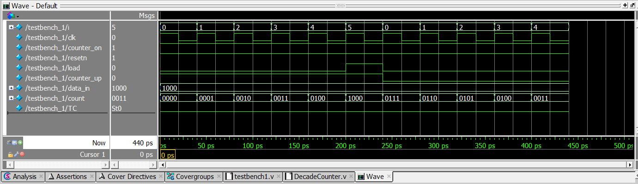

2] Use two decade counter modules to form a two-digit decimal up/down counter.

-> Verilog code for the counter:

*module* twoDigitDecadeCounter(input counter_up,

input load,

input reset,

input counter_on,

input clk,

input [7:0] data_in,

output [7:0] count,

output TC);

wire n1;

decadeCounter cunit(counter_up,

 load,

 reset,

 counter_on,

 clk,

 data_in[3:0],

 count[3:0],

 n1);

decadeCounter cdigit(counter_up,

 load,

 reset,

 counter_on,

 n1,

 data_in[7:4],

 count[7:4],

 TC);

*endmodule*

Verilog code for the testbench:

*module* testbench_2();

integer i;

reg clk, counter_on, resetn, load, counter_up;

reg [7:0] data_in;

wire [7:0] count;

wire TC;

twoDigitDecadeCounter d1(counter_up,

load, resetn, counter_on,

clk, data_in, count, TC);

initial

begin

    resetn=1;#1; resetn=0; #1; resetn=1;

    load=0; data_in =8'b01001000;

    counter_on=1; counter_up =1;

    for( i=0; i<20; i=i+1)begin

    clk =1; #20; clk =0; #20;

    end

    load =1;

    clk =1; #20; clk =0; #20; load =0;

    counter_up =0;

    for( i=0; i<20; i=i+1)begin

    clk =1; #20; clk =0; #20;

    end

end

*endmodule*

Full Screenshot:

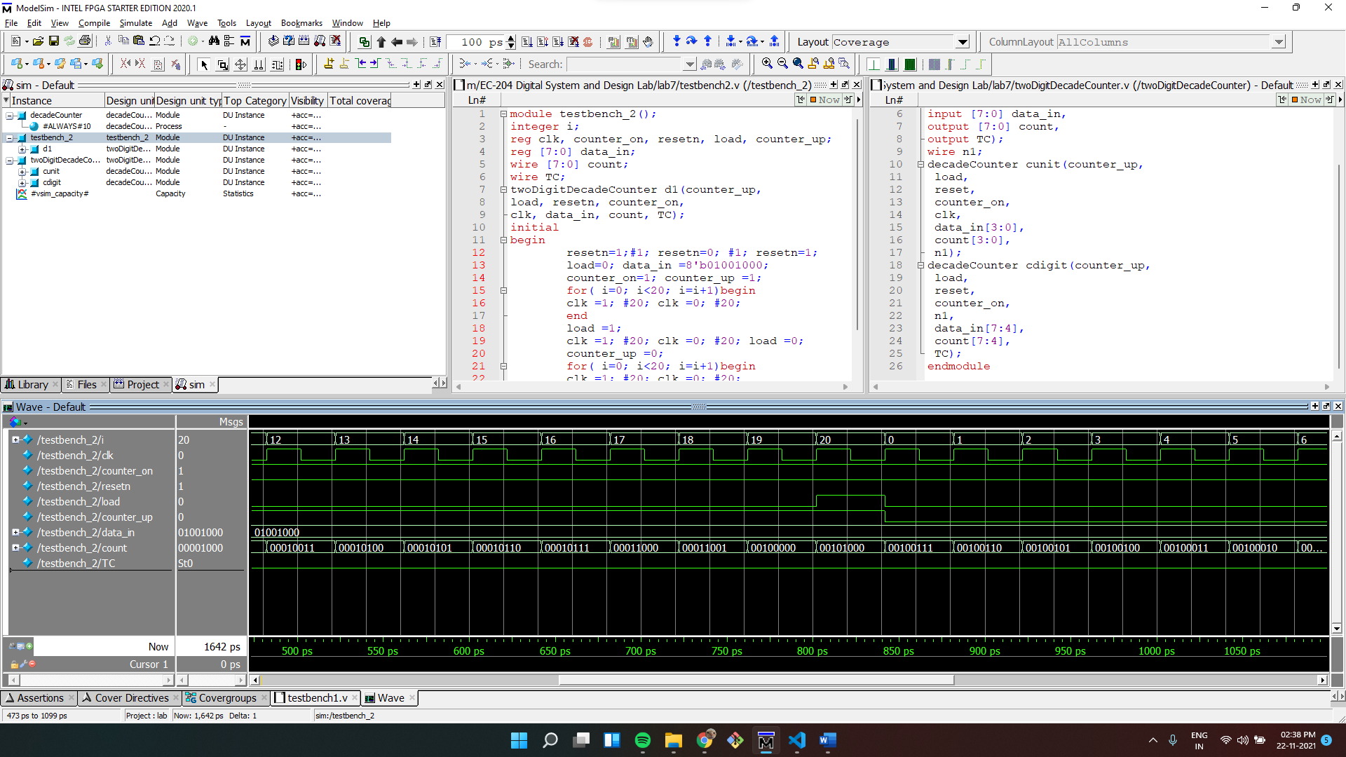

Wave:

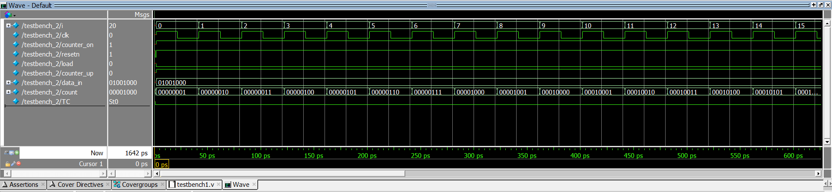

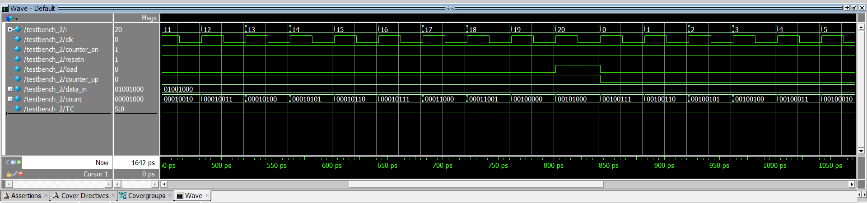

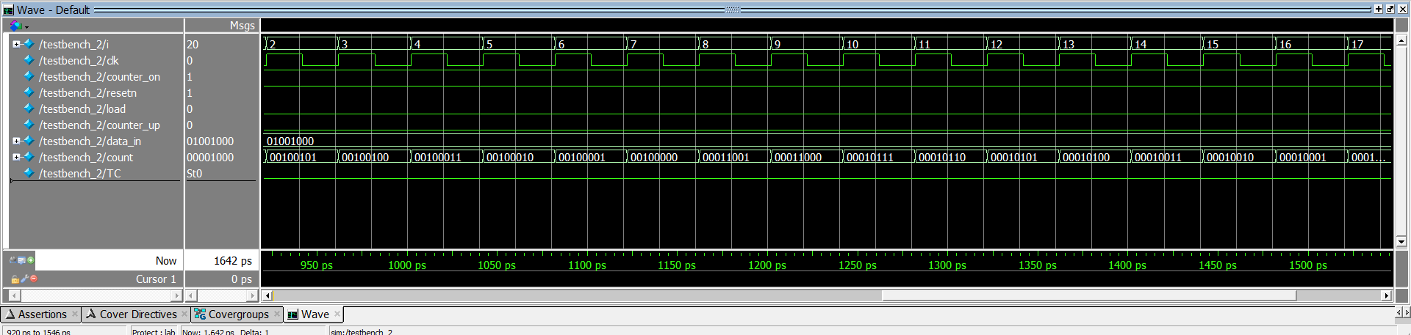

3] Design an n-bit program counter (PC) that has the following functions:

1. It is cleared to 0 when the asynchronous reset is asserted
2. It is loaded a new value in parallel when the PCload is asserted
3. It is incremented by 1 when the PCinc is asserted

We will consider n as 4 for our working example.

-> Verilog code for the Program counter:

*module* programCounter(reset, clk, PCload, PCinc, load_in, PC);

parameter n=4;

input reset, clk, PCload, PCinc;

input [n-1:0] load_in;

output reg [n-1:0] PC;

always @(negedge reset, posedge clk)

begin

    if(!reset) PC <= 0;

    else if (PCload) PC <= load_in;

    else if(PCinc) PC <= PC+1;

end

*endmodule*

Verilog code for the testbench:

*module* testbench_3();

integer i;

reg resetn, clk, PCload, PCinc;

reg [3:0] load_in;

wire [3:0] PC;

programCounter pc1(resetn, clk, PCload, PCinc, load_in, PC);

initial

begin

    resetn=1;#1; resetn=0; #1; resetn=1;

    PCload=0; load_in =4'b0100;

    PCinc=1;

    for( i=0; i<12; i=i+1)begin

    clk =1; #20; clk =0; #20;

    end

    PCload =1;

    clk =1; #20; clk =0; #20; PCload =0;

    for( i=0; i<6; i=i+1)begin

    clk =1; #20; clk =0; #20;

    end

end

*endmodule*

Wave:

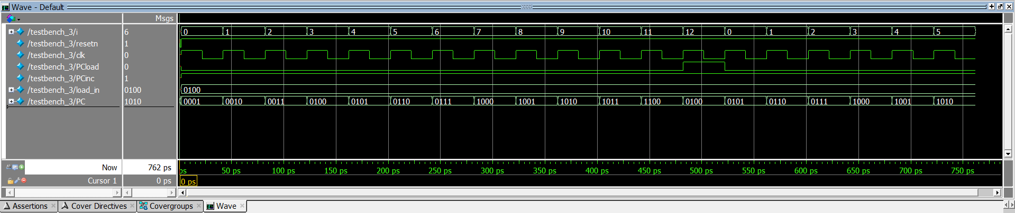

Full Screenshot:

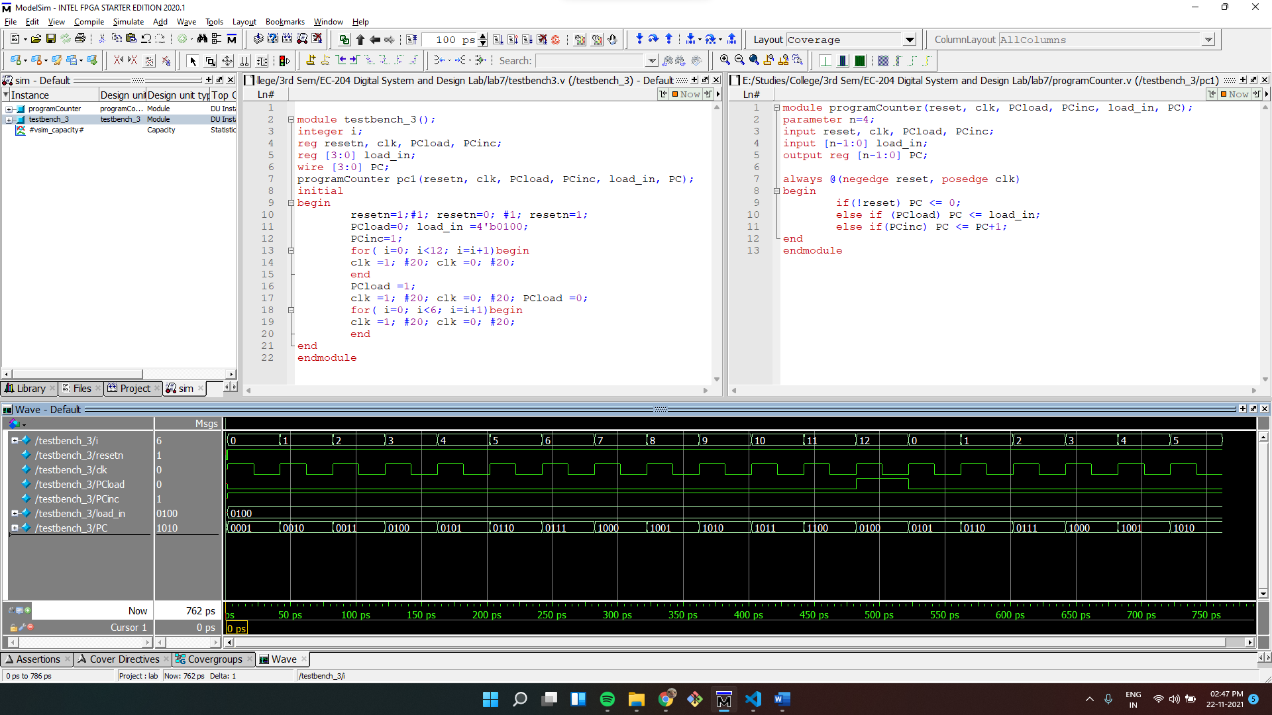

4] Model the functionality of Shift register 74194.

-> Verilog code for the Shift Register:

*module* shiftRegister74194(input MRn, CP, Dsr, Dsl,

  input [1:0]S, input [3:0] P, output reg [3:0] Q);

always@(negedge MRn, posedge CP)

begin

    if(!MRn) Q <= 0;

    else if(S==2'b01) begin

        if(Dsr) Q<= {1'b1, Q[3:1]};

        else  Q<= {1'b0, Q[3:1]};

    end else if(S==2'b10) begin

        if(Dsl) Q<= {Q[2:0], 1'b1};

        else  Q<= {Q[2:0], 1'b0};

    end else if(S==2'b11) Q <= P;

end

*endmodule*

Verilog code for the testbench:

*module* testbench_4();

integer i;

reg clk, MRn, Dsr, Dsl;

reg [1:0] S;

reg [3:0] P;

wire [3:0] Q;

shiftRegister74194 ut(MRn, clk, Dsr, Dsl,

  S, P, Q);

initial

begin

    MRn=1;#1; MRn=0; #1; MRn=1;

    P =4'b1000;

    S=2'b01;

    Dsr=1; Dsl=1;

    for( i=0; i<10; i=i+1)begin

    clk =1; #20; clk =0; #20;

    end

    Dsr=0;

    for( i=0; i<10; i=i+1)begin

    clk =1; #20; clk =0; #20;

    end

    S=2'b11;

    clk =1; #20; clk =0; #20; S=2'b10;

    for( i=0; i<10; i=i+1)begin

    clk =1; #20; clk =0; #20;

    end

    Dsl=0;

    for( i=0; i<10; i=i+1)begin

    clk =1; #20; clk =0; #20;

    end

end

*endmodule*

Wave:

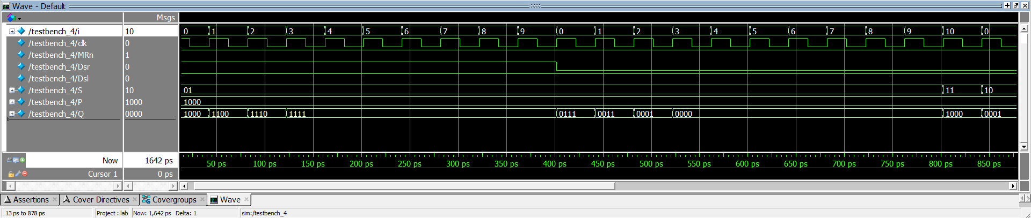

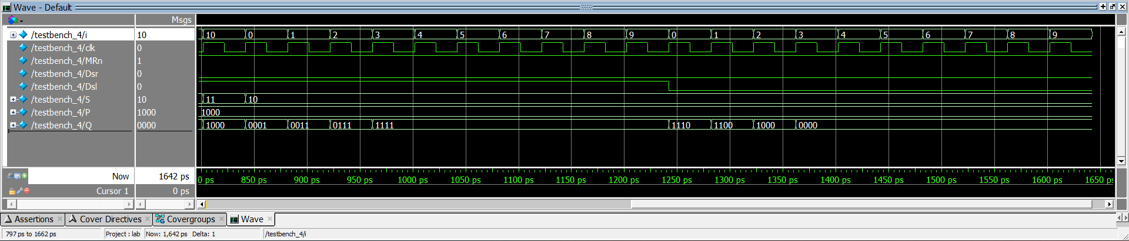

Full Screenshot:

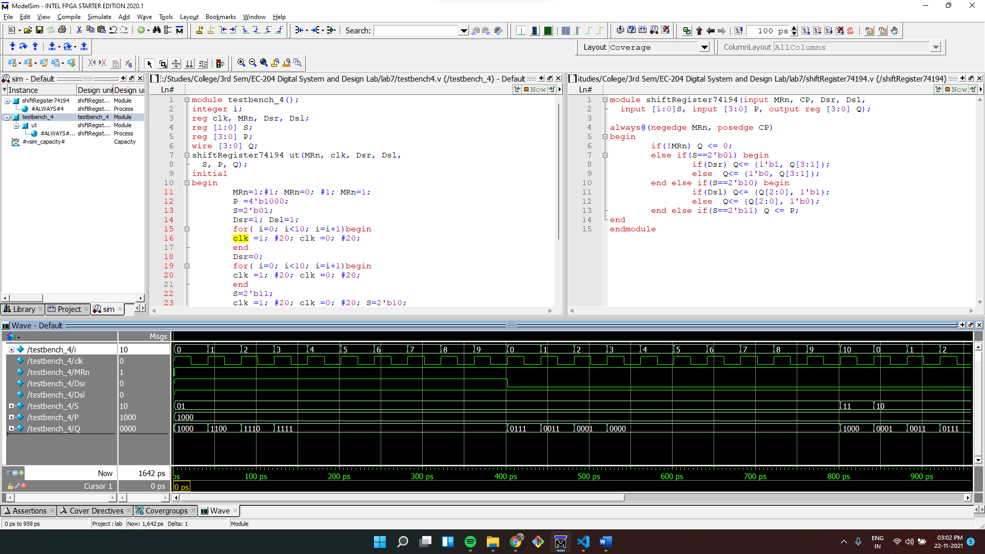

5]Write a Verilog module for a 4 bit self-correcting ring counter.

-> In a self-correcting ring counter, the current state bits resets if they enter a invalid state.

Verilog code for the ring counter:

*module* rignCounterSelfCorrecting(input clk,

 input resetn,

 output reg [3:0] Q);

always @(negedge resetn, posedge clk)

begin

    if(!resetn) Q <= 4'b1000;

    else if(Q==4'b1000 || Q==4'b0100 || Q==4'b0010) Q <= Q >> 1;

    else Q<=4'b1000;

end

*endmodule*

Verilog code for the testbench:

*module* testbench_5();

integer i;

reg resetn, clk;

reg [3:0] load_in;

wire [3:0] Q;

rignCounterSelfCorrecting ut(clk, resetn,Q);

initial

begin

    resetn=1;#1; resetn=0; #1; resetn=1;

    for( i=0; i<12; i=i+1)begin

    clk =1; #20; clk =0; #20;

    end

end

*endmodule*

Wave:

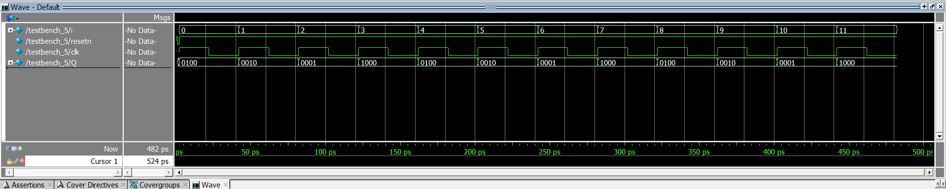

Full Screenshot:

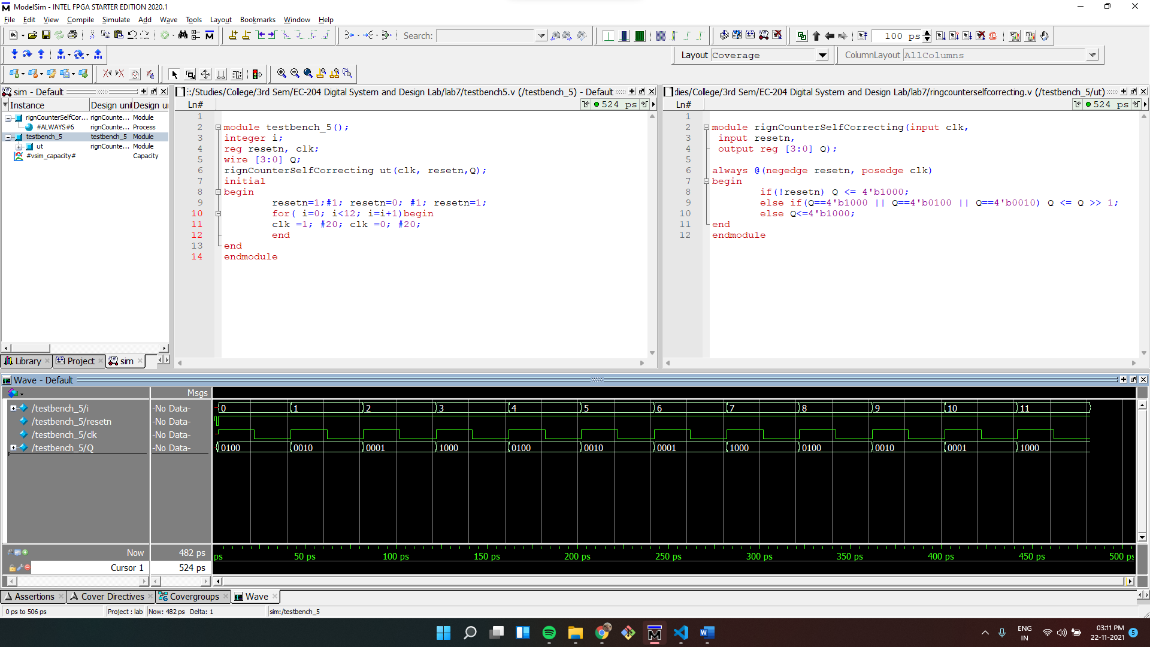

6]Write a Verilog module for a Pseudo random sequence generator for n=8. Primitive polynomial is 1 + 𝑥2 + 𝑥3 + 𝑥4 + 𝑥8.

-> This can be done using xor gates.

Verilog code for the sequence generator:

*module* pseudoRandomSeqGenerator( resetn, clk, Q);

parameter n =8;

input resetn, clk;

output reg [n-1:0] Q;

always @(negedge resetn, posedge clk)

begin

    if(!resetn) Q<={1'b1, {n-2{1'b0}}};

    else begin

        Q <= Q >> 1;

        Q[n-1] <= Q[7] ^ Q[3] ^ Q[2] ^Q[1];

    end

end

*endmodule*

Verilog code for the testbench:

*module* testbench_6();

integer i;

reg resetn, clk;

wire [7:0] Q;

pseudoRandomSeqGenerator ut(resetn, clk, Q);

initial

begin

    resetn=1;#1; resetn=0; #1; resetn=1;

    for( i=0; i<50; i=i+1)begin

    clk =1; #20; clk =0; #20;

    end

end

*endmodule*

Full Screenshot:

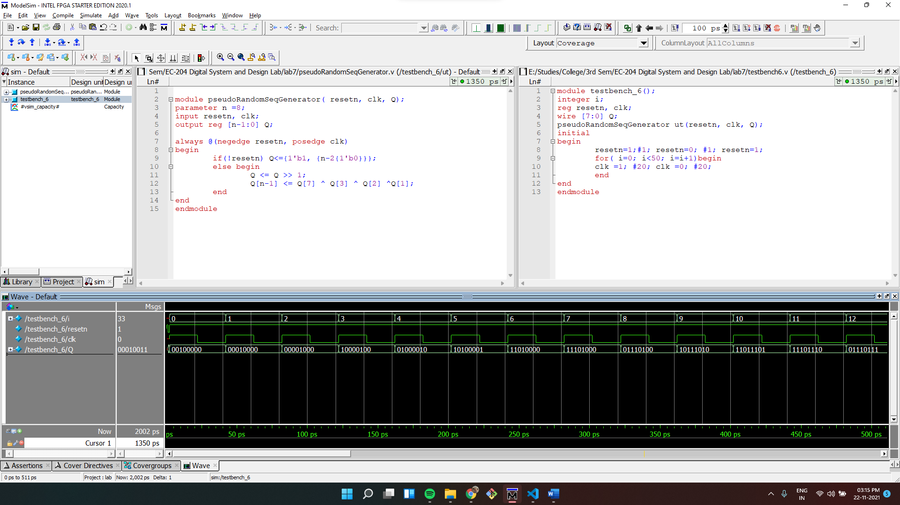

Wave:

