**EC204**

**Digital System Design Lab**

**Lab – 9**



**Utkarsh R Mahajan**

**201EC164**

1] A digital system has a single input X and a single output Y. The system is to analyse each sequence of four binary digits and produce the corresponding 2’s complement of the 4-bit sequence. Assume each 4 bit sequence is occurring with the LSB first. Draw the minimal state diagram for the system and model in Verilog.

e.g. X = 0101000111000100

Z = 0110000110110111

->

To simplify, we will make use of 2 state machines and then link them together.

After analysing the sequence we get the following state diagrams:

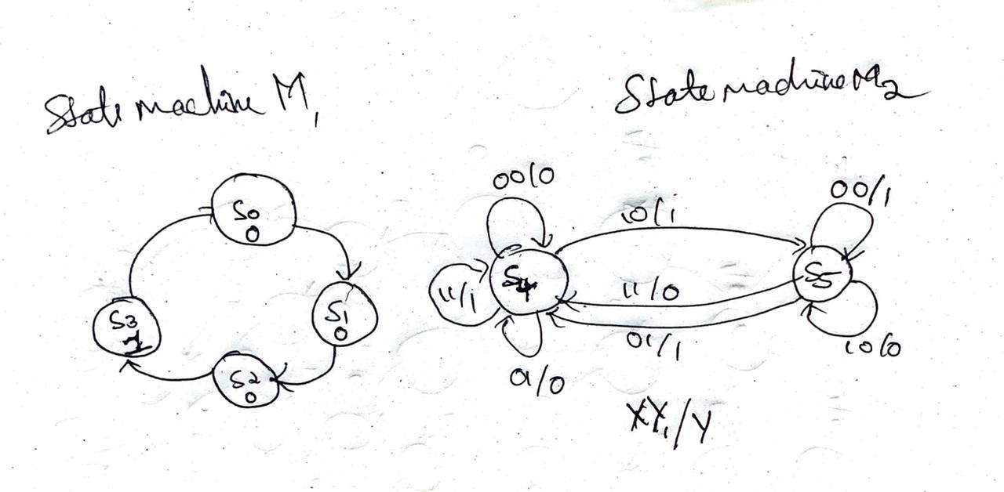

From the following state diagram, we get the following:

Verilog Code:

module comp2gen(

    input X, clk, resetn,

    output reg Y,output reg [2:0] m1cs, m1ns, m2cs, m2ns);

parameter S0=0, S1=1, S2=2, S3=3, S4=4, S5=5;

reg Y1;*// output for the m1 module.*

always @(negedge resetn, posedge clk)*//for changing states every clock cycle or to reset.*

begin

    if(!resetn) begin

    m1cs<= S0; m2cs<= S4; end

    else begin m1cs <= m1ns; m2cs<= m2ns; end

end

always @(m1cs) *// for changing the output for m1 state machine.*

begin

    m1ns =m1cs; Y1= 0; *//default values for m1ns and output Y1 of the m1 state machine.*

    case(m1cs)

    S0: m1ns = S1;

    S1: m1ns = S2;

    S2: m1ns = S3;

    S3: begin

        m1ns = S0;

        Y1=1;

        end

    endcase

end

always @(*) *// for changing the output for m2 state machine.*

begin

    m2ns=m2cs; Y=0; *//default values for m2ns and output Y of the m2 state machine.*

    case(m2cs)

    S4: begin

    Y=X;

    if(X&&~Y1) m2ns=S5; else m2ns=S4;

    end

    S5: begin

    Y=~X;

    if(Y1) m2ns=S4; else m2ns=S5;

    end

    default:m2ns=S4;

    endcase

end

endmodule

Testbench Code:

module testbench1();

reg X, clk, resetn;

wire Y;

wire [2:0] m1cs, m1ns, m2cs, m2ns;

reg [15:0] testinput;

integer i;

comp2gen ut(.X(X),.clk(clk),.resetn(resetn),.Y(Y), .m1cs(m1cs), .m1ns(m1ns), .m2cs(m2cs), .m2ns(m2ns));

initial

begin

    X=0; clk=1;

    resetn=1; #1; resetn=0; #1; resetn=1;

    testinput = 16'b0101000111000100;

    for( i=15; i>=0; i=i-1)begin

        X = testinput[i];

        clk =1; #20;

clk =0; #20;

    end

end

endmodule

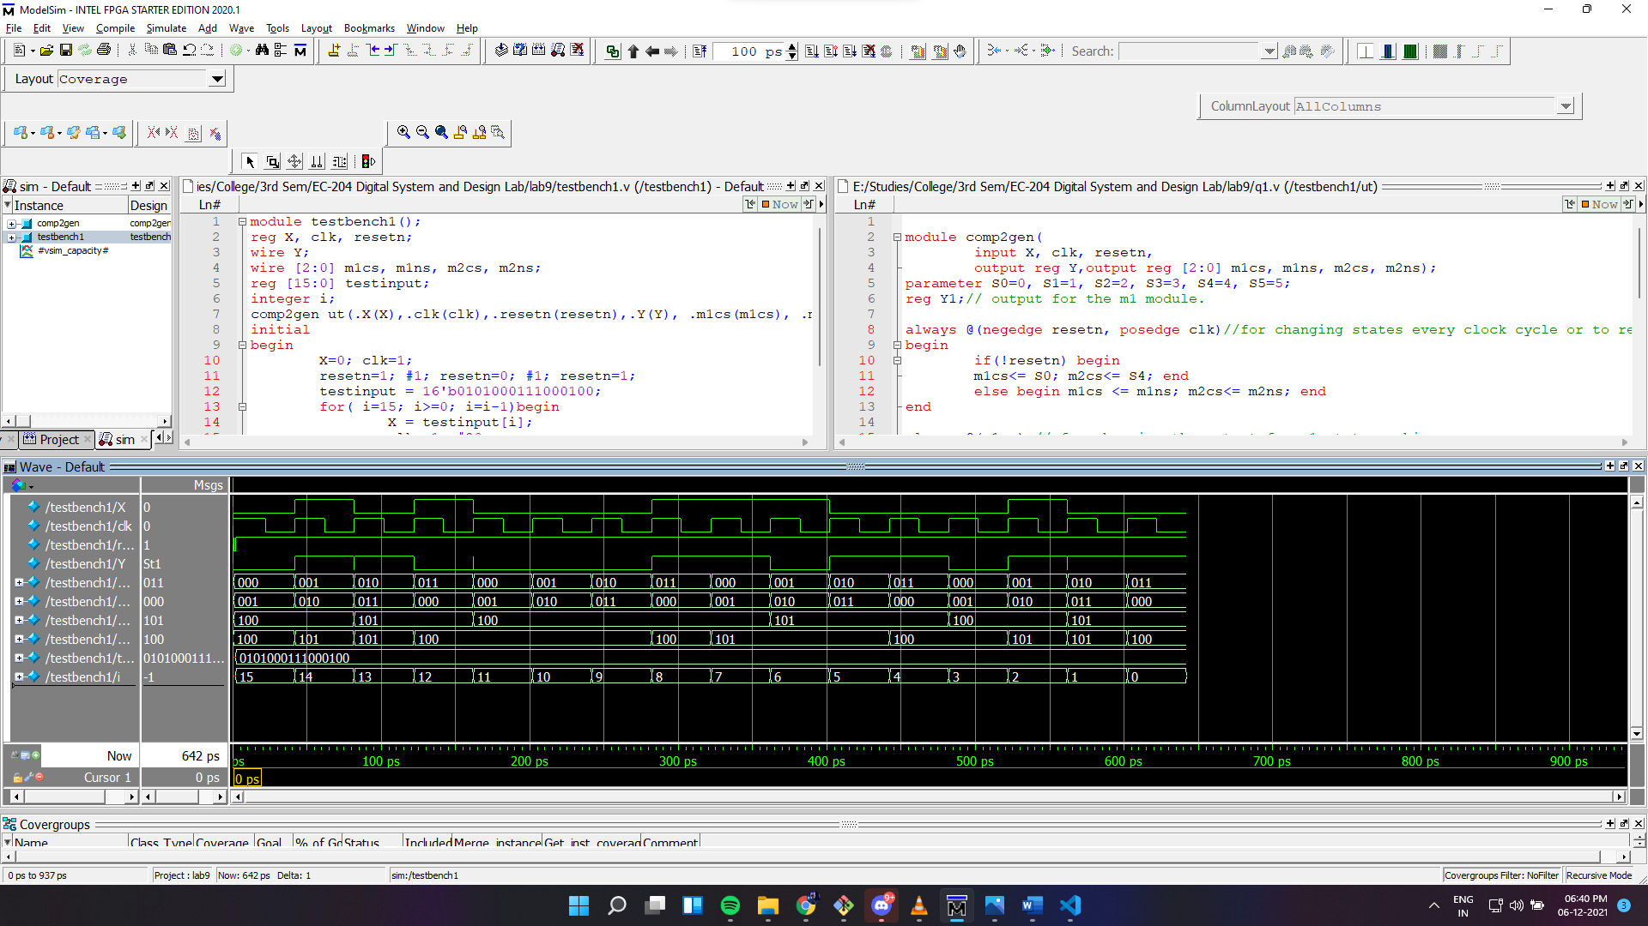

Output wave:

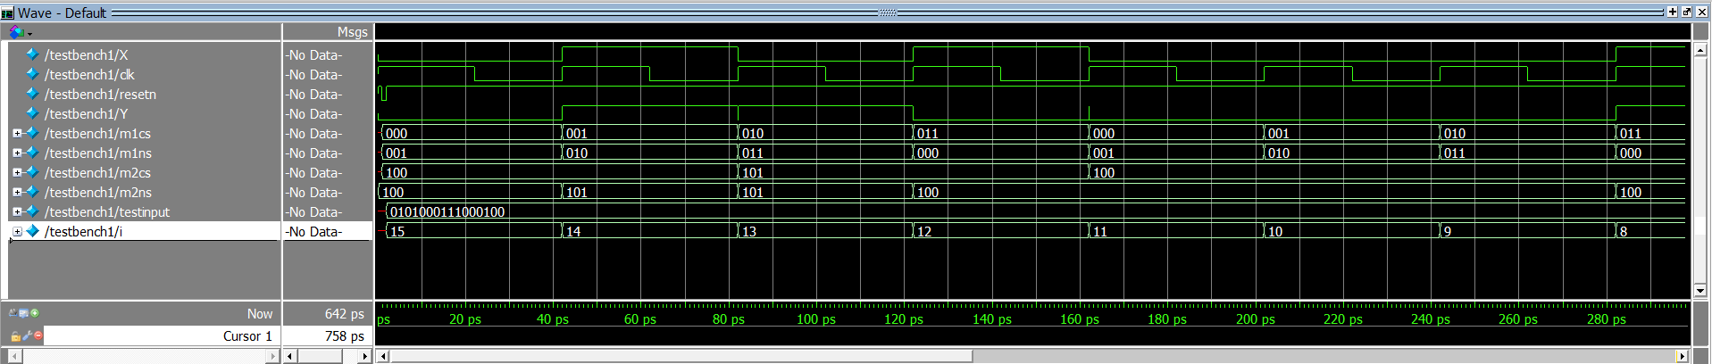

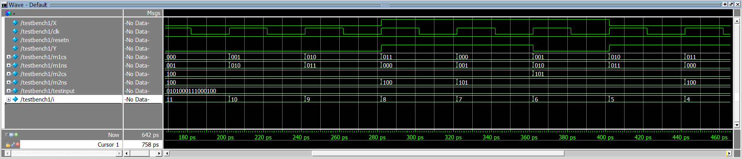

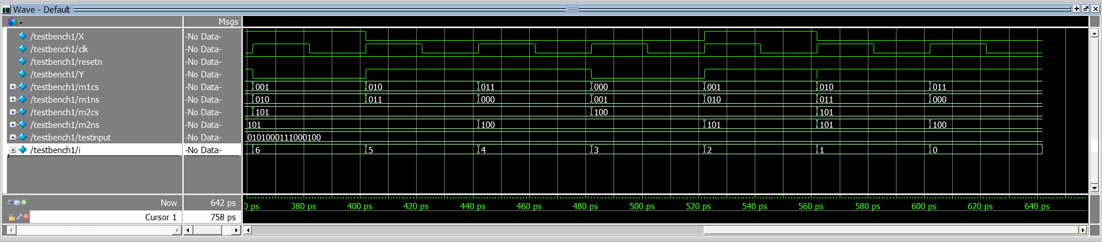

2] Implement a serial adder in Verilog to add two 8 bit numbers using a single full adder and registers

-> for the serial adder we will make use of a D flip flop for storing the carry of each bit. 3 shift registers, 2 for taking inputs and 1 for storing the output sequentially. For the first 8 cycles of clock, it will take input and for the next 8 cycles the output will be computed and shifted to the output shift register. The resetn is a negative edge triggered reset which will set everything to default values.

Register count stores the counts of cycles that have taken place so that after complete calculation of the addition of 8bit numbers it will be active.

*// sum output is at output reg sum and the carry of the sum is at output reg C.*

module serial_adder(

    input ain, bin, clk, start, resetn,

    output reg [7:0] sum, output reg done, output reg c);

*//wires for connecting different modules*

wire [7:0] rxQ, ryQ, rsQ;wire fas, fac, dffc;

reg [3:0] count =4'b1111;

reg [7:0] D =0;

reg load = 0;

*//connecting wires from modules to output registers.*

assign sum = rsQ;

assign c = fac;

shiftreg regX(.D(D), .load(load), .shiftR(!done),.lin(ain), .clk(clk), .Q(rxQ));

shiftreg regY(.D(D), .load(load), .shiftR(!done),.lin(bin), .clk(clk), .Q(ryQ));

shiftreg regSum(.D(D), .load(load), .shiftR(!done),.lin(fas), .clk(clk), .Q(rsQ));

fulladder fa(.a(rxQ[0]), .b(ryQ[0]), .cin(dffc), .sum(fas), .cout(fac));

dff da(.d(fac), .reset(load), .clk(clk), .q(dffc));

*//for decrementing counter and making a reset button for entire module.*

always @(posedge clk, negedge resetn)

begin

    if(!resetn) begin

    load<= 1;

    count<=15;

    done<=0;

    end else if(start) begin

    load<= 0;

    if(count >0) begin done <= 0;

    count<= count -1;

    end

    else done <=1;

    end

end

endmodule

*//single bit full adder module required.*

module fulladder(input a, b, cin, output sum, cout);

    assign sum = cin^(a^b);

    assign cout = (a&b) | cin&(a^b);

endmodule

*// D flip flop*

module dff(input d, reset, clk, output reg q);

    always@(posedge clk, posedge reset)

    begin

    if(reset) q=0;

    else begin

        q=d;

    end

    end

endmodule

*//8 bit shift register with load support.*

module shiftreg (input [7:0]D, input load, shiftR, lin, clk, output reg [7:0]Q);

always @(load)

begin

    if(load) Q<=D;

end

always @(posedge clk)

begin

    if(shiftR) Q <= {lin, Q[7:1]};

end

endmodule

TestBench:

module testbench2();

reg a, b, clk, start, resetn;

wire [7:0]sum;

wire done, c;

reg [7:0] testinputx, testinputy;

integer i;

serial_adder ut(.ain(a), .bin(b), .clk(clk), .start(start), .resetn(resetn),.sum(sum), .done(done), .c(c));

initial

begin

*//giving starting default values*

    a=0; b=0; start=1; clk=0;

*//setting teh module at reset.*

    resetn=1; #1; resetn=0; #1; resetn=1;

*//input values for x and y, from left to right.*

    testinputx = 8'b01010110;

    testinputy = 8'b10110010;

*//cyclic inputs x and y transversing the above values.*

    for( i=7; i>=0; i=i-1)begin

        a = testinputx[i];

        b = testinputy[i];

        clk =1; #20;

        clk =0; #20;

    end

*//additional cycles for computing the adder result.*

    for( i=7; i>=0; i=i-1)begin

        clk =1; #20;

        clk =0; #20;

    end

end

endmodule

For the input given in the example, we can see the following output.

Output wave:

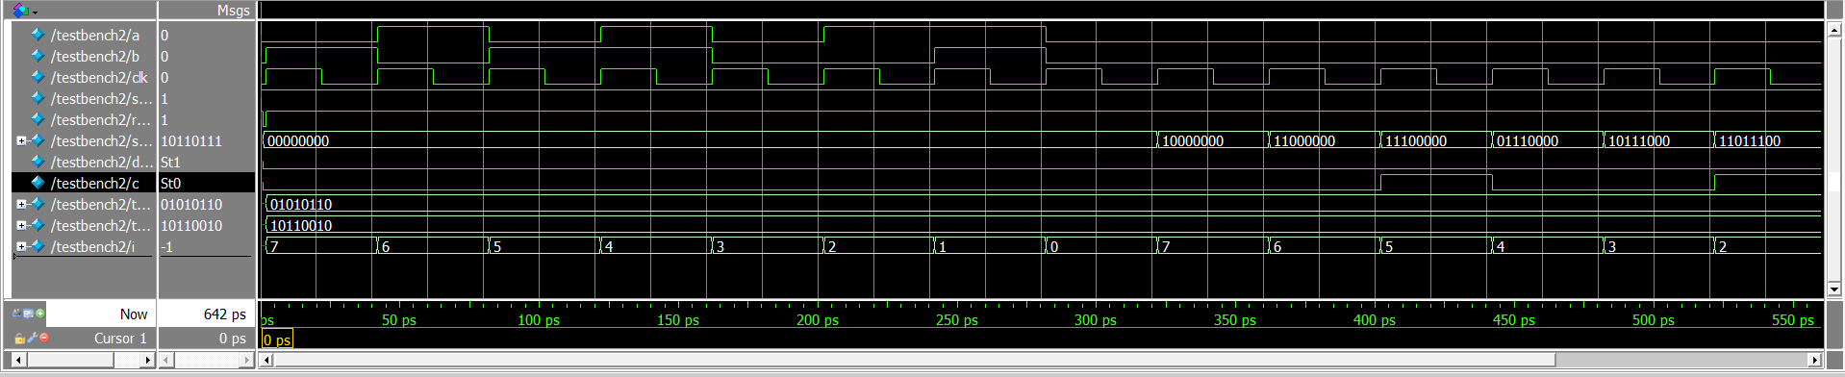

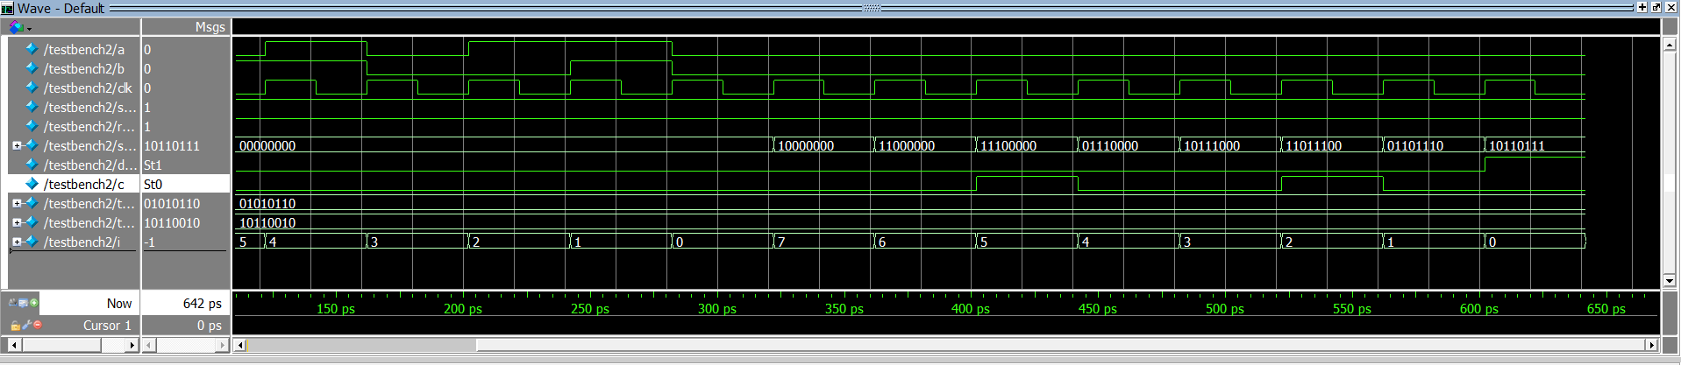

Full Screenshot:

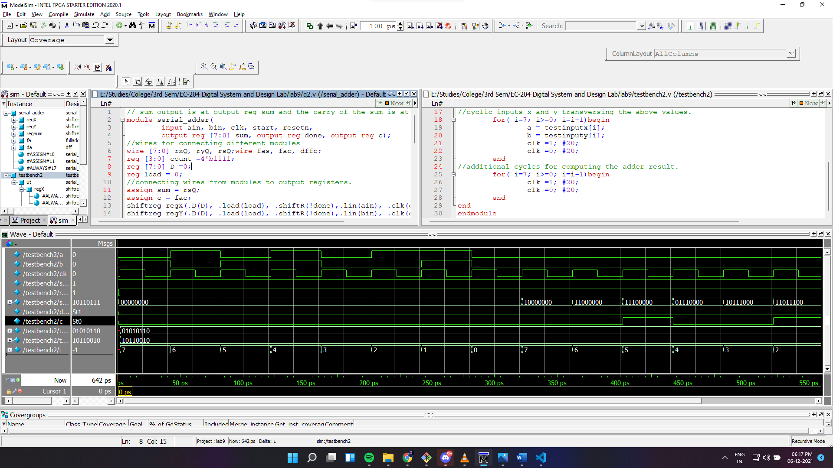

For input: ain=10101000 , bin= 00010010

Output wave:

