**EC205**

**Analog Electronics Lab**

**Lab – 10**

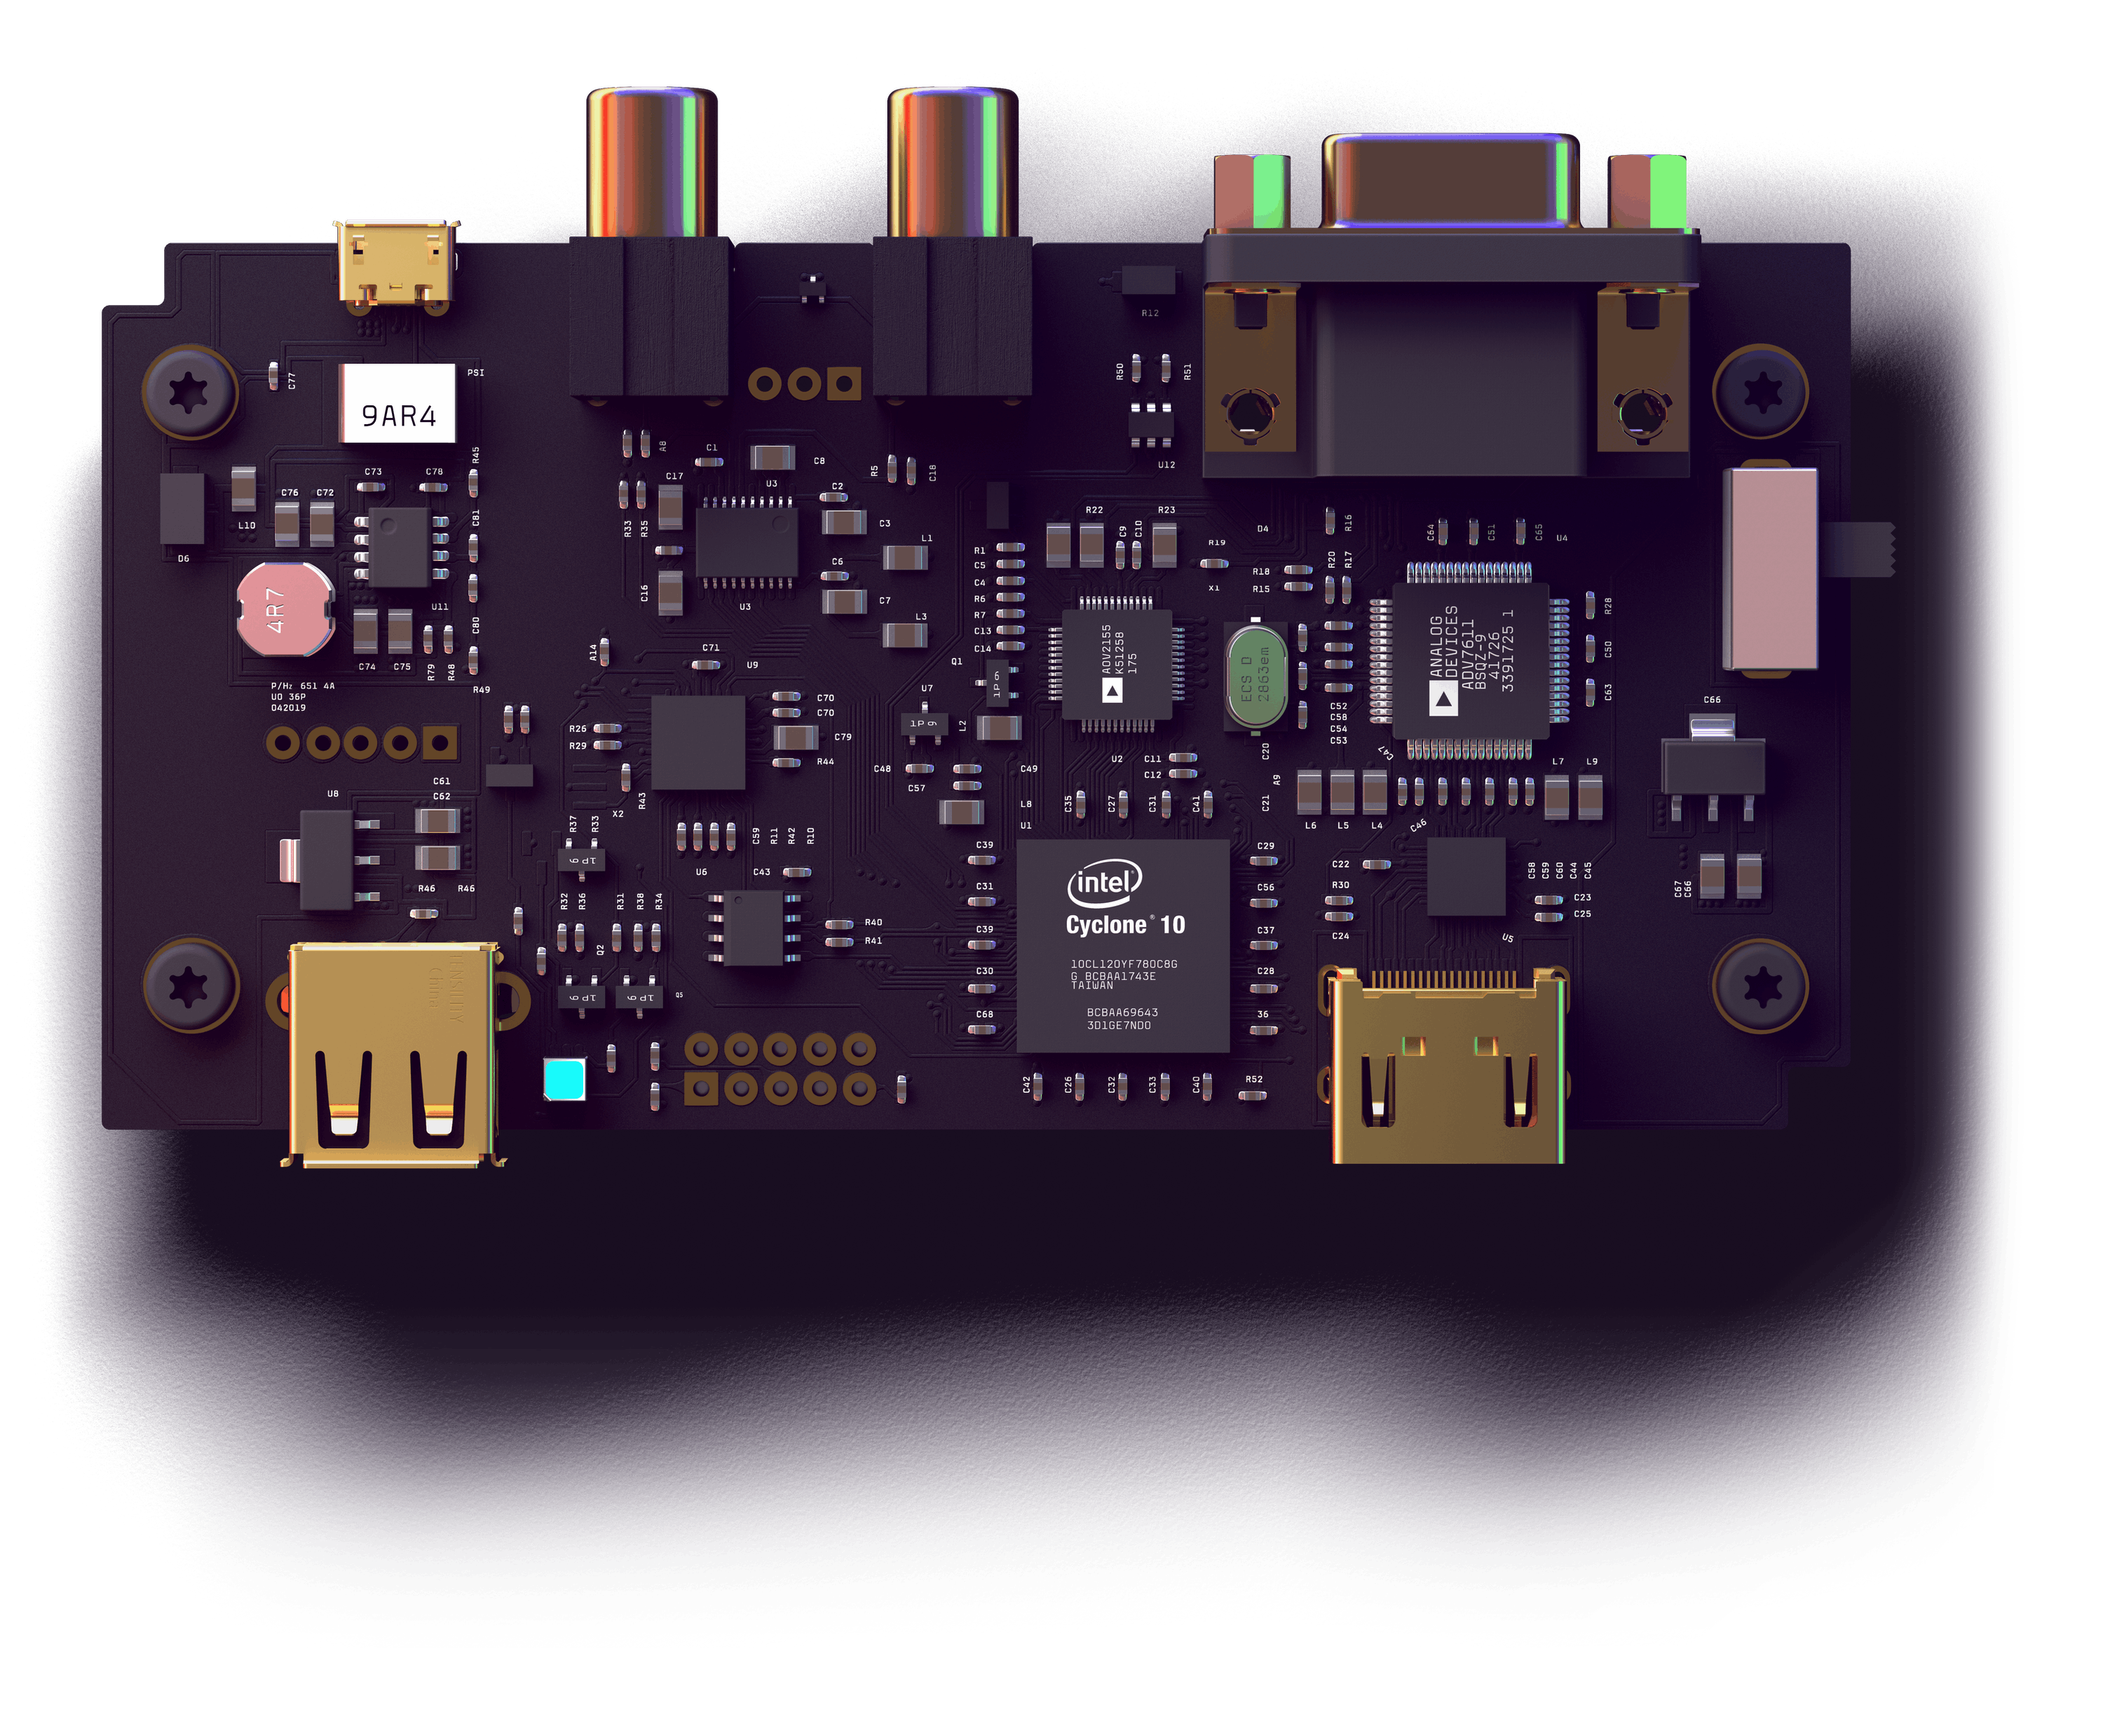

**Utkarsh R Mahajan 201EC164**

**Sannan Ali 201EC159**

**Experiment 9: Study of Comparator and Schmitt Triggers**

**Aim:** To design and study a µA741 based Comparator, Inverting Schmitt trigger and non-inverting Schmitt trigger circuits.

1. Test the comparator for Vin = 5 sin(200πt) and Vref = 0 V, 2 V and -3 V. (In hardware lab: Observe the transfer characteristic of the circuit by setting the DSO in X-Y mode.)

Circuit Diagram:

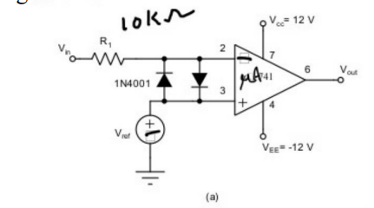

Circuit in LTspice:

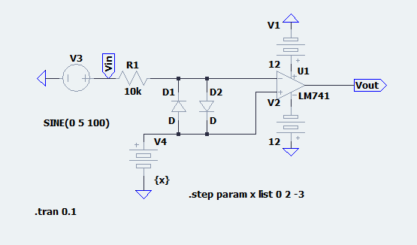

Waveform: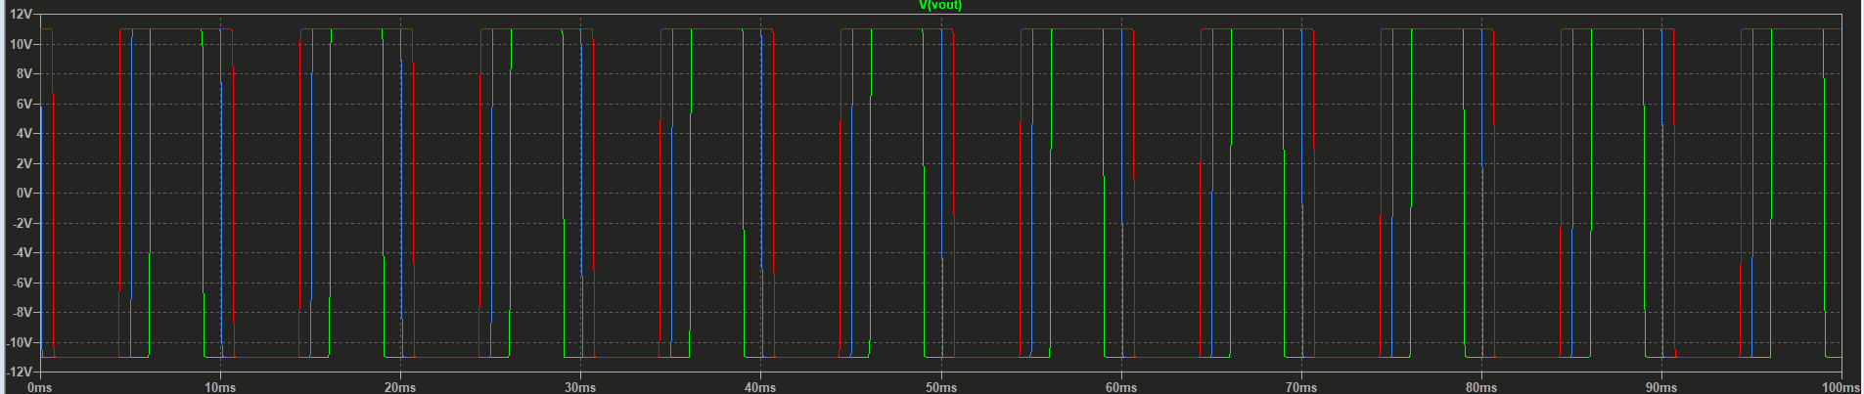

Only for Vref=0v:

Circuit in LTspice:

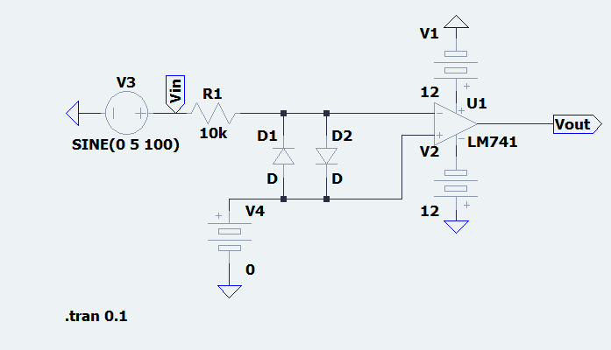

Waveform:

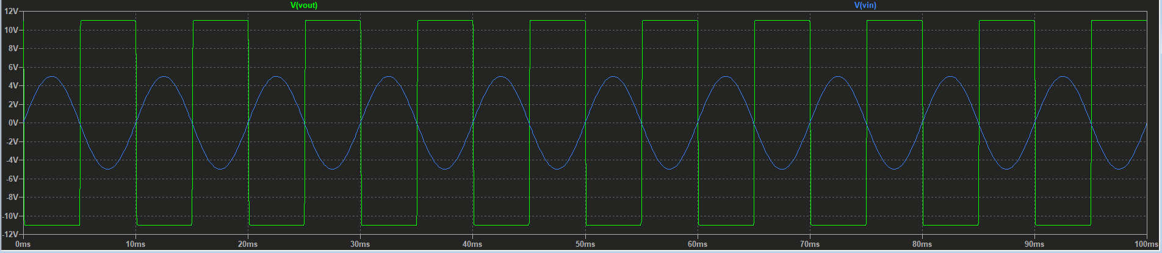

Only for Vref=2v:

Circuit in LTspice:

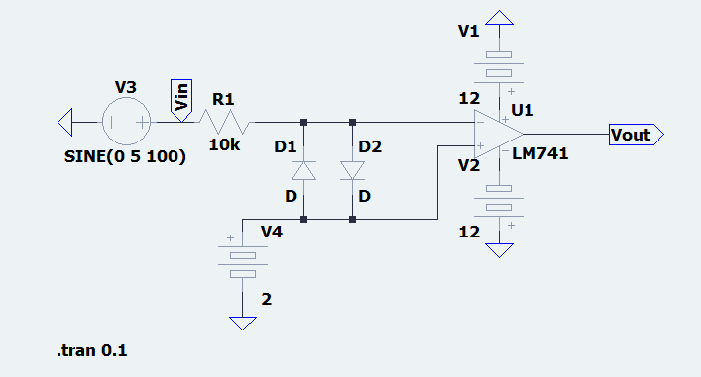

Waveform:

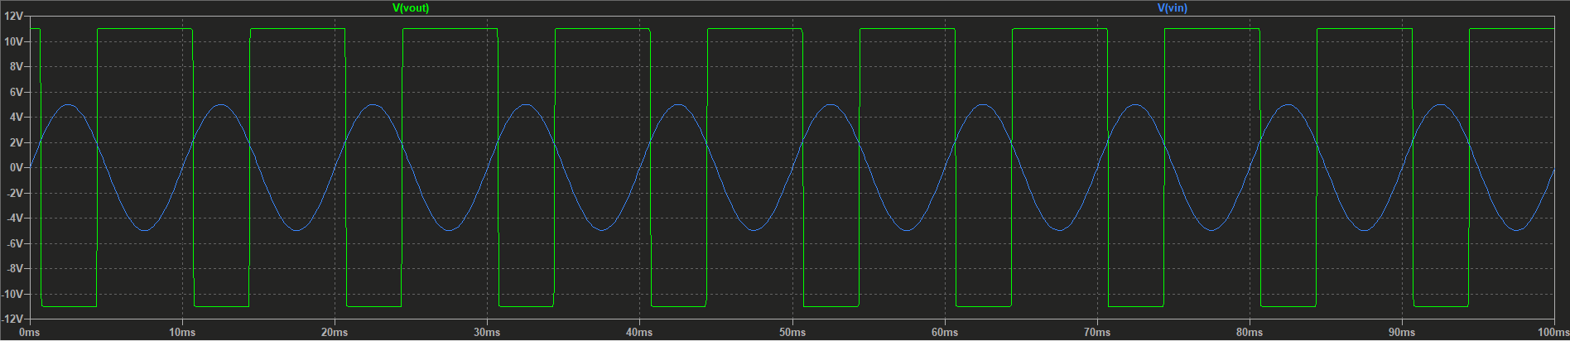

Only for Vref=-3v:

Circuit in LTspice:

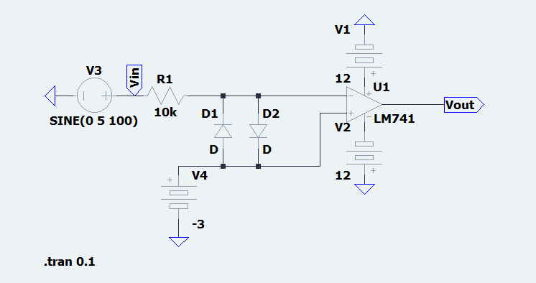

Waveform:

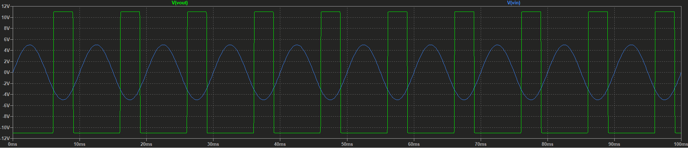

2. Design the inverting Schmitt trigger circuit for VLT = -3 V and VUT = 3 V. Assume the saturation voltage, Vsat = Vcc- 1 V. Observe the input and output waveforms. (In hardware lab: Observe the transfer characteristic of the circuit by setting the DSO in X-Y mode). What will be the output if the amplitude of input is set to 2 V?

->

Circuit Diagram:

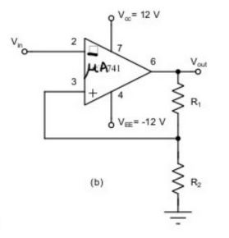

Considering Vcc= 13V.

Given Vsat = Vcc-1,

Knowing that for inverting Schmitt trigger,

VUT= Vsat

VLT= (-Vsat)

Considering R2 =1kΩ

Matching the above conditions,

we get R1 =3kΩ

Circuit in LTspice:

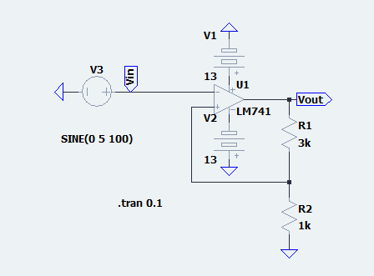

Waveform:

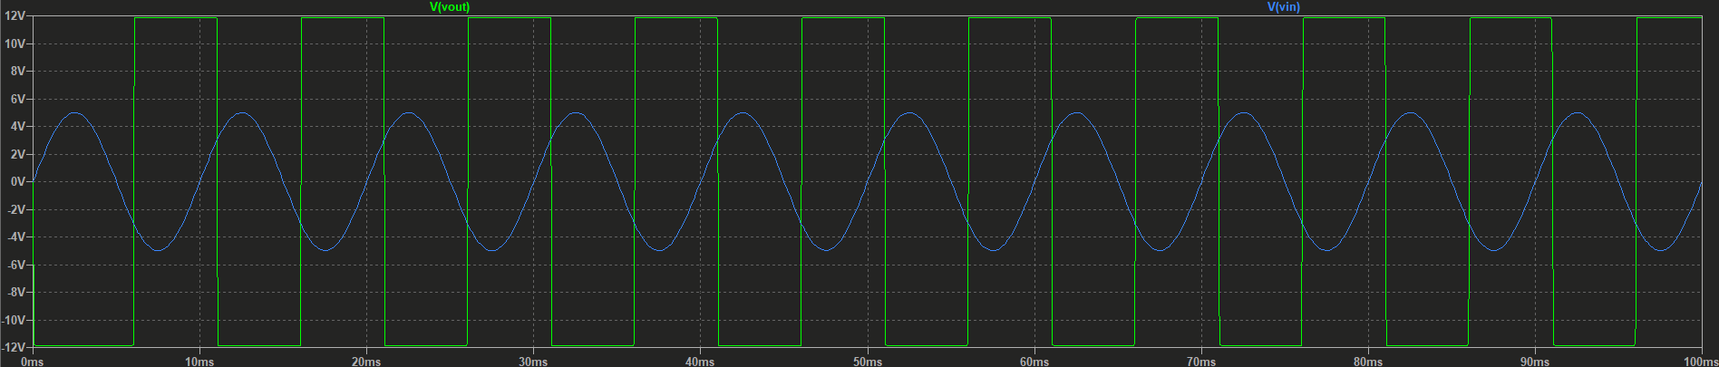

If we take 2V as input, the output will be low since it never the input voltage never crosses the required trigger voltage.

Circuit in LTspice:

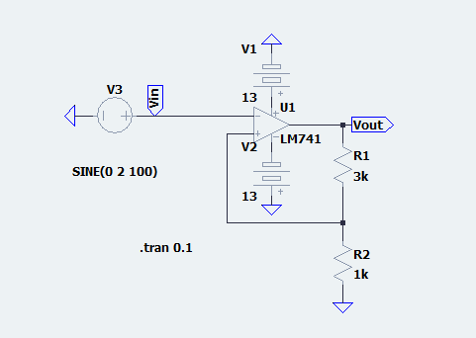

Waveform:

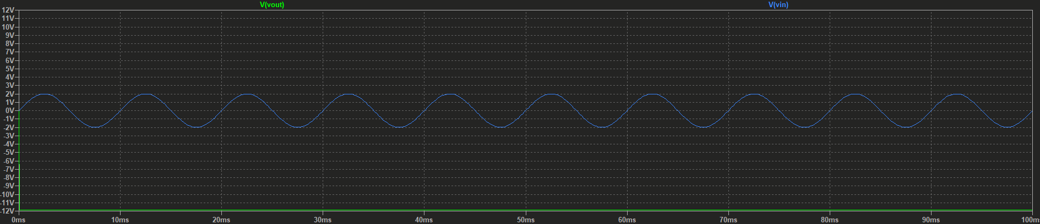

We can see that the waveform is as expected.

3. Design the non-inverting Schmitt trigger circuit for VLT = -4 V and VUT = 4 V. Assume the saturation voltage, Vsat = Vcc- 1 V. Observe the input and output waveforms. (In hardware lab: Observe the transfer characteristic of the circuit by setting the DSO in X-Y mode.)

->

Circuit Diagram:

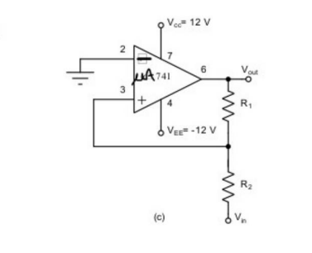

Considering Vcc= 13V.

Given Vsat = Vcc-1,

Knowing that for inverting Schmitt trigger,

VUT= Vsat = 4V

VLT= (-Vsat) = -4V

Considering R2 =1kΩ

Matching the above conditions,

we get R1 =3kΩ

For 5V amplitude:

Circuit in LTspice:

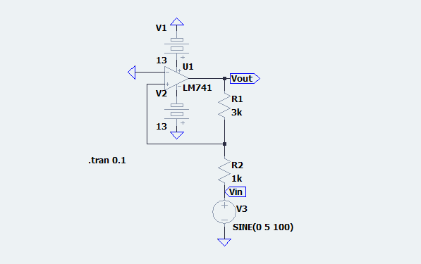

Waveform:

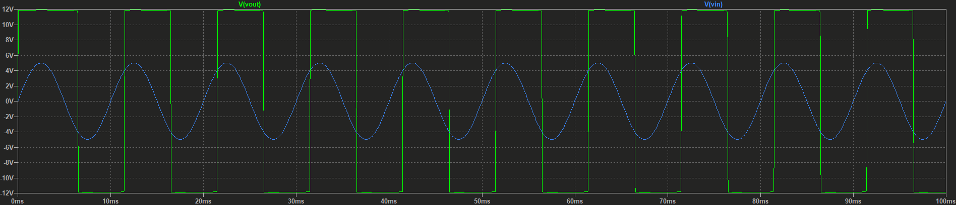

For 2V amplitude:

Circuit in LTspice:

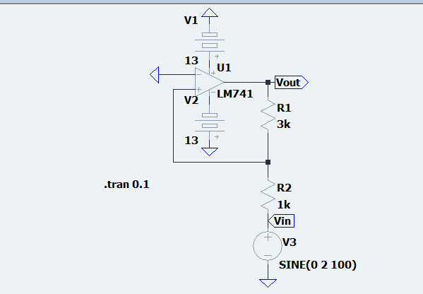

Waveform:

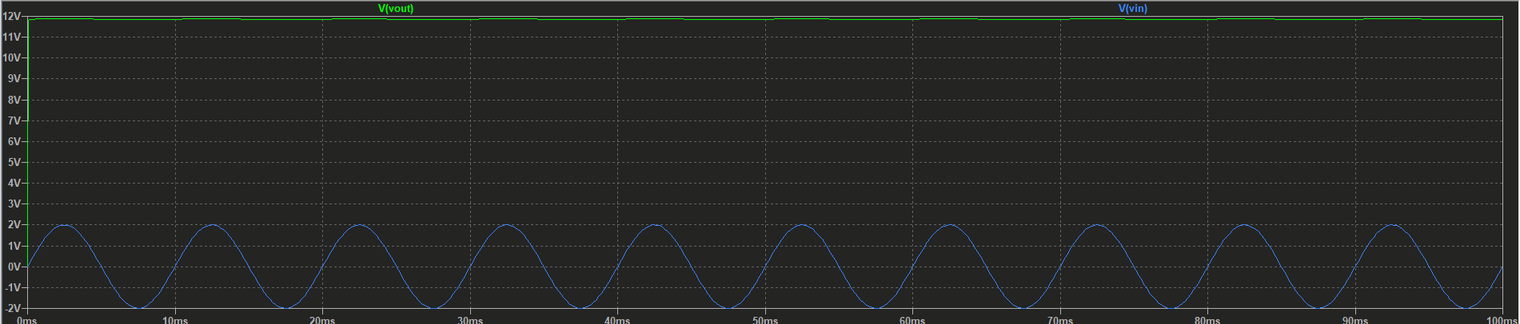

Think about these:

What happens if the input terminals of op-amp in comparator circuit are interchanged?

-> Since we will be just switching the input terminal from the negative to output, we will get a inverted output compared to the output of original circuit.

Can you design a Schmitt trigger circuit where |VLT| ≠ |VUT| If yes, how? Design any one circuit.

-> Yes, we can design Schmitt trigger circuit with unequal thresholds. We can do it in many ways. For Inverting circuit, we can do it by using an additional Vref source or using additional resistor with diodes for having different resistance for opposite current flow.

We will build a circuit for the 2nd method.

Considering Vcc= 13V.

Given Vsat = Vcc-1 =12V,

Knowing that for inverting Schmitt trigger,

VUT= Vsat

VLT= (-Vsat)

Considering R1 =3kΩ

We will set VUT=6V and VLT= 3V,

Matching the above conditions,

we get R2 =3kΩ and R3 =1kΩ

Circuit in LTspice:

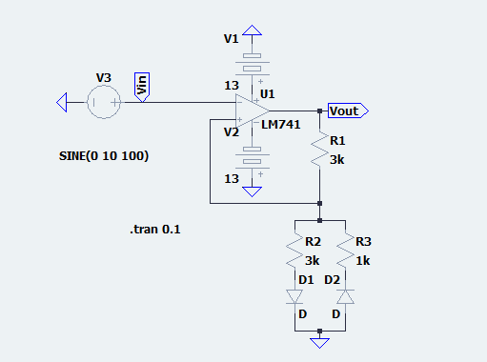

Waveform:

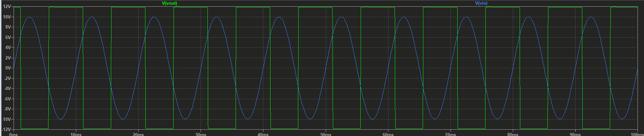

For 5V amplitude:

Circuit in LTspice:

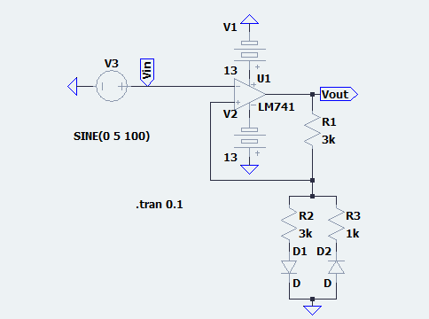

Waveform:

