**EC205**

**Analog Electronics Lab**

**Lab – 2**

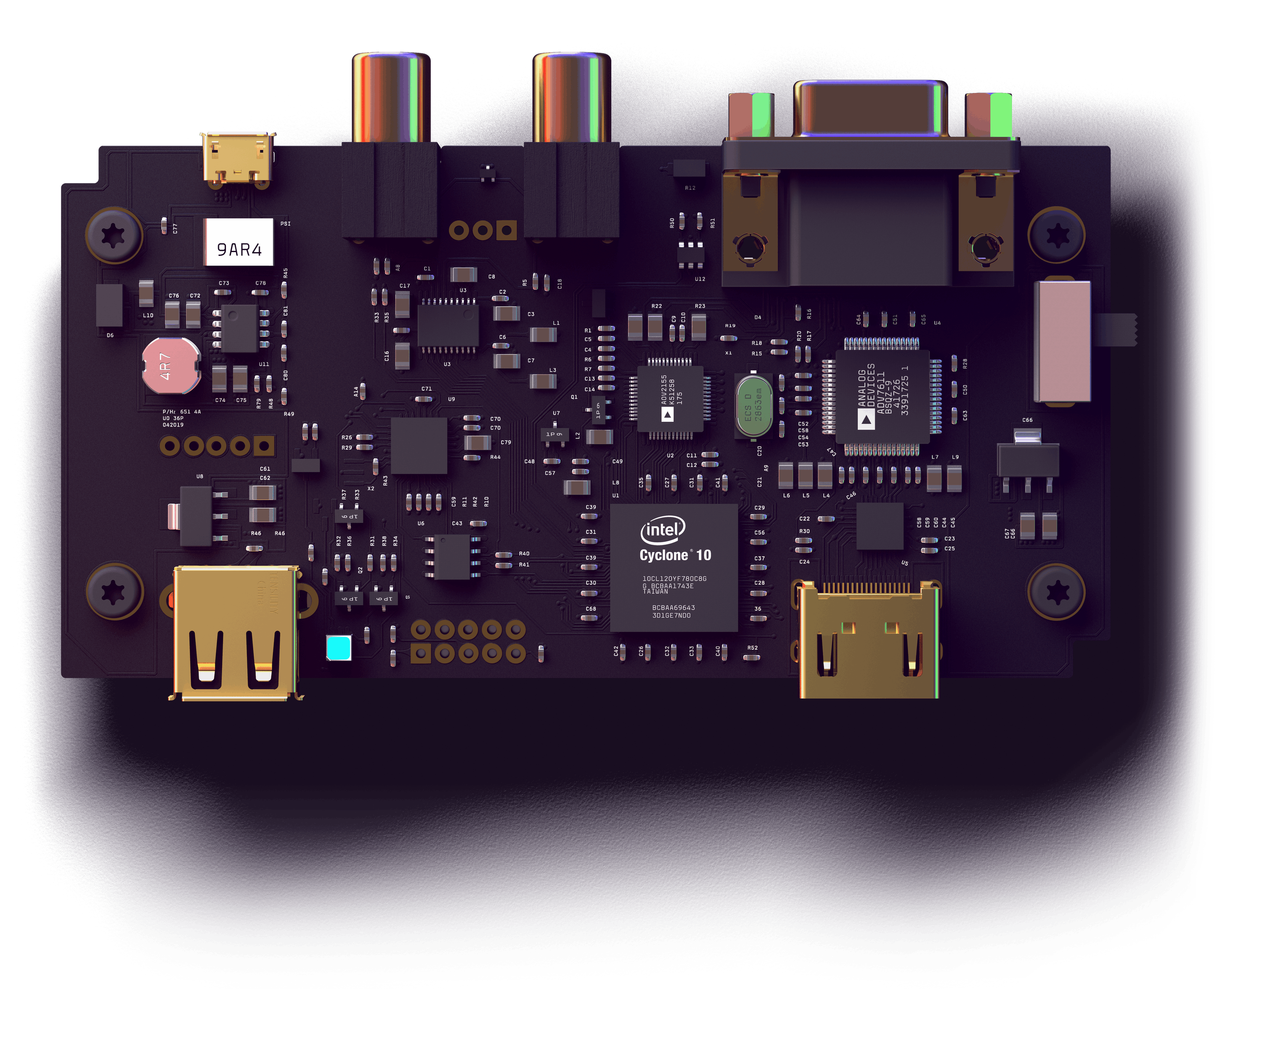

**Utkarsh R Mahajan 201EC164**

**Sannan Ali 201EC159**

**Experiment 2: Clipping and Clamping Circuits**

**Aim: To study clipping circuits and clamping circuits**

**i) Clipping Circuits**

**ii) Clamping Circuits**

**i.1]**

**Output will be clipped when in forward bias.**

**Circuit diagram:**

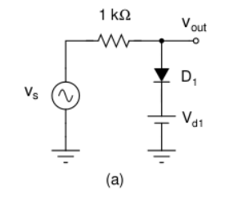

**Circuit in LTspice:**

**Case 1: for Vd1=2V**

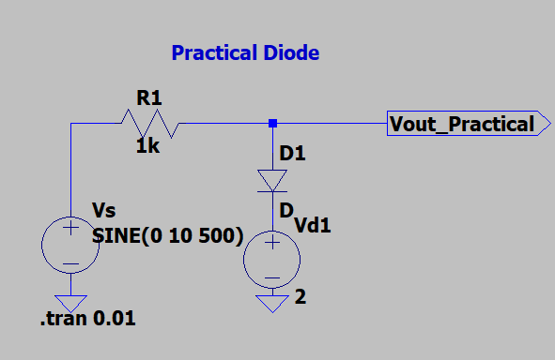

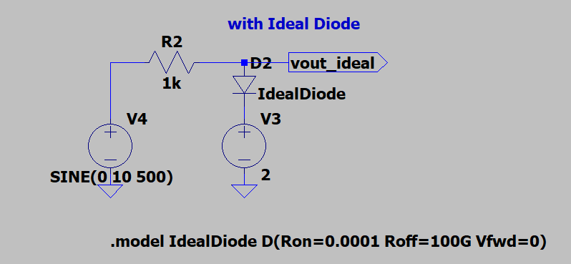

**Results:**

**For a practical Diode**

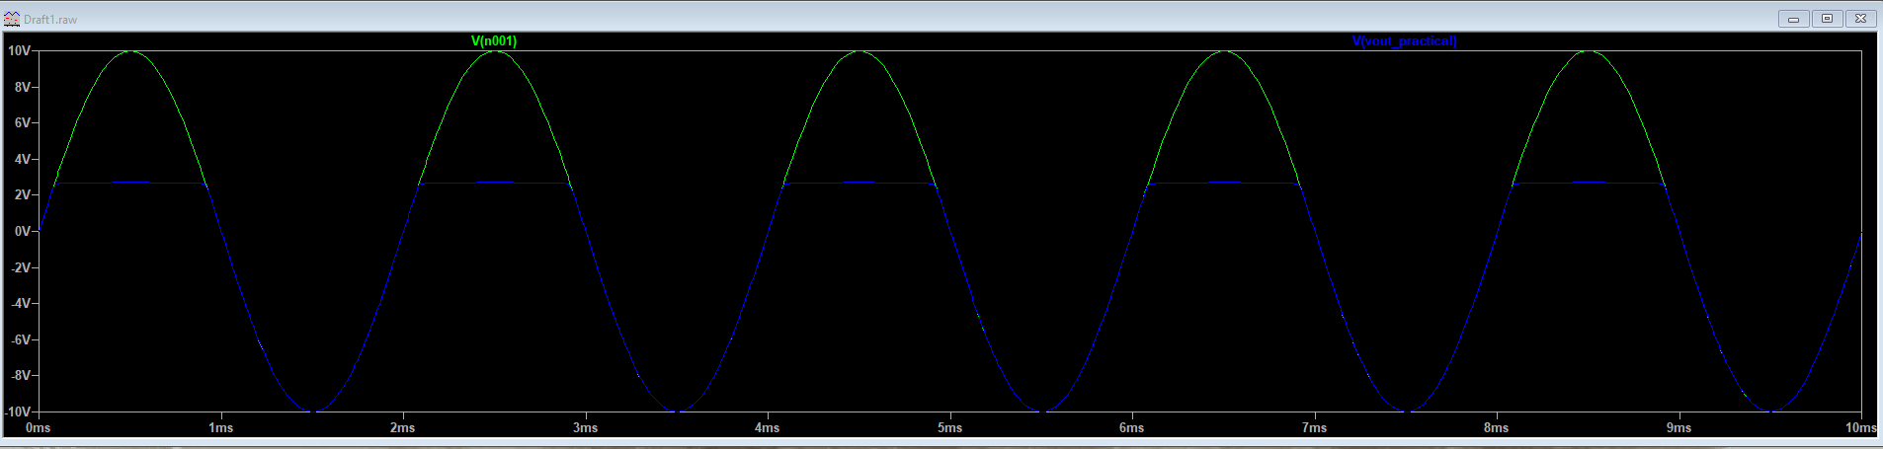

**For a Ideal Diode**

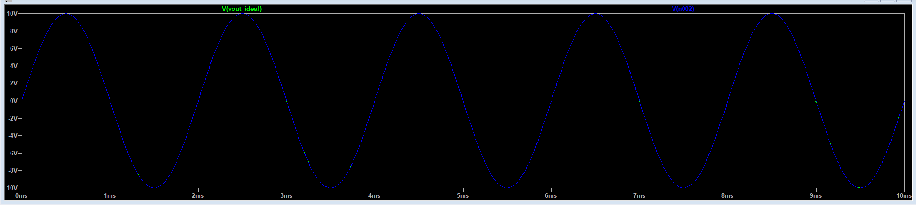

**Comparison between both**

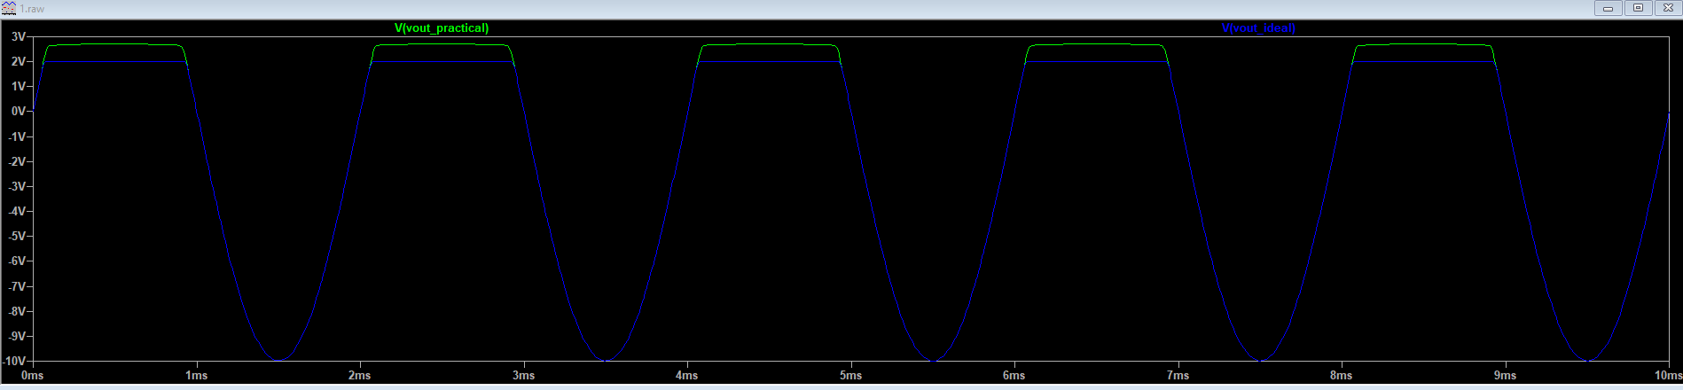

**Circuit in LTspice:**

**Case 2: Vd2=-2V**

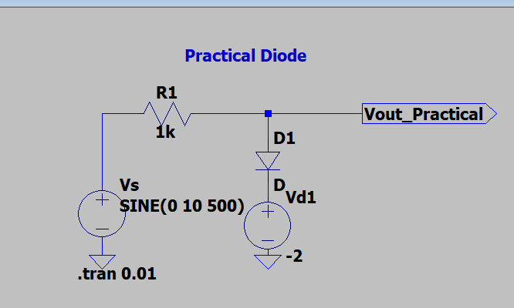

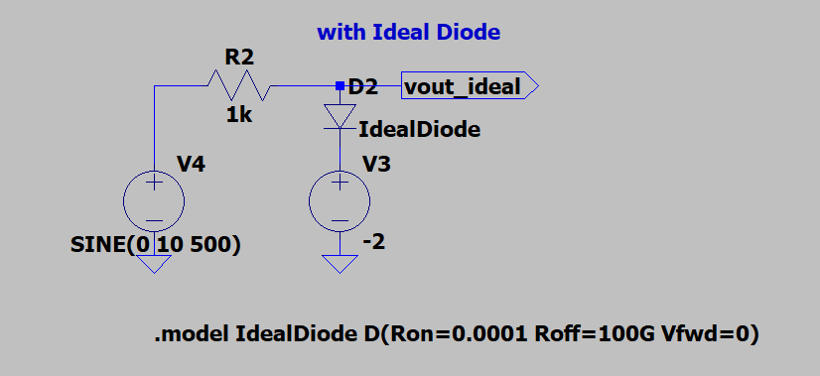

**Results:**

**For a practical Diode**

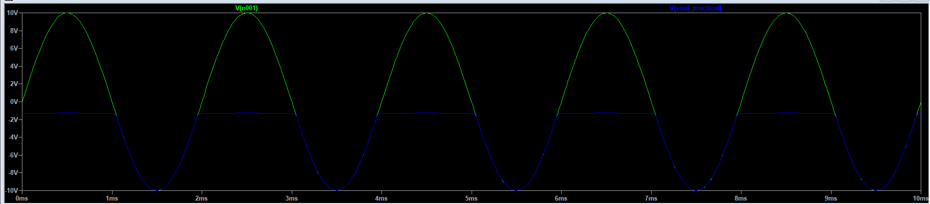

**For a Ideal Diode**

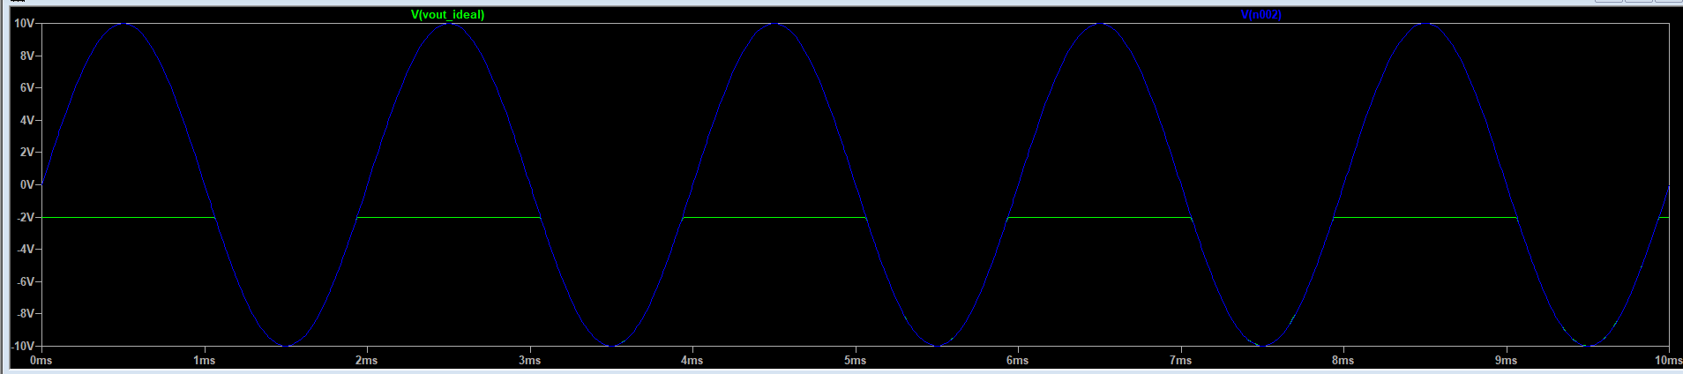

**Comparison between both**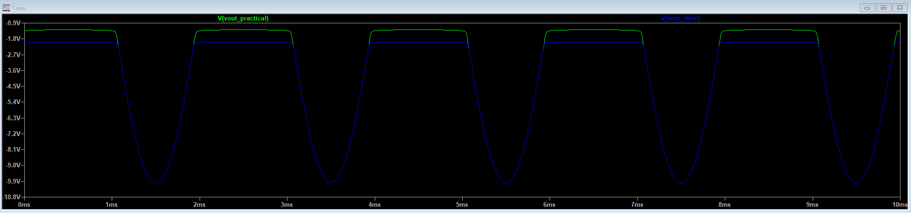

**i.2]**

**Output Voltage will be clipped.**

**Circuit diagram:**

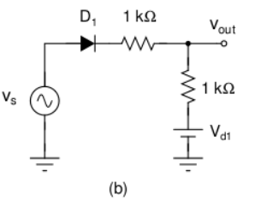

**Circuit in LTspice:**

**for Vd1=2V**

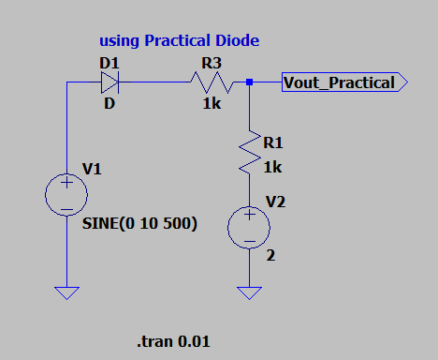

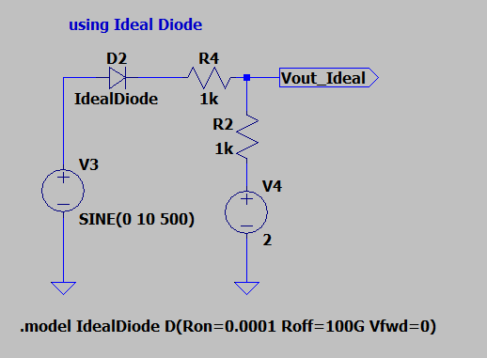

**Results:**

**For a practical Diode**

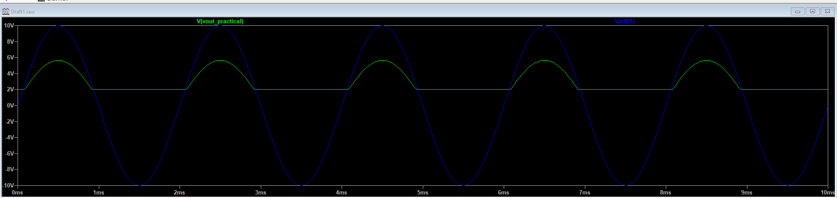

**For a Ideal Diode**

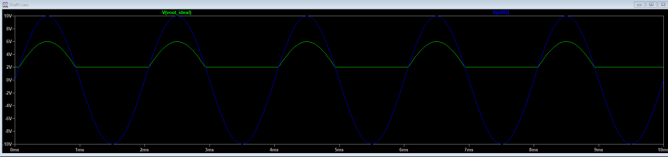

**Comparison between both**

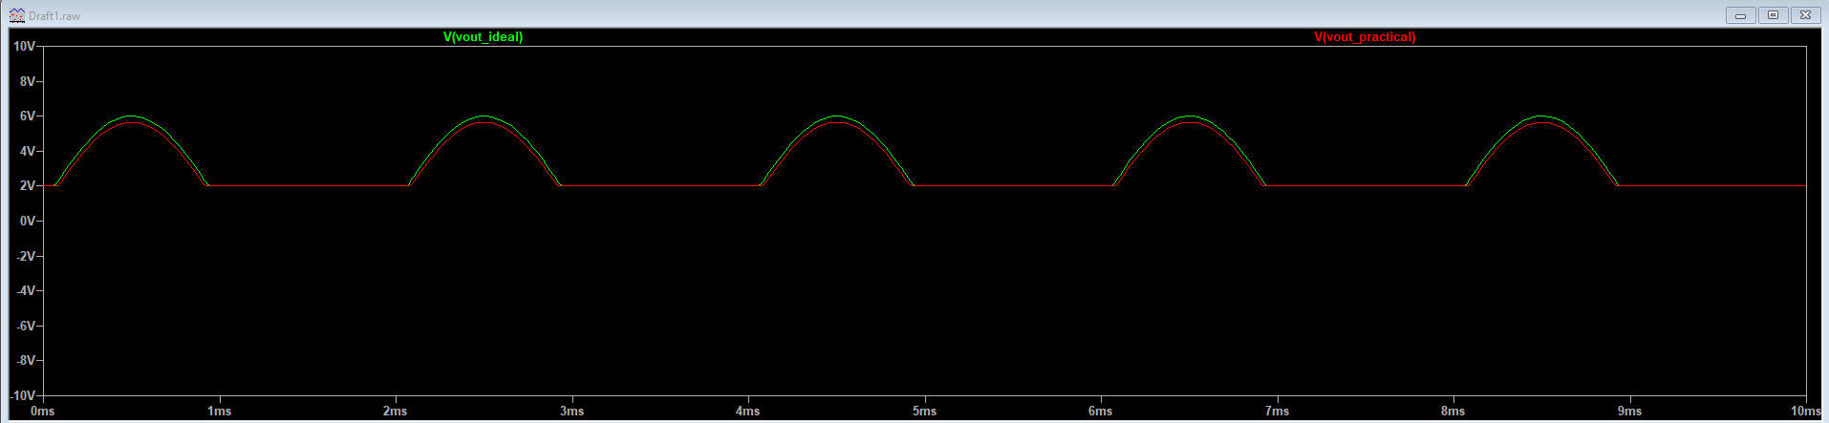

**i.3]**

**Output Voltage will be clipped.**

**Circuit diagram:**

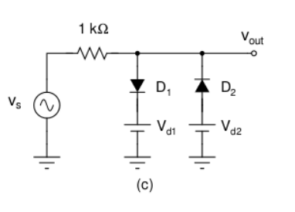

**Circuit in LTspice:**

**for Vd1=2V and Vd2=-2V**

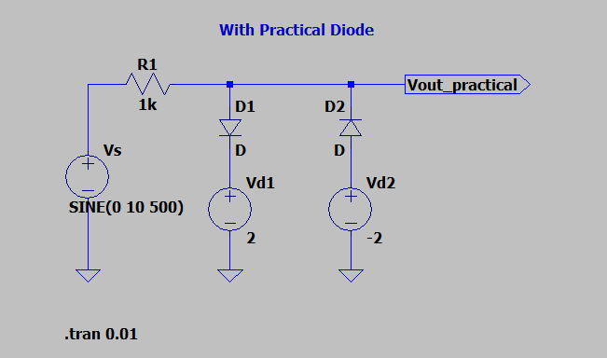

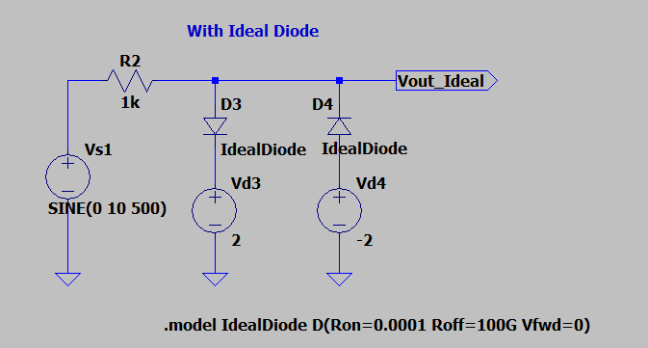

**Results:**

**For a practical Diode**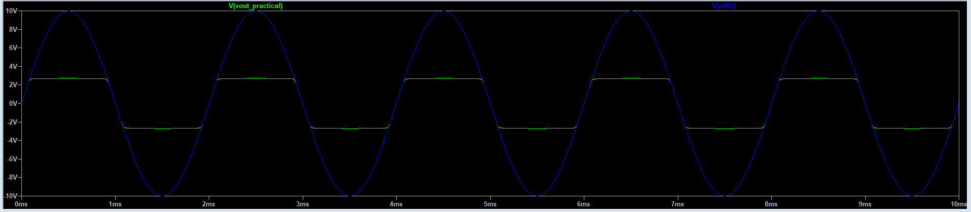

**For a Ideal Diode**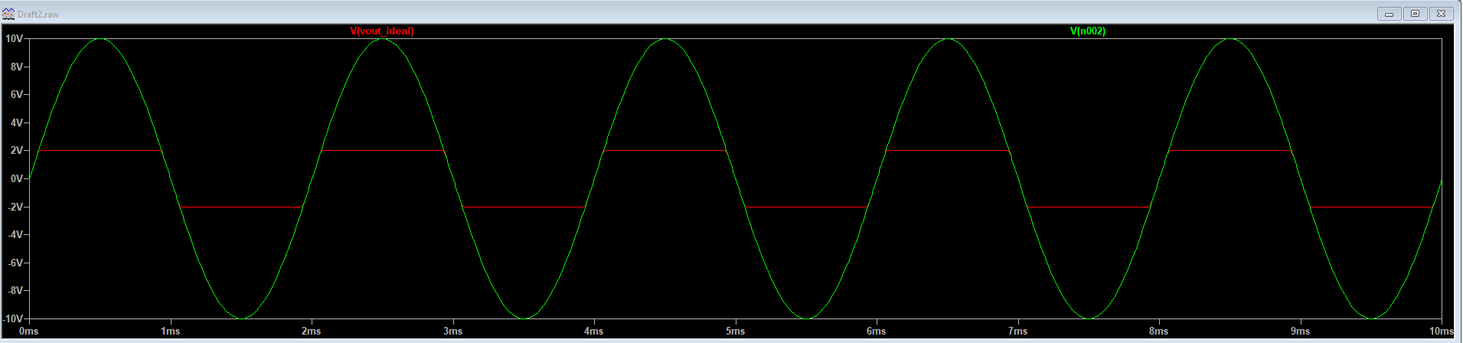

**Comparison between both**

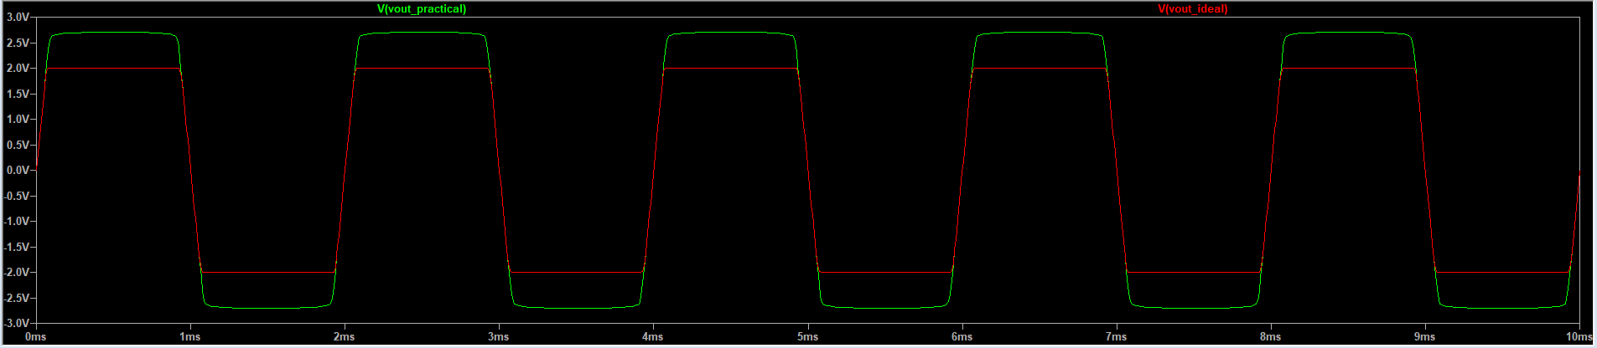

**ii]**

**Output voltage will be clamped**

**Circuit diagram:**

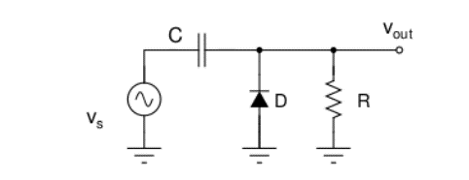

**Case 1: for VSpeak=10V, f=1kHz RC=10Ts so we take R = 10kΩ and C=1µF**

**Circuit in LTspice:**

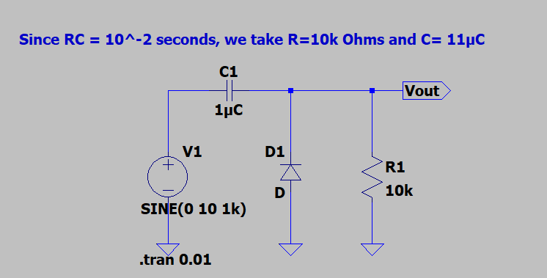

**Results:**

