**EC205**

**Analog Electronics Lab**

**Lab – 3**

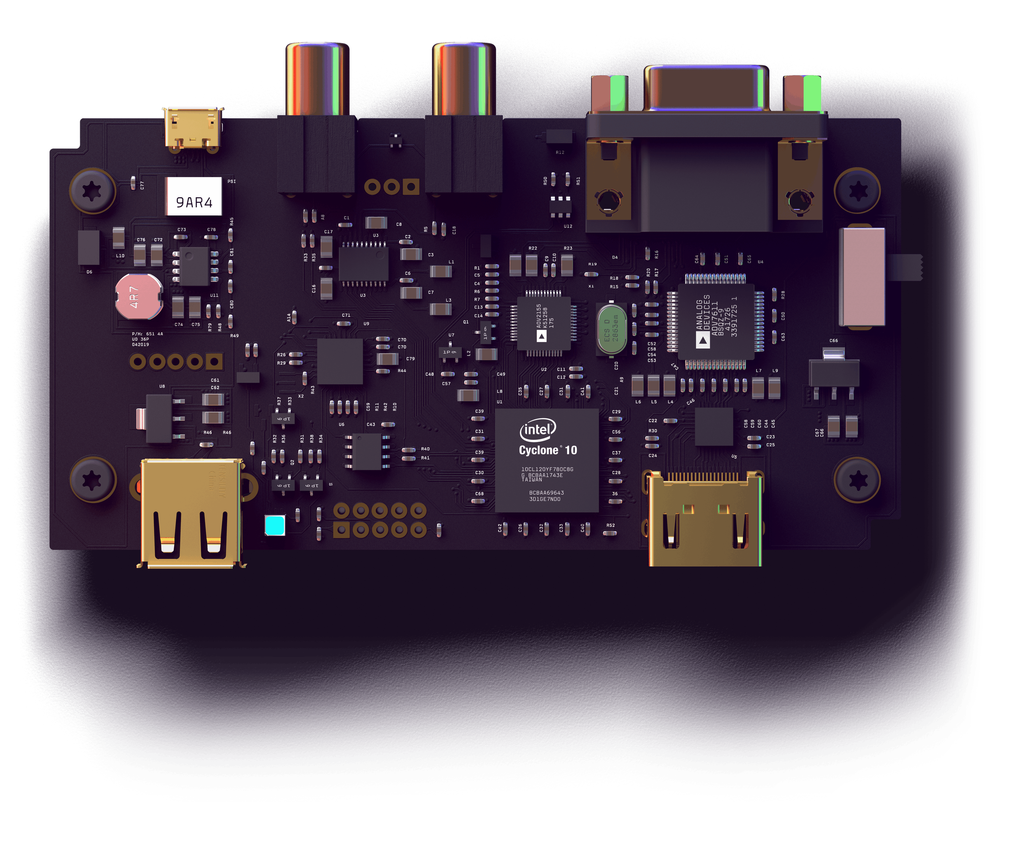

**Sannan Ali 201EC159**

**Utkarsh R Mahajan 201EC164**

**Experiment 3: Full-wave Rectifier, Unregulated and Regulated Power supply**

**Aim:**

* **To design a full-wave bridge rectifier for an average output voltage of 8 V to feed 1kQ load.**
* **To design an unregulated power supply for an output voltage of approximately 10 V and current 0.1 A.**
* **To design a regulated power supply for an output voltage of 5 V and current of 0.1 A using voltage regulator chip /iA7805.**

**Experiment (a)**

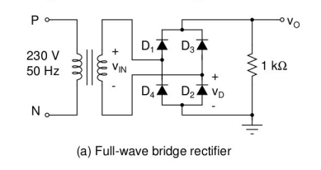

**Circuit in LTspice:**

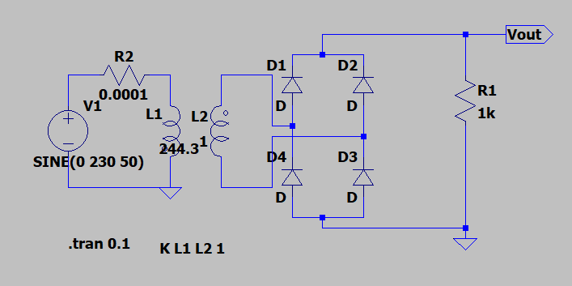

**Output Waveform**

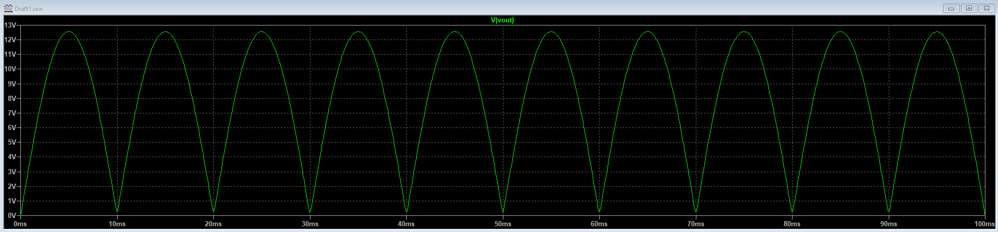

1. **VOut(avg) =8V**

**Vtransformer =  VOut(peak)  = = = 12.566370V**

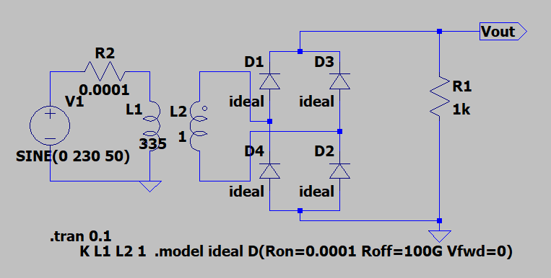

1. **we can expect a drop in our final average output voltage.**

**Here with standard diode without changing secondary voltage of transformer in ltspice from ideal diode, New VOut(avg) will be 6.6504V instead of 8V.**

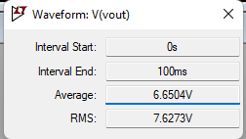

1. **VDC = 8V VAC = 9.1352V for standard diode**

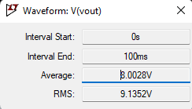



**=**

**= 0.5513**

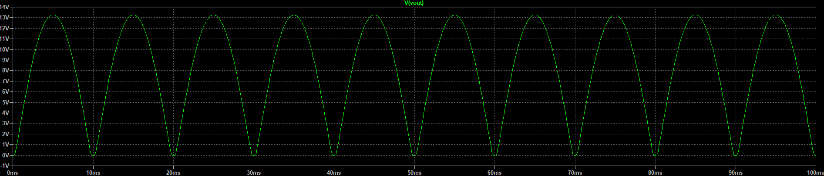

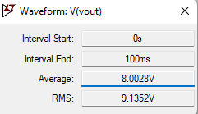

1. **Voltage waveform across D2**

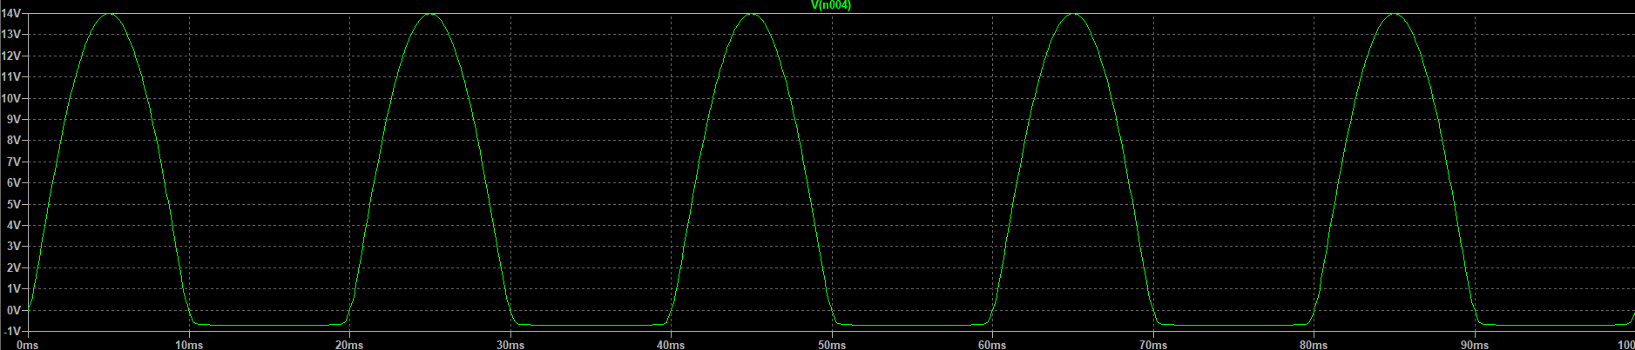

1. **peak inverse voltage with Ideal diode will be 0V.**

**while -0.7V with standard diode**

1. **Vrms = 4V**

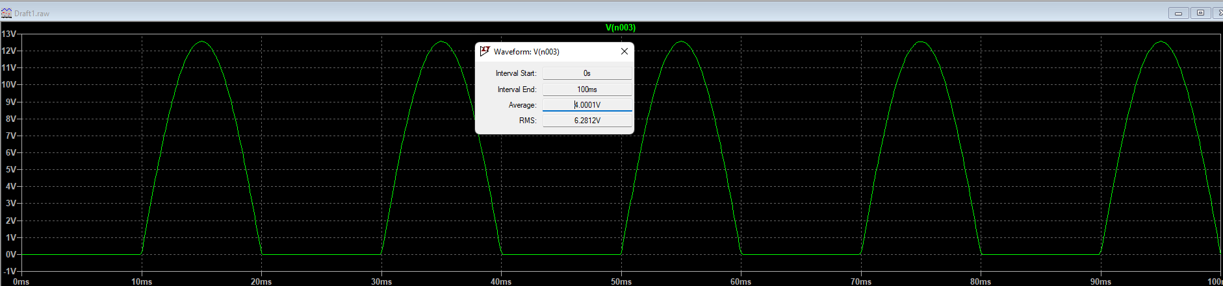

**Experiment (b)**

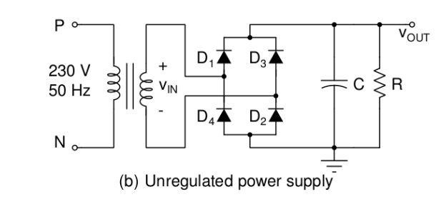

**Circuit in LTspice:**

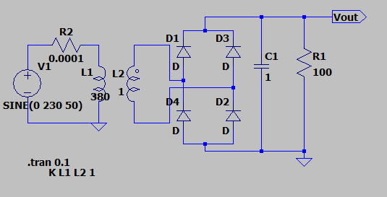

**Waveform:**

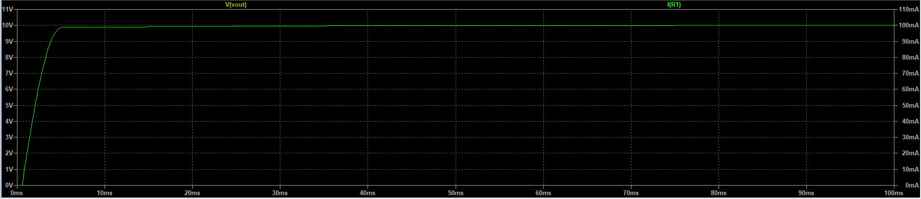

**Values Observed in LTspice:**

**VDC = 9.7479V**

**VAC = 9.8255V**

**=**

**= 0.1264**

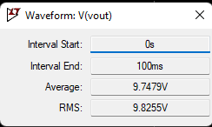

**Theoretical Values considering unfilitered output:**

**VDC = = = 6.366V**

**VAC = = = 7.0710V**

**=**

**= 0.4834**

**Theortical values considering Filtered output:**

**VAC = VOut = VDC = 10V**

**We can see that the experimented voltages are bit lower than the theoretical values considering filtered output.**

**Unfilitered Rectifier Circuit:**

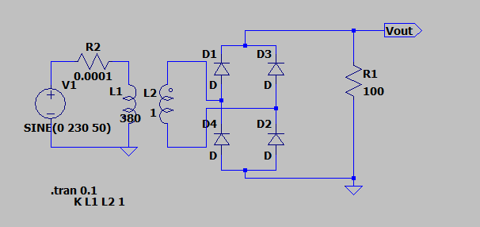

**Waveform:**

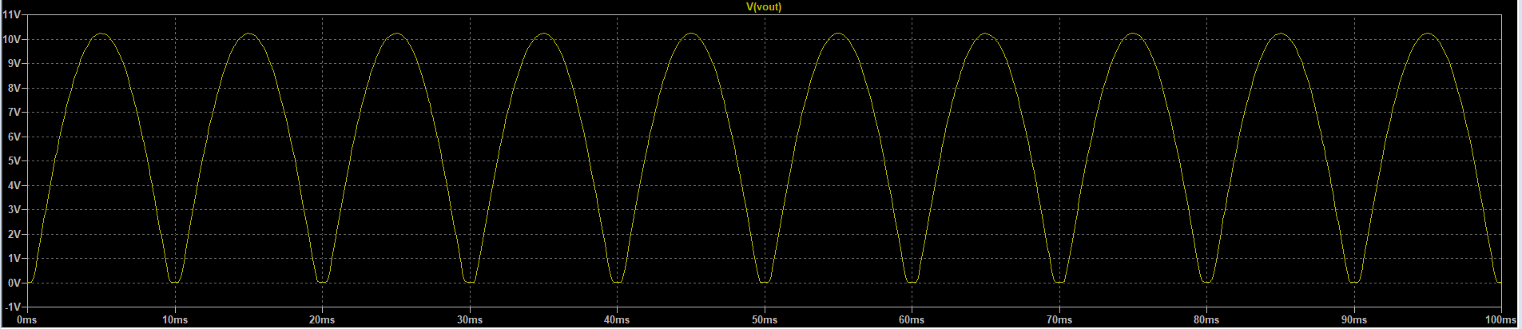

**VAC = 6.9848V**

**VOut = 10V**

**VDC = 6.0576V**

**The Unfiltered rectifier output ac and dc voltage values are lower than the filtered rectifier output as expected.**

**Experiment (c)**

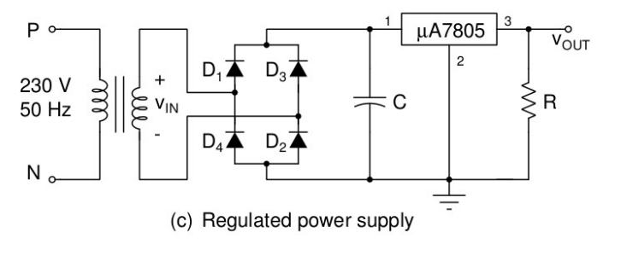

**Circuit in LTspice:**

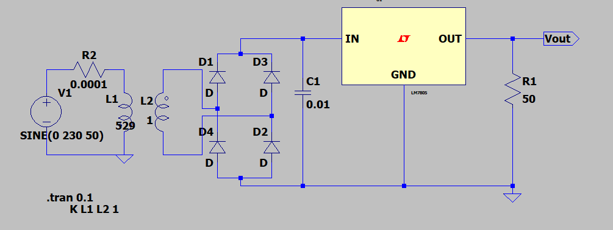

**Waveform:**

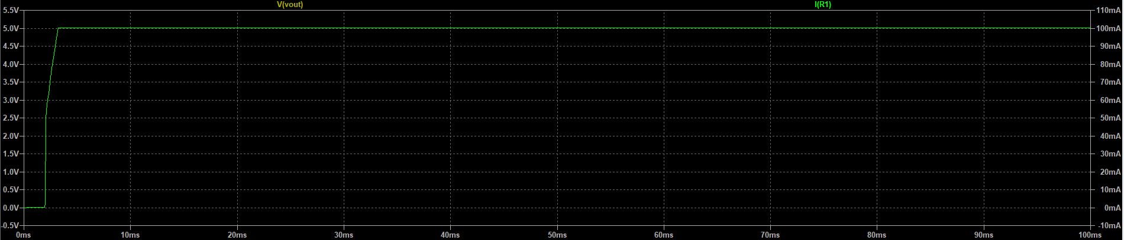

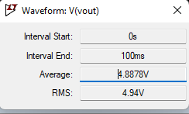

**VDC = 4.8878V**

**Answer the following (Not more than two sentences for each question)**

1. **Why electrolytic capacitors are used in the filter circuit?**

Electrolytic capacitors are preferred because they have polarity and are available in values from 1 to thousands of and are also cheap.

1. **How to identify the polarity of the capacitor?**

The stripe on the electrolytic capacitor indicates the negative end.

1. **Discuss the limitations of the electrolytic capacitor.**

large leakage currents: They have large current leakage, value tolerances: they have high tolerance compared to some alternatives, equivalent series resistance and a limited lifetime.

1. **What is a rectifier diode?**

Rectifier Diode is a semiconductor device used to convert alternating current to direct current. It has obvious unidirectional conductivity, and can be made of materials such as semiconductor germanium or silicon.

1. **What is the repetitive peak current of the diode?**

The repetitive peak forward surge current is the maximum current surge the diode can handle as repetitive pulses without damaging itself.