**EC205**

**Analog Electronics Lab**

**Lab – 4**

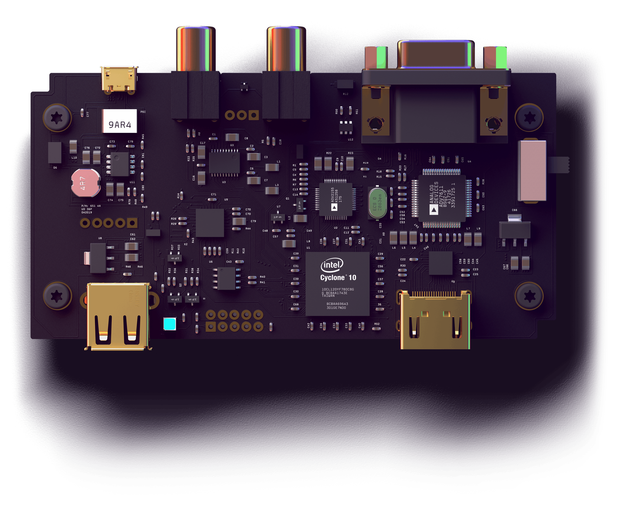

**Utkarsh R Mahajan 201EC164**

**Sannan Ali 201EC159**

**Experiment 3: RC Circuit - AC and Transient Analysis**

**Aim:**

**a) To study the behavior of a simple RC circuit for sinusoidal excitation.**

**b) To study the transient behavior of a simple RC circuit for square-wave excitation.**

**Experiment (a)**

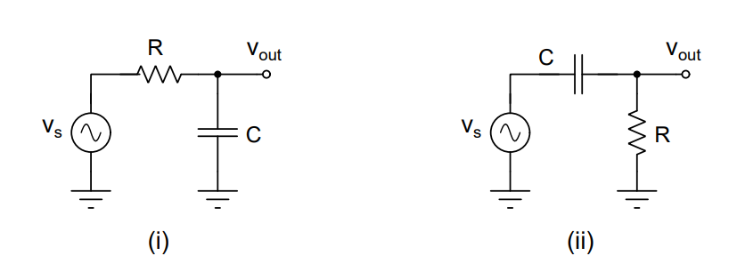

**For figure (i)**

**(a) & (b)**

**Circuit in LTspice:**

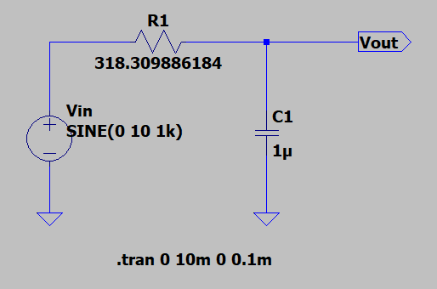

**Output Waveform**

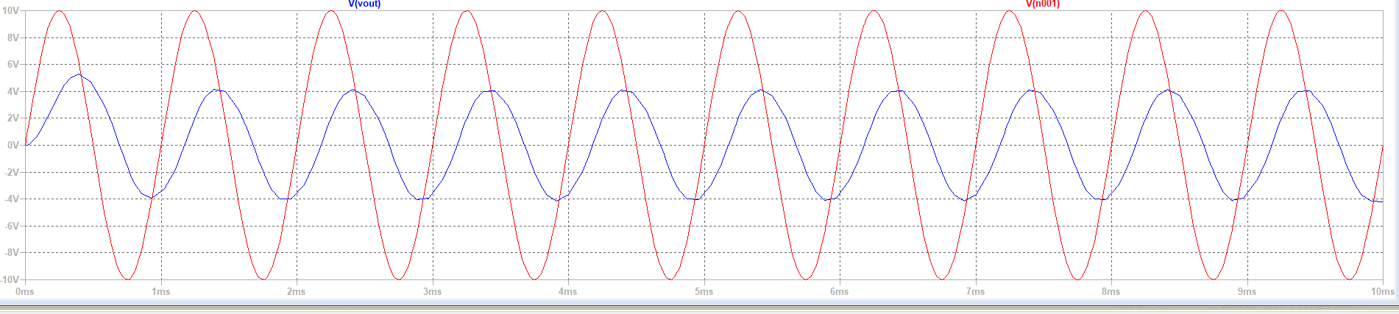

**(c) Circuit in LTspice:**

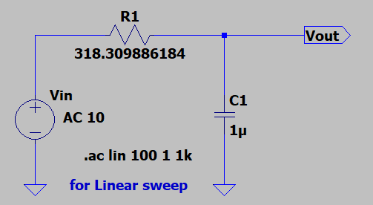 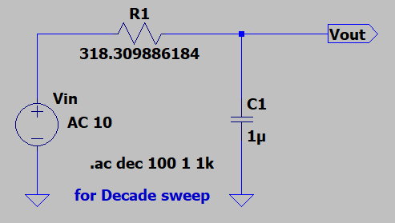

**Output Waveform**

For linear frequency sweep:

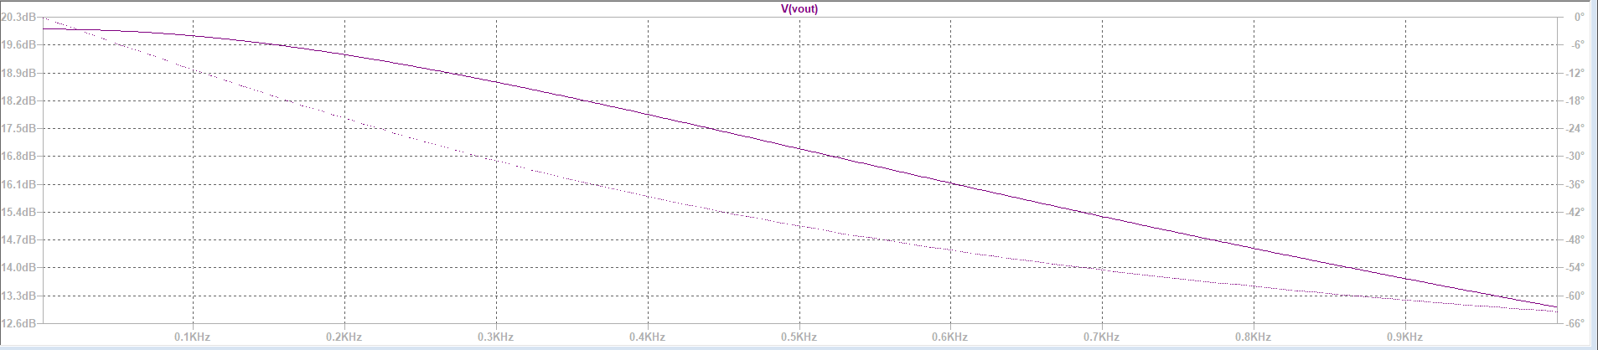

For decade frequency sweep:

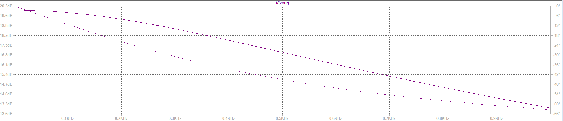

**(d)**

From the above graph, for some values we can see that,

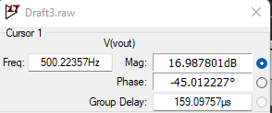 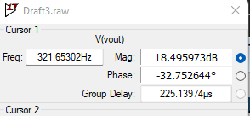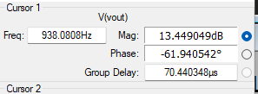

**(e)**

**DC gain:** ideal dc gain: 1

Considering at f=0, AC source a constant dc source,

LT Circuit for calculation:

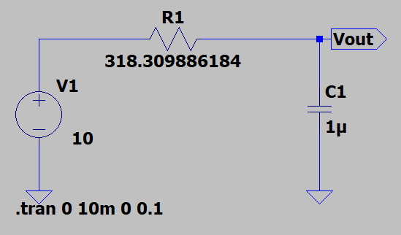

For Vout:

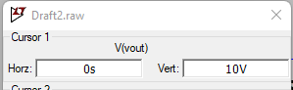

Vout =10v.

Therefore, Practical DC Gain = = =1

These values seem to match each other.

**Cut-off frequency:** ideal value: = 500hz.

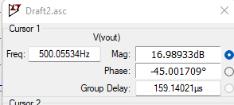

We can see from the waveform statistics that the values are close or matching.

**Roll-off:** 20 dB/decade

**(f)**

T1=738.86463µs, T2=521.26638µs, f=500hz(cut-off freq)

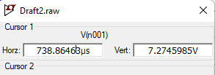 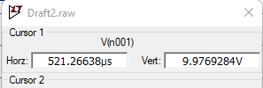

**=**

**(g) For figure (ii)**

**(g.a) & (g.b) Circuit in LTspice:**

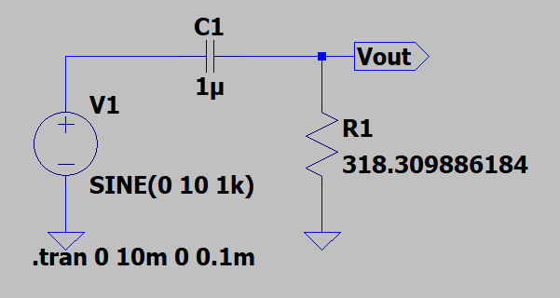

**Output Waveform:**

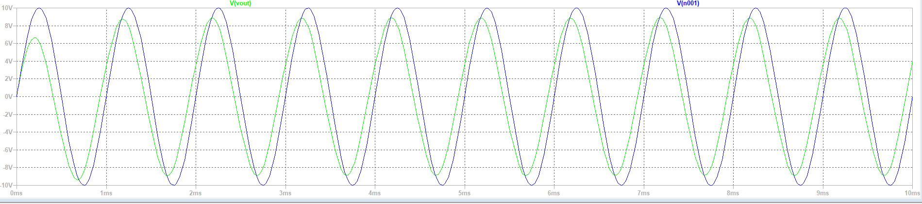

**(g.c) Circuit in LTspice:**

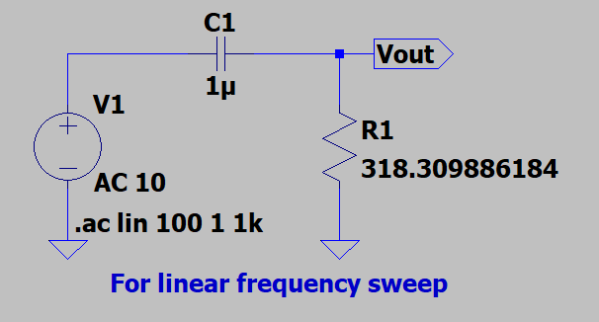 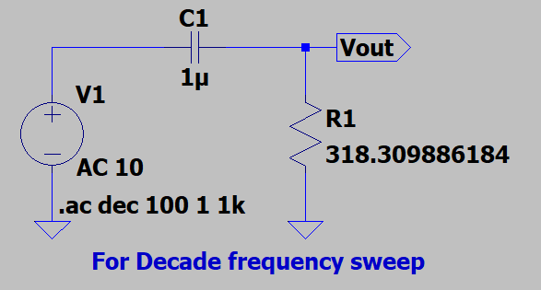

**Output Waveform**

For linear frequency sweep:

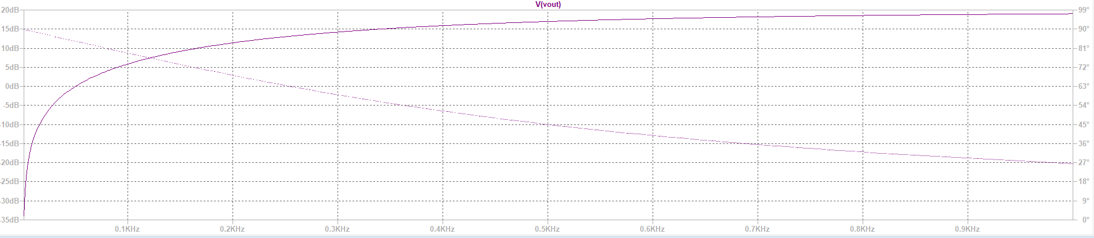

For decade frequency sweep:

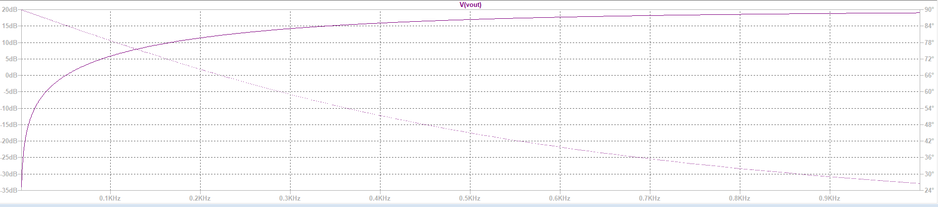

**(g.d)**

From the above graph, for some values we can see that,

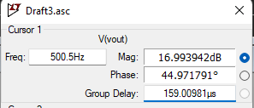 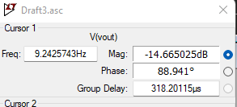 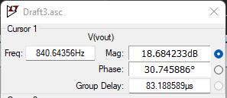

**(g.e)**

**DC gain:** ideal dc gain: 0

Considering at f=0, AC source a constant dc source,

LT Circuit for calculation:

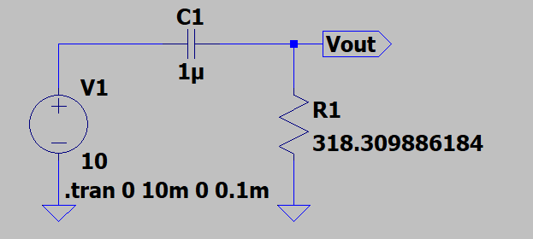

For Vout:

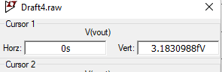

As t->0 Vout magnitude tends to 0.

Therefore, Practical DC Gain = = =0

These values seem to match each other.

**Cut-off frequency:** ideal value: = 500hz.

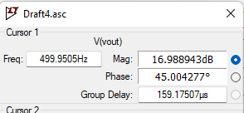

Which is approximately close to the ideal value.

**Roll Off** : 20 dB/decade

**(g.f)**

T1= 348.69281µs, T2=480.19533µs, f=500hz(cut-off freq)

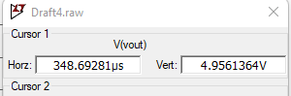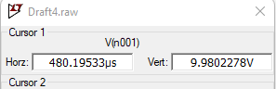

**=**

**Experiment (b)**

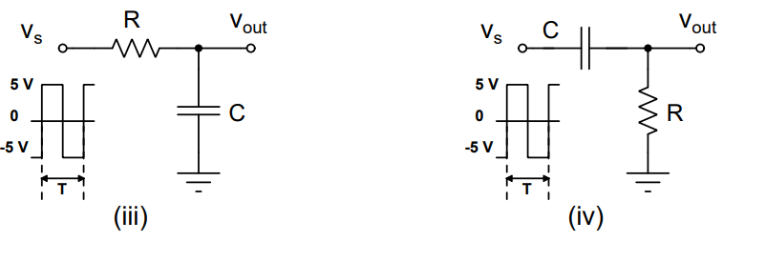

1. **Circuit in LTspice:**

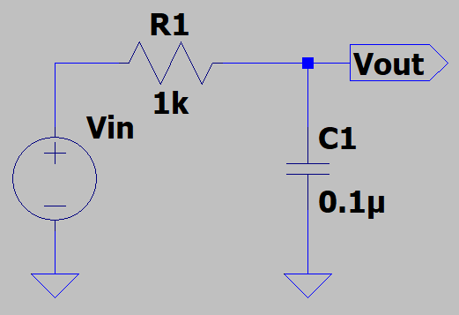

**(b) Circuit in LTspice:**

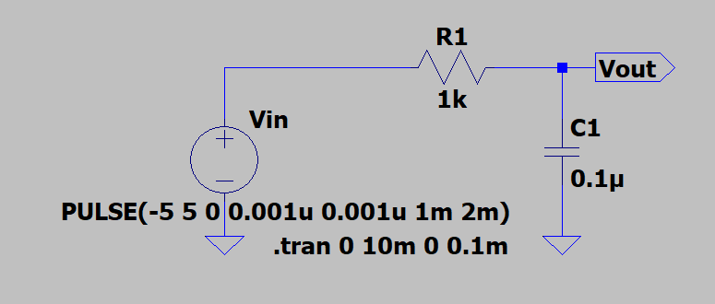

**Input Waveform**

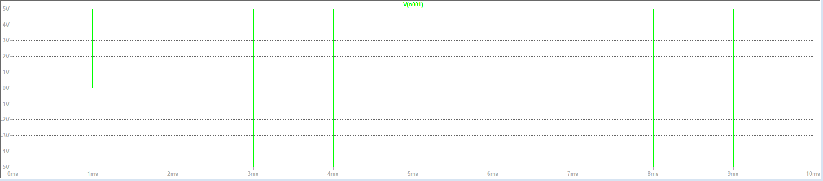

**(c)**

**T=0.4ms**

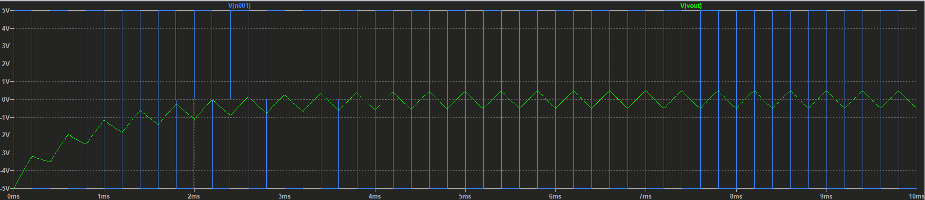

**T=2ms**

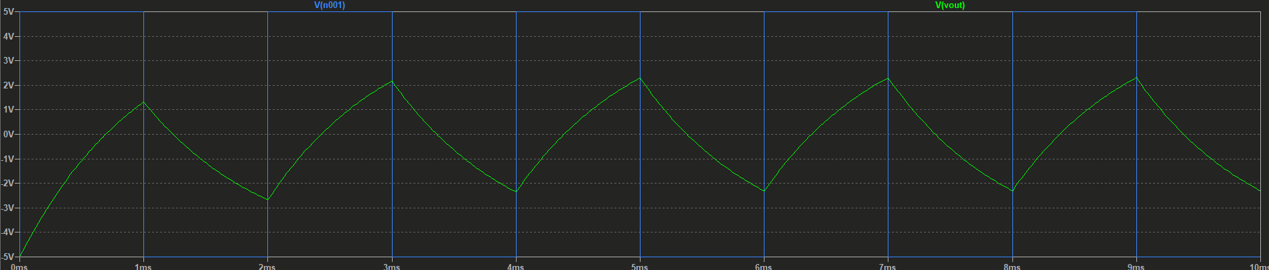

**T=20ms,** transient time stop = 0.1s

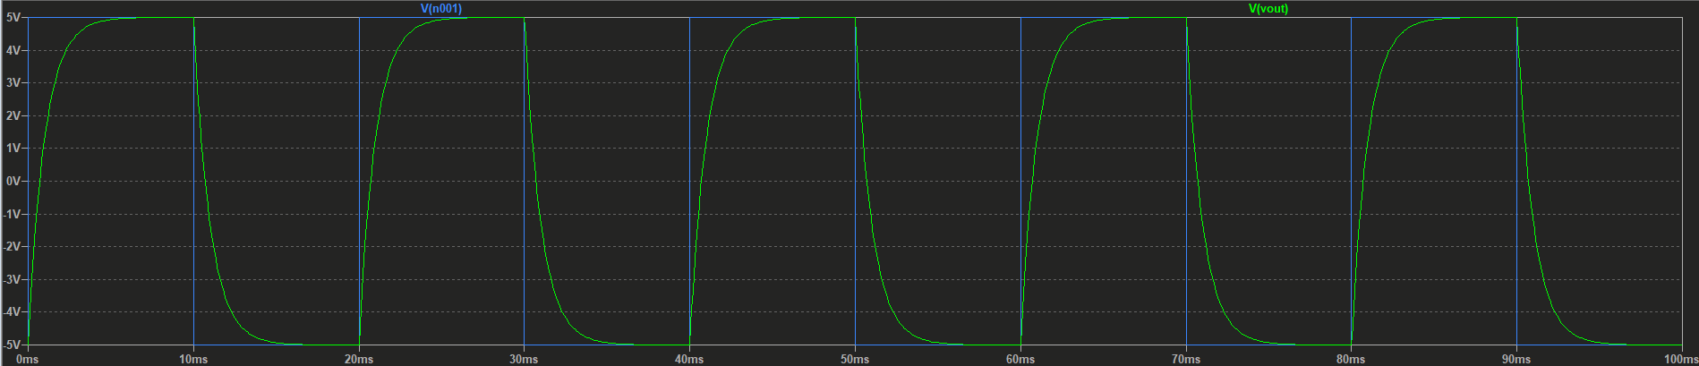

**(d) Circuit in LTspice:**

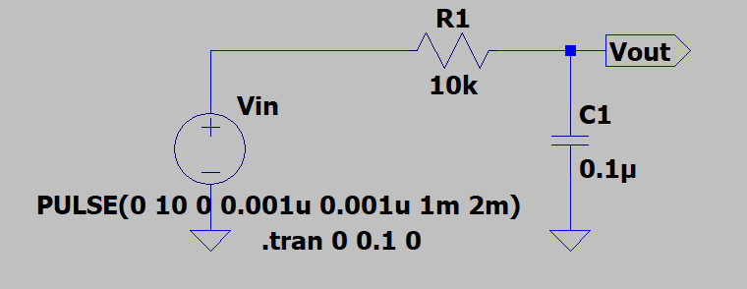

**Output waveform:**

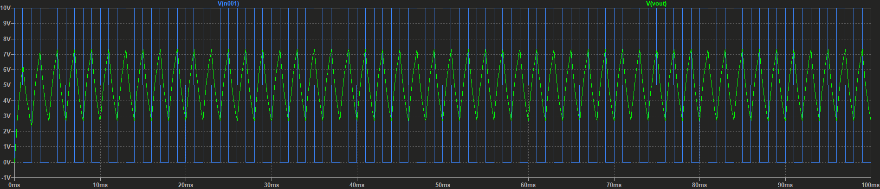

**Observations:**

We can observe that the output waveform is same as for the previous circuits with same frequency, this is because only the input voltage has been shifted up and not the frequency or shape.

**(e.a) Circuit in LTspice:**

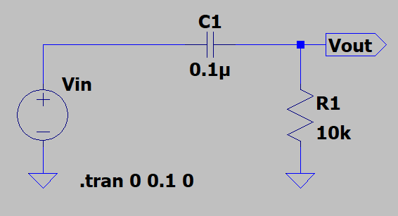

**(e.b) Circuit in LTspice:**

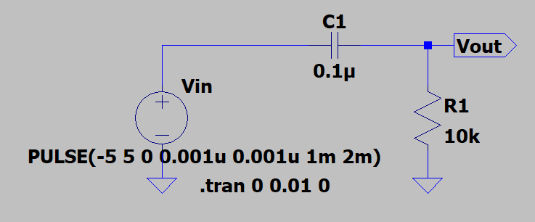

**(e.c) T=0.4ms**

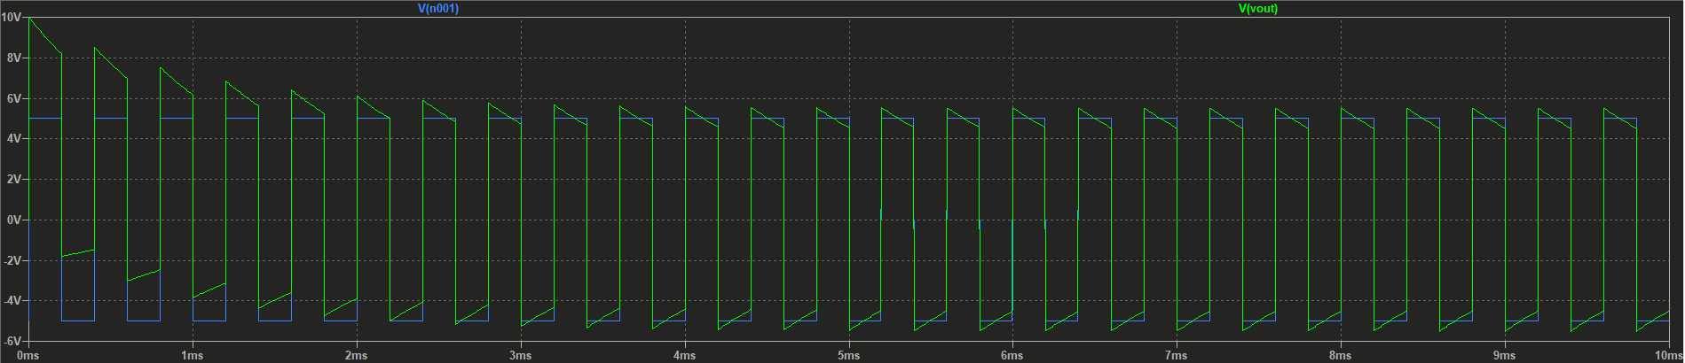

**T=2ms** | transient time stop = 0.1s

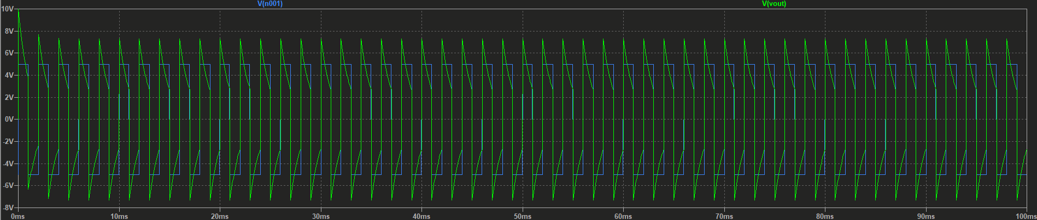

**T=20ms** | transient time stop = 1s

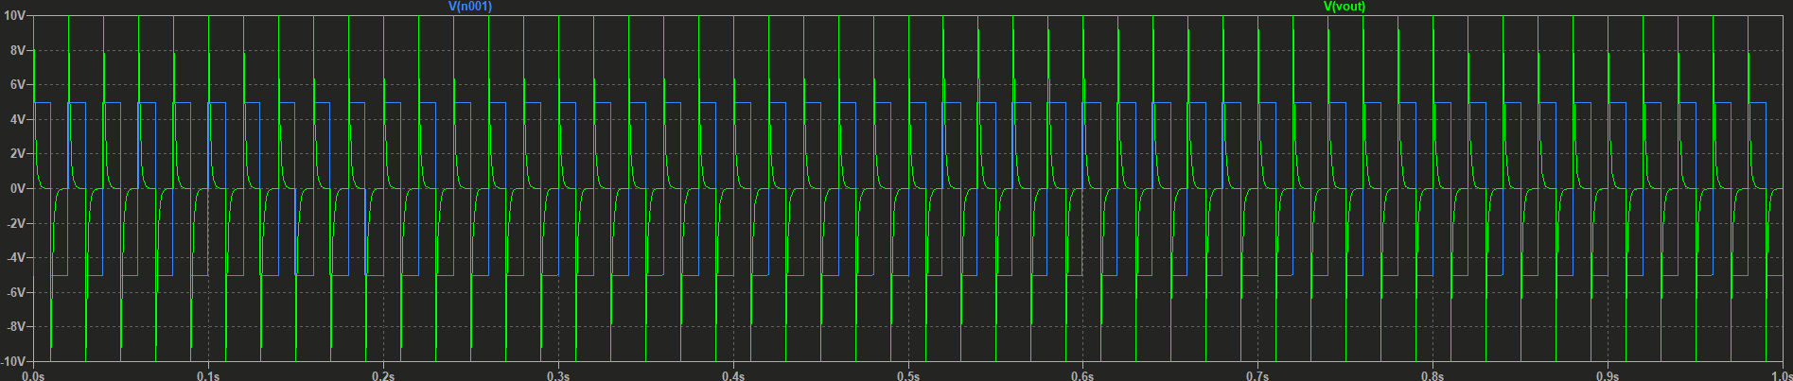

**(e.d)**

**Circuit in LTspice:**

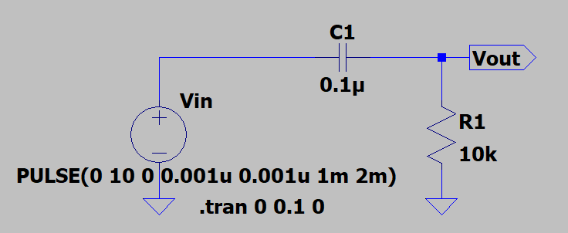

**Output waveform:**

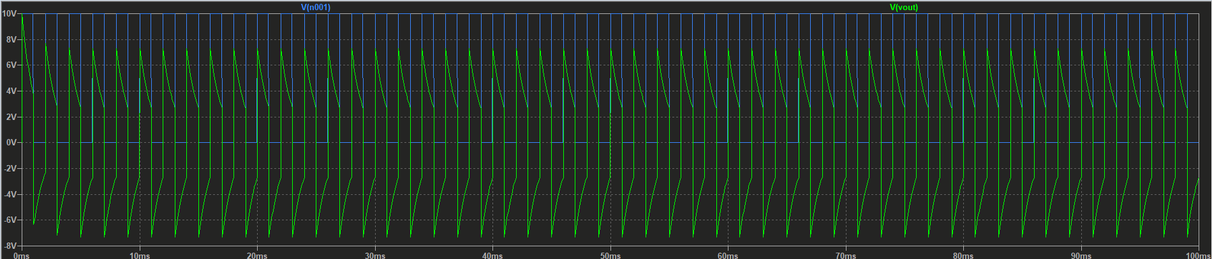

**Observations:**

We can observe that the output waveform is same as for the previous circuits with same frequency, this is because only the input voltage has been shifted up and not the frequency or shape.