**EC205**

**Analog Electronics Lab**

**Lab – 5**

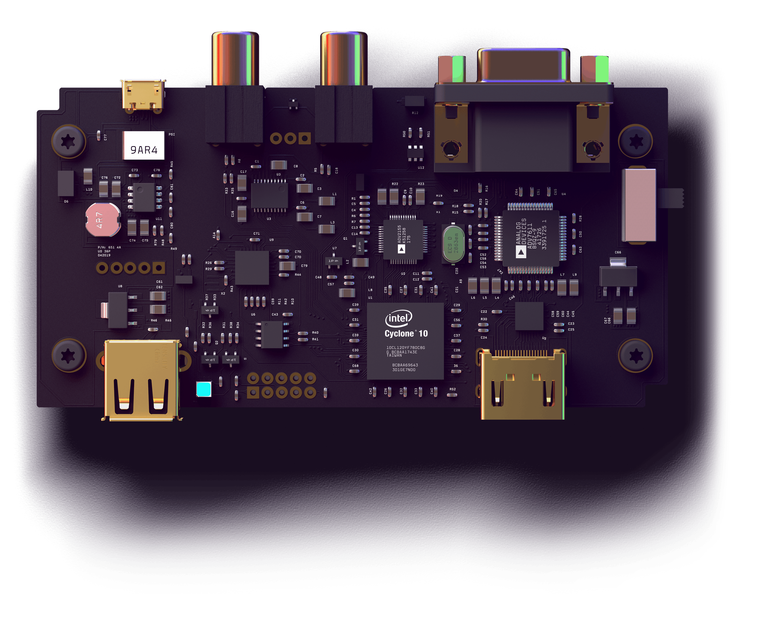

**Utkarsh R Mahajan 201EC164**

**Sannan Ali 201EC159**

**Experiment 5: Effect of Negative Feedback**

**Aim:** To study the effect of negative feedback on gain and bandwidth of the amplifier.

**Background :**

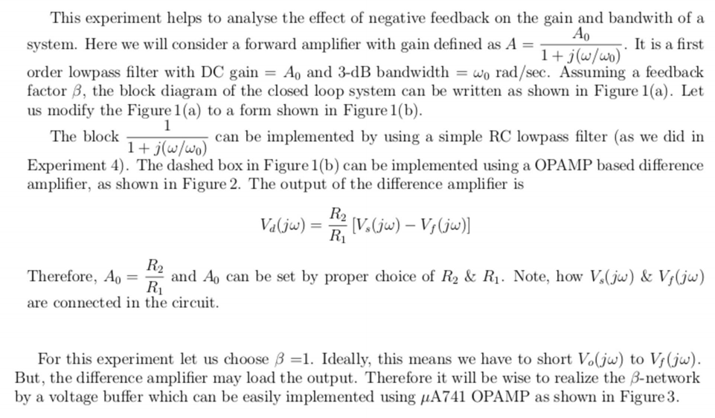

**Procedure:**

**Design the RC-filter for a cutoff frequency of 200 Hz (Design such that R Is of the order of kΩ)**

fCutoff = 200Hz =

Considering R =10kΩ,

using the above formula for cutoff frequency,

we get, C=79.617834395µF

Circuit Diagram:

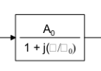

Circuit in LTSpice:

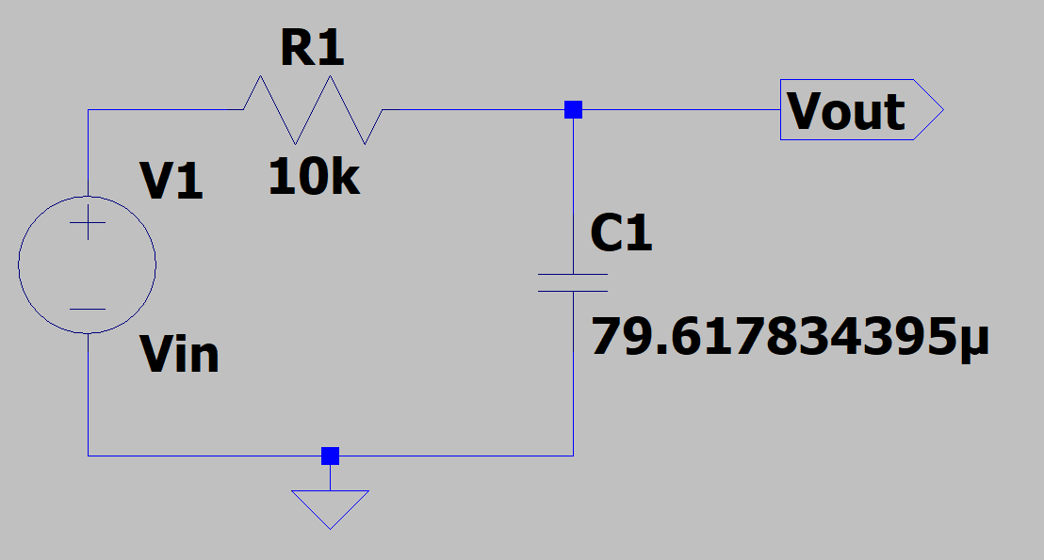

**Design the difference amplifier for A0=10.**

Circuit Diagram:

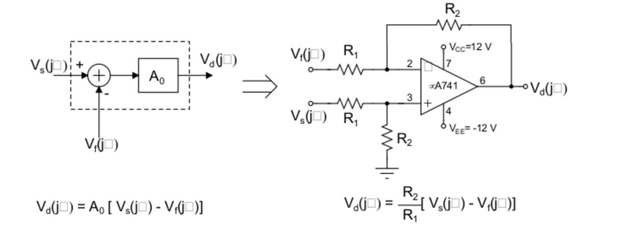

For A0=10, We have to choose R2 and R1 such that they are in ration 10:1.

So lets consider R2 = 10k Ω and R1 = 1k Ω

Circuit in LTSpice:

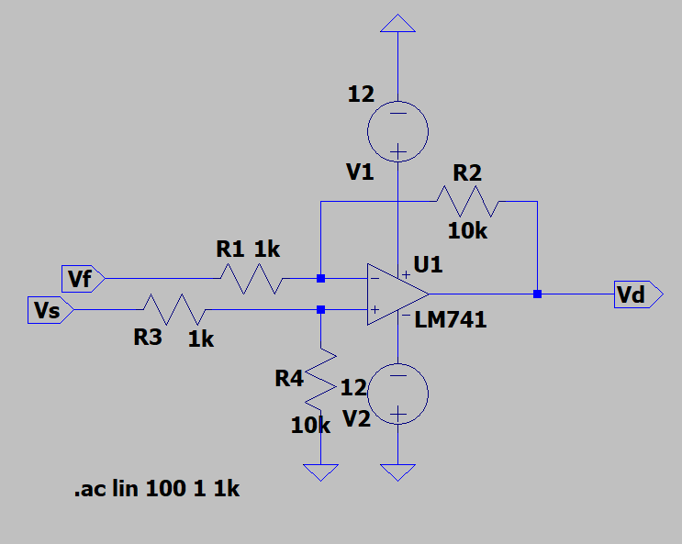

**Voltage Buffer:**

Circuit Diagram:

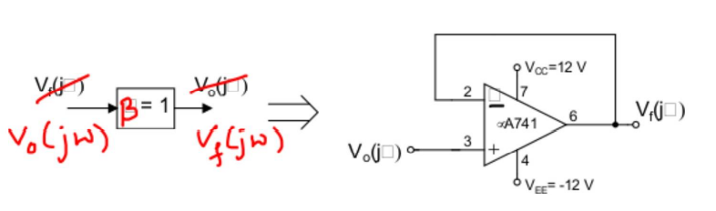

Circuit in LTspice:

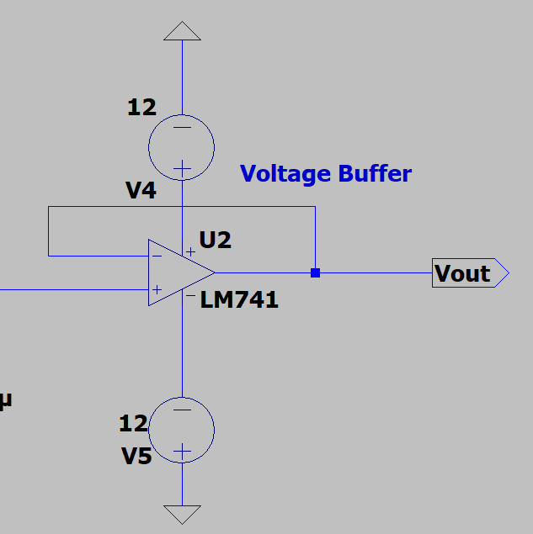

**Obtain the magnitude response of the forward amplifier. For this, set the feedback input of the difference amplifier Vf(jω)=0 and set the other input to 1 Vpp (Note: Take care not to connect output of the buffer to the input of the difference amplifier, otherwise you will end up shorting the output of the buffer to ground which can damage the op-amp used for the buffer in the hardware lab). Find all the salient features of the magnitude response.**

Circuit in LTspice:

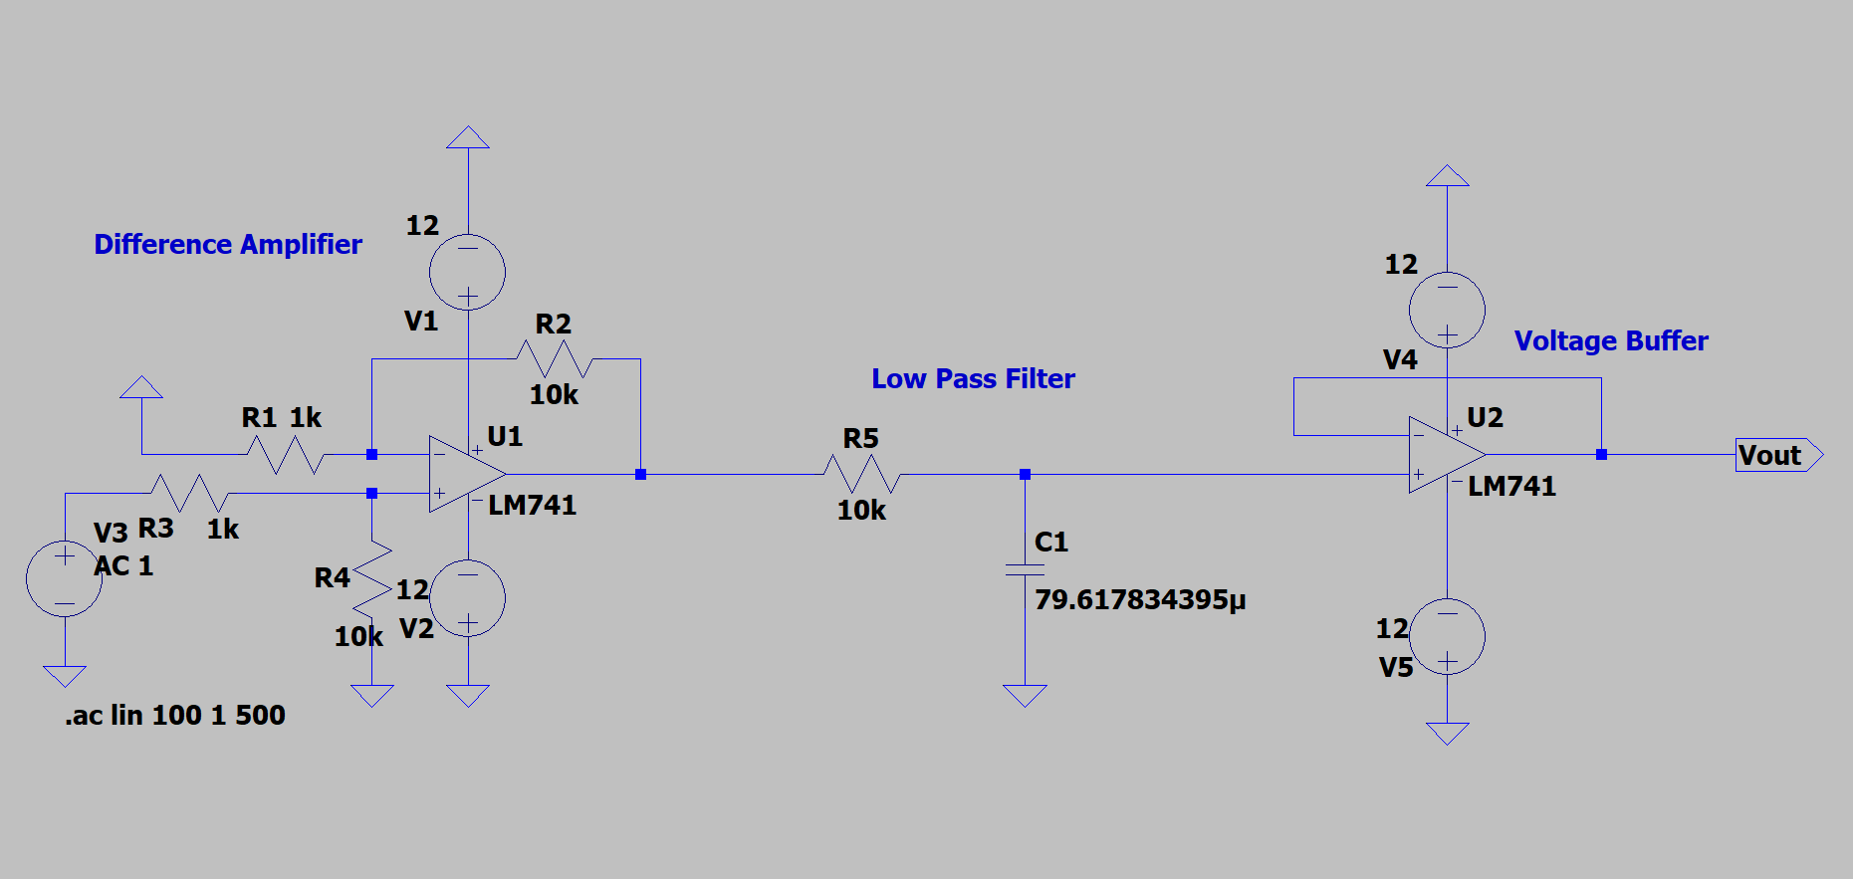

Observations:

Waveform:

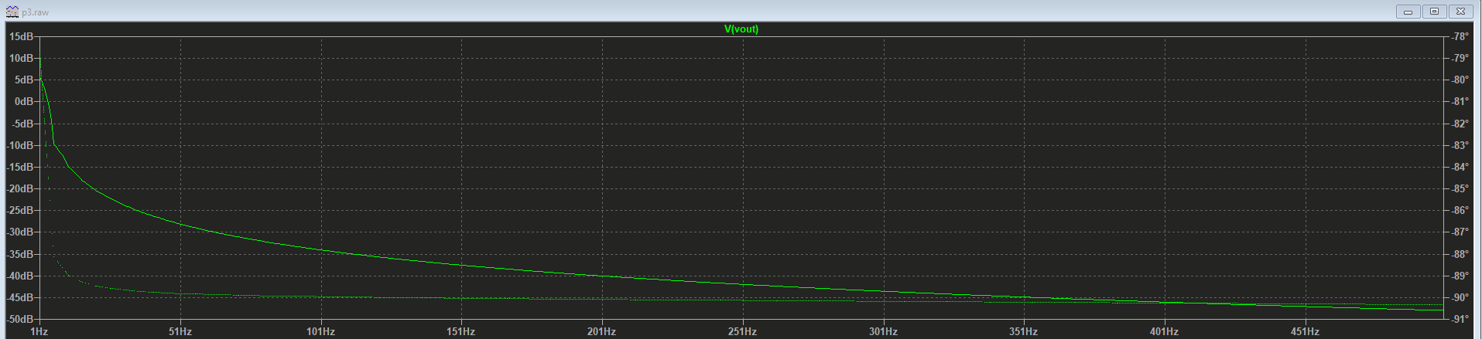

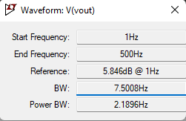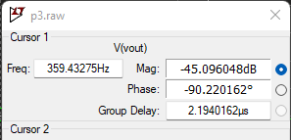

**Now close the loop by connecting output of the voltage buffer to the feedback input of difference amplifier.**

Circuit Diagram:

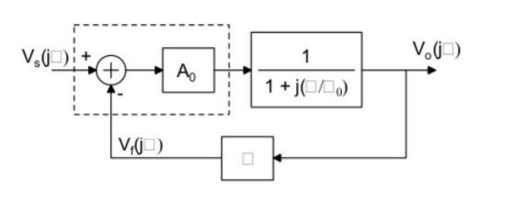

Circuit in LTspice:

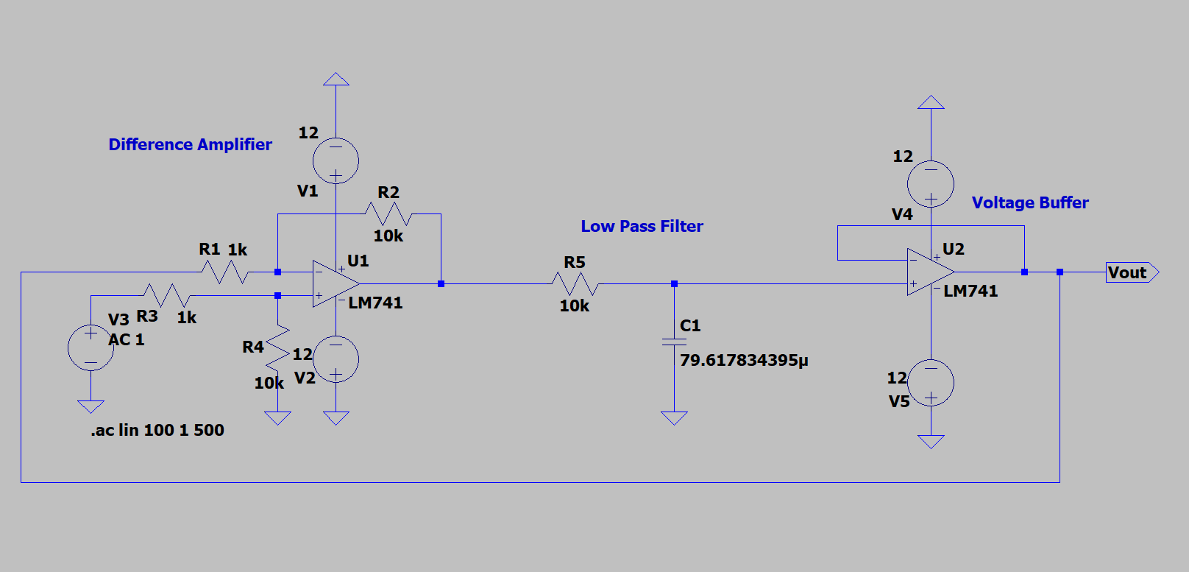

**Obtain the magnitude response and compare it with that of the forward amplifier**

Observations:

Waveform:

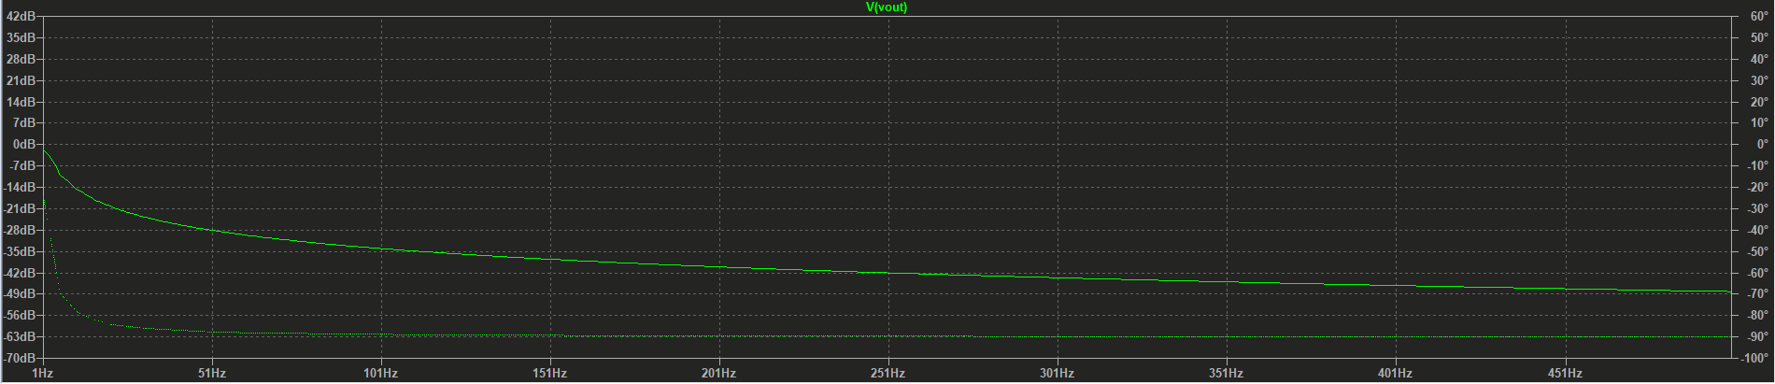

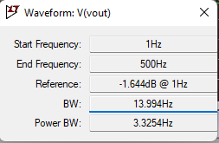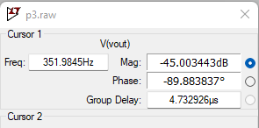

Comparison:

Taking both the circuits and and developing the waveform, we get.

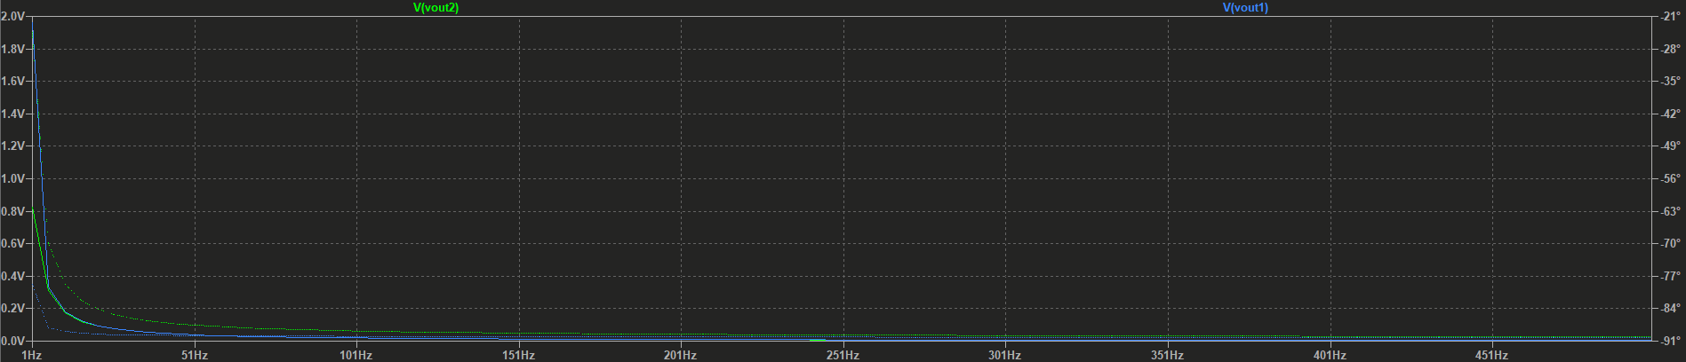

From which we can see that the voltage in the 2nd case is of lower value at lower frequency as compared to in the 1st case(grounded feedback).