**EC205**

**Analog Electronics Lab**

**Lab – 6**

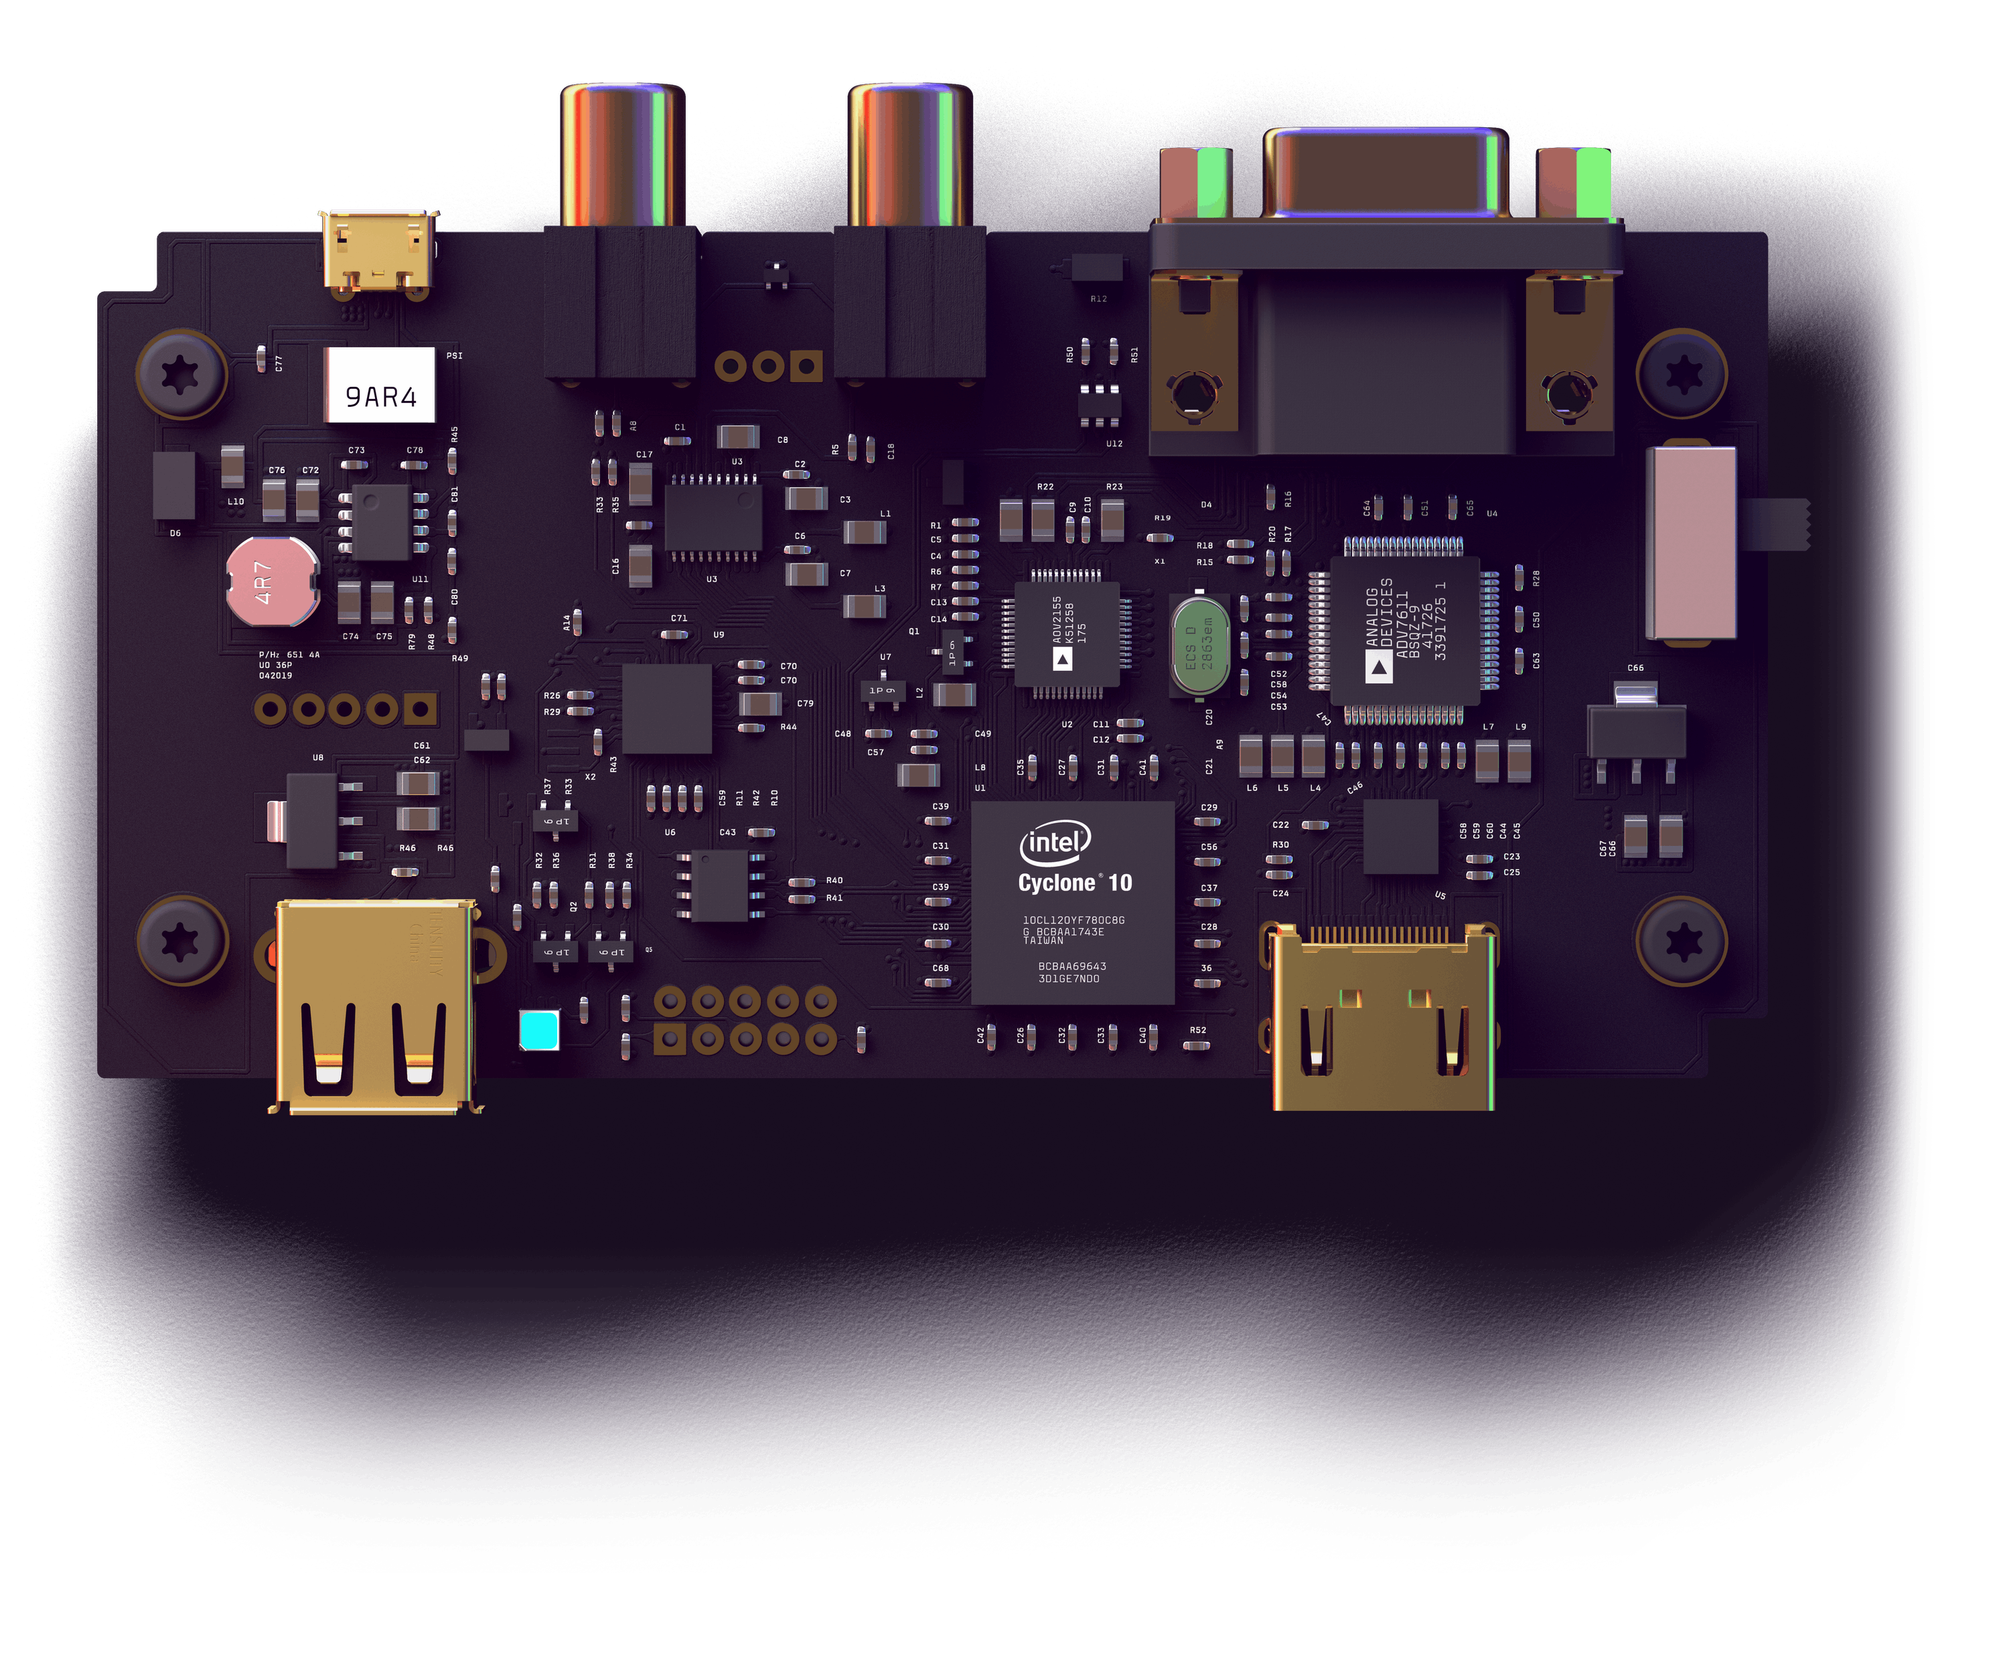

**Utkarsh R Mahajan 201EC164**

**Sannan Ali 201EC159**

**Experiment 6: Non-inverting Amplifier**

**Aim:** To design a OPAMP µA741 based non-inverting amplifier with gain adjustable between 2 and 10.

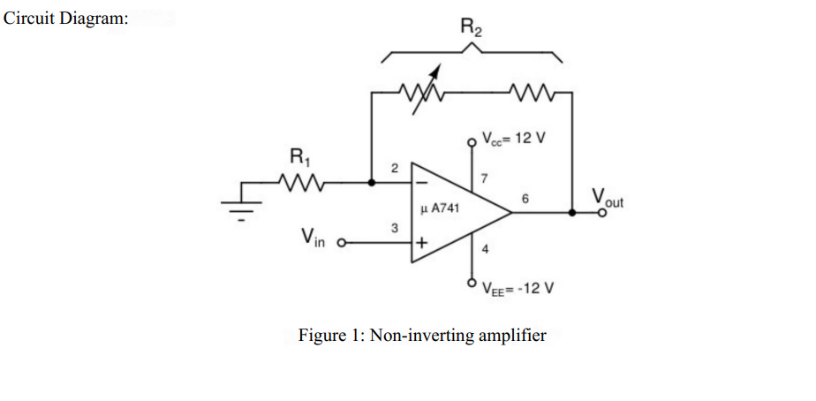

**1. Design a non-inverting amplifier whose gain can be adjusted between 2 and 10 (approximately). Choose resistances of the order of kilo ohm.**

->

2 < < 10

2 < < 10

Considering R1 =1KΩ , 1k < R2 < 9k

Using .step function and using R as parameter we will test it for values from 1k to 9k with step of 1k.

Circuit in LTSpice:

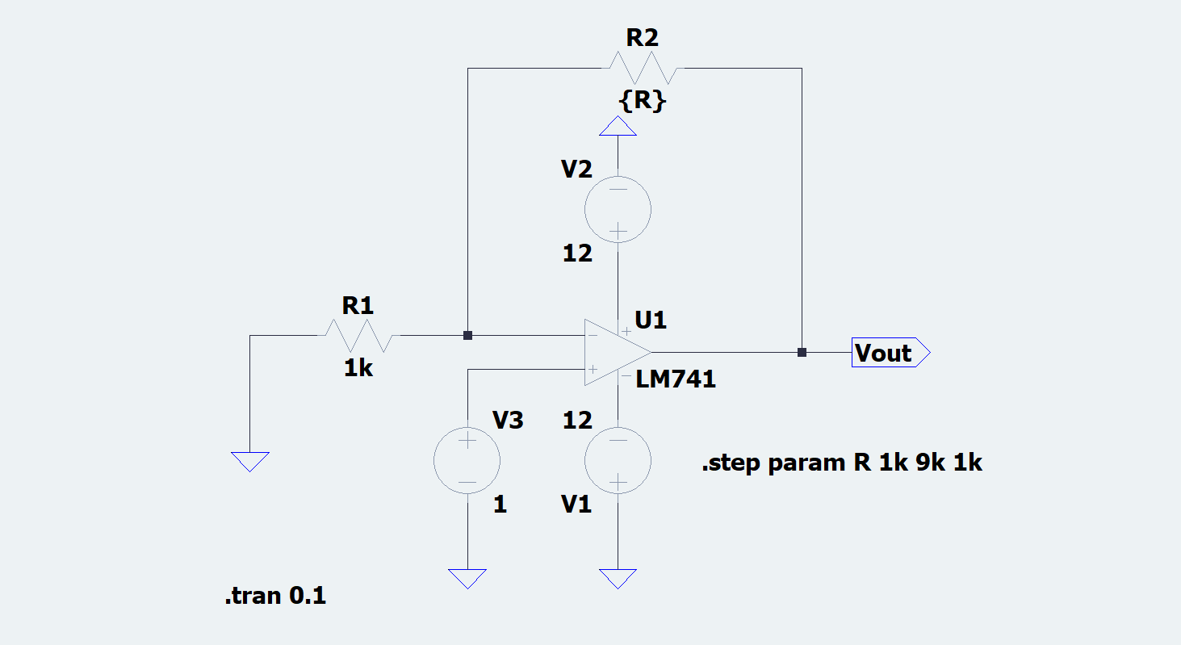

Observations:

Waveform:

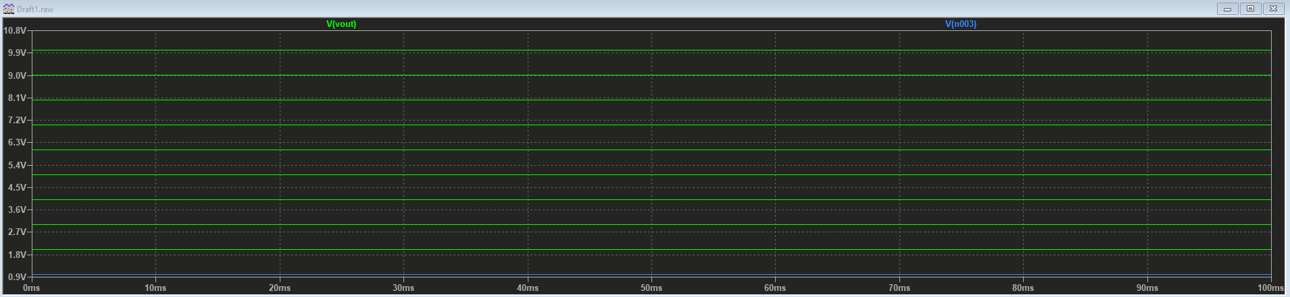

The green lines shows the output for different values of resistance.

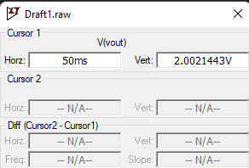

For DC op input

Circuit in LTSpice:

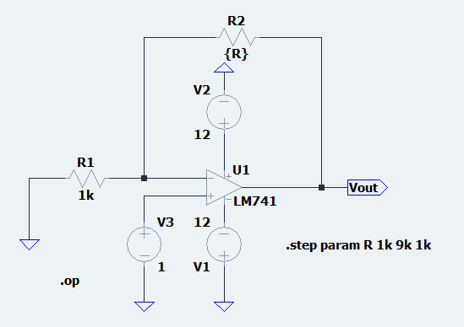

Observations:

Waveform:

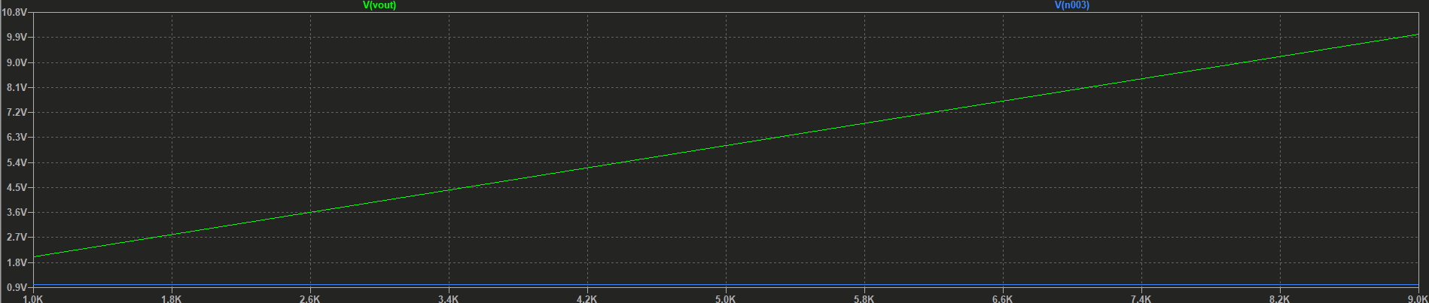

We can see that the Vout is 10v for 9kΩ resistance(of R2) as expected from the formula for the gain.

**2. Test the designed circuit for gain settings of 2,6 and 10 with a suitable DC input voltage. Gain adjustments should be done by using a potentiometer. Tabulate your observation in the format shown in Tablet.**

For gain of 2, R2 = 1kΩ

Circuit in LTSpice:

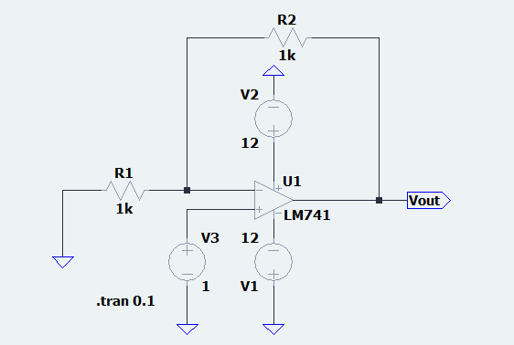

Observations:

Waveform:

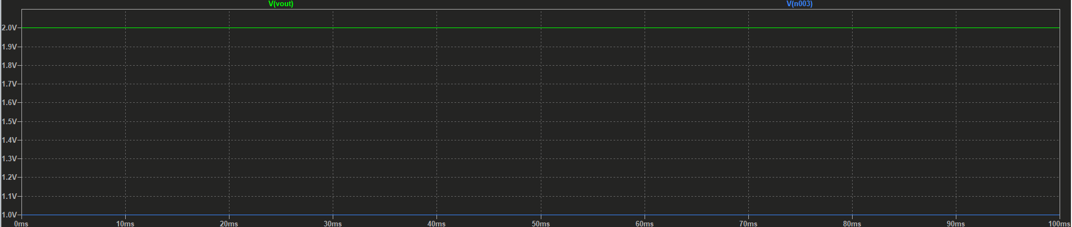

For gain of 6, R2 = 5kΩ

Circuit in LTSpice:

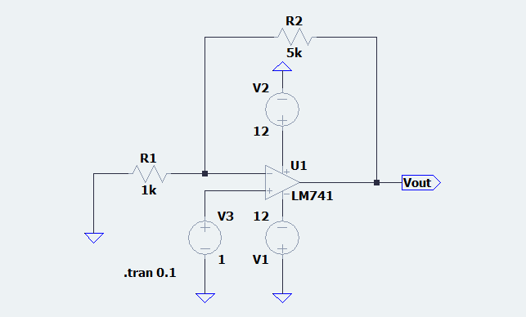

Observations:

Waveform:

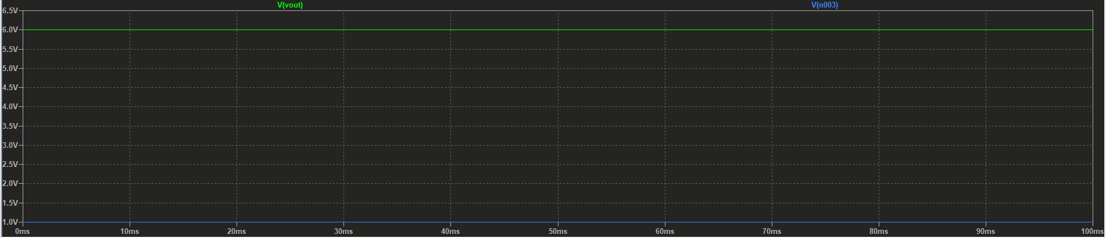

For gain of 10, R2 = 9kΩ

Circuit in LTSpice:

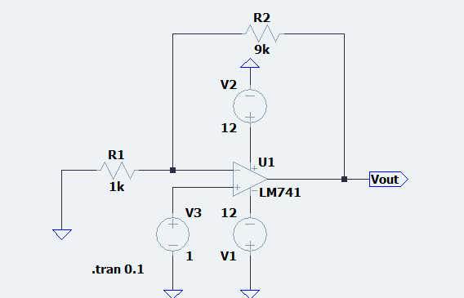

Observations:

Waveform:

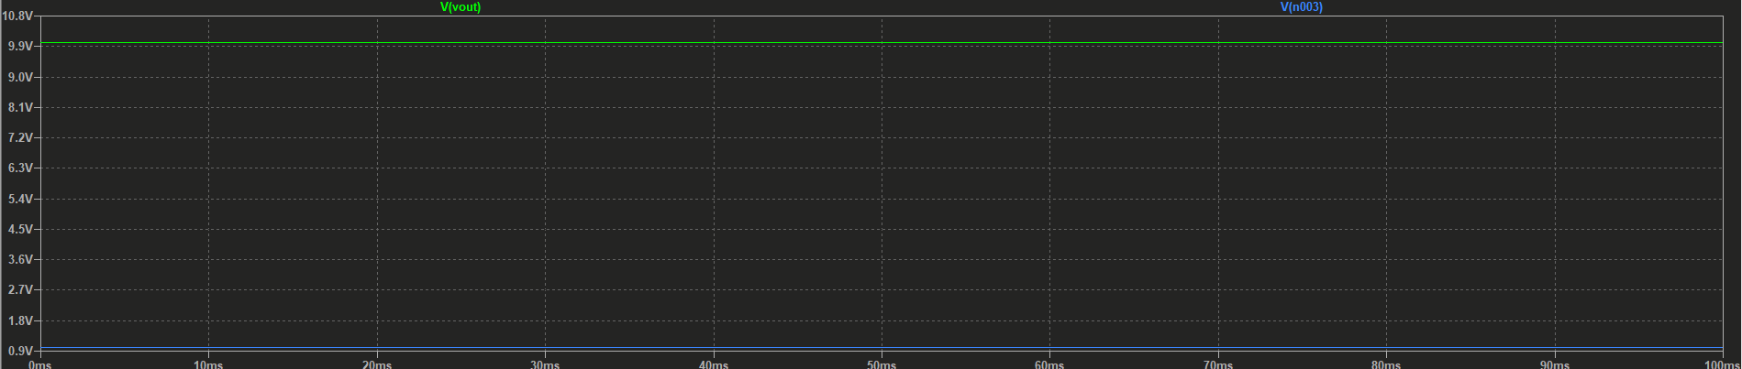

**3. Find output saturation voltages (+ve and -ve) of the Opamp you used**

|  |  |  |  |  |  |  |
| --- | --- | --- | --- | --- | --- | --- |
| Gain Setting | R1 (Q) | R2(Q) | Expected Gain | Vin(volts) | Vout Volts | Observed gain |
| 2 | 1 | 1 | 2 | 1 | 2.002 | 2.002 |
| 6 | 1 | 5 | 6 | 1 | 6.006 | 6.006 |
| 10 | 1 | 9 | 10 | 1 | 10.010 | 10.010 |

+ve Saturation Voltage: +10.932 V

-ve Saturation Voltage: -10.932 V

From the data sheet of µA741, find the following.

1. Open loop gain (DC gain)

->106Db when drawing 2000Ohm Load

2. Input Impedance

-> 2 MΩ

3. Output impedance

->75 MΩ

4. Unity gain bandwidth

->1 MHz

5. Slew Rate

->0.5 V/ms

6. Maximum source/sink capacity of the opamp

->10mA/2mA

7. Common-mode rejection ratio (CMRR)

-> 90dB

8. Input Bias Current

-> 80nA

9. Input Offset Voltage

-> 1mV

Think about these

Can you modify the circuit to get a gain <1? You may use additional resistances but not op-amps.

-> Yes, we can get a gain below 1 using resistors for dividing the output voltage. Since the least voltage we can gain is just greater than 1, while 1 isn’t possible without having R2 as 0. We take 2 another resistors R3 and R4 at output connected in series and then take the output Vout from between and set the value of R4 as lower than that of R3 so more potential gets dropped at R3 leading to a voltage ratio lesser than 1 at R4. Taking a lower value R2 like 1 Ω we can achieve a gain lower than 1.

For example, lets take a very lower value of R2 compared to R1, R2=1 Ω and R1=1k Ω

Circuit in LTSpice:

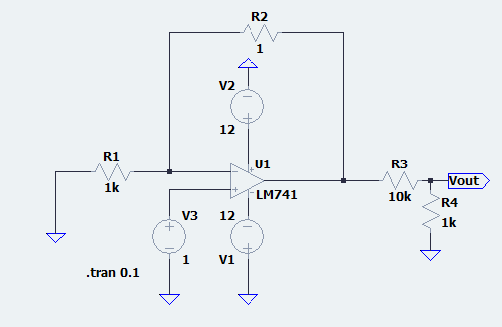

Observations:

Waveform:

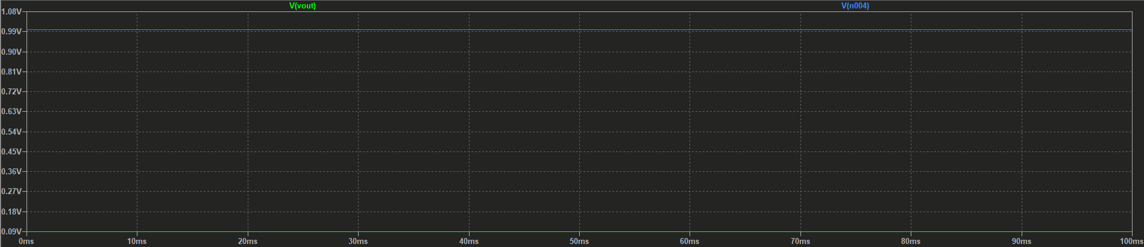

We can see that the output voltage is less than 1 and since the input voltage is 1. The gain is less than 1.

The gain of the amplifier depends on the ratio of resistors but not their absolute values. However, The lower bound on the resistors is in fact decided by the source/sink capacity of the opamp. Is there a upper bound? Do the following.

Choose R1 = R2, i.e gain of 2. Observe the output for resistor values 10 k Ω 1M Ω and 10 M Ω for an input of 1kHz, 1 V peak-to-peak sinusoidal signal. Measure peak-to-peak and average value of both input and output waveforms. What do you notice? why? (Hint: Input Bias current of the opamp)

->

R=10 k Ω Circuit in LTSpice:

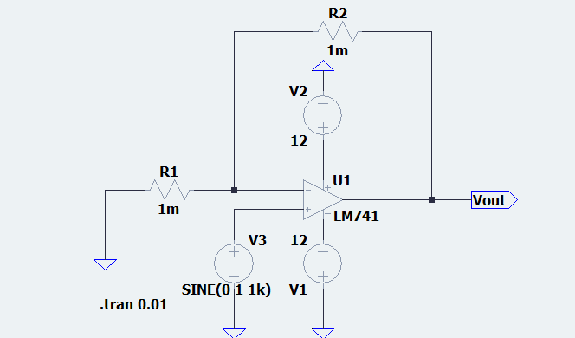

Observations:

Waveform:

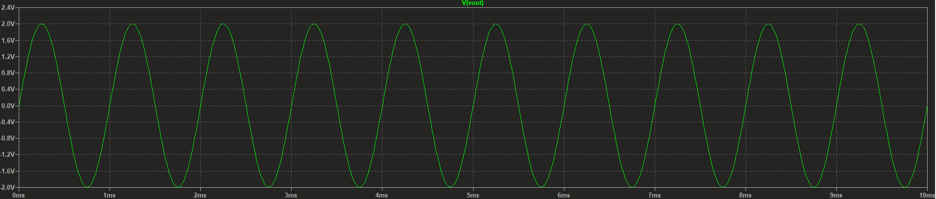

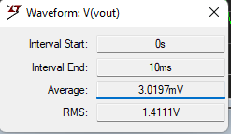

Vavg=3.0197mV

Vp2p=200mV

For R = 1M Ω, Circuit in LTSpice:

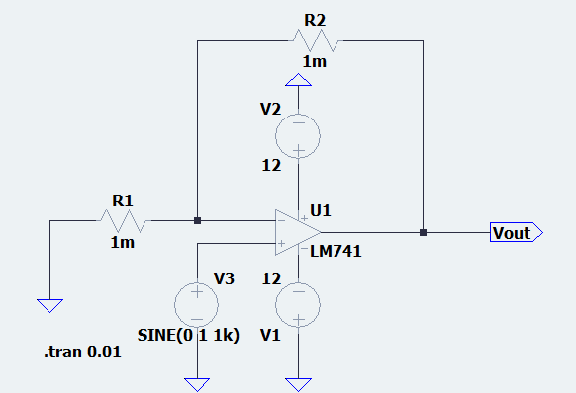

Observations:

Waveform:

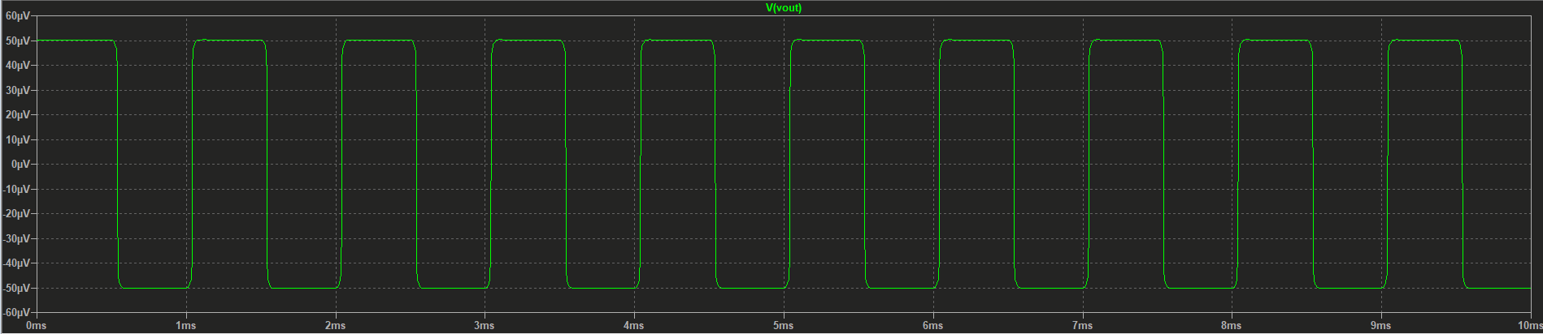

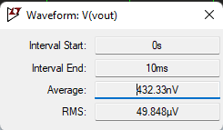

Vavg= 432.33nV

Vp2p= 50 µV

For R = 10M Ω, Circuit in LTSpice:

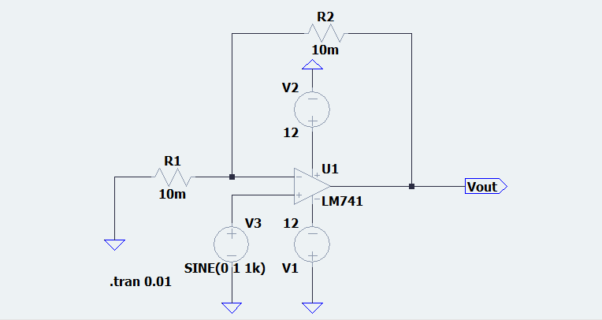

Observations:

Waveform:

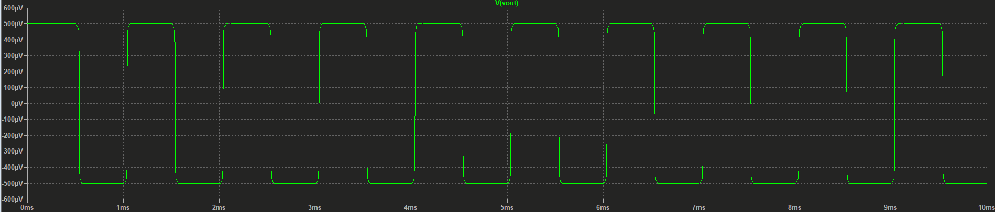

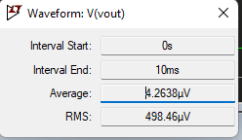

Vavg= 4.2638µV

Vp2p= 500 µV

Final Observations:

We see that the with increase in Resistance, the peak voltage keeps decreasing and then again increase.

Repeat the above experiment by placing a resistor equal to R1 || R2 in series with the input voltage source. What do you see?

->

R=10 k Ω Circuit in LTSpice:

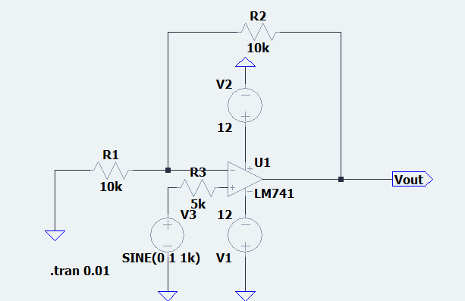

Observations:

Waveform:

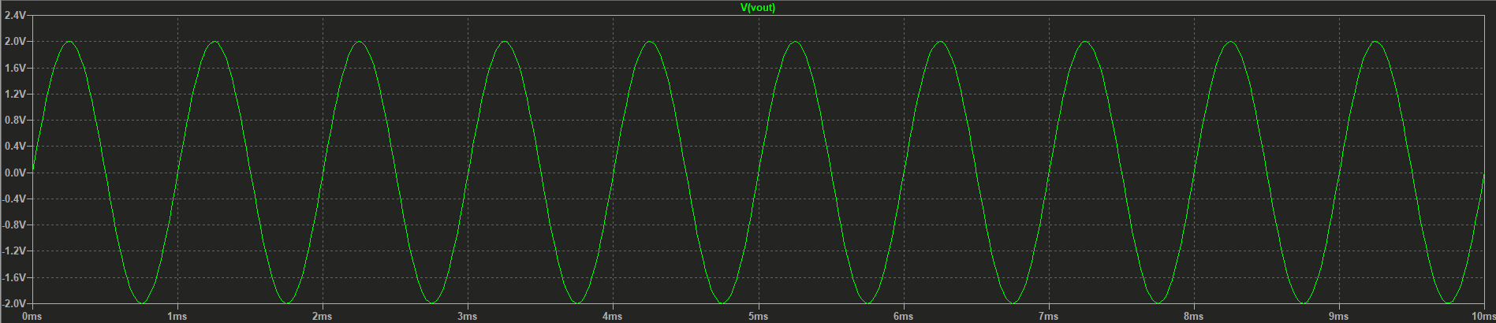

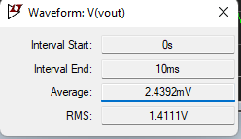

Vavg= 2.4392mV

Vp2p= 1.9986415V

R=1MΩ, Circuit in LTSpice:

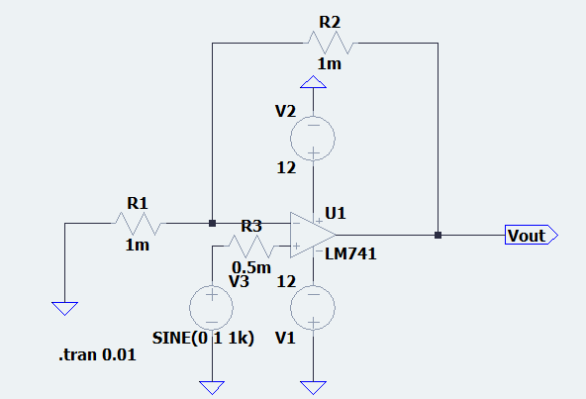

Observations:

Waveform:

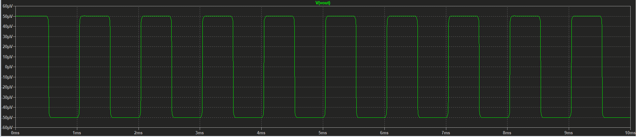

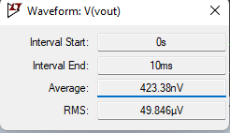

Vavg=423.38nV

Vp2p=50µV

R=10 M Ω Circuit in LTSpice:

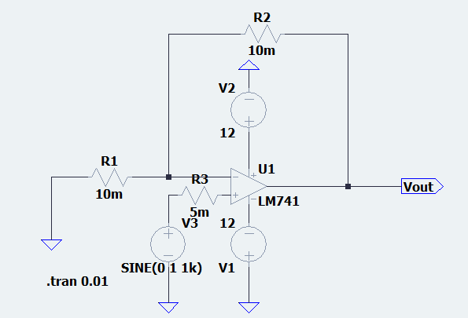

Observations:

Waveform:

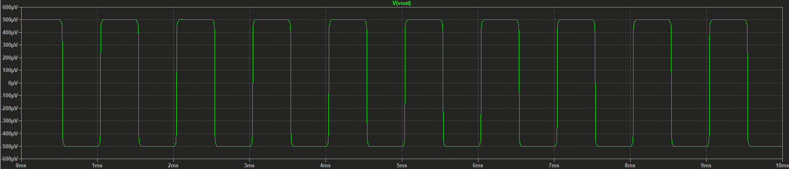

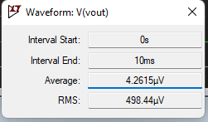

Vavg=4.2615µV

Vp2p=500µV