**EC205**

**Analog Electronics Lab**

**Lab – 7**

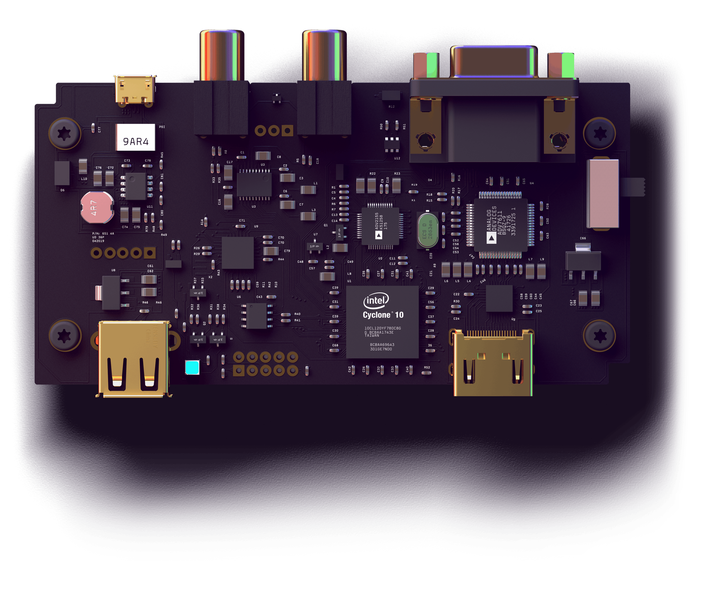

**Utkarsh R Mahajan 201EC164**

**Sannan Ali 201EC159**

**Experiment 7: Inverting Adder**

**Aim:** To design an Inverting Adder to add signals.

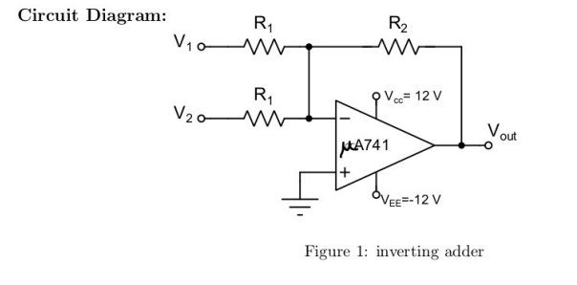

**1.** Design the inverting adder and test it with two inputs Vi = 2sin(10007rt) and V2 = 3 V DC. Observer and analyze the output waveform

->

= v1+v2 = 2sin(1000πt) + 3

= (2sin(1000πt) + 3)

KΩ

= [2sin(1000πt) + 3]

Circuit in LTSpice:

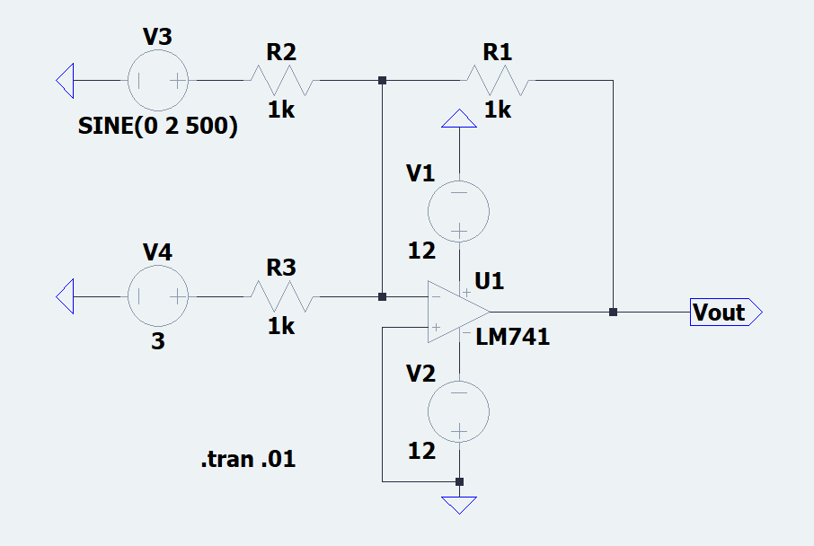

Observations:

Waveform:

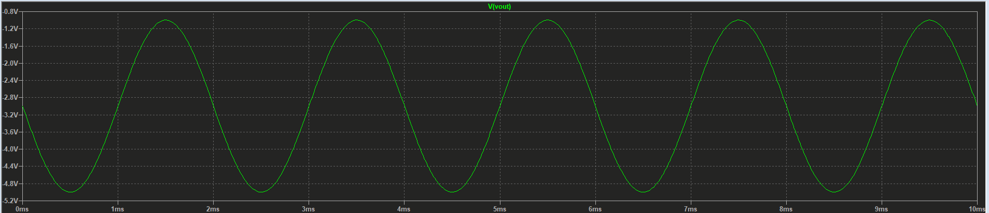

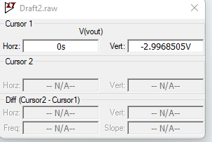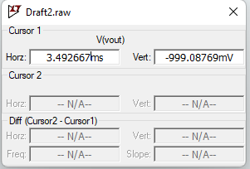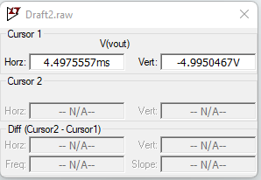

Think about these

What is the impedance seen by each of the input signal source?

With R1 = R2 = 10 kΩ, apply a sinusoidal input of 10 V peak-to-peak and frequency 1 kHz at V1 and set V2 to zero. You should observe an inverted sine wave of 10 V peak-to-peak at the output. Now slowly start increasing the input frequency upto 1 MHz. What do you notice? Can you justify the observation?

->

Circuit in LTSpice:

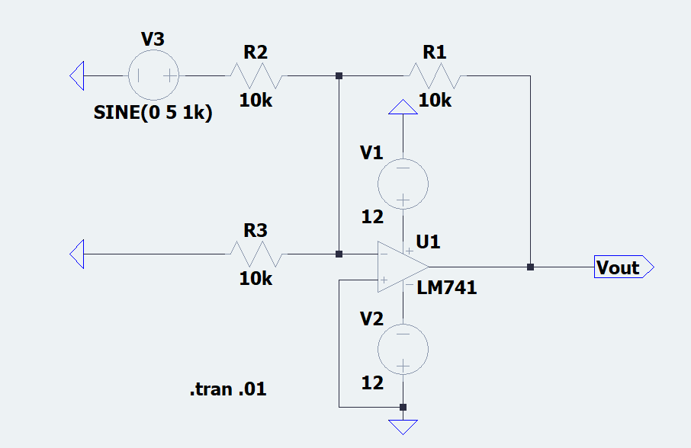

Observations:

Waveforms:

at f=1kHz

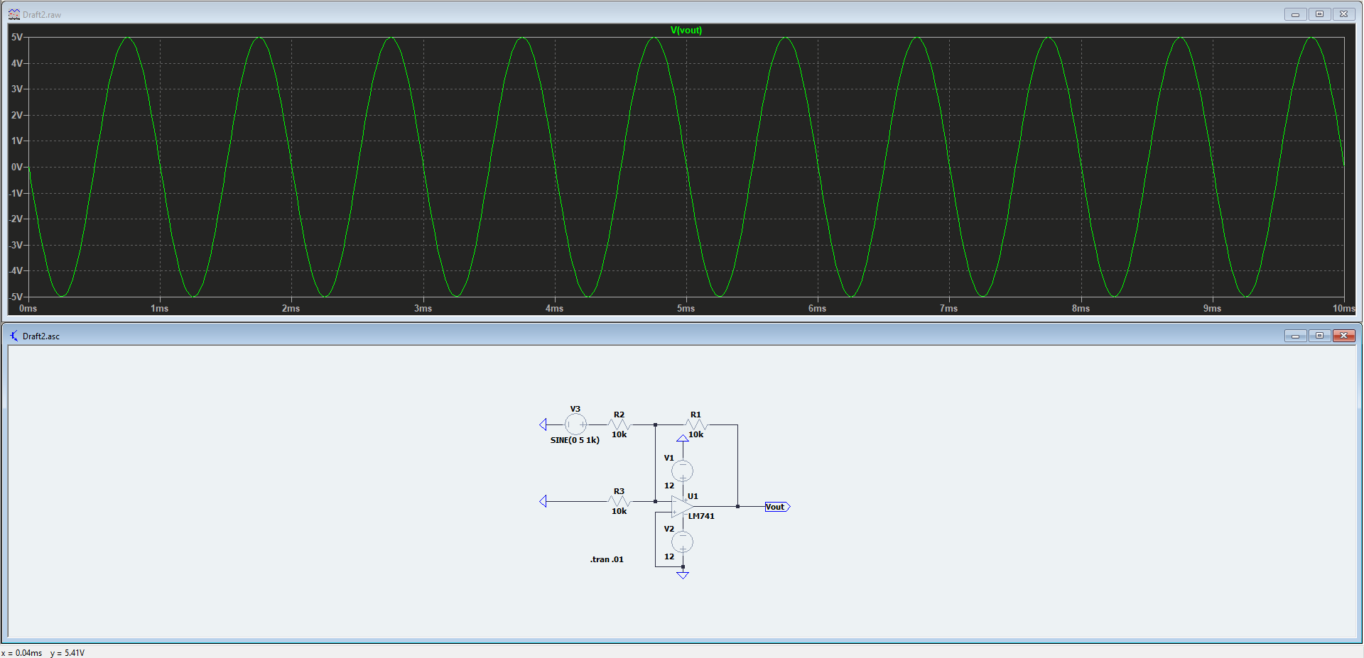

No distortions

at f=10kHz

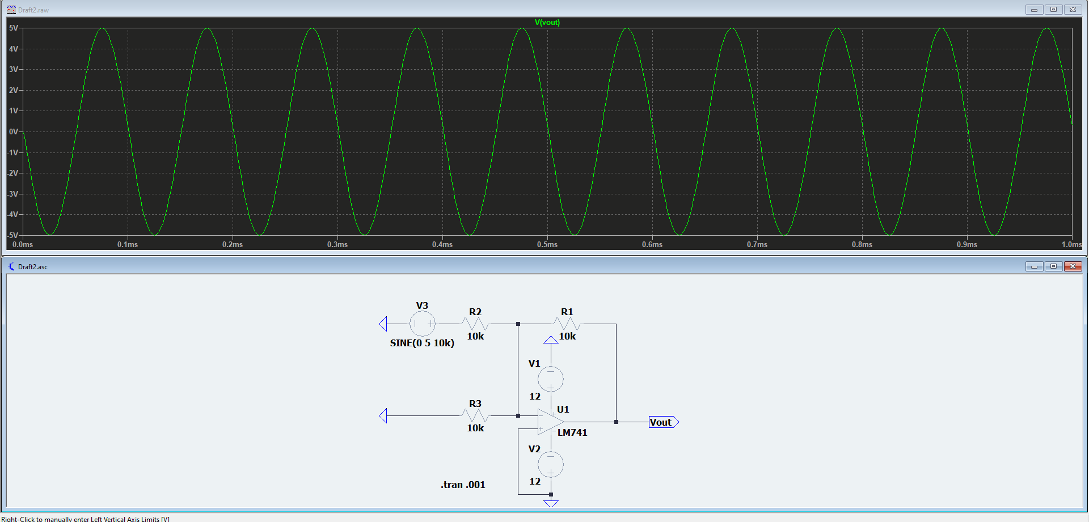

Some distortions are seen.

at f=100kHz

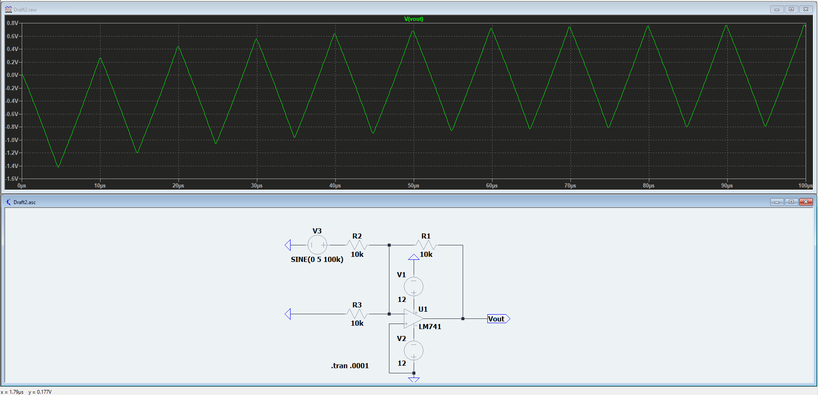

Heavy distortions.

At 1Mhz

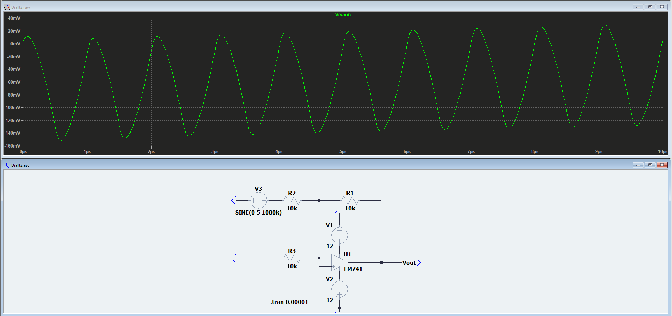

From the above 3 waveforms we can see that the distortion of the shape of the waveform increases and gain decreases with increase in frequency which is due to the poles created by the presence of parasitic capacitances in the op Amp.

For 2 Vp2p Circuit:

Circuit in LTSpice:

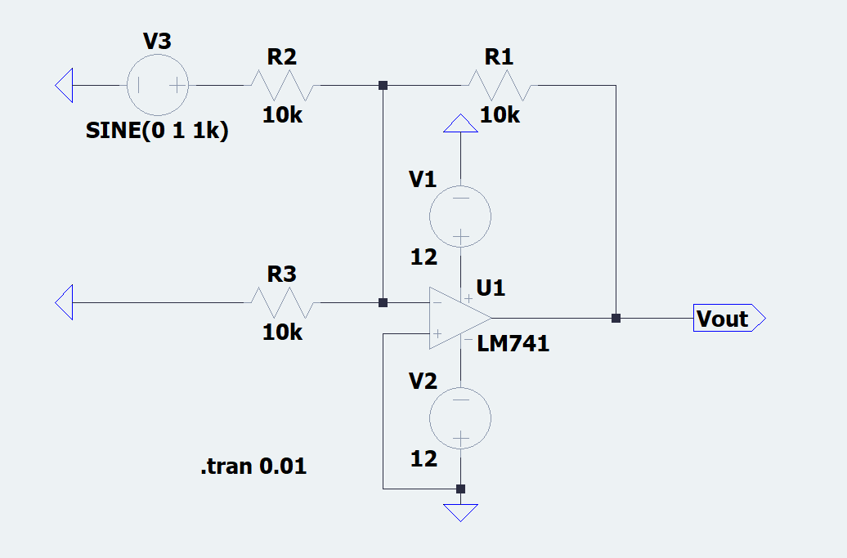

Observations:

Waveforms:

at f=1kHz

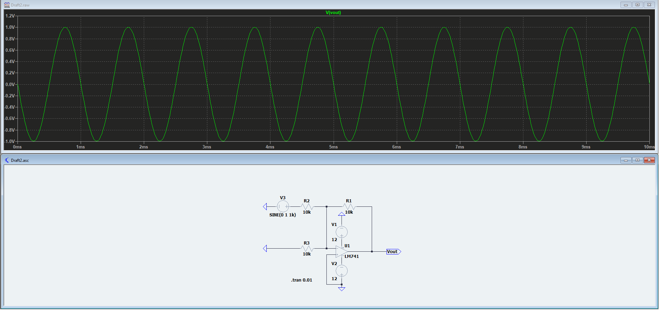

at f=10kHz

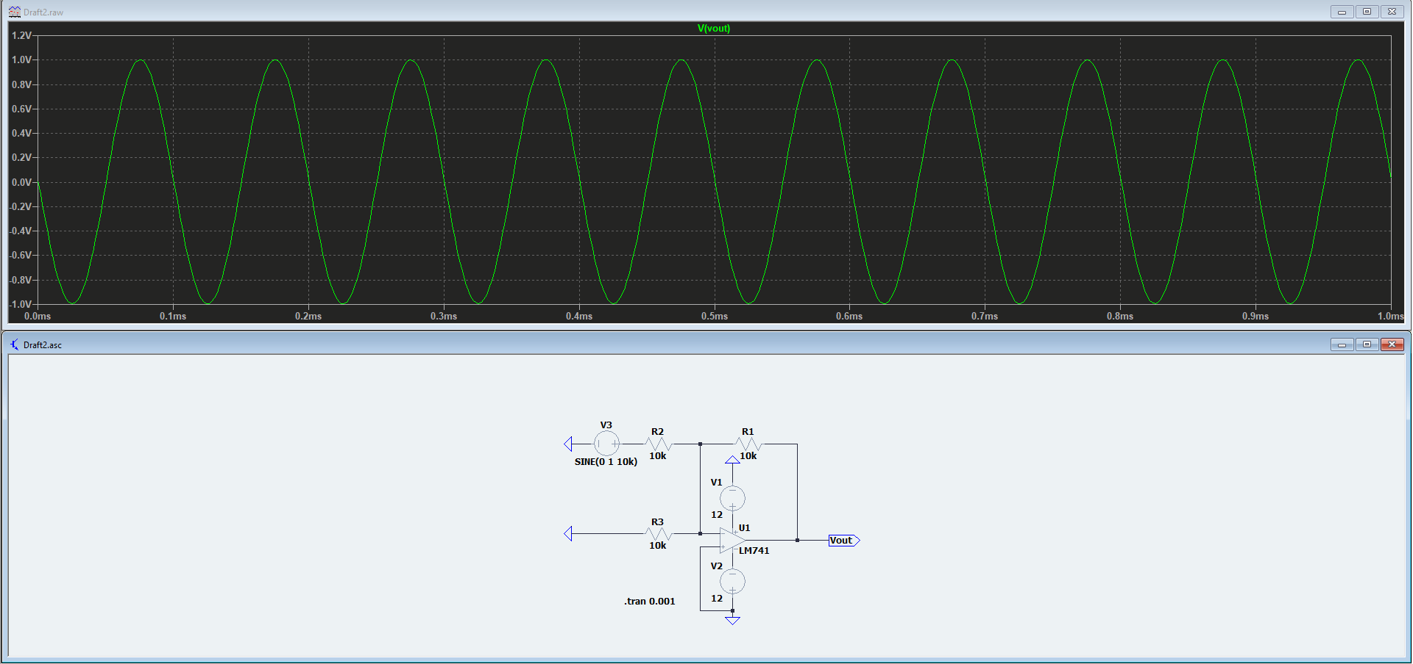

At f=50kHz

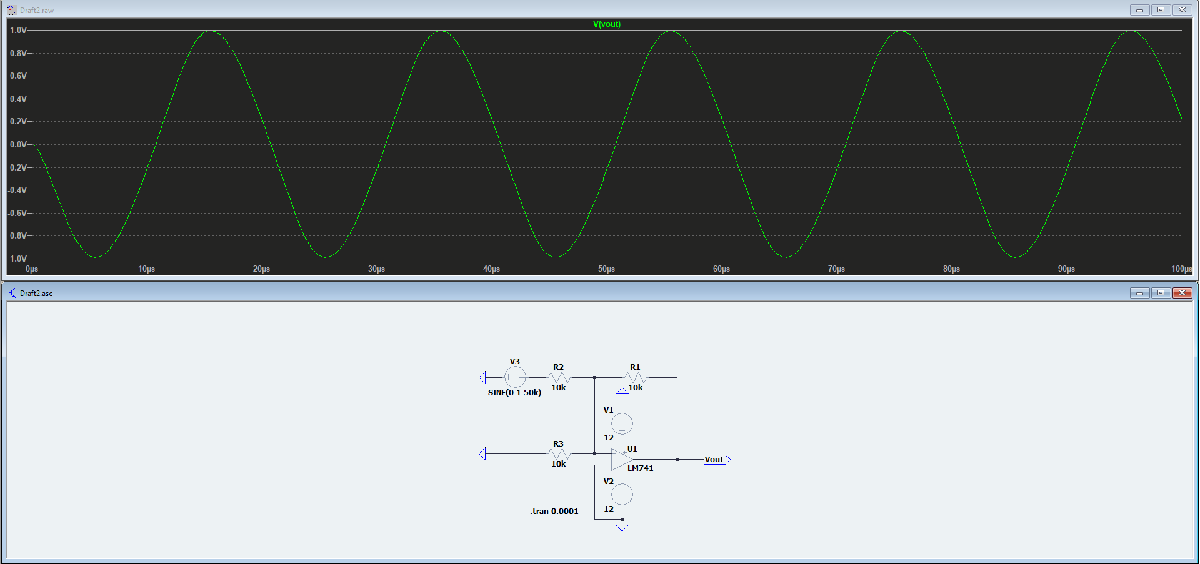

At f=100kHz

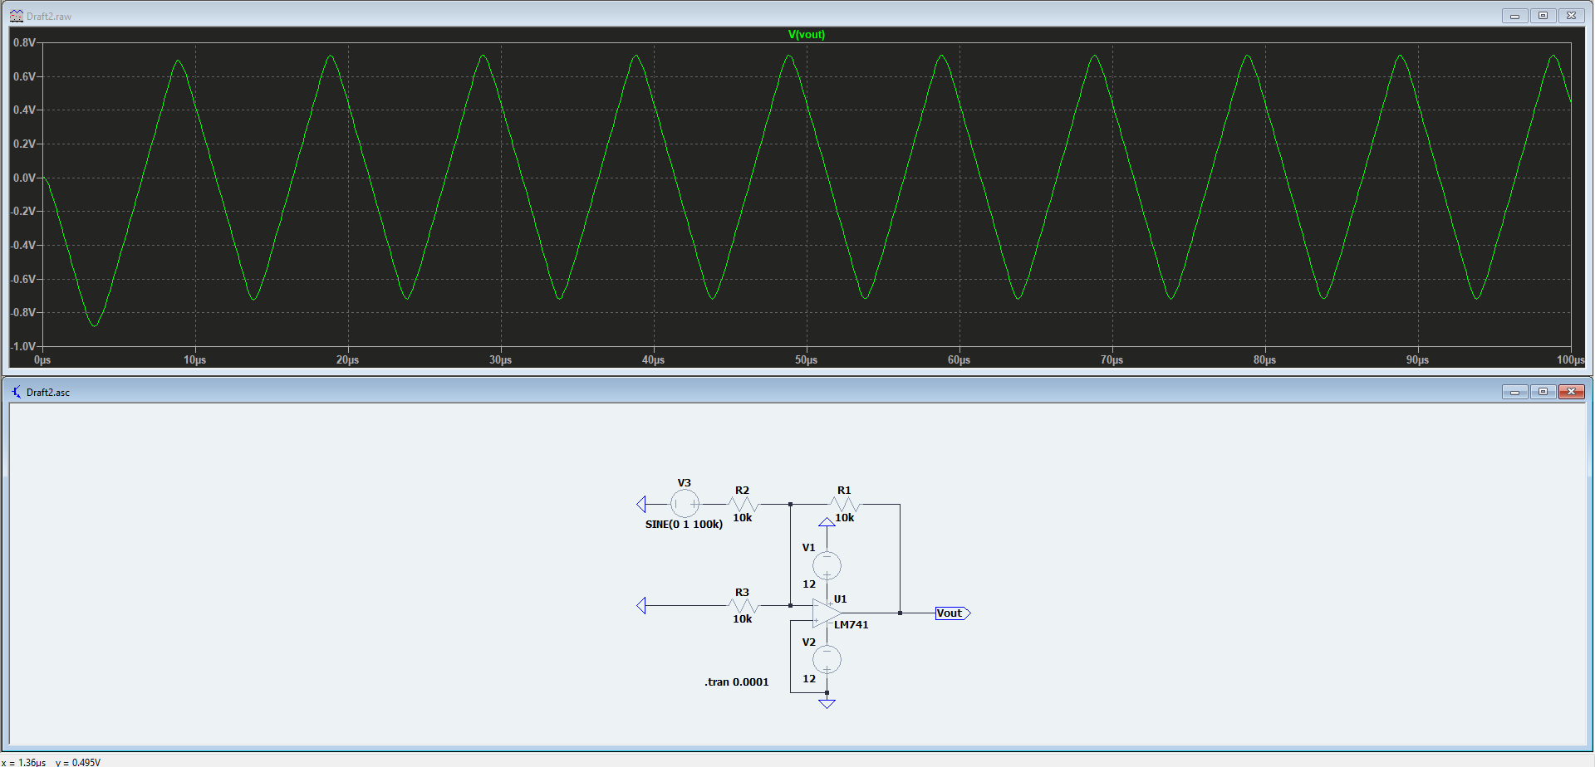

At f=1MHz

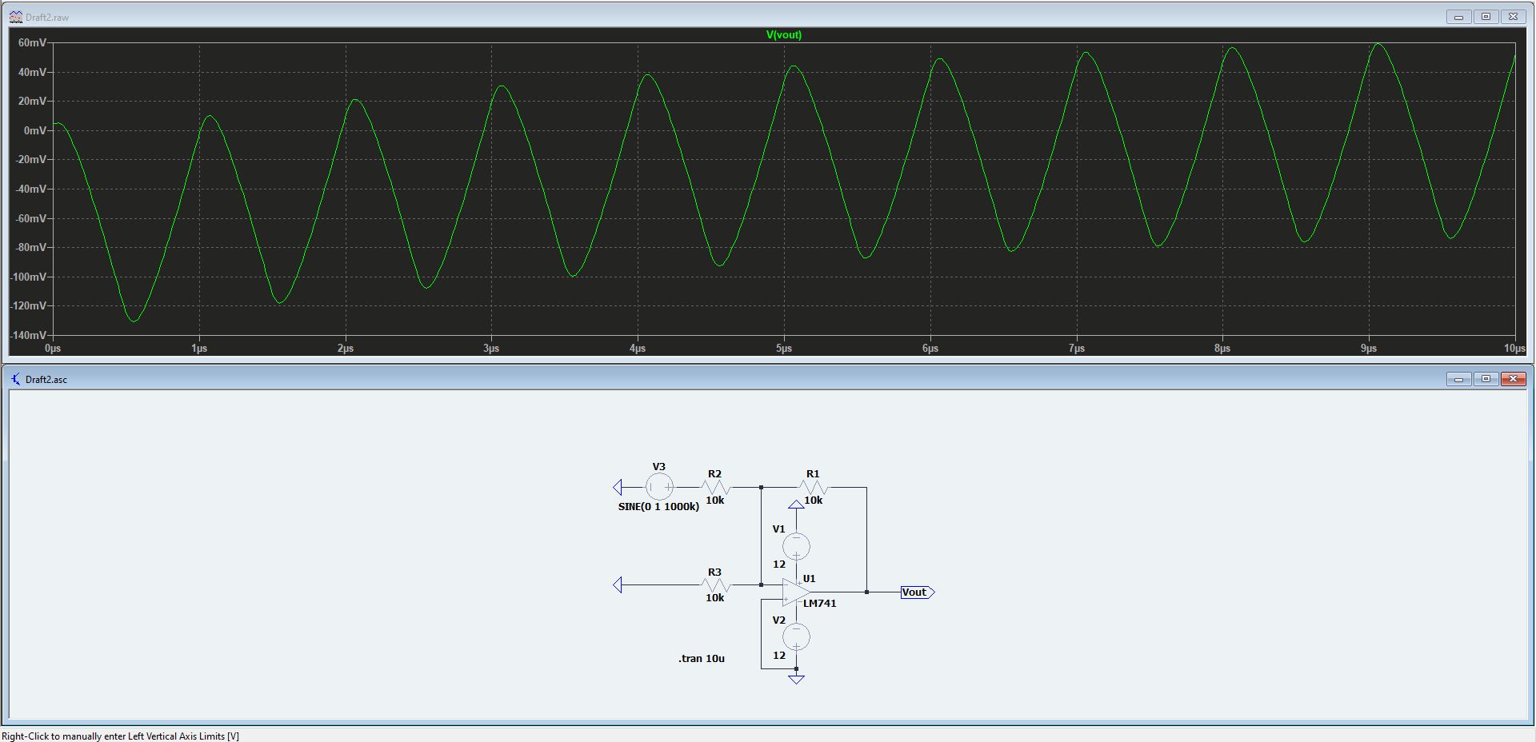

From the above waveforms we can see that the distortions are very huge starting from 100Khz, not from 50Khz like in the case of 10Vp2p voltage.

Take a µA741 op Amp and short circuit both the inverting and non-inverting terminals of the op Amp to ground. What voltage do you expect at the output when the op Amp is powered and what do you actually see? (input and output offset voltage)

->

Circuit in LTSpice:

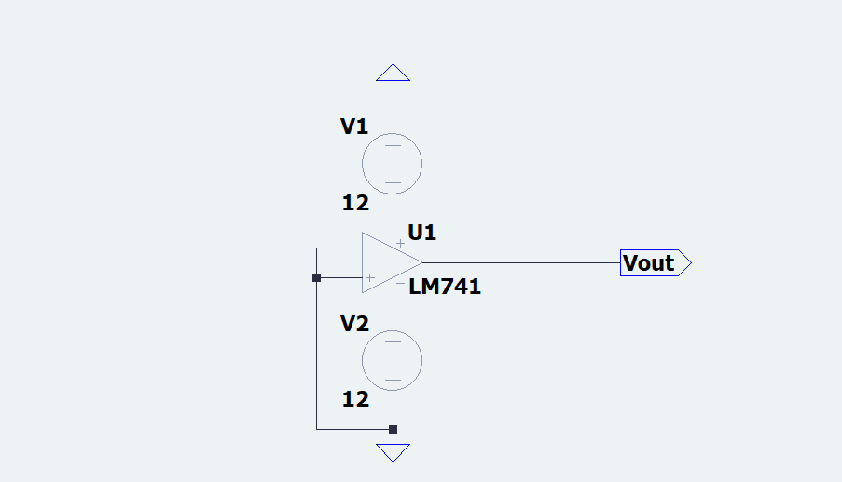

Observations:

Waveforms:

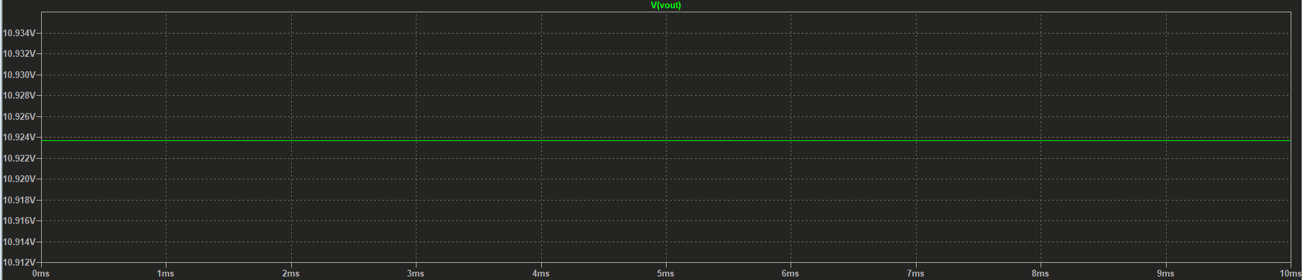

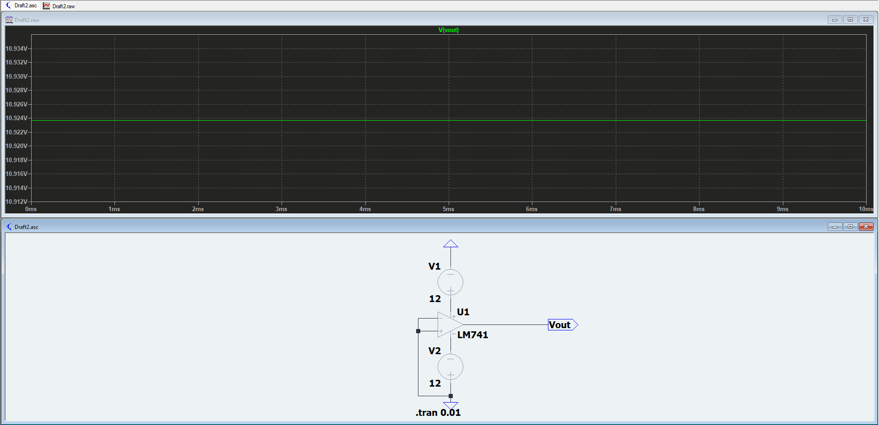

As we can see even when the input voltage is 0V, the output voltage is to be seen at around 10.924Volts. This is due to the non-ideal characteristics of the op Amp which causes an offset voltage.