**EC205**

**Analog Electronics Lab**

**Lab – 8**

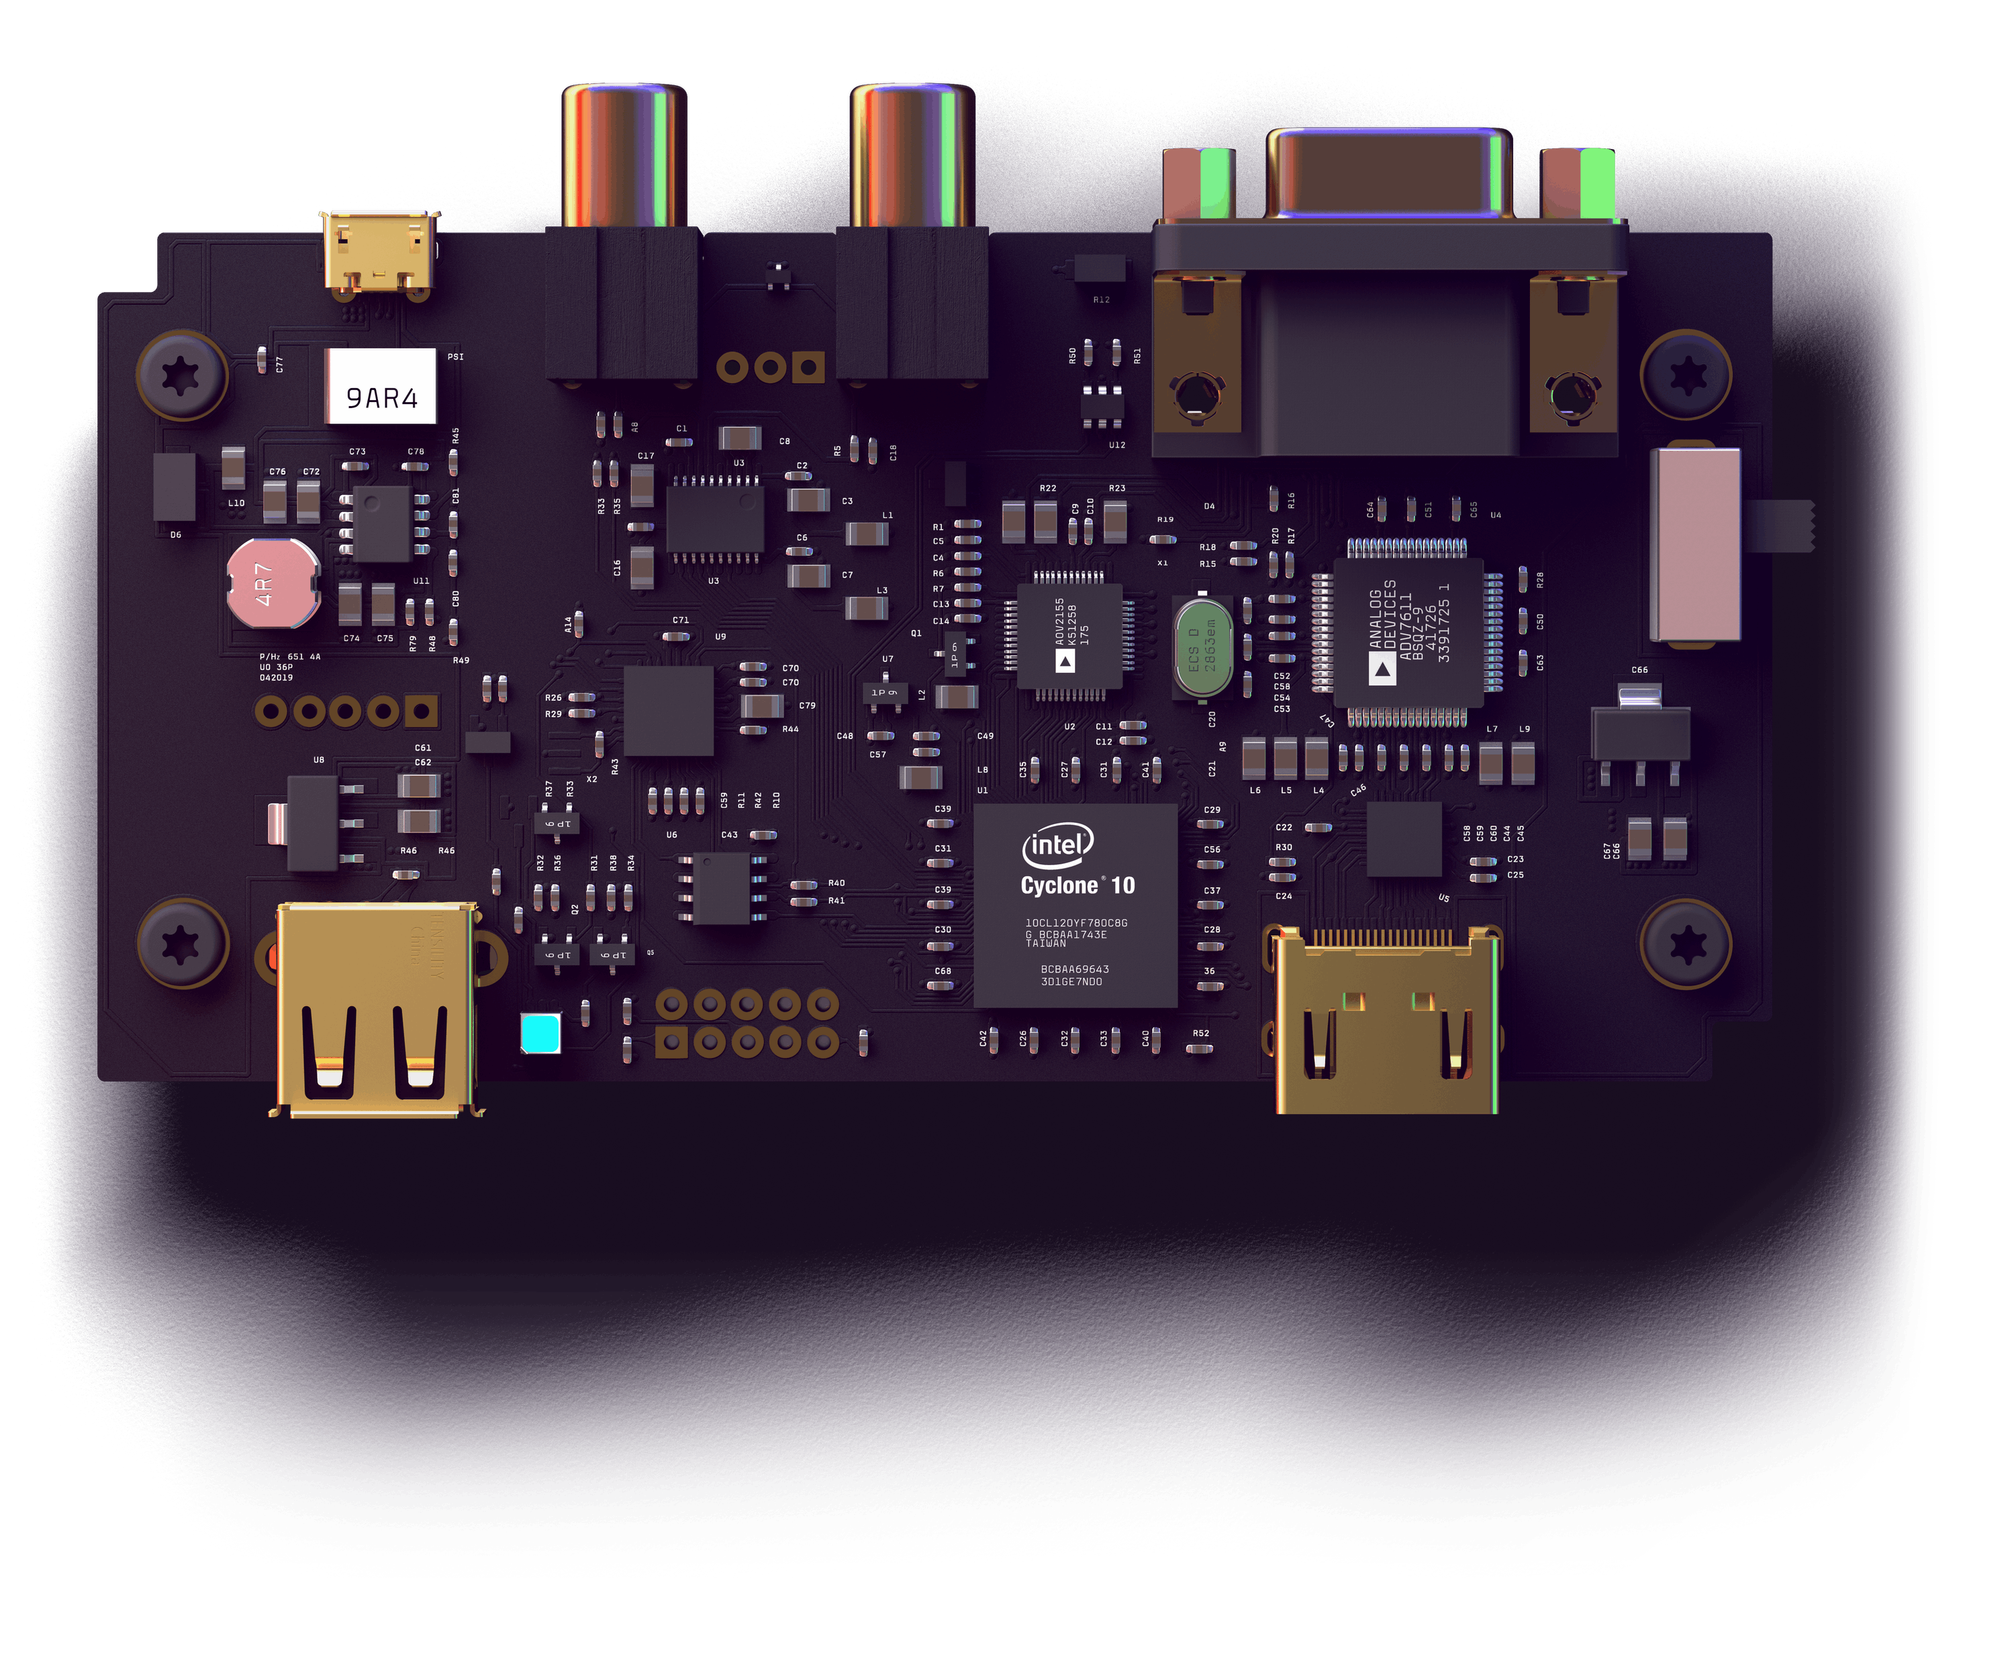

**Utkarsh R Mahajan 201EC164**

**Sannan Ali 201EC159**

**Experiment 8: All-pass filter (Phase shifter)**

**Aim:** To design μ based All-pass filter (phase Shifter)

Circuit Diagram:

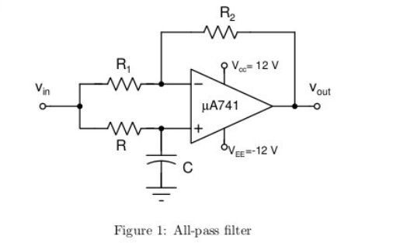

1.The circuit shown is an All-pass filter. This is also called as Phase Lag circuit.

2.Choose the component values such that for an input Vin(t)=2sin(4000πt), the output is Vout(t)=2sin(4000πt-).

We know that the Transfer function for the circuit is,

H(jw) = ,

considering R1 = R2 =10kΩ. We get a magnitude gain of 1.

|H| =1 & -180°< Φ<0°

Given, ∠H = -2tan-1() = -60°

From the V equations we know that f=2k Hz ,

Assuming, C=1μF and using it in the above equation, we get.

R=45.94Ω

3. Simulate the circuit and verify.

Circuit in LTspice:

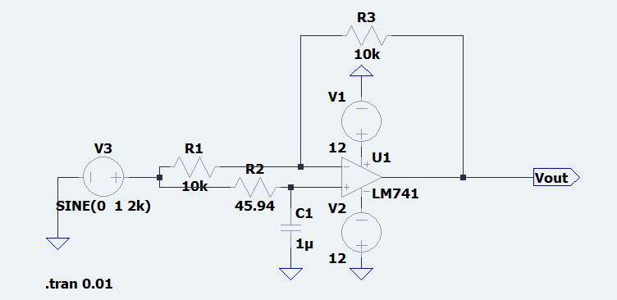

Simulation in LTspice:

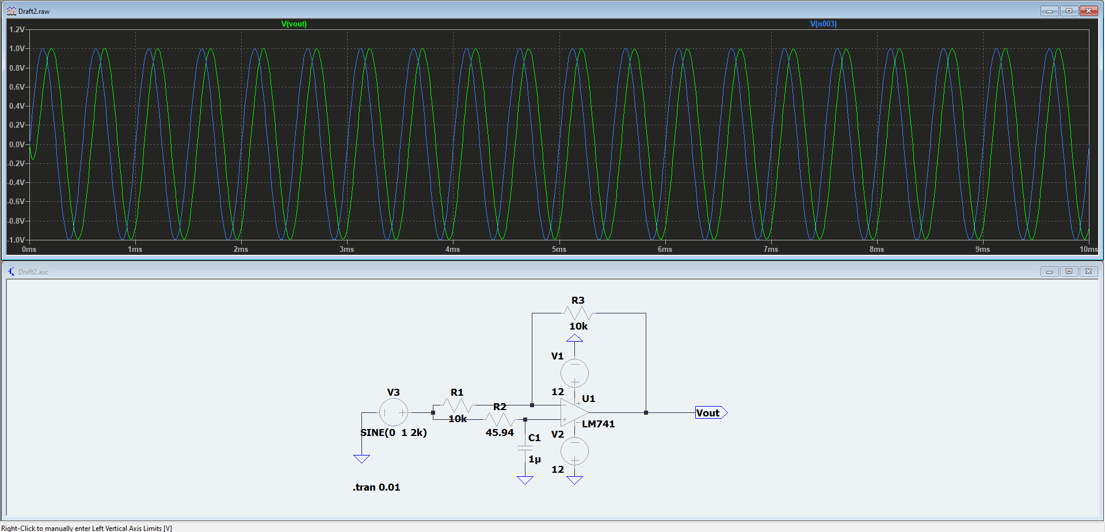

Wave:

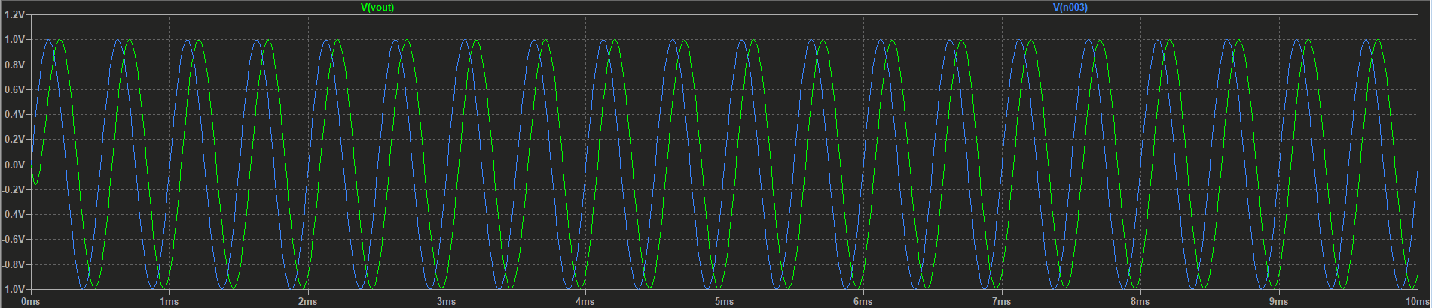

Observations:

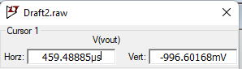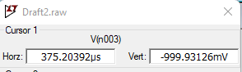

Verification

Phase=Δt*f*360° =2π*2*10-3*(375.20392-459.48885) =-0.33713972 =-

We can see that the results match our expected outputs.

4. Also obtain the frequency response of the filter.

Circuit in LTspice:

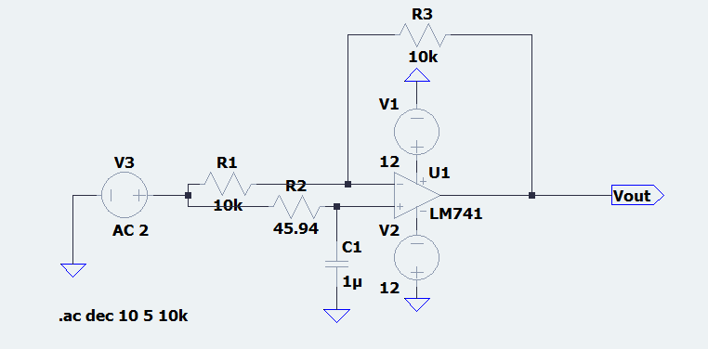

Observations:

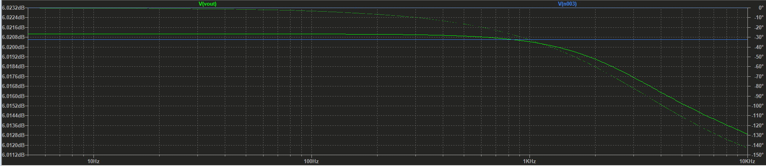

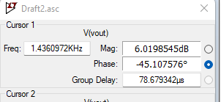

5.Modify the circuit to behave as an All-pass filter that introduces a leading phase. Verify its salient features.

It can be simply done by switching the resistor R with Capacitor C.

Circuit in LTspice:

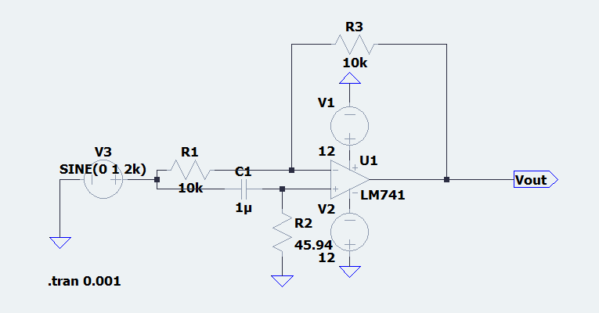

Observations:

Wave:

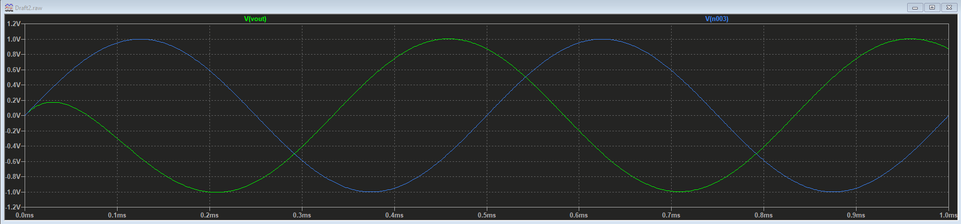

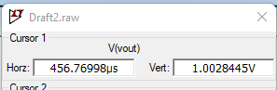

Verification:

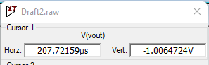

Frequency Response:

Circuit in LTspice:

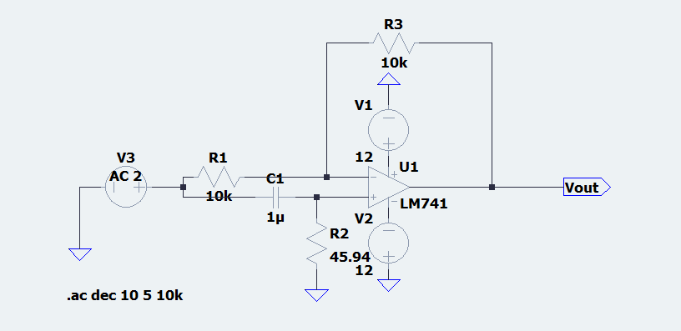

Observation:

