**EC205**

**Analog Electronics Lab**

**Lab – 9**

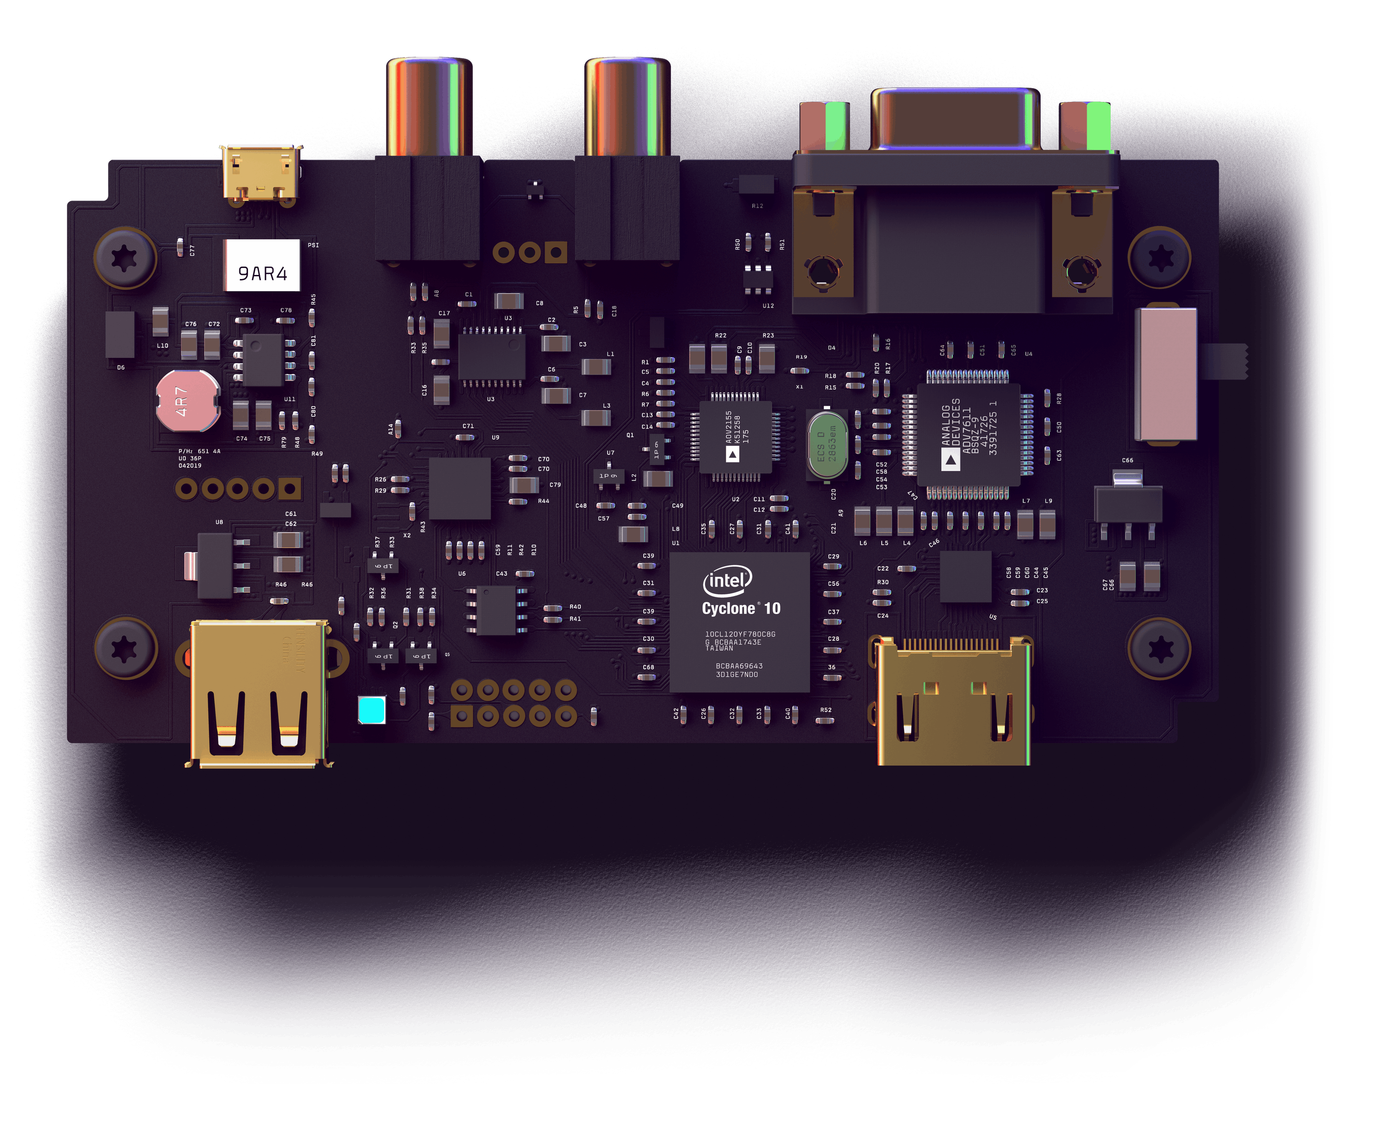

**Utkarsh R Mahajan 201EC164**

**Sannan Ali 201EC159**

**Experiment 9: Second order Low-pass and High-pass filter**

**Aim:** To design and study a μA741 based Sallen-Key Low-pass and High-pass filter

Circuit Diagram:

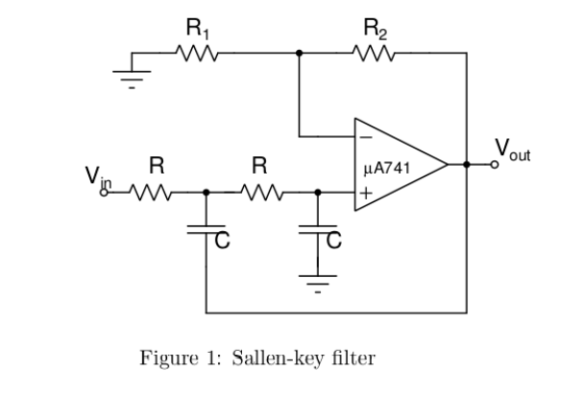

1. Design the low-pass filter for three different Q values (0.5, 0.707 and 2) for a cut-off frequency = 1 kHz. Obtain the magnitude response and phase response. (For hardware lab: Note that the input signal should be such that the peak-to-peak value of the output Is at least 100 mV when the filter attenuation increases to 40 dB)

->

Transfer Function for low pass filter H(S) =

We know that for the following circuit, we get

fc = , and Q = where K= 1+

considering R=1kΩ and using fc= 1 kHz.

C= =0.1591 µF

From -40dB= 20log (), since Vout >= 100mV

Vin = 100Vout = 100 x 100x10-3 V = 10Vp2p

For Q=0.5,

Let us consider R1 = 1kΩ

K=1, R2 has to be 0Ω.

For Q=0.707,

K=1.585, R2=0.5855kΩ

For Q=2,

K=2.5, R2=1.5kΩ

Circuit in LTSpice:

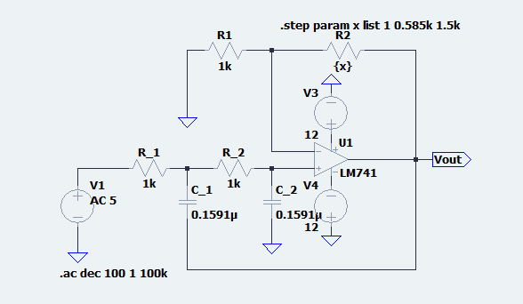

2. Simulate the circuit and obtain the frequency response. Determine the DC gain, the cut-off’ frequency and stop-band roll-off and compare with the designed.

Frequency/phase Response:

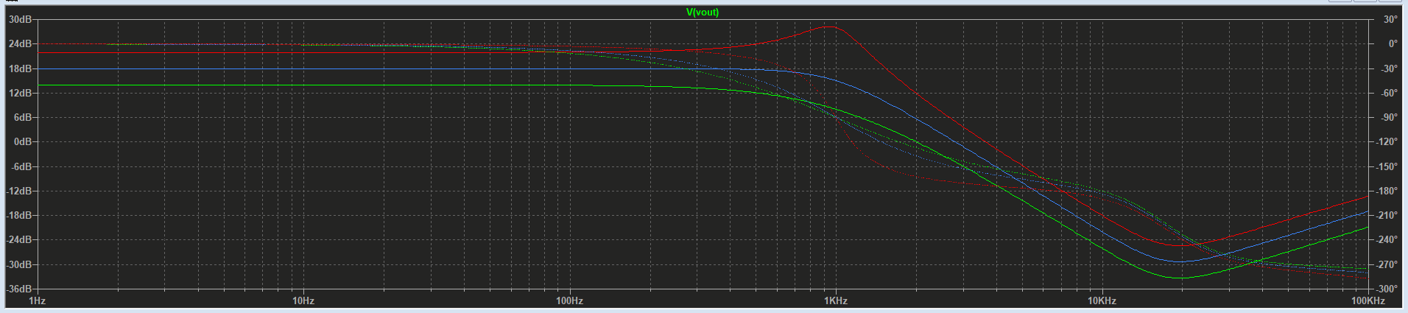

For Q=0.5,

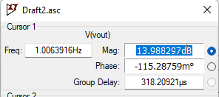 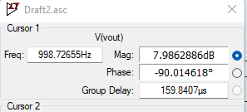

Gain = 13.988297dB

Fc= 998.72655Hz

K=1, R2 has to be 0Ω.

Stop band roll-off

= (-17.4233+6.041181)/((5.9926-3.0038)*103)

= -0.036

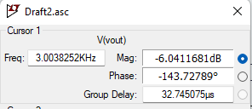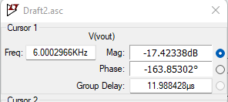

For Q=0.707,

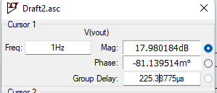 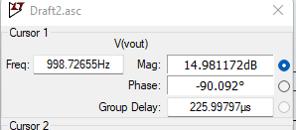

Gain = 17.980184dB

Fc= 998.72655Hz

Stop band roll-off

= (-13.1897+1.2040)/((5.9926-3.0038)*103)

=-0.038

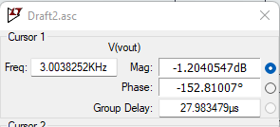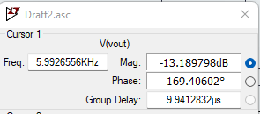

For Q=2,

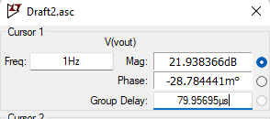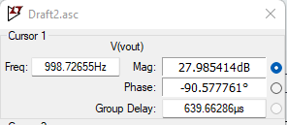

Gain = 21.938366dB

Fc= 998.72655Hz

Stop band roll-off

= (-9.0548-3.6344)/((5.9926-3.0038)*103)

=-0.041

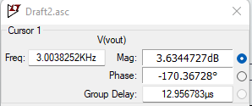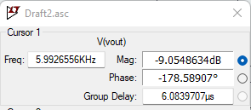

Fmaxgain=fc = 103* = 0.935 kHz

|H(jw)|max at Fmaxgain = = = 5.16

3.Tabulate the results in the format shown in Table 1 below.

|  |  |  |  |  |  |  |
| --- | --- | --- | --- | --- | --- | --- |
| Q | Ri | k | F0 Frequency at which gain = QK | Hp (max gain) | Fp Frequency at which max gain occurs | Stop band roll-off |
| 0.5 | 1 | 2 | 998.72655 | 13.988297dB | 1Hz | -0.036 |
| 0.707 | 0.585k | 1.585 | 998.72655 | 17.980184dB | 30.417337Hz | -0.038 |
| 2 | 1.5k | 2.5 | 998.72655 | 28.275992dB | 931.12805Hz | -0.041 |

4. Now, ground the input terminal of the filter (Remember to disconnect the Signal Generator in the hardware lab). Adjust R2such that the gain K = (1+ R2/R1) becomes slightly higher than 3. You will see the filter oscillating. What is the reason?

Let K = 3.2, We get R= 2.2KΩ

Circuit in LTspice:

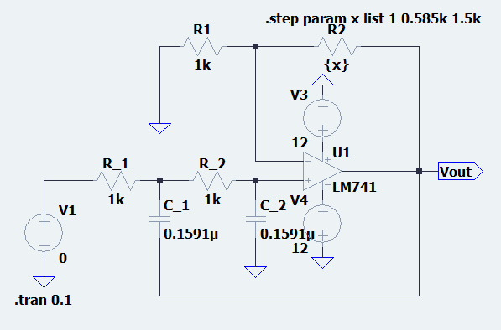

Observation: waveform:

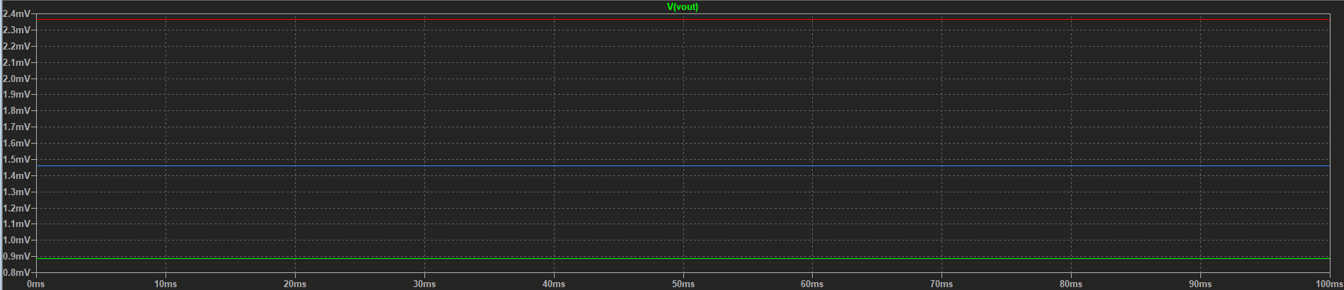

When the gain value is greater than 3, the system become oscillatory because its tending towards system instability.

5. Convert the filter designed in step-1 to a high-pass filter. Observe and note down the salient features for Q = 0.707.

-> It can be easily made by just switching Capacitors and Resistors at the input.

As for Q=2, we will use the resistor values from above questions as it will be applicable here too.

Transfer Function for high pass filter H(S) =

fmaxgain=

Circuit in LTspice:

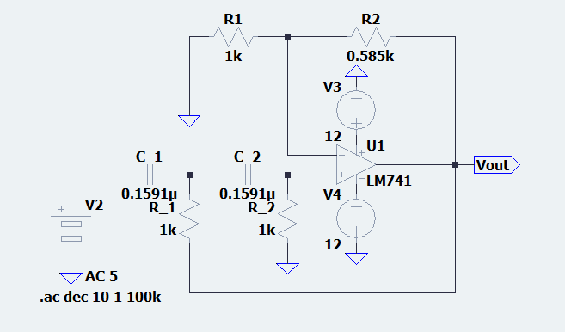

Observations:

Frequency/phase Response:

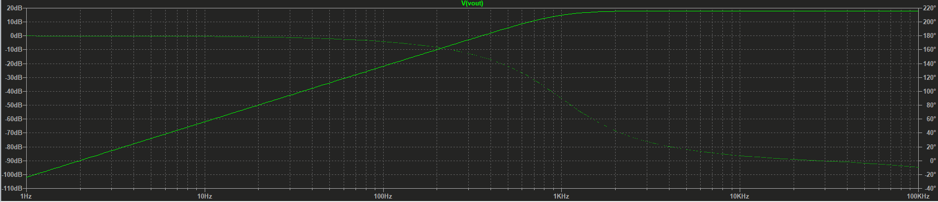

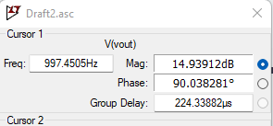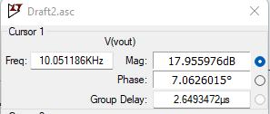

fc= 997.4505Hz

For roll off factor:

= (-21.974468+61.999192)/(100.2556-10.012772)

=0.44352249244

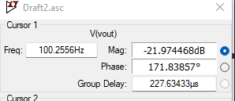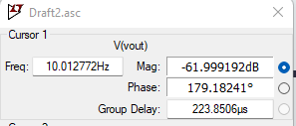

Hmax= 17.955976dB,

fmaxgain=10.0511 kHz

fmax(expected) = = 1.00015 kHz