**EC-211**

**Digital Signal Processing Lab**

**KEIL Programming Assignment**

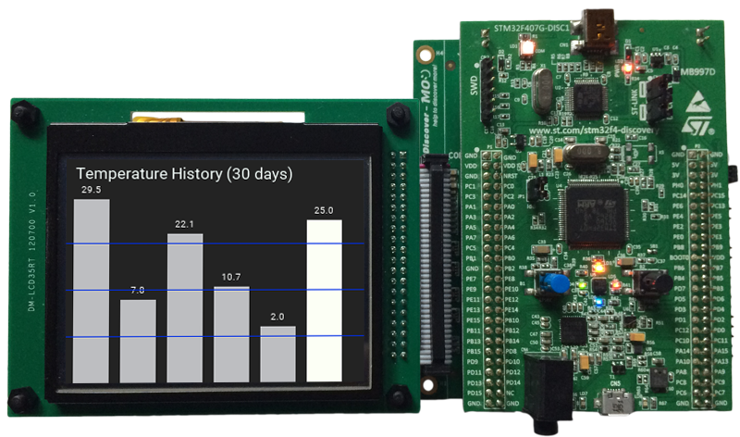

Utkarsh Mahajan 201EC164

ARNAV RAJ 201EC109

Objective: Write a C program to find the convolution of the sequences

x[n]=[-1, -2, 6, 6 , -7, 0, -1, 3, 4, 5] and

y[n]=[-5, 4, 3, -7, -8, 0, 10, -3, 2, -6].

Show the memory map of the input and output arrays.

**->** We will use dynamic allocation for our result array(where our convolution will be stored).

Source Code:

*#include* <stdio.h>

*#include* <stdlib.h>

int main(){

    int x [10] = {-1, -2, 6, 6 , -7, 0, -1, 3, 4, 5};

    int y [10] = {-5, 4, 3, -7, -8, 0, 10, -3, 2, -6};

*// size of x*

    int m = sizeof(x)/sizeof(x[0]);

*// size of y*

    int n = sizeof(y)/sizeof(y[0]);

*// allocating memory for convolution (m+n-1)*

    int* z =(int*)malloc((m+n- 1) * sizeof(int));;

*// initiazializing all values to 0.*

*for*(int i=0; i<m+n-1; i++) {

        z[i]=0;

    }

*//calculating Convolution*

*for*(int i=0; i<m+n-1; i++) {

*for*(int k=0; k<m;k++){

*if*(!(i-k>(m-1) || i-k<0)){

                z[i] += x[k]*y[i-k];

            }

        }

    }

*//deinitialize dynamic memory*

    free(z);

*return* 0;

}

Setup in Keil:

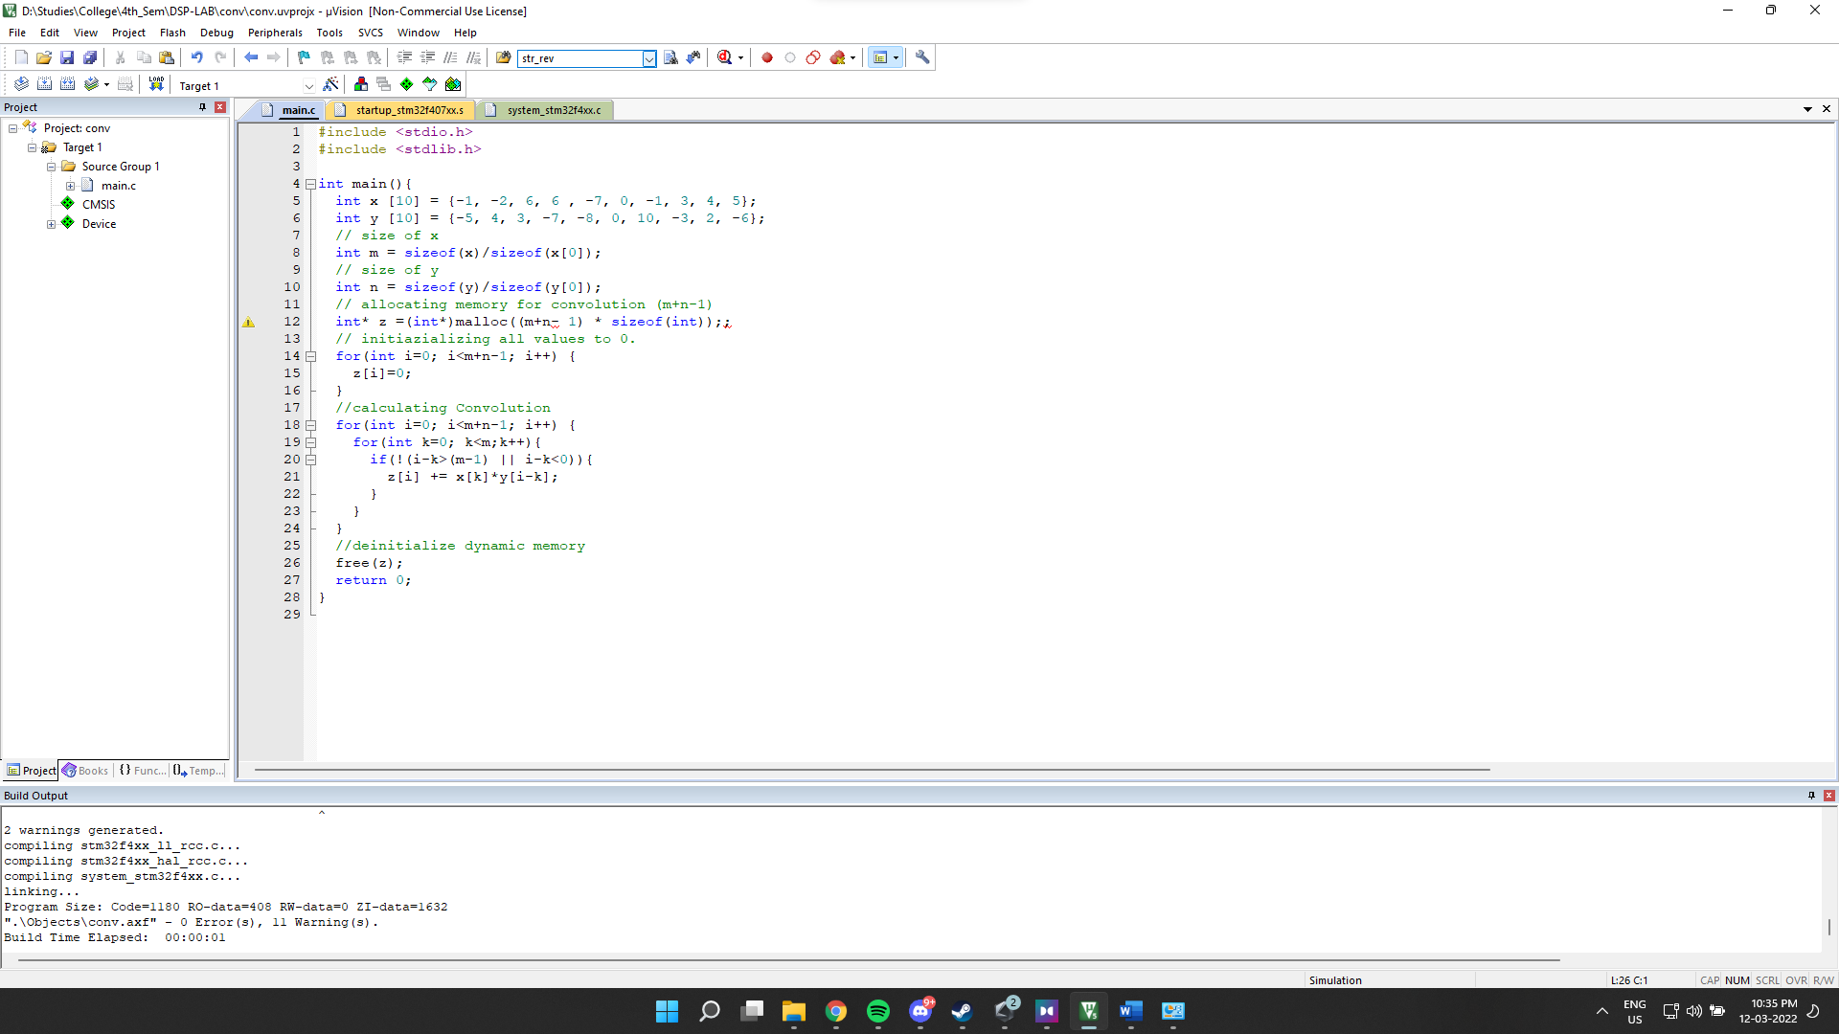

Debugging:

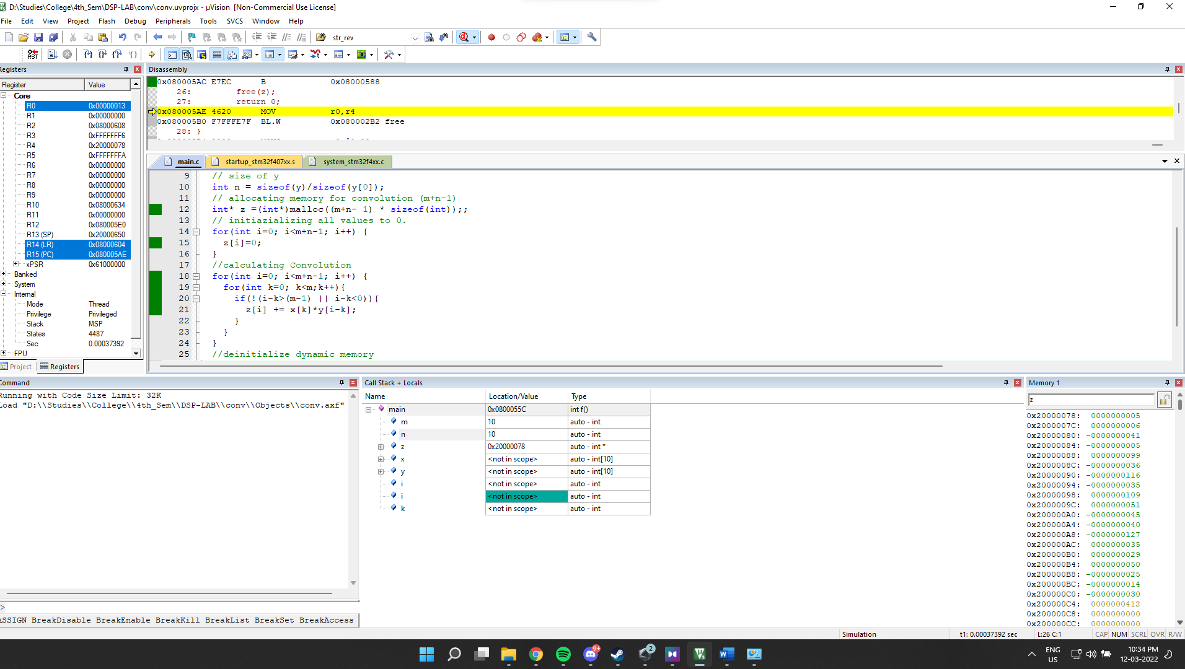

Call stack + Locals

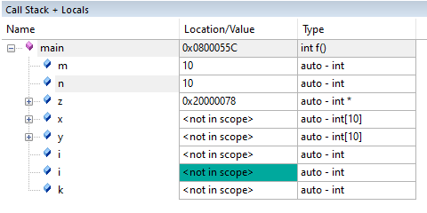

Since we have used dynamic allocation for z, we can see only the first element in z. call stack, we will use Memory viewer to see the entire array.

Memory viewer:

