EC-206

Microprocessors

Assignment-1

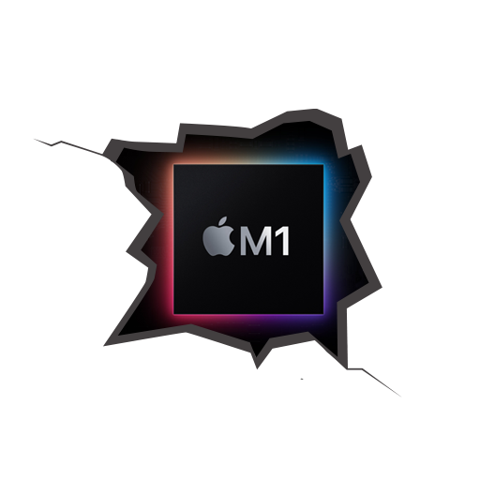

Utkarsh Mahajan

201EC164

1. List various microprocessors and micro-controllers which follow the RISC architecture. Write a brief description for each.

RISC stands for **Reduced Instruction Set Computer Processor**, a microprocessor architecture with a simple collection and highly customized set of instructions.

It is built to minimize the instruction execution time by optimizing and limiting the number of instructions. It means each instruction cycle requires only one clock cycle, and each cycle contains three parameters: fetch, decode and execute. The RISC processor is also used to perform various complex instructions by combining them into simpler ones. RISC chips require several transistors, making it cheaper to design and reduce the execution time for instruction.

Some of the various microprocessors and micro-controllers which follow the RISC architecture are:

Microprocessors: Apple M1(ARM), RISC-V, Power PC

Micro-controllers: PIC1x, ARM Cortex-M3, TMS570LS3137 (Texas instrument microcontroller)

**The Power PC**

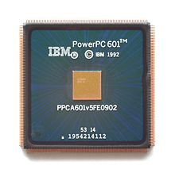

PowerPC (short for Performance Optimization With Enhanced RISC – Performance Computing, sometimes abbreviated as PPC) is a RISC architecture created by the 1991 Apple–IBM–Motorola alliance, known as AIM. PowerPC, as an evolving instruction set, has since 2006 been renamed Power ISA but lives on as a legacy trademark for some implementations of Power Architecture based processors.

The PowerPC is designed along RISC principles, and allows for a superscalar implementation. Versions of the design exist in both 32-bit and 64-bit implementations. Starting with the basic POWER specification, the PowerPC added:

* Support for operation in both big-endian and little-endian modes; the PowerPC can switch from one mode to the other at run-time (see below). This feature is not supported in the PowerPC 970. This was the reason Virtual PC took so long to be made functional on 970-based Macintosh computers.
* Single-precision forms of some floating point instructions, in addition to double-precision forms
* Additional floating point instructions at the behest of Apple.
* A complete 64-bit specification that is backward compatible with the 32-bit mode
* fused multiply-add
* A paged memory management architecture which is used extensively in server and PC systems.

**Apple M1 (SOC)**

The M1 was the first Apple-designed System on a Chip (SoC) that's been developed for use in Macs. It marked Apple's first step toward transitioning away from the Intel chips that the Cupertino company used in Macs since 2006 which is 14 years after they switched from PowerPC to Intel.



The M1 has four high-performance "Firestorm" and four energy-efficient "Icestorm" cores, providing a hybrid configuration similar to ARM DynamIQ and Intel's Lakefield and Alder Lake processors. This combination allows power-user optimizations not possible with previous Apple-Intel architecture devices.

Apple claims the energy-efficient cores use one-tenth the power of the high-performance ones. The high-performance cores have an unusually large 192 KB of L1 instruction cache and 128 KB of L1 data cache and share a 12 MB L2 cache; the energy-efficient cores have a 128 KB L1 instruction cache, 64 KB L1 data cache, and a shared 4 MB L2 cache. The SoC also has a 16MB System Level Cache shared by the GPU.

The M1 integrates an Apple designed eight-core (seven in some base models) graphics processing unit (GPU). Each GPU core is split into 16 Execution Units, each containing eight Arithmetic Logic Units (ALUs). The M1 GPU contains up to 128 Execution units or 1024 ALUs, which Apple says can execute up to 24,576 threads simultaneously and have a maximum floating-point (FP32) performance of 2.6 TFLOPs.

**RISC-V**



RISC-V is an open standard instruction set architecture (ISA) based on established reduced instruction set computer (RISC) principles.

Unlike most other ISA designs, the RISC-V ISA is provided under open-source licenses that do not require fees to use. A number of companies are offering or have announced RISC-V hardware, open-source operating systems are available and the instruction set is supported in several popular software toolchains.

There are many advantages of using RISC-V over x86 or ARM like:

**Free**: RISC-V is open-source, there is no need to pay for the IP.

**Simple**: RISC-V is far smaller than other commercial ISAs.

**Modular**: RISC-V has a small standard base ISA, with multiple standard extensions.

**Stable**: Base and first standard extensions are already frozen. There is no need to worry about major updates.

**Extensibility**: Specific functions can be added based on extensions. There are many more extensions are under development, such as Vector.

**Micro-controllers:**

A microcontroller is a small and low-cost microcomputer, which is designed to perform the specific tasks of embedded systems like displaying microwave information, receiving remote signals, etc. The general microcontroller consists of the processor, the memory (RAM, ROM, EPROM), Serial ports, peripherals (timers, counters), etc.

**PIC1x ( PIC Microcontroller )**

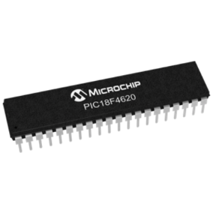

PIC Microcontrollers are small computers on a chip with some special properties: – CPU, code memory, data memory, and IO Ports all included on a single chip. – Dedicated to one task. – Small and low cost. – Embedded in many consumer devices.

* Easy to program.
* Better online documentation.
* Low cost. PICSPEED – Can use crystals, clock oscillators, or even an RC circuit. – Some PICs have a built-in 4MHz RC clock. – 16F877 and 16F877A 8 bytes of FLASH Program Memory,368 bytes of Data Memory (RAM), 256 bytes of EEPROM Data Memory,20 MHz operating speed(200 ns instruction cycle), Max. 25 mA current from an output pin, Low-power consumption, Wide Operating Voltage: 2.0 – 5.0 V, Timers – Timer0: 8-bit timer/counter with 8-bit Prescaler – Timer1: 16-bit timer/counter with prescaler, can be incremented during sleep via external crystal/clock – Timer2: 8-bit timer/counter with 8-bit period register, Prescaler and postscaler.

**ARM Cortex-M3**

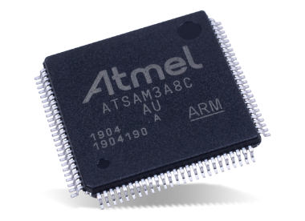

The processor is designed for high-performance, real-time processing in cost-constrained applications and can handle complex tasks. Any Arm Cortex-M3 microcontroller offers high scalability combined with an optimal trade-off between performance and cost. Cortex-M3 microcontrollers are widely used and offer several benefits:

They meet performance requirements in entry-level applications.

They are also suitable for general-purpose applications.

The architecture of the Arm Cortex-M3 processors offers high scalability and allows existing designs to be 11 reused across different projects.

And, thereby allows you to lower overall ownership costs and ease development steps.

**TMS570LS3137 (Texas instrument microcontroller)**

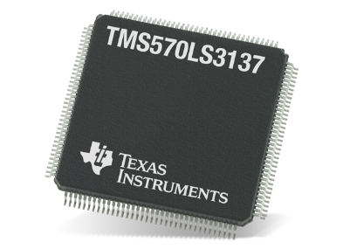

Texas Instruments TMS570LS3137 16/32-Bit RISC Flash Microcontrollers provide safety architecture in a high performance automotive-grade microcontroller designed for safety systems. The TMS570LS3137 integrates the ARM Cortex-R4F Floating-Point CPU, which utilizes an efficient 1.66DMIPS/MHz. The CPU provides up to 298 DMIPS through the use of configurations that can run up to 180MHz. 3MB of integrated flash, along with 256KB of data RAM offer single-bit error correction and double-bit error detection on the device.’

* High-Performance Automotive-Grade Microcontroller for Safety-Critical Applications
* Dual CPUs Running in Lockstep
* ECC on Flash and RAM Interfaces
* Built-In Self-Test (BIST) for CPU and On-chip RAMs
* Error Signaling Module With Error Pin 9
* Voltage and Clock Monitoring

2. Mention the specific applications for which these microprocessors and micro-controllers are used.

**Power PC:**

The first implementation of the architecture was the PowerPC 601, released in 1992, based on the RSC, implementing a hybrid of the POWER1 and PowerPC instructions. This allowed the chip to be used by IBM in their existing POWER1-based platforms.

T he PowerPC is mostly found in **controllers in cars**. For the automotive market, Freescale Semiconductor initially offered many variations called the MPC5xx family such as the MPC555, built on a variation of the 601 core called the 8xx and designed in Israel by MSIL (Motorola Silicon Israel Limited). The 601 core is single issue, meaning it can only issue one instruction in a clock cycle. To this they add various bits of custom hardware, to allow for I/O on the one chip.

**Networking** is another area where embedded PowerPC processors are found in large numbers. MSIL took the QUICC engine from the MC68302 and made the PowerQUICC MPC860. This was a very famous processor used in many **Cisco** edge routers in the late 1990s

Honda also uses PowerPC processors for **ASIMO**.

In 2003, BAE Systems Platform Solutions delivered the Vehicle-Management Computer for the **F-35 fighter jet**. This platform consists of dual PowerPCs made by Freescale in a triple redundant setup.

**Apple M1**

The Apple M1 is an ARM-based system on a chip (SoC) designed by Apple Inc. as a central processing unit (CPU) and graphics processing unit (GPU) for its Macintosh desktops, MacBook notebooks, iPad Pro and iPad Air tablets.

It provides astonishing performance for developers compiling code, artists working in huge 3D environments that were previously impossible to render, and video professionals who can transcode video to ProRes up to 5.6x faster than with a 28-core Mac Pro with Afterburner making it a favorite choice for developers and artists.

**RISC-V**

Designers have access to RISC-V technology in several ways. There are companies that offer RISC-V as IP cores that can be used to produce custom cores optimized for specific applications. Other suppliers offer complete RISC-V processors that can be integrated into systems. And in other cases, RISC-V cores have been integrated into SoCs such as FPGAs along with other types of processors and peripherals.

Several RISC-V development efforts are targeting applications such as artificial intelligence (AI), machine learning (ML), deep learning (DL), and other high-performance embedded applications.

**General Applications of these Microcontrollers and Microprocessors**

**Household Devices**

The programmable thermostat allows the control of temperature in homes. In this system, a microprocessor works with the temperature sensor to determine and adjust the temperature accordingly. High-end coffee makers, Washing machines, and radio clocks contain microprocessor technology.

**Entertainment**

The use of microprocessors in entertainment equipment, toys, and home entertaining applications is making them more useful and full of features.

**Embedded Systems**

At Home, Several modern devices in the home are microprocessors based i.e. cameras. washing machines, calculators, hi-fi systems, telephones, microwave ovens, burglar alarms, etc. The input is usually simple numeric keyboards, sensors, and buttons or while the output includes lights, simple LCD screen displays, motors and relays, LEDs, buzzers, etc.

**Office Automation and Publication**

A microprocessor-based system with software packages has changed the office environment. Microprocessor-based systems are being used for spreadsheet operations, word processing, storage, etc. Publication technology has revolutionized the microprocessor. Communication In communication the telephone industry is most important. In this industry, microprocessors are used in digital telephone sets, telephone exchange modems, etc. The use of microprocessors in satellite communication and, television, has made teleconferencing possible.

**Applications of microcontrollers:**

The application area of microcontrollers is so vast, that probably we won’t be able to finish listing them all. Here we will categorize different application areas of microcontrollers:

1. Consumer Electronics Products: Toys, Cameras, Robots, Washing Machine, Microwave Ovens, etc. [any automatic home appliance]
2. Instrumentation and Process Control: Oscilloscopes, Multi-meter, Leakage Current Tester, Data Acquisition and Control, etc.
3. Medical Instruments: ECG Machine, Accu-Check, etc.
4. Communication: Cell Phones, Telephone Sets, Answering Machines, etc.