**EC-210**

**Microprocessors Lab**

**LAB-1**



Utkarsh Mahajan 201EC164

ARNAV RAJ 201EC109

Objective: The aim of this lab is to introduce to ARM assembly levels programming and use of KEIL µvision tools.

**Exercise:**

1.2] Observe the use of MOV and MVN instructions in loading a 32 bit immediate data into the registers.

Syntax for MOV:

MOV{cond}{S} Rd, Operand2

for MVN:

MVN{cond}{S} Rd, Operand2

S: is an optional suffix. If S is specified, the condition code flags are updated on the result of the operation

Cond: is an optional condition code

Rd: is the ARM register for the result.

Operand2: is a flexible second operand.

Source Code for the exercise:

    AREA Qone, CODE, READONLY

    EXPORT  Reset_Handler

Reset_Handler

Start   MOV R1, #0x0012 *;*

        MVN R2, #0x0025 *;*

Stop B Stop *; Stop program*

    END

Keil µvision setup:

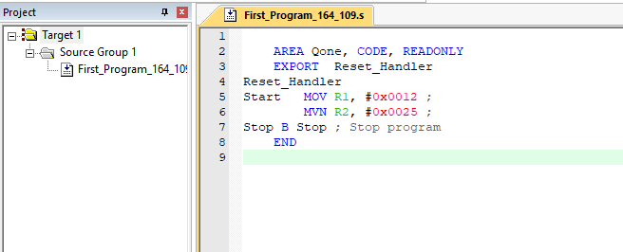

Debugging:

Initially:

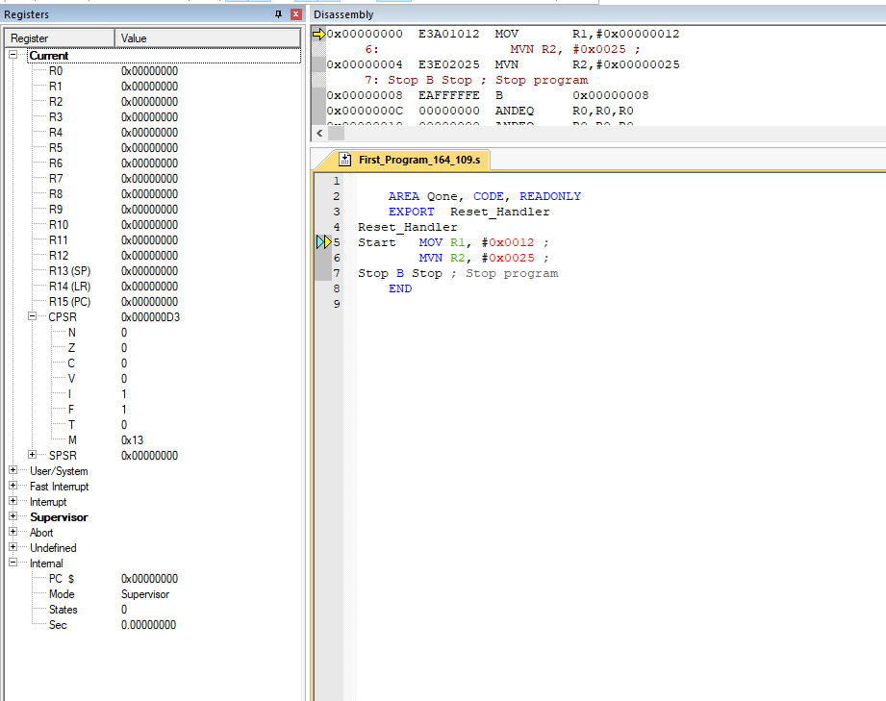

Step 1:

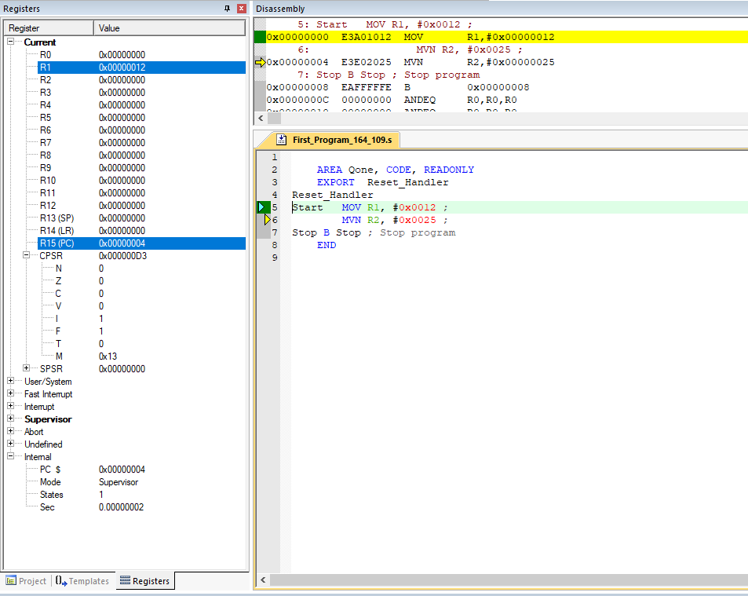

We can see that the immediate value 0x0012(18 in decimal) gets loaded in R1.

Step 2:

We can see that the value loaded in R2 is 0xFFFFFFDA which is a bit-wise negation of our operand2 immediate value 0x0025 in 32bits.

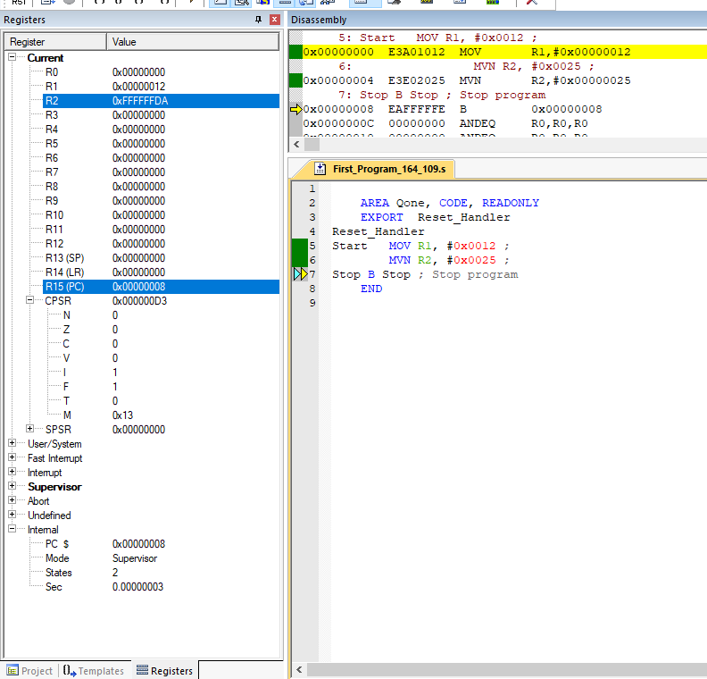

Step 3:

here the program stops and everything after the END is ignored.



Observation:

From the above we can see that,

MOV instruction stores the value of operand2 into Rd (destination register).

MNV instruction stores the result of bitwise NOT operation of 32-bit extended operand2 value into Rd (destination Register).

1.3] Demonstrate the use of LSL, LSR, ASR, ROR, RRX with MOV, MVN, MOVS and MVNS for different data. Observe the results and conditional code flags in CPSR.

-> To demonstrate the use of , LSR, ASR, ROR, RRX with MOV, MVN, MOVS and MVNS, we will write a source code using these instruction and try debugging it in Keil µVision 4 to display its working.

Source Code for the exercise:

        AREA Qtwo, CODE, READONLY

        EXPORT  Reset_Handler

Reset_Handler

Start   MOV R1, #0xF4*;*

        LSL R2, R1, #8*;*

        MVN R3, #0xD3*;*

        LSR R4, R3, #2*;*

        MOVS R5, #-200*;*

        ASR R6, R5, #4*;*

        ASR R7, R2, #12*;*

        MOV R1, #0*;*

        MVNS R0, R5*;*

        ROR R5, R2, #9*;*

        RORS R3, R4, #1*;*

        RRX R7, R3*;*

Stop B Stop *; Stop program*

    END

Keil µvision setup:

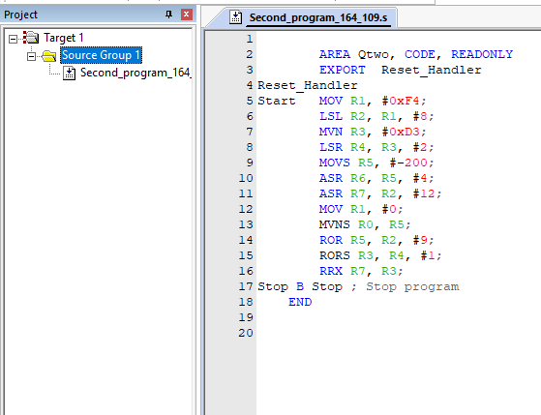

Debugging and Observations:

Initially:

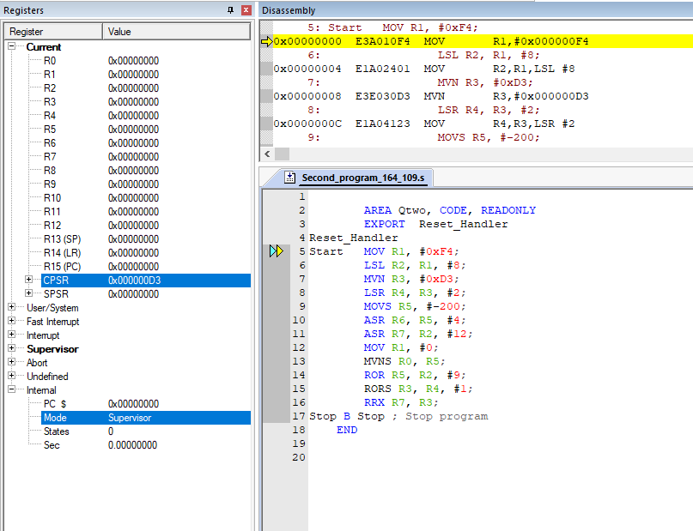

Step1:

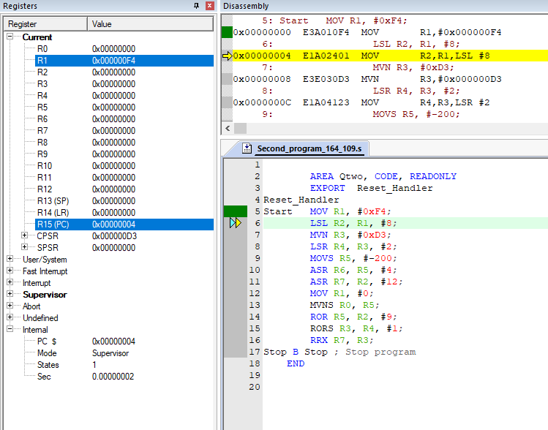

MOV instruction stores the immediate value 0xF4(hexadecimal) in the 32-bit register R1.

Step2:

LSL instruction logically left shifts the value stored in register R1 by 8 bits and is stores it in R2.

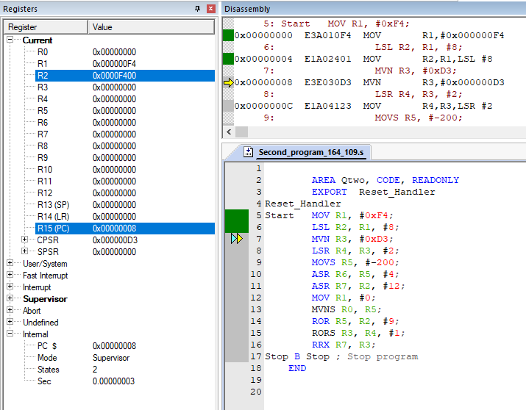

Step 3:

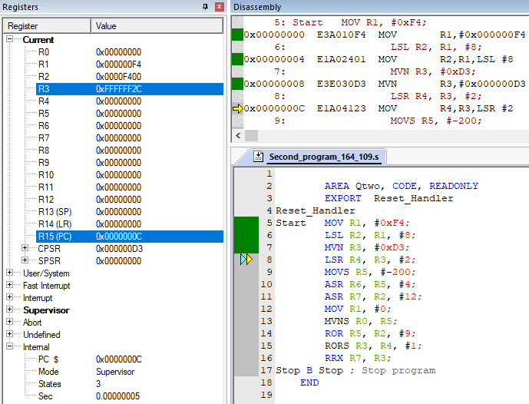

We can see that MVN instruction stores the value 0xFFFFFF2C which is a bit-wise negation of our operand2 immediate value 0xD3 in 32bits.

Step 4:

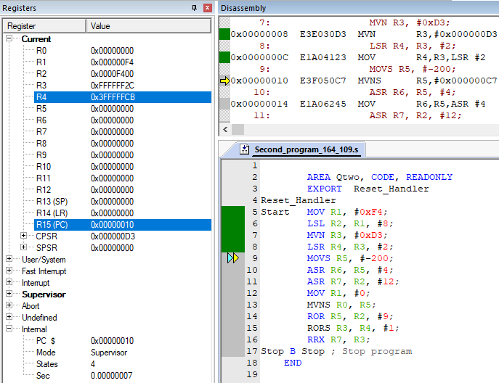

We can see that LSR instruction stores the 2-bits logically right shifted value of R3 into R4 with 0 in vacated bits location.

Step 5:

MOVS instruction here stores the value of the operand2(-200 here) into register R5 and updates the register CPSR’s N and Z flags. Since -200 is negative and not zero. N will be set to 1 and Z to 0.

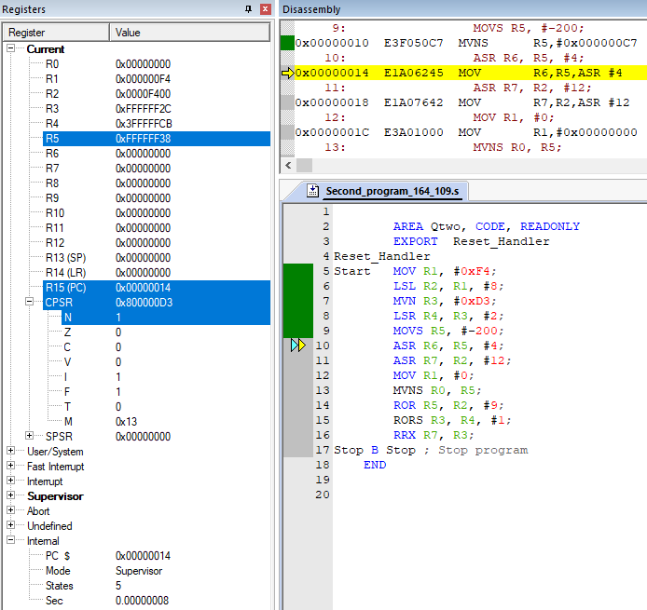

Step 6:

Here, ASR instruction right shifts the value stored in register R5(0xFFFFFF38) by 4bits and stores it in Register R6(0xFFFFFFF3) and copies the sign bit into vacated bit positions on the left.

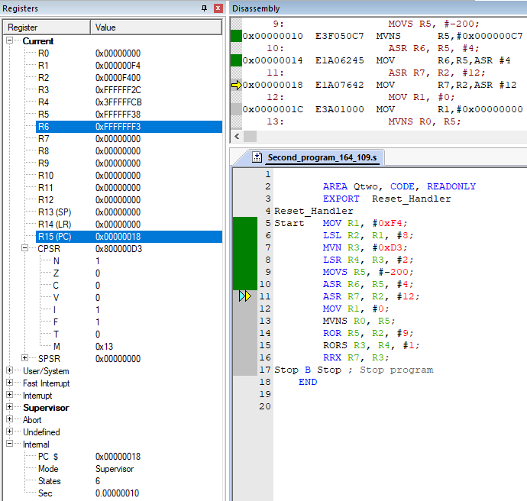

Step 7:

Similar to the previous step of execution, we can see that the value stored in register R2(0x0000F400) right shifted by 12bits with left vacant bits copying the sign bit is stored in register R7(0x0000000F).

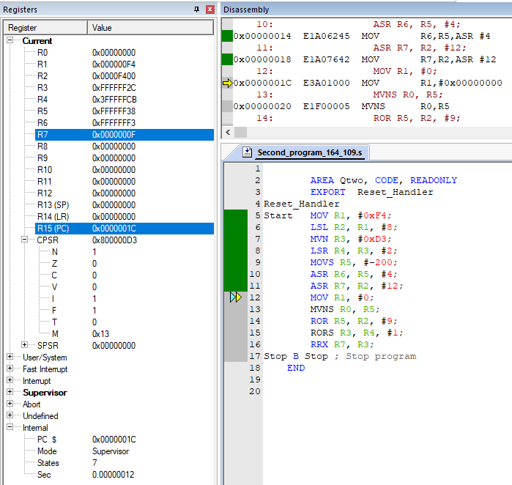

Step 8:

MOV instruction stores the immediate value 0 in the 32-bit register R1. We can see that it does not affect(update) the Z flag of the CPSR due to the absence of S suffix.

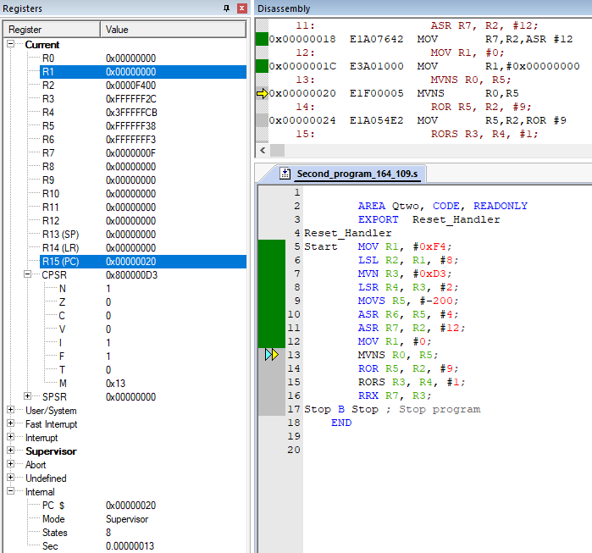

Step 9:

We can see that MVNS instruction stores the value 0x000000C7 which is a bit-wise negation of the value stored in register R5 and also updates the N and Z flags. Here the stored value is positive hence N and Z are updated to 0.

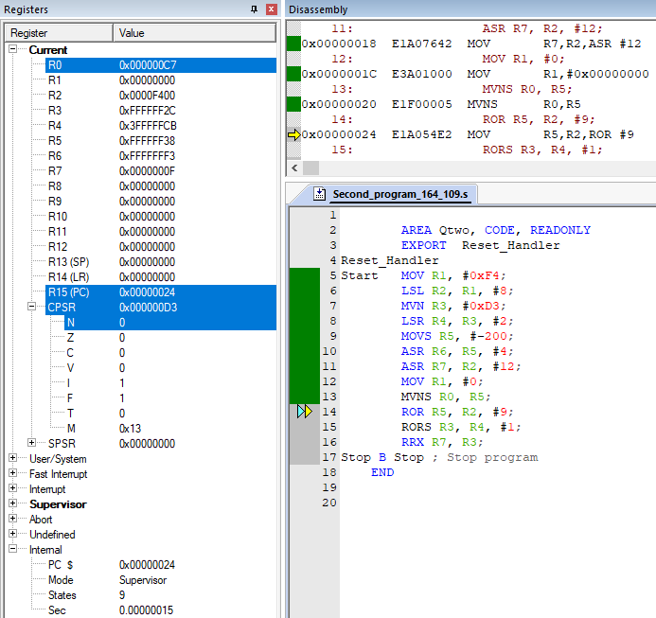

Step 10:

We can see that the ROR instruction rotates the value stored in register R2 towards the right by 9 bits as specified and gets it gets stored in Register R5.

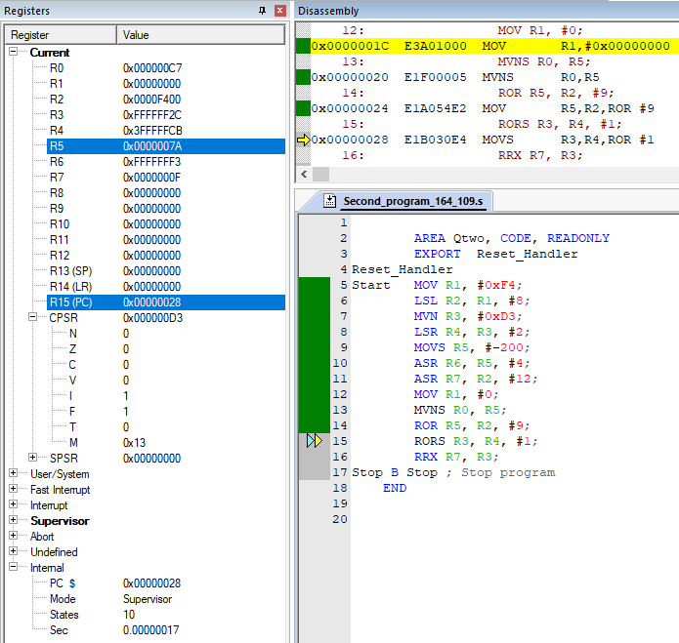

Step 11:

Here, RORS instruction rotates the value of register R4 by a bit towards the right and that value is stored in register R3. Since the S suffix is used. It will also update the CPSR flags. The carry flag C gets updated with the value stored in the right most bit of the before the last rotation (here it rotates once hence before the rotation). The N and Z flags are also updated according to the final value stored in register R3. N for negative and Z for zero value.

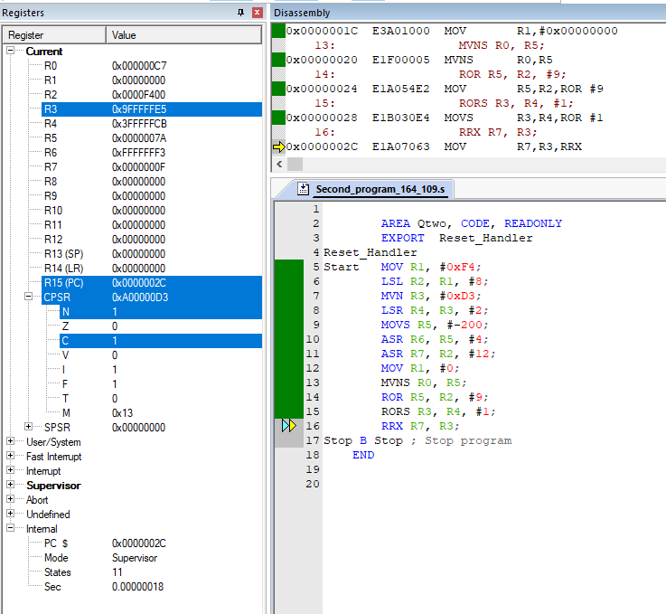

Step 12: Here, The RRX instruction rotates the value stored in register R3 towards right by 1 bit and replaces the MSB(most significant bit) with the C flag stored in CPSR and later stores this value in register R7. Since in the previous instruction C flag was set to 1. The MSB here is set to 1 in register R7.

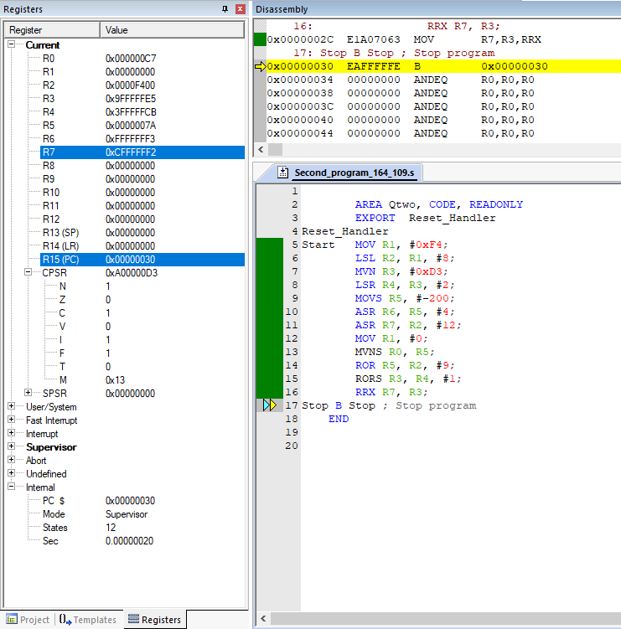

Step 13: here the program stops and everything after the END is ignored.

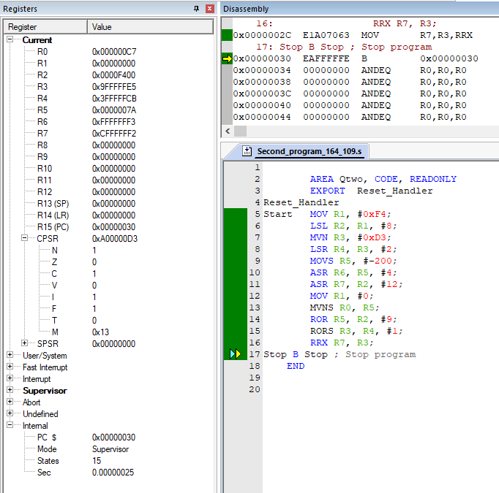

Results:

We can see that the instructions used in the program update the flag Values stored in CPSR only when the S suffix is used.

**From above we can infer that the uses for the following instructions are:**

LSL: provides the value of a register multiplied by a power of two, inserting zeros into the vacated bit positions.

* If S is specified, the LSL instruction updates the N and Z flags according to the result.
* The C flag is unaffected if the shift value is 0. Otherwise, the C flag is updated to the last bit shifted out.

LSR: It provides the unsigned value of a register divided by a variable power of two, inserting zeros into the vacated bit positions.

* If S is specified, the instruction updates the N and Z flags according to the result.
* The C flag is unaffected if the shift value is 0. Otherwise, the C flag is updated to the last bit shifted out.

ASR: It provides the signed value of the contents of a register divided by a power of two. It copies the sign bit into vacated bit positions on the left.

If S is specified, the ASR instruction updates the N and Z flags according to the result.

The C flag is unaffected if the shift value is 0. Otherwise, the C flag is updated to the last bit shifted out.

ROR: It provides the value of the contents of a register rotated by a value. The bits that are rotated off the right end are inserted into the vacated bit positions on the left.

* If S is specified, the instruction updates the N and Z flags according to the result.
* The C flag is unaffected if the shift value is 0. Otherwise, the C flag is updated to the last bit shifted out.

RRX: It provides the value of the contents of a register shifted right one bit. The old carry flag is shifted into bit[31]. If the S suffix is present, the old bit[0] is placed in the carry flag.

* If S is specified, the instruction updates the N and Z flags according to the result.
* The C flag is unaffected if the shift value is 0. Otherwise, the C flag is updated to the last bit shifted out.