**EC-210**

**Microprocessors Lab**

**LAB-4**



Utkarsh Mahajan 201EC164

ARNAV RAJ 201EC109

Objective: To study defining memory area, constant in the assembly program

**Exercise:**

**4.2]** Reverse the string and check if the string is a palindrome.

->

Source Code:

        AREA AllocSpace, DATA,NOINIT,READWRITE

*;Space for storing reversed string*

str_rev SPACE 1024*;*

*;Actual Code*

        AREA hmm, CODE, READWRITE

*EXPORT* Reset_Handler

Reset_Handler

*;Pointer to the input string*

        LDR R1, =str_src *;*

*;Pointer to the reversed string*

        LDR R2, =str_rev *;*

*;storing the input's pointer in R8*

        ADD R8, R1, #0*;*

*;Storing the result's pointer in R9*

        ADD R9, R2, #0*;*

*; load a byte from input string and update the pointer*

lth     LDRB R3, [R8],#1*;*

*; counting length (total = length +1)*

        ADD R4, #1*;*

*; Check for End of string*

        CMP R3, #0 *;*

*; If not go back to lth to count length*

        BNE lth*;*

*; total = (length +1) - 1*

        SUB R4, #1*;*

*;storing length in R5*

        ADD R5, R4, #0*;*

*; R8 to point to the last value just before the 0 (NULL).*

        SUB R8, #2*;*

*; for iteration count R5 = R5 -1;*

res SUB R5, #1*;*

*; Loading the value in reverse order in R3*

        LDRB R3, [R8],#-1 *; load a byte and update the pointer*

*; Storing the loaded value;*

        STRB R3, [R9],#1 *; store byte and update the pointer*

*; checking if R5 is 0. which indicated we are done reversing.*

        CMP R5, #0 *; Check for End of string*

*; If its not then loop again.*

        BNE res

*; storing null in R3*

        MOV R3, #0*;*

*; adding NULL at the end of the reversed string*

        STRB R3, [R9]*;*

*;Restoring length in R5*

        ADD R5, R4, #0*;*

*;storing starting addresses of input & reversed string.*

        ADD R8, R1, #0*;*

        ADD R9, R2, #0*;*

*;checking if the input string is palindrome*

*; by comparing same index bits of input and reversed string.*

pal LDRB R3, [R8],#1 *;*

        LDRB R4, [R9],#1 *;*

*; checking for end of string*

        CMP R3, #0*;*

*; As once it reaches end means it's a palindome.*

        BEQ ipa*;*

*;comparing bytes.*

        CMP R3, R4*;*

*; if equal -> it can be a palindrome hence looping for next index*

        BEQ pal*;*

*; If not equan then its not a palindrome*

*;storing 0 in R0 (output register)*

np      MOV R0, #0*;*

*; jump to stop;*

        BAL *stop;*

*;storing 1 in R0 (output register) if input is a palindrome*

ipa     MOV R0, #1*;*

        BAL *stop;*

stop BAL *stop*

*; input_string*

str_src DCB "reviver",0*;*

        NOP

*END*

Debugging:

Initial Memory: (after getting the address through register)

Memory 1 shows input memory and memory 2 shows output(reversed)

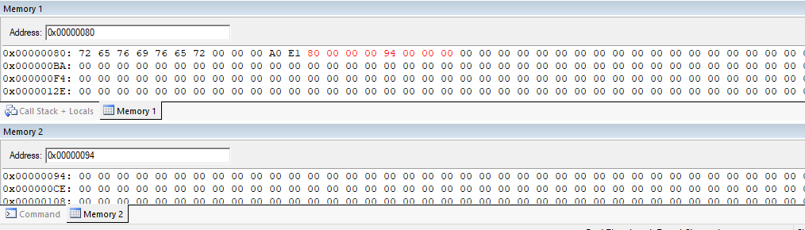

Setup:

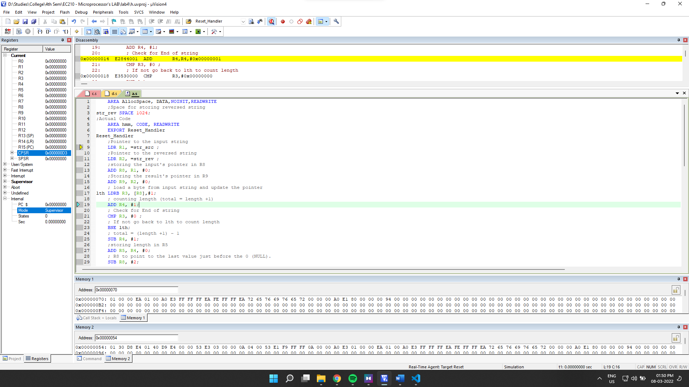

Final Output:

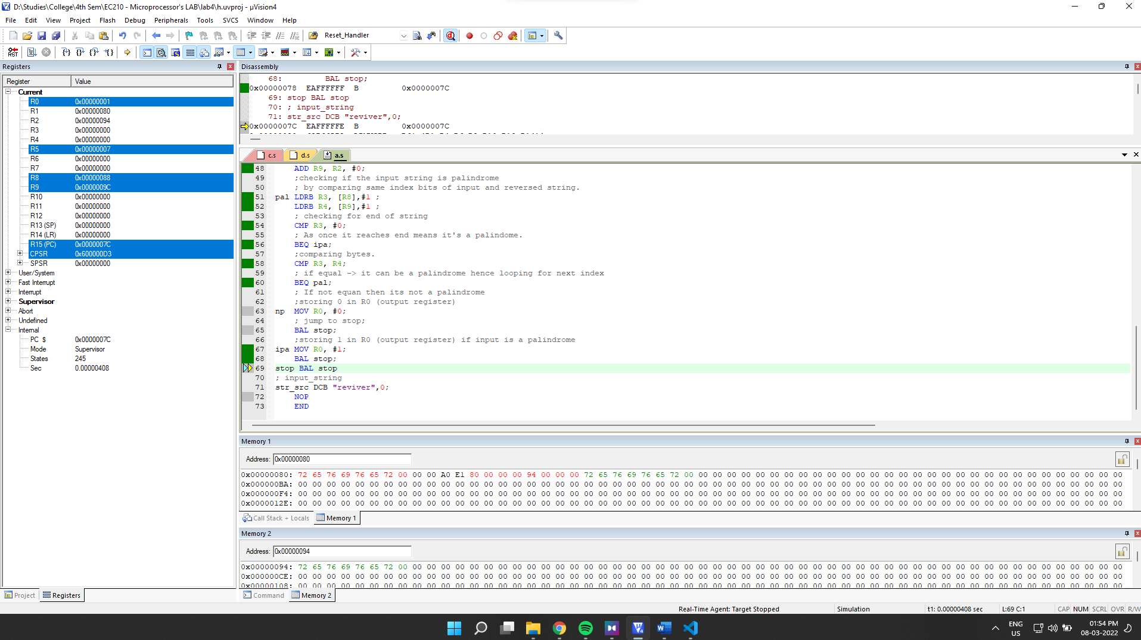

Final Register Values:

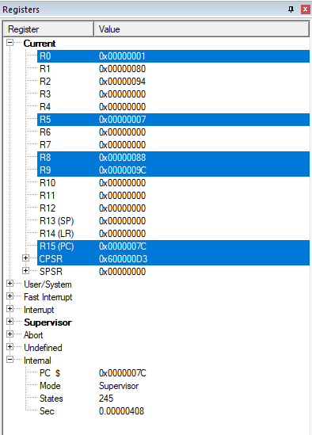

Final Memory:

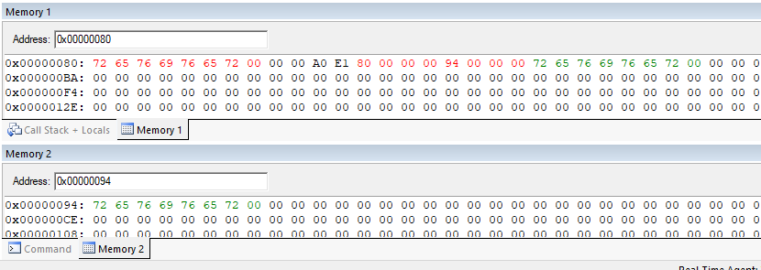

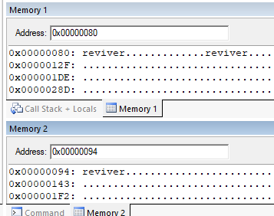

**Observation**: The output of if the string was palindrome is stored in R0. We can see that its 1 and our input string is actually also an palindrome. We can also see the output memory in memory2. It is reverse of the string that we entered.

**For input string**: "random text"

Output register:

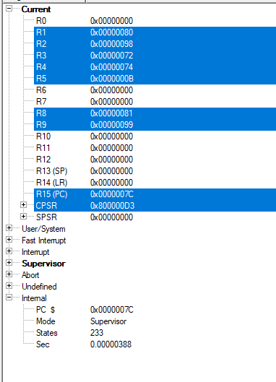

Output memory:

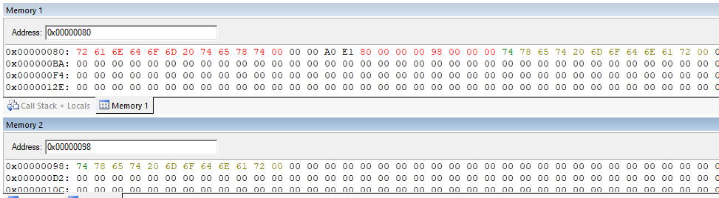

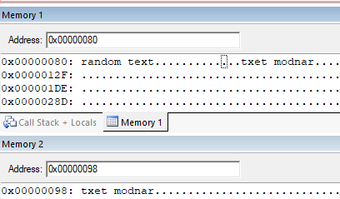

**Observation**: we can see that R0 is indicating the input string is not a palindrome and we can also see the reversed string in output memory (2).

**4.3]** Find the substring in Main string

->

Source Code:

        AREA hmm, CODE, READWRITE

*EXPORT* Reset_Handler

Reset_Handler

*; Pointer to the input string*

        LDR R1, =str_src *;*

*; Pointer to the input substring*

        LDR R2, =sub_str*;*

*;storing the input string's pointer in R8*

        ADD R8, R1, #0*;*

*;storing the input substring's pointer in R9*

        ADD R9, R2, #0*;*

*; Loading the first byte(char) of the substring*

        LDRB R4, [R9],#1 *;*

*; for storing the index.*

        MOV R5, #0*;*

*;loading the chars of input string.*

ind     LDRB R3, [R8],#1 *;*

*; incrementing the index.*

        ADD R5, #1*;*

*; Check for End of string*

        CMP R3, #0 *; Check for End of string*

*; if it reaches the end of string -> not found*

        BEQ nf*;*

*;comparing 1st char of substring and i'th char of string*

        CMP R3, R4*;*

*;back to iteration if not equal.*

        BNE ind*;*

*; else*

*; storing index in R10 for inner loop.*

        ADD R10, R8, #0*;*

*; comparing subsequent characters*

ver LDRB R3, [R10],#1 *; load a byte and update the pointer*

        LDRB R4, [R9],#1 *; load a byte and update the pointer*

        CMP R4, #0 *; Check for End of sub string*

*; if entire substring satisfies, we return.*

        BEQ iss*;*

*;Check if char's are equal*

        CMP R3, R4 *;*

*;If not equal, point R9 to start of string and reload R4*

        ADDNE R9, R2, #0*;*

        LDRBNE R4, [R9],#1 *;*

*;back to main iteration if not equal.*

        BNE ind*;*

*; if current chars are equal loop further.*

        BEQ ver

*;storing -1 if substring not found.*

nf      MOV R0, #-1*;*

        BAL *stop;*

*; storing index of substring in R0 if substring found.*

iss     ADD R0, R5, #-1*;*

        BAL *stop;*

stop BAL *stop*

*; input string*

str_src DCB "reviver",0*;*

*; input substring*

sub_str DCB "vive",0*;*

        NOP

*END*

Debugging:

Initial Memory: (after getting the address through register)

Memory 1 shows input string and memory 2 shows input substring

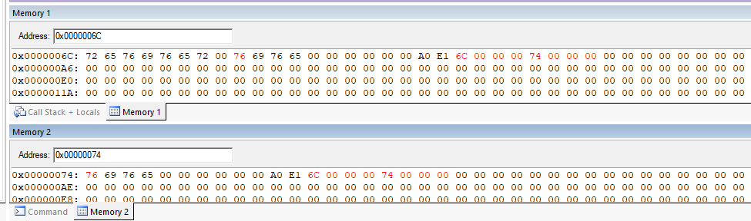

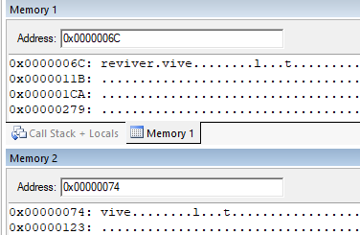

Setup:

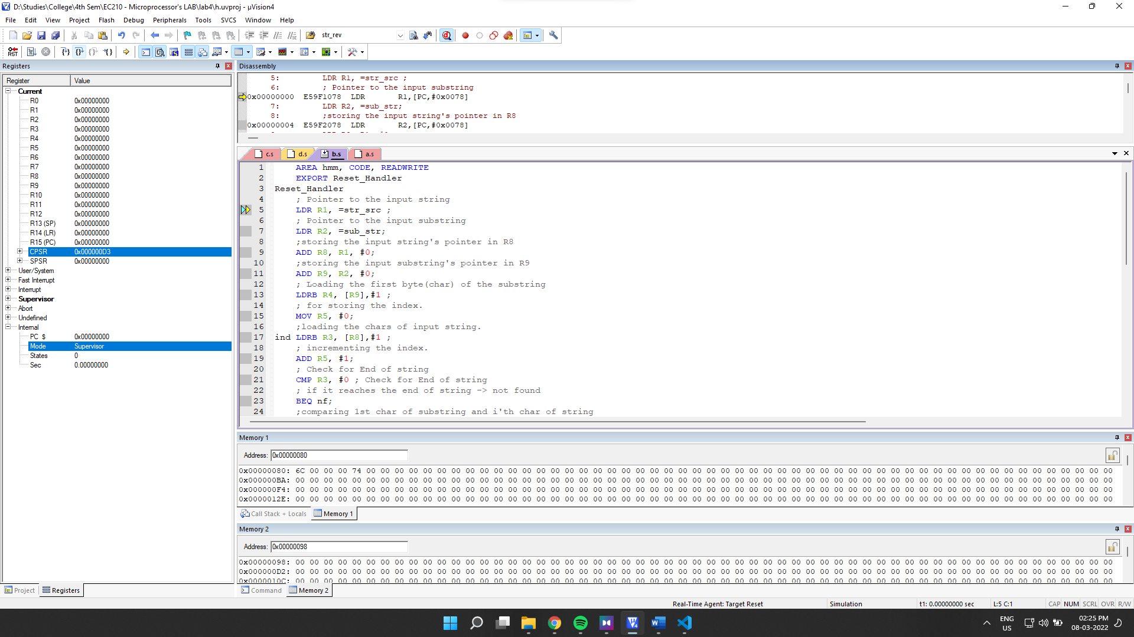

Final Output:

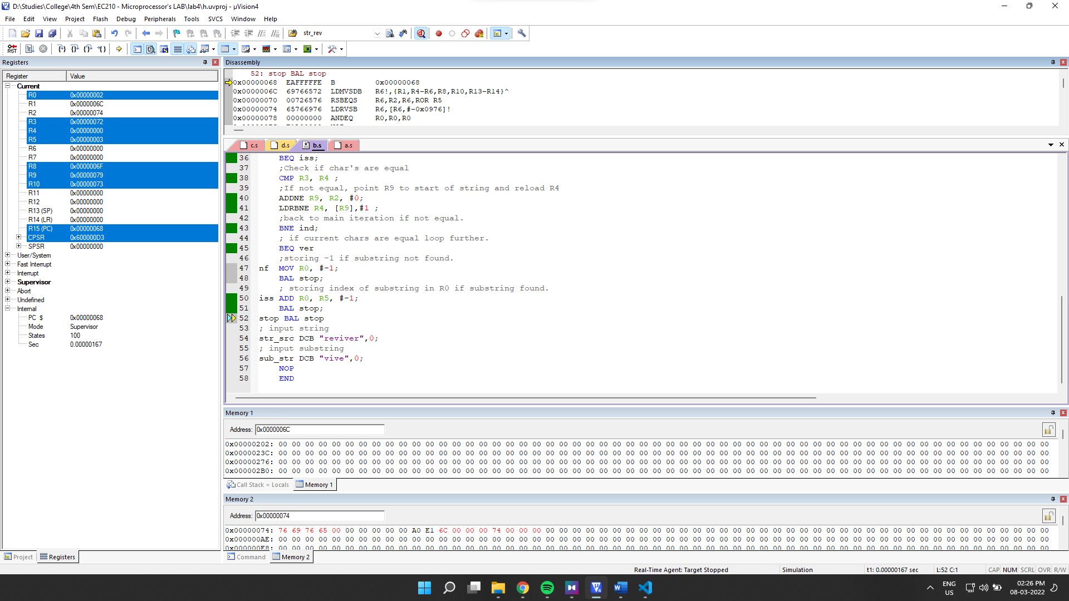

Final Register Values:

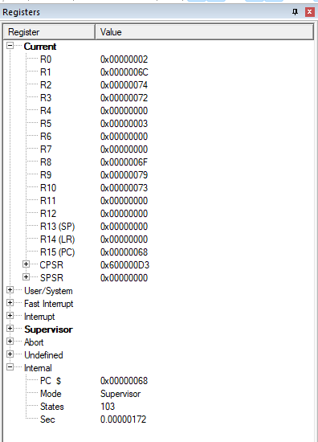

**Observation**: We can see that the output stored in R0 is 2. Which is correct as our input string a substring were “reviver” and “vive” respectively from which we can see that vive starts at index 2 (counting from 0).

**4.4]** Insert a substring in main string at given position.

->

Source Code:

        AREA AllocSpace, DATA,NOINIT,READWRITE

*;Space for storing the final string*

str_rev SPACE 1024

        AREA hmm, CODE, READWRITE

*EXPORT* Reset_Handler

Reset_Handler

*;Pointer to the input string*

        LDR R1, =str_src *;*

*;Pointer to the substring*

        LDR R2, =sub_str *;*

*;Pointer to result string*

        LDR R12, =str_rev *;*

*;Pointer to index*

        LDR R11, =sub_index *;*

*;loading index in R10;*

        LDRB R10, [R11]*;*

*;storing the input string's pointer in R8*

        ADD R8, R1, #0*;*

*;storing the input substring's pointer in R9*

        ADD R9, R2, #0*;*

*;for iteration till the insertion index*

        MOV R7, #0*;*

*;result's pointer in R12.*

        ADD R6, R12, #0*;*

*;storing the prefix part of string in result(before the insertion index)*

*;load a byte and update the pointer*

pref LDRB R3, [R8],#1 *;*

*;store byte and update the pointer*

        STRB R3, [R6], #1*;*

*;incrementign R7.*

        ADD R7, #1*;*

*;check if the insertion index is reached.*

        CMP R7, R10*;*

*; if not then loop. again to pref.*

        BNE pref

*; storing the substring in consequent index in result.*

*; load a byte and update the pointer*

sbst LDRB R3, [R9],#1 *;*

*;store byte and update the pointer*

        STRB R3, [R6], #1*;*

*;Check for End of string*

        CMP R3, #0 *;*

*; If not, then loop.*

        BNE sbst

*; subtract result pointer, so the null value can be rewritten*

        SUB R6, #1*;*

*;storing the suffix part, the part that existed at right of insertion index*

*;load a byte and update the pointer*

sufx LDRB R3, [R8],#1 *;*

*; store byte and update the pointer*

        STRB R3, [R6], #1*;*

*; Check for End of string*

        CMP R3, #0 *;*

*; if not , loop again*

        BNE sufx

done MOV R0, #1*;*

        BAL *stop;*

stop BAL *stop*

*;input string*

str_src DCB "reviver",0*;*

*;input substring*

sub_str DCB "abc",0*;*

*;input insertion index*

sub_index DCB 2*;*

        NOP

*END*

Debugging:

Initial Memory: (after getting the address through register)

Memory 1 shows input string, memory 2 input substring and memory 3 will hold output result string.

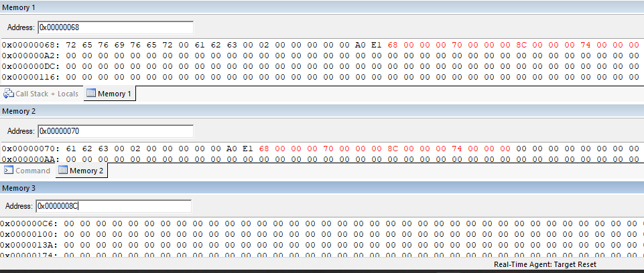

Index:

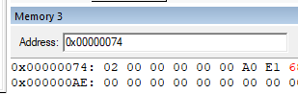

Setup:

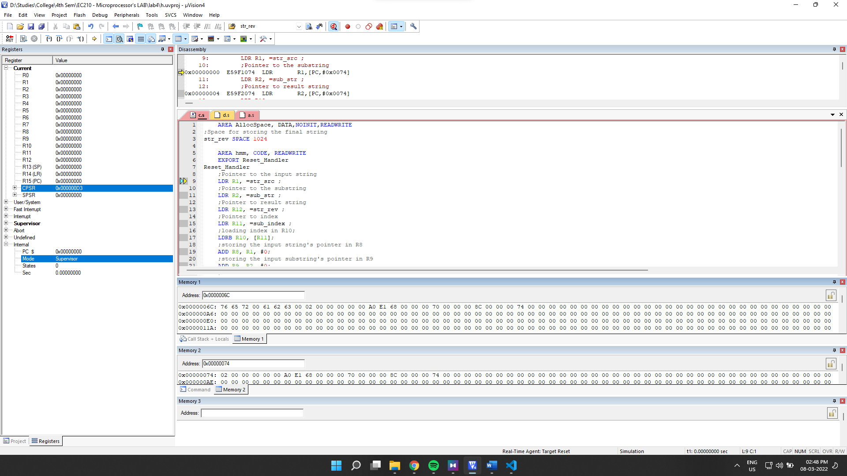

Final Output:

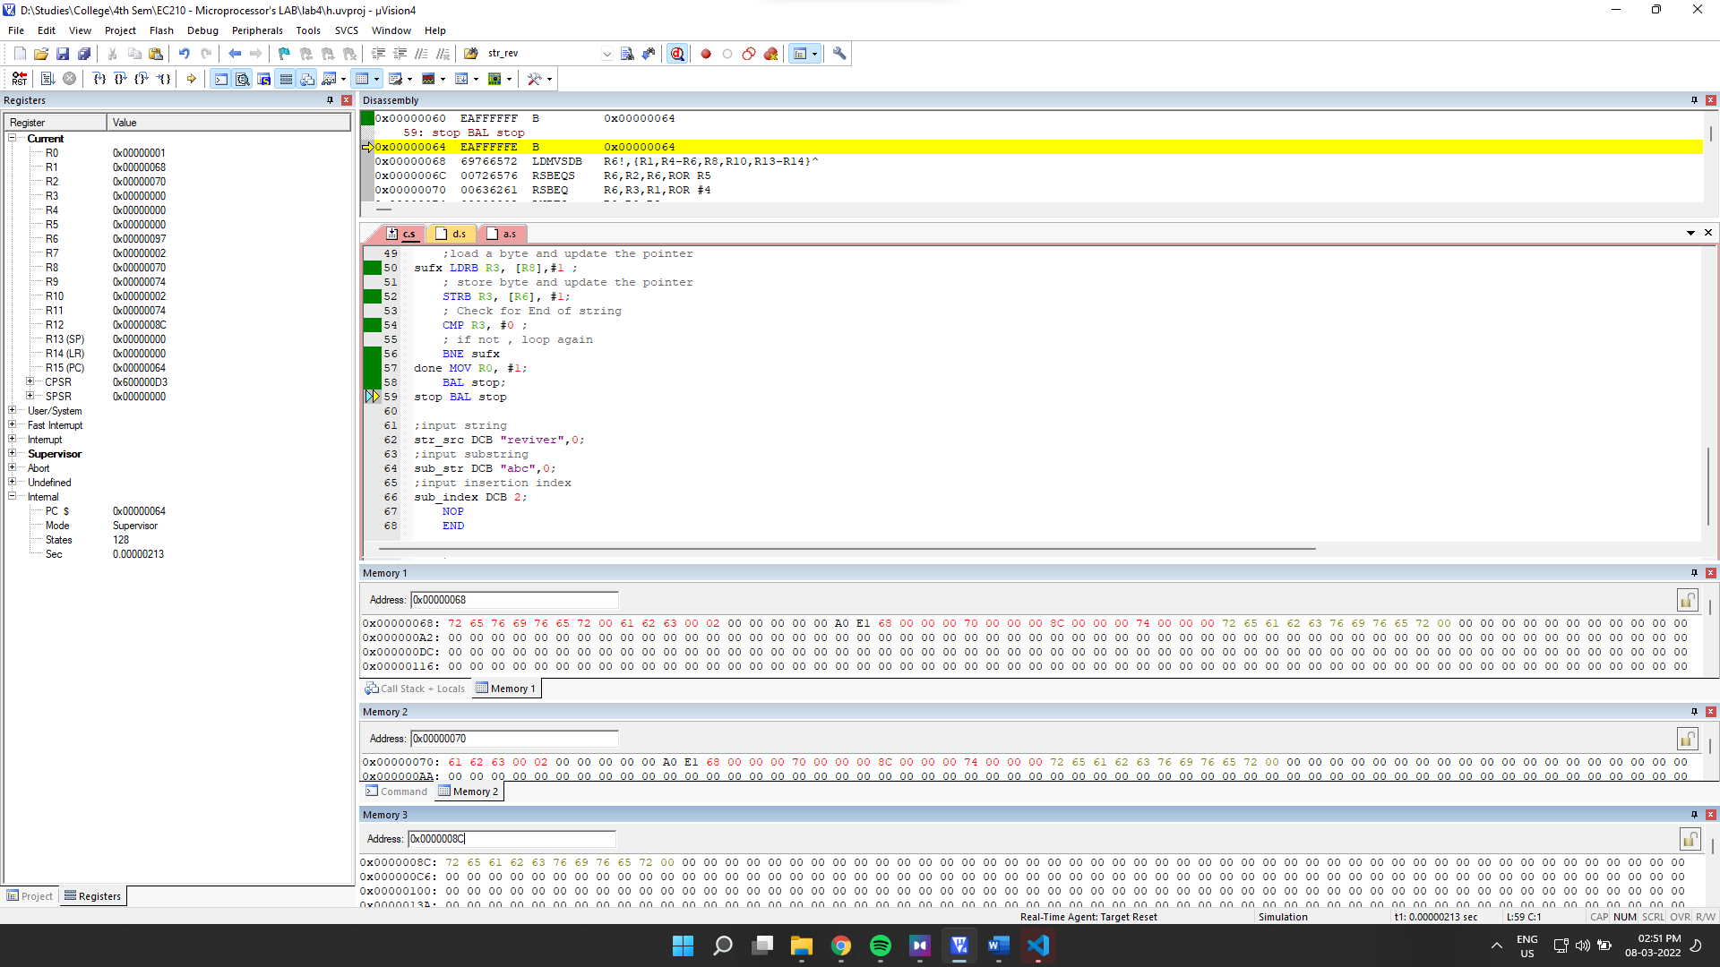

Final Memory:

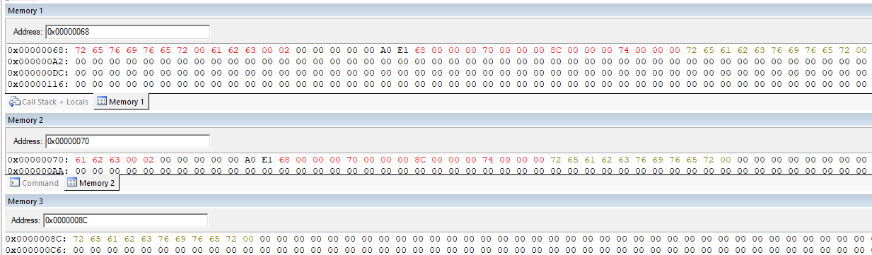

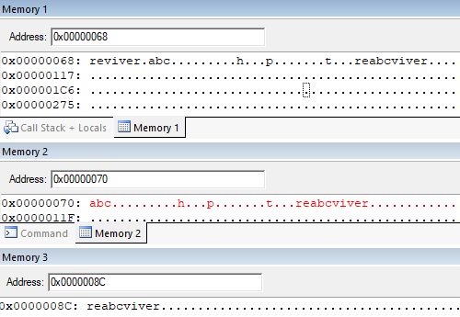

**Observation**: We can see that in memory3, we have our final string. We can compare both the input string and substring with that of in memory 3 and verify that it contains the string with substring at insertion index.

**4.5]** Squeeze a string removing all the blank spaces and store it in the same location

-> We will copy the input string to the space. And then we will operate on it. This way we can directly operate on the same memory.

Source Code:

        AREA AllocSpace, DATA,NOINIT,READWRITE

*;Space for the input string*

str_main SPACE 1024

        AREA hmm, CODE, READWRITE

*EXPORT* Reset_Handler

Reset_Handler

*;Pointer to the string*

        LDR R1, =str_main *;*

*;Pointer to the input string*

        LDR R2, =str_src *;*

*;storing the string's pointer in R8*

        ADD R4, R1, #0*;*

*;storing the input's pointer in R8*

        ADD R5, R2, #0*;*

*;for storing the input String;*

*; loading characters from input string.*

fill LDRB R3, [R5], #1*;*

*;storing the character in result space*

        STRB R3, [R4], #1*; store byte and update the pointer*

*;checking if end of line is reached*

        CMP R3, #0*;*

*; if not then loop.*

        BNE fill*;*

*; for storing no of zeroes encountered*

        MOV R4, #0*;*

*; Pointer to the string in R5*

        MOV R5, R1*;*

*;loading character from string*

sqz LDRB R3, [R5]*;*

*; checking if its a space*

        CMP R3, #32*;*

*; if its a space then add 1 to R4.*

        ADDEQ R4, #1*;*

*; if not then calculate index to move towards left.*

        SUBNE R6, R5, R4*;*

*; and also store the current value towards left at that index.*

        STRBNE R3, [R6]*;*

*; update the string's iterator*

        ADD R5, #1*;*

*;check if string ends.*

        CMP R3, #0*;*

*; if not then loop.*

        BNE sqz*;*

*;R0 to change to 1 at the end of the loop.*

done MOV R0, #1*;*

        BAL *stop;*

stop BAL *stop;*

str_src DCB "This is a text",0*;*

        NOP

*END*

Initial Memory: (after getting the address through register and loading the value into the reserved space)

Memory 1 will hold the input string and later also the result.

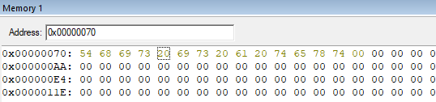

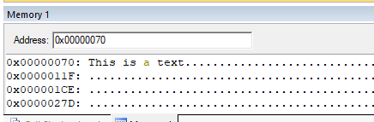

Setup:

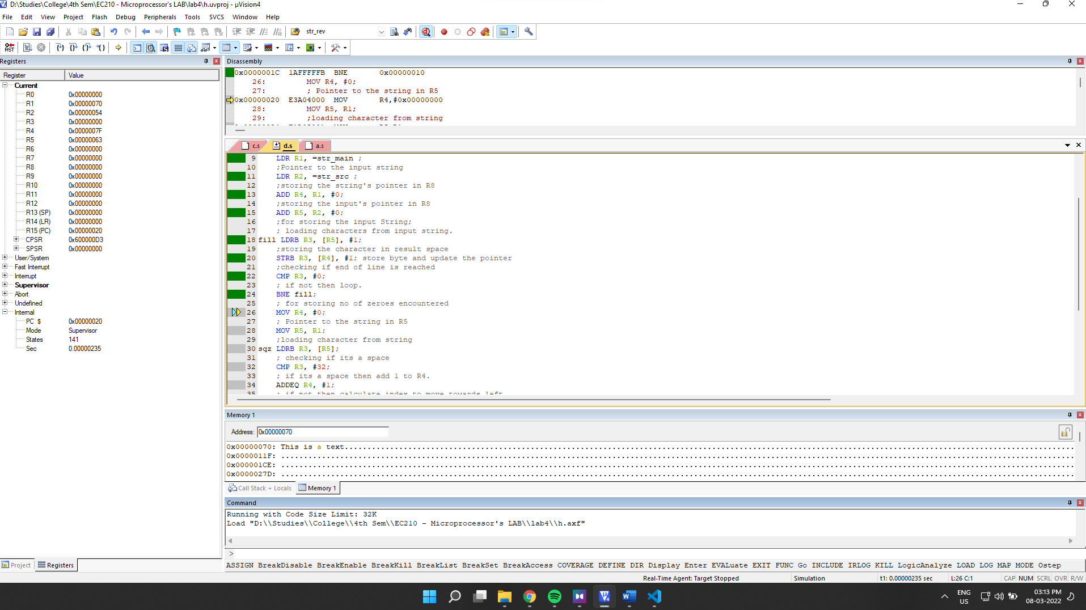

Final Output:

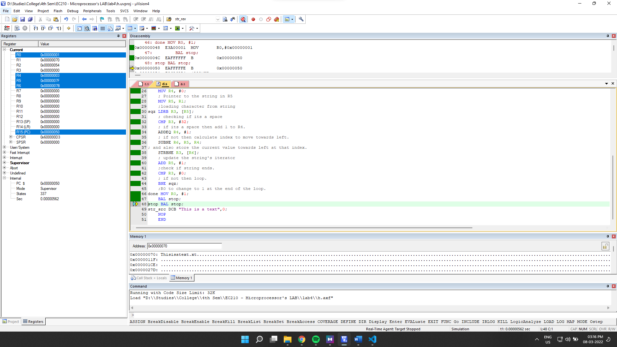

Final Memory:

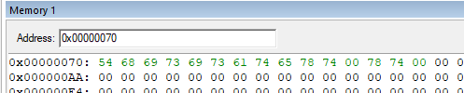

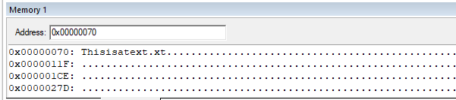

**Observation**: We can see that the final string is squeezed and all spaces are removed.