**EC-210**

**Microprocessors Lab**

**LAB-5**



Utkarsh Mahajan 201EC164

ARNAV RAJ 201EC109

Objective: To study defining memory area, constant in the assembly program.

**Exercise:**

**5.2]** Check if the given number is odd or even.

->Source Code:

    AREA AllocSpace, DATA,NOINIT,READWRITE

*;Space for storing result*

result SPACE 1*;*

*;Actual Code*

    AREA hmm, CODE, READWRITE

*EXPORT* Reset_Handler

Reset_Handler

*;address to the input number*

    LDR R1, =inputnumber *;*

*;address to the result*

    LDR R2, =result *;*

*; load the  input number from memory*

    LDR R3, [R1]*;*

*; Getting the last bit*

    AND R4, R3, #1*;*

*; Checking if it is zero*

    CMP R4, #0*;*

*;if not zero-> not divisible.*

    MOVNE R4, #0xFF*;*

*; storing result as 0xFF;*

    STRBNE R4, [R2]*;*

    BNE *stop*

*; if zero ->divisible*

    ADD R4, R4, #1*;*

*; storing result as 1;*

    STR R4, [R2]*; storing 0*

stop BAL *stop*

*; input_number*

inputnumber DCD 0x43D8E5F7*;*

    NOP

*END*

Debugging:

Initial Memory: (after getting the address through register)

Memory 1 shows input and memory 2 will store output

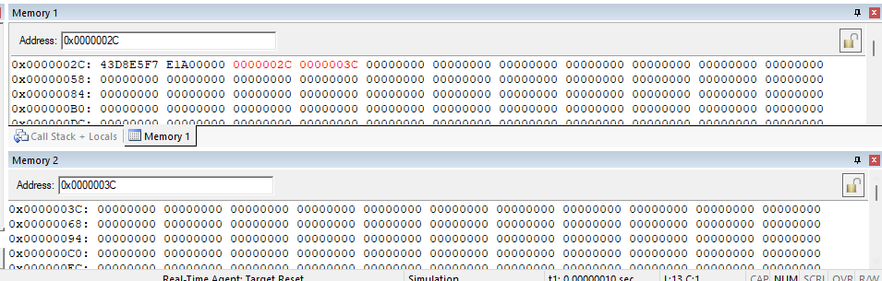

Setup:

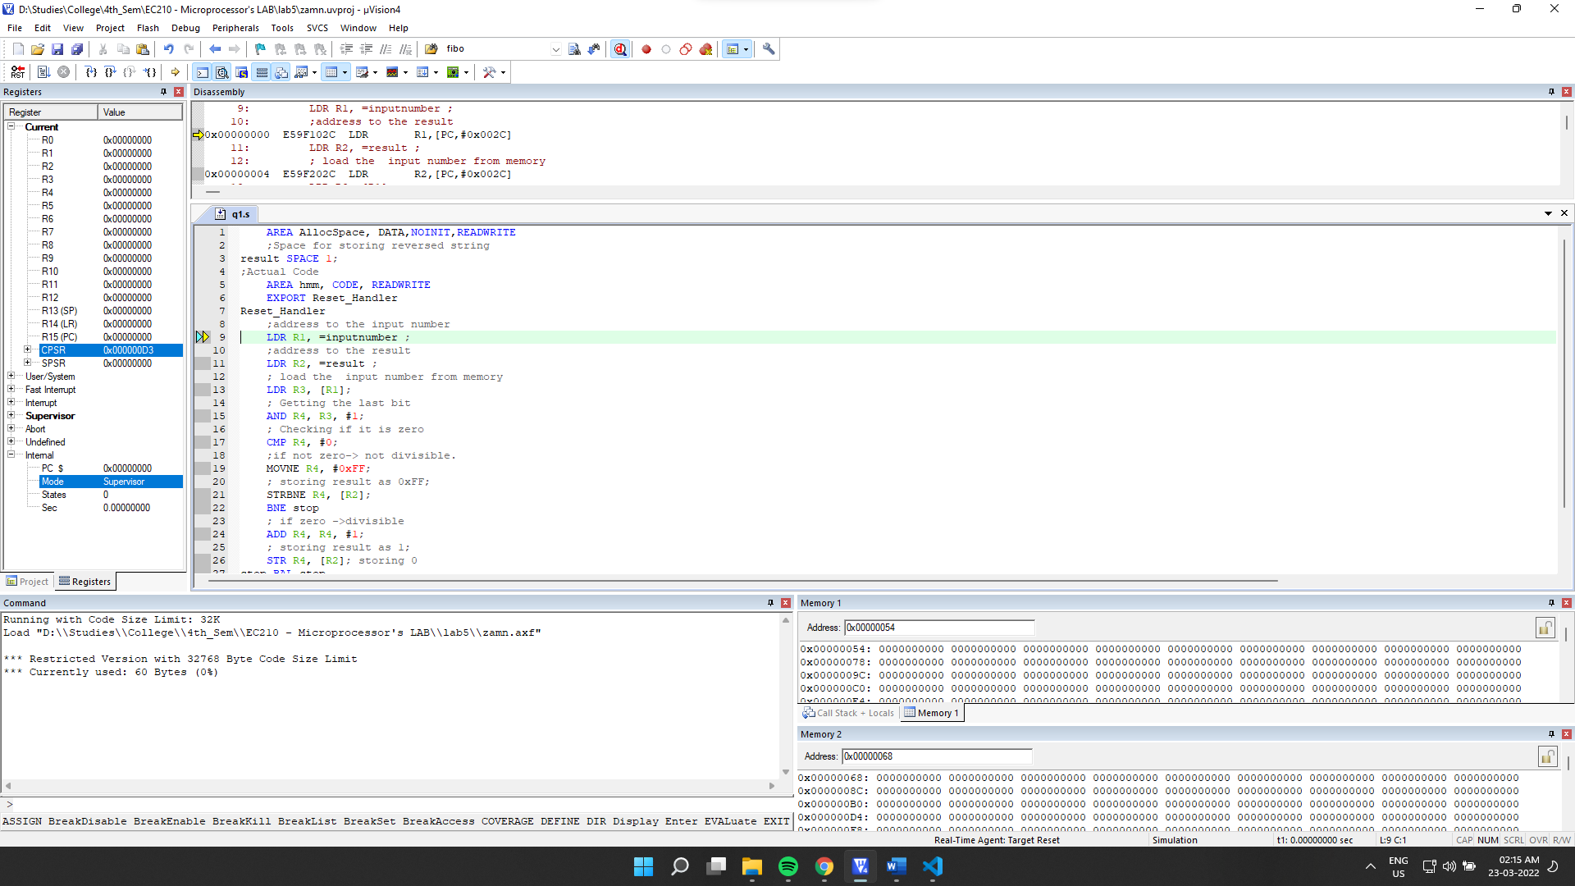

Final Output:

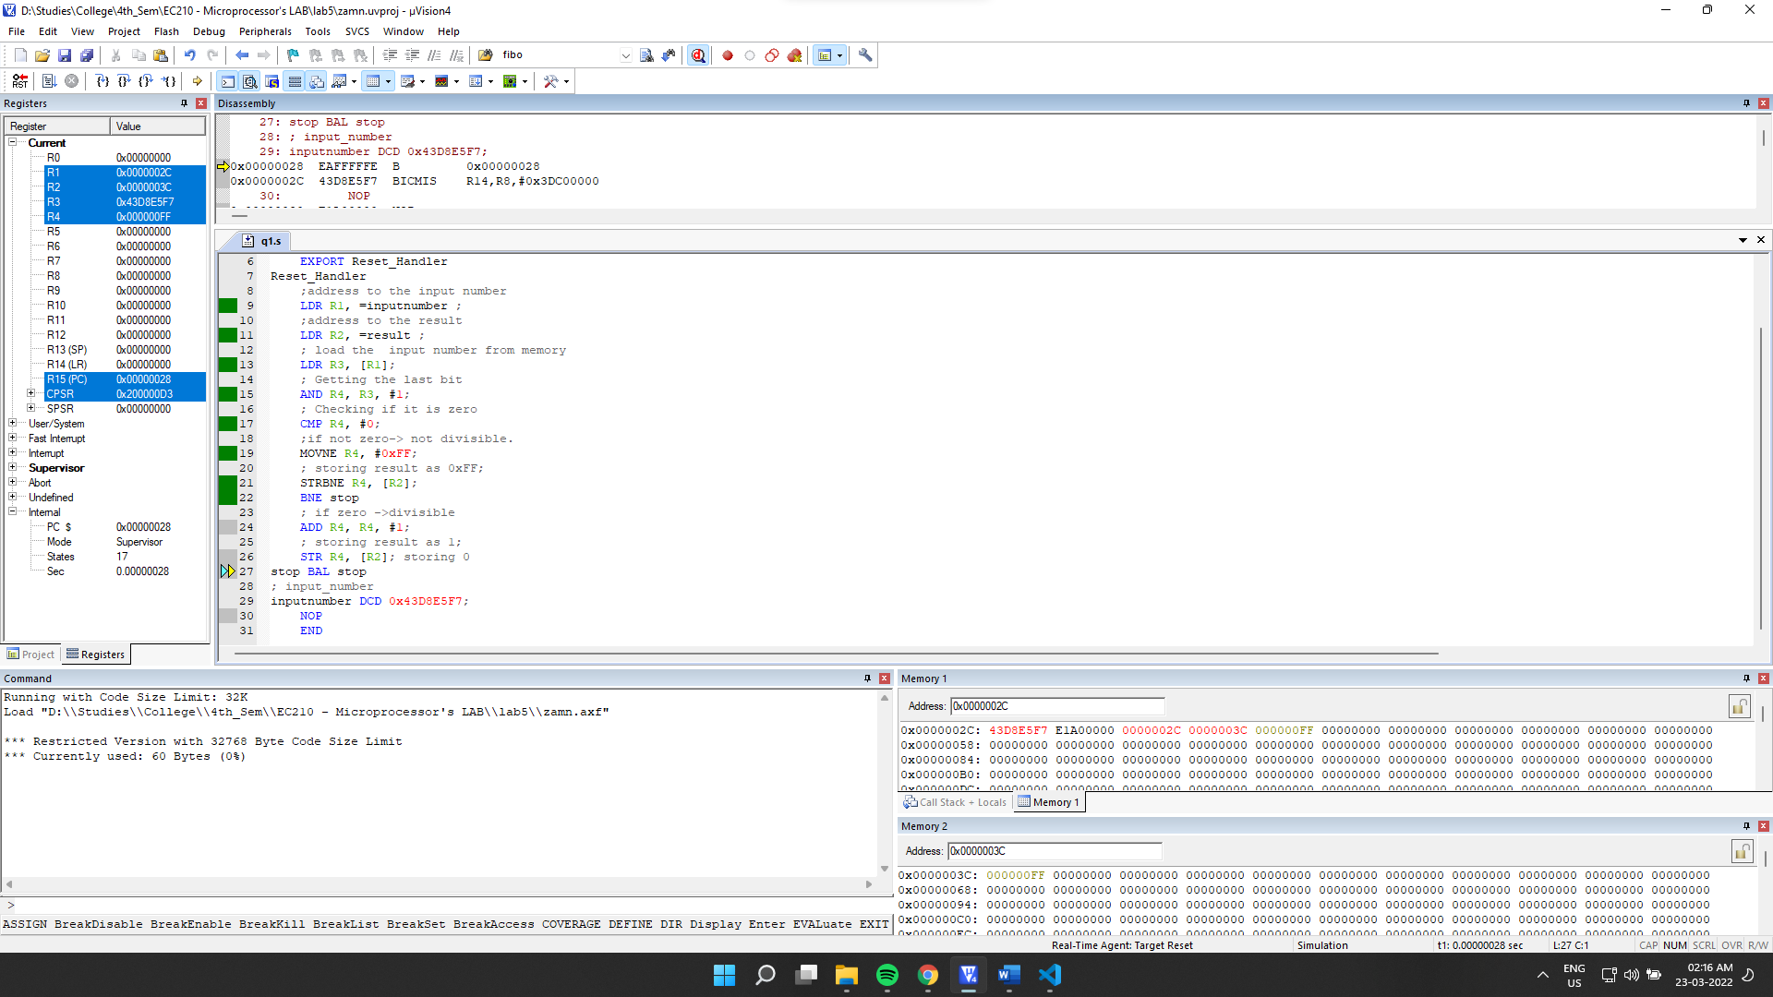

Final Memory:

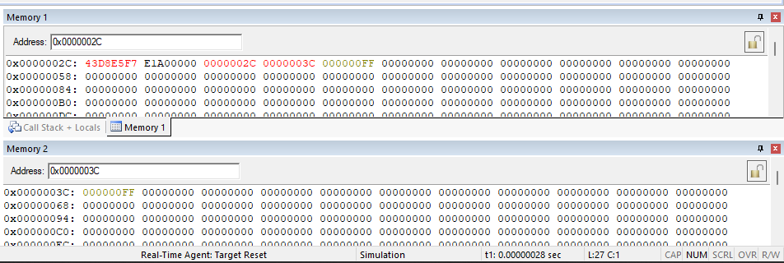

**Observation**:

We can see that the output 0xFF for the given input is correct. 0x43D8E5F7 Is not divisible by 2.

**For input number**: 0x4FF02ED6

Initial Memory:

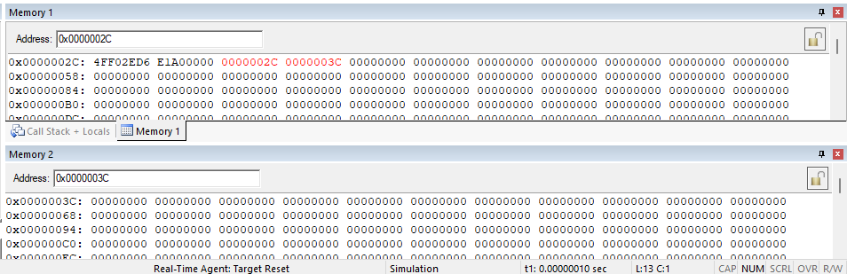

Final memory:

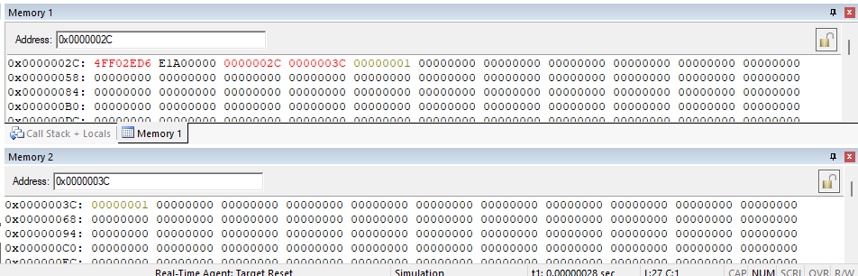

**Observation**: we can see the output for the given input 0x4FF02ED6 is correct. The input is divisible by 2.

**5.3]** Find the number of occurrences of a digit in a number.

->

Source Code:

    AREA AllocSpace, DATA,NOINIT,READWRITE

*;Space for storing result*

result SPACE 1*;*

*;Actual Code*

    AREA hmm, CODE, READWRITE

*EXPORT* Reset_Handler

Reset_Handler

*;address to the input number*

    LDR R1, =inputnumber *;*

*;address to the input digit to cmp*

    LDR R2, =inputdigit*;*

*;address to the result*

    LDR R3, =result *;*

*; load the  input number from memory*

    LDR R4, [R1]*;*

    LDRB R9, [R2]*;*

*; Getting the last bit*

    MOV R5, R4*; R5 = R4*

    MOV R6, #0*; for quotient*

*;dividing and finding nth digit.*

*;division by the use of subtracting*

*; until a remainder is found.*

*; where remainder < 10*

div SUB R5, R5, #10*; subtracting by 10*

    CMP R5, #10*; checking if remainder < 10*

*;incrementing iterator to store quotient*

    ADD R6, R6, #1*;*

*; if remainder >=10 then loop to sub further.*

    BPL div

*;least digit stored in R5*

*;checking if remainder is equal to the input digit.*

    CMP R9, R5*;*

*;If yes then increment count*

    ADDEQ R10, R10, #1*;*

*;comparing quotient and 10.*

    CMP R6, #10*;*

*;if quotient >10 then store quotient in remainder*

    MOVPL R5, R6*;*

*; && reset quotient*

    MOVPL R6, #0*;*

*; && loop again*

    BPL div*;*

*; the last digit will be in R6*

*; so compare that to input again.*

    CMP R6, R9*; for the last digit*

*;if yes increment counter;*

    ADDEQ R10, R10, #1*;*

*; storing result as 1;*

    STR R10, [R3]*; storing answer*

stop BAL *stop*

*; input_number*

inputnumber DCD 142534*;*

inputdigit DCB 4*;*

*END*

Debugging:

Initial Memory: (after getting the address through register)

Memory 1 shows input number and memory 2 shows input digit while memory 3 will hold result (no of occurrences).

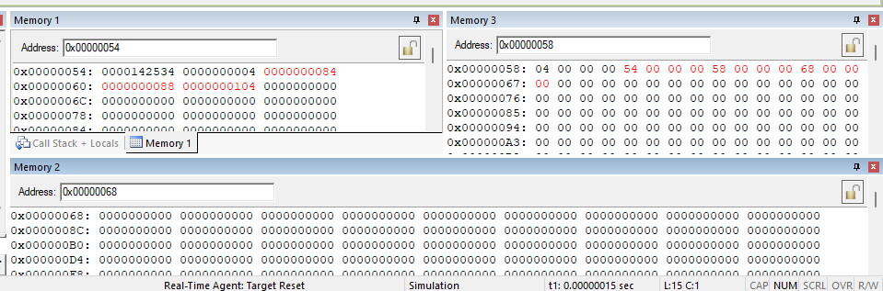

Setup:

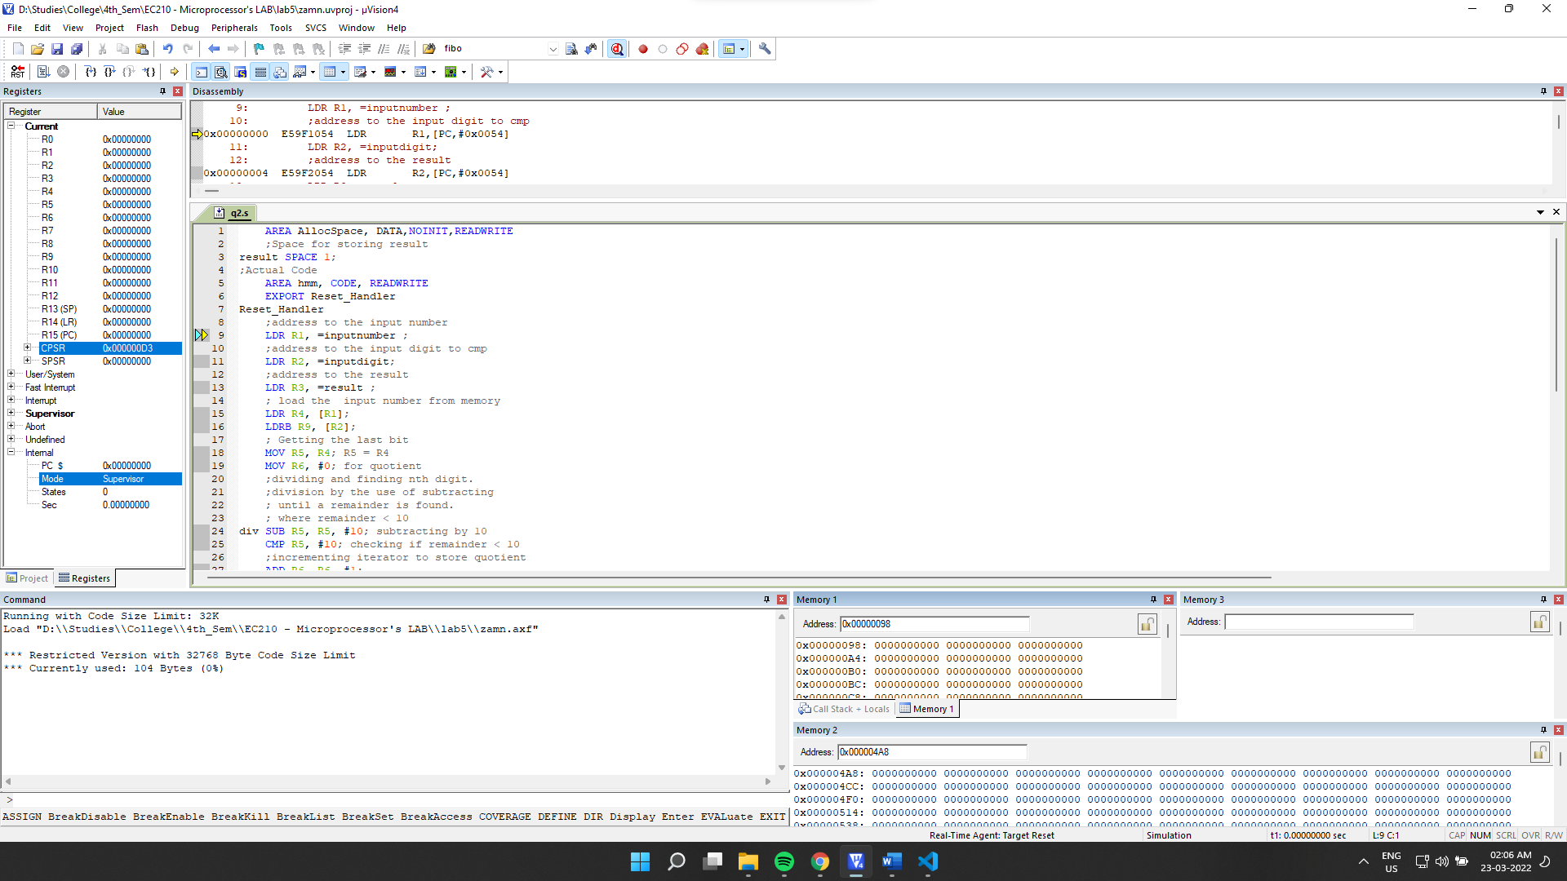

Final Output:

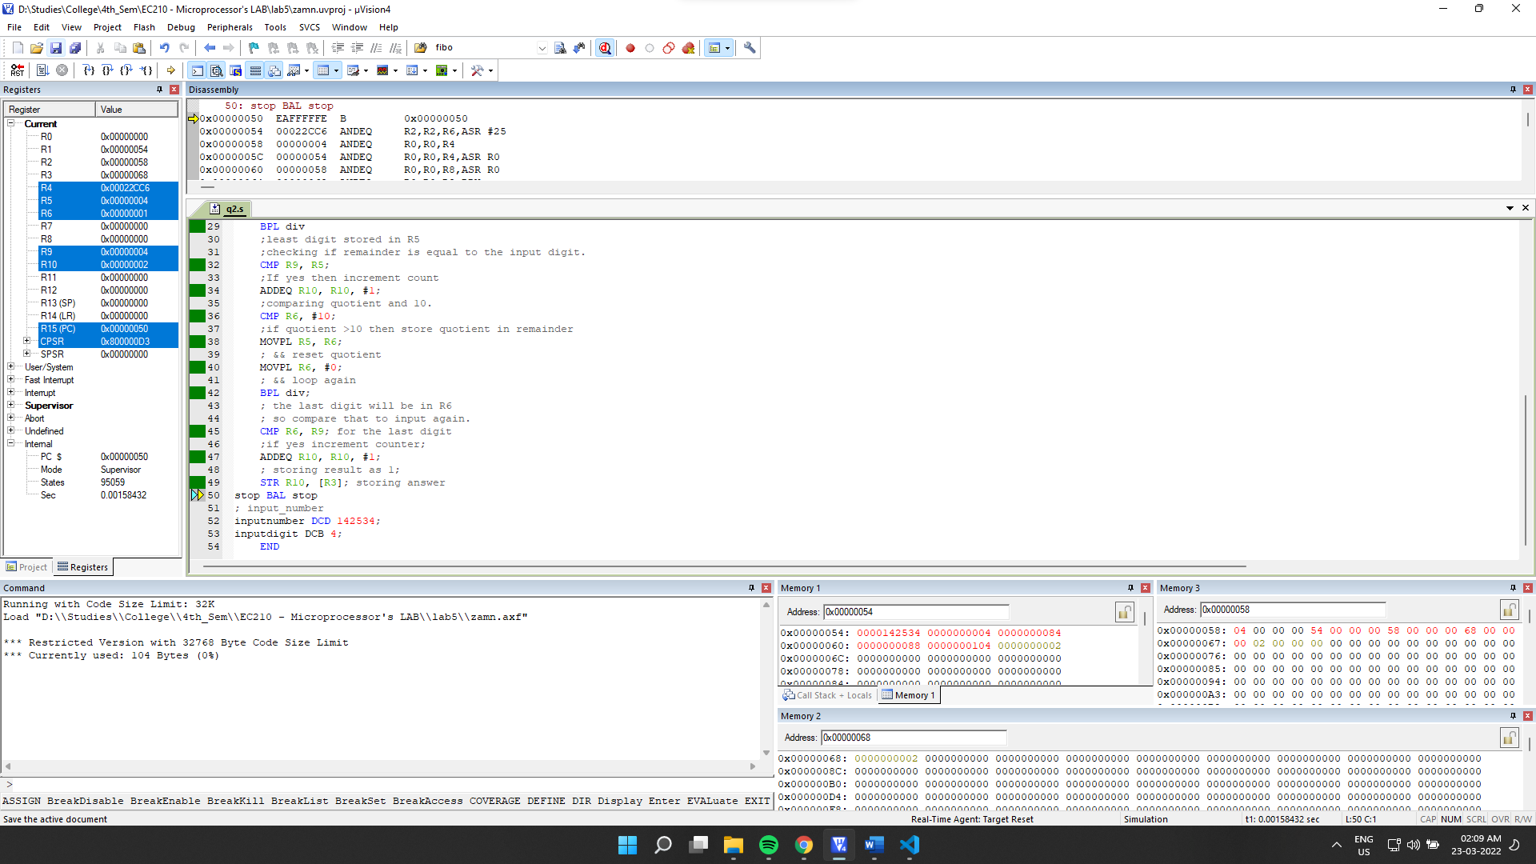

Final Memory:

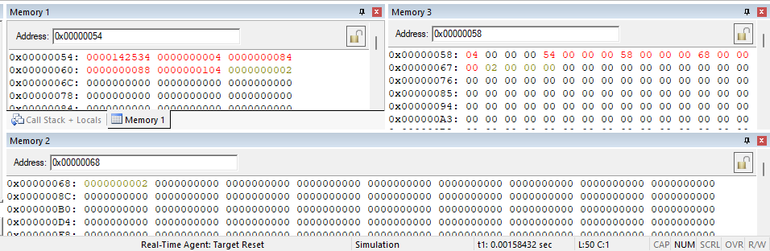

**Observation**:

We can see that our result stored in memory2 is 2 which is correct as digit 4 repeats twice in the input 142534.

**5.4]** Reverse the given number.

->

Source Code:

    AREA AllocSpace, DATA,NOINIT,READWRITE

*;Space for storing reversed string*

array SPACE 1024*;*

result SPACE 1024*;*

*;Actual Code*

    AREA hmm, CODE, READWRITE

*EXPORT* Reset_Handler

Reset_Handler

*;address to the input number*

    LDR R1, =inputnumber *;*

*;address for space used in operation*

    LDR R2, =array*;*

    MOV R12, R2*;*

*;address to the result*

    LDR R3, =result *;*

*; load the  input number from memory*

    LDR R4, [R1]*;*

    LDRB R9, [R2]*;*

*; Getting the last bit*

    MOV R5, R4*; R5 = R4*

    MOV R6, #0*;*

    MOV R7, #0*; for storing no of nos.*

*;dividing and finding nth digit.*

*;division by the use of subtracting*

*; until a remainder is found.*

*; where remainder < 10*

div SUB R5, R5, #10*; subtracting by 10*

    CMP R5, #10*; checking if remainder < 10*

*;incrementing iterator to store quotient*

    ADD R6, R6, #1*;*

*; if remainder >=10 then loop to sub further.*

    BPL div

    ADD R7, #1*; incrementing nos.*

    STRB R5, [R2], #1*; storing digits*

*;comparing quotient and 10.*

    CMP R6, #10*;*

*;if quotient >10 then store quotient in remainder*

    MOVPL R5, R6*;*

*; && reset quotient*

    MOVPL R6, #0*;*

*; && loop again*

    BPL div*;*

*; check if quotient is zero*

    CMP R6, #0*;*

*; increment no of digits counter if no*

    ADDNE R7, #1*;*

*; &&  store it in R2 if no.*

    STRBNE R6, [R2]*; storing last digit*

*;*

    MOV R9, #0*; i for  iteration*

    MOV R5, #0*; for storing result*

    MOV R8, #1*; for multiple of 10*

    MOV R4, #0*; for storing digit;*

    MOV R6, #0*;*

    MOV R10, #10*;*

*;loading ith digit in R4*

mult LDRB R4, [R2], #-1*;*

*; multiplying it with 10^i*

    MUL R6, R4, R8*;*

*; adding it to Result register*

    ADD R5, R5, R6*;*

*;incrementing iterator*

    ADD R9, #1*;*

*; multiplying multiplying register with 10.*

    MUL R13, R8, R10*;*

*; storing it back into multiplkying register*

    MOV R8, R13*;*

*; checking if i< n  (n= no of digits)*

    CMP R7, R9*;*

*; if yes then loop*

    BPL mult

*;store final result in [R3] memory.*

    STR R5, [R3]*;*

stop BAL *stop*

*; input_number*

inputnumber DCD 142534*;*

*END*

Debugging:

Initial Memory: (after getting the address through register)

Memory 1 shows input number and memory 2 will hold reversed no.

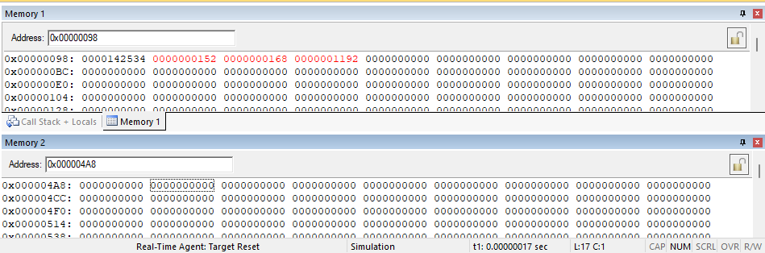

Setup:

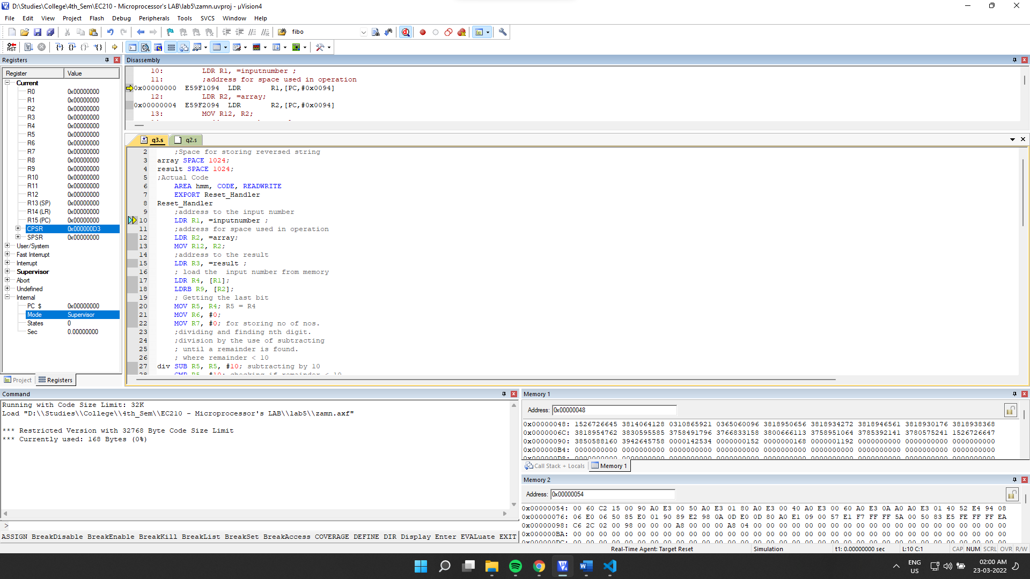

Final Output:

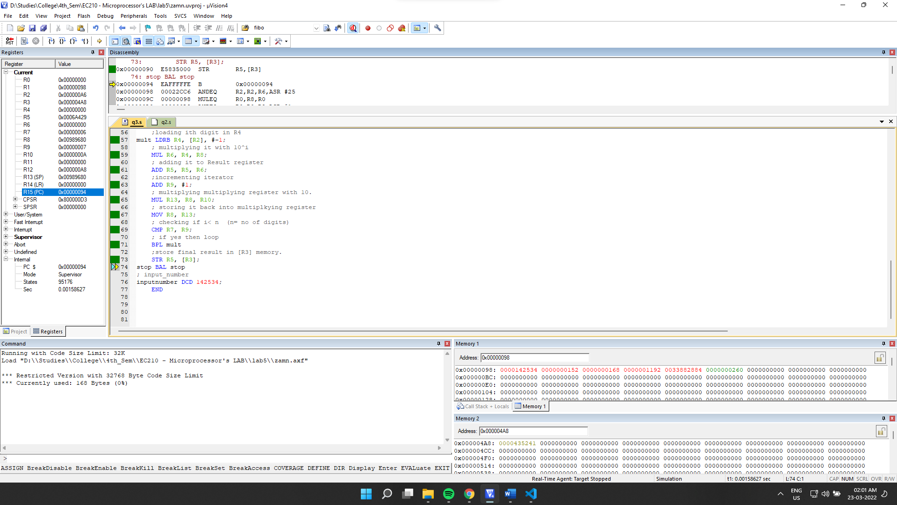

Final Memory Values:

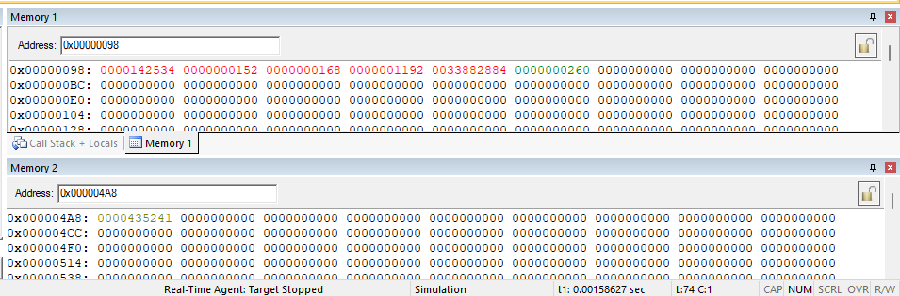

**Observation**: We can see that for input 142534, we have achieved its reverse 435241 stored in result memory location.

**5.5]** Check whether the given number is a Fibonacci number.

-> For input 144, which is a Fibonacci Number

Source Code:

    AREA AllocSpace, DATA,NOINIT,READWRITE

*;Space for storing result*

result SPACE 1*;*

*;Actual Code*

    AREA hmm, CODE, READWRITE

*EXPORT* Reset_Handler

Reset_Handler

*;address to the input number*

    LDR R1, =inputnumber *;*

*;address to the result*

    LDR R2, =result *;*

    MOV R4, #1*; (n-1)th term*

    MOV R5, #1*; nth term*

*; load the  input number from memory*

    LDR R3, [R1]*;*

*; base case check if input ==0;*

    CMP R3, #0*;*

*; as 0 is a fib no for f(0), store & jump*

    MOVEQ R6, #1*;*

    BEQ dun

*;for other cases n>0;*

*;as f(1)==f(2)==1;*

*; it doesn't matter in iteration.*

*; while comparing.*

*;comparing nth fib, initially R5, f(1)=f(2)*

chk CMP R3, R5*;*

*; storing 1 in result register if it matches any fibb.*

    MOVEQ R6, #1*;*

*; jumping to store result in memory*

    BEQ dun

*; if input > current F(n),*

*;We will calculate F(n+1) and store it in R5*

*; And Current F(n) in R4;*

    ADDPL R7, R4, R5*;*

    MOVPL R4, R5*;*

    MOVPL R5, R7*;*

*; LOOP to check again.*

    BPL chk*;*

*; if input < F(n) then its not a fibonacci number*

*; store 0XFF in result register;*

    MOV R6, #0xFF*; :o*

*; store result in memory.*

dun STRB R6, [R2]*;*

stop BAL *stop*

*; input_number*

inputnumber DCD 144*;*

*END*

Debugging:

Initial Memory: (after getting the address through register)

Memory 1 shows input, memory 2 will hold output.

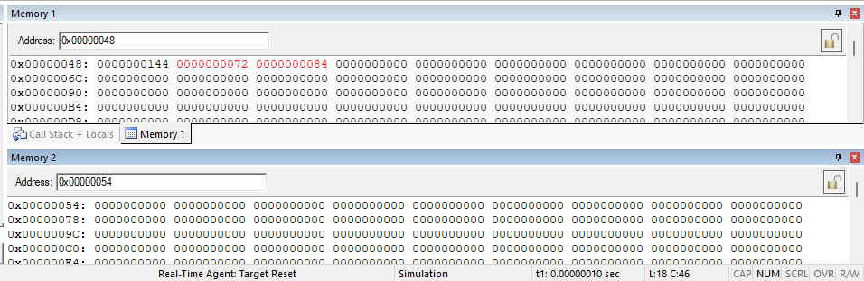

Setup:

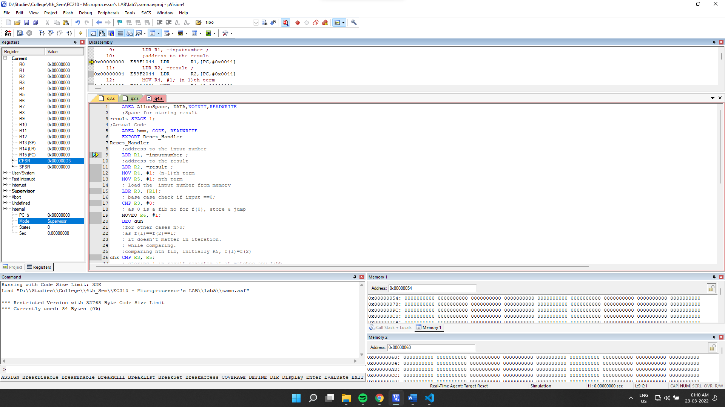

Final Output:

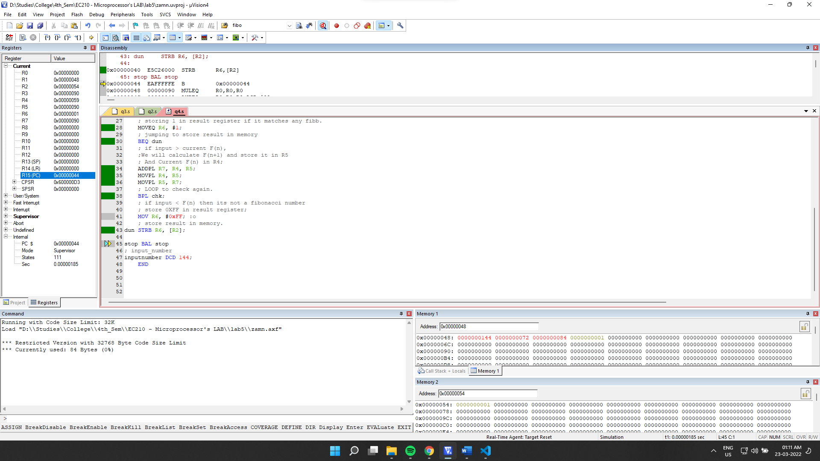

Final Memory:

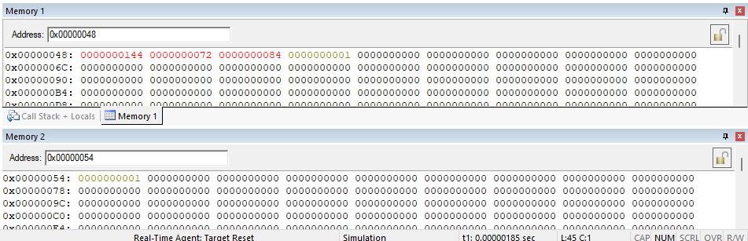

**Observation**: We can see that in memory2, 1 is stored. Output generated for the input 144 is correct as it is a Fibonacci number.

For Input 65:

Initial Memory:

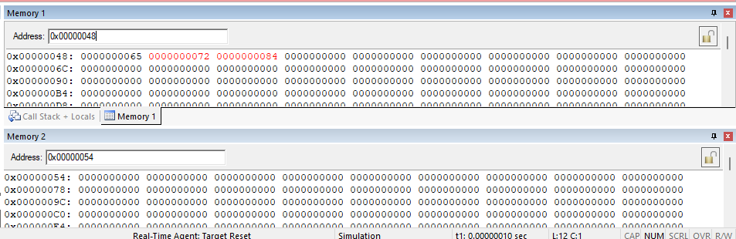

Final Memory:

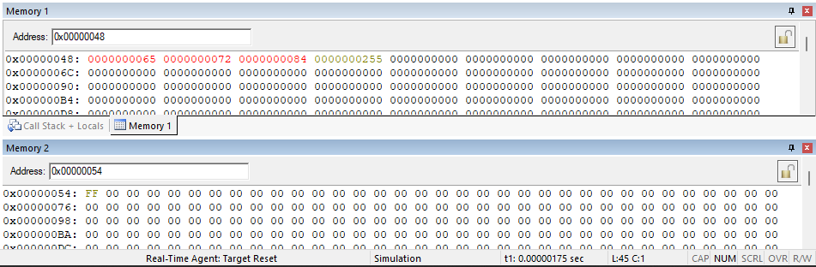

Observation: we can see that the output is 0xFF is correct as the input 65 is not a Fibonacci number.

**5.6]** To generate the Fibonacci numbers up to the given number

->

Taking input =11

Source Code:

    AREA AllocSpace, DATA,NOINIT,READWRITE

*;Space for storing result*

result SPACE 1024*;*

*;Actual Code*

    AREA hmm, CODE, READWRITE

*EXPORT* Reset_Handler

Reset_Handler

*;address to the input number*

    LDR R1, =inputnumber *;*

*;address to the result*

    LDR R2, =result *;*

    MOV R4, #1*; (n-1)th term*

    MOV R5, #1*; nth term*

*; load the  input number from memory*

    LDR R3, [R1]*;*

*; base_case if the input number is 0;*

    CMP R3, #0*;*

    MOVEQ R6, #0*;*

    BEQ dun

*;base_case if the input number is 1;*

    CMP R3, #1*;*

    MOVEQ R6, #1*;*

    BEQ dun

*; for input number >1*

    MOV R9, #2*; iterator i from 2 to n.*

chk CMP R3, R9*; checking if i==n*

    BEQ dun *; jump to store if done.*

    ADD R9, #1*; increment iterator*

*; nth term = (n-1)th + (n-2)th*

    ADD R7, R4, R5*;*

*; storing nth term in R5*

    MOV R4, R5*;*

*;storing (n-1)th term in R4*

    MOV R5, R7*;*

*; jump to chk to loop till i==n*

    BPL chk*;*

*;store the result in [R2]*

dun *STR* R5, [R2]*;*

stop BAL *stop*

*; input_number*

inputnumber DCD 11*;*

*END*

Initial Memory: (after getting the address through register and loading the value into the reserved space)

Memory 1 will hold the input no and memory 2 will hold result (Fibonacci no).

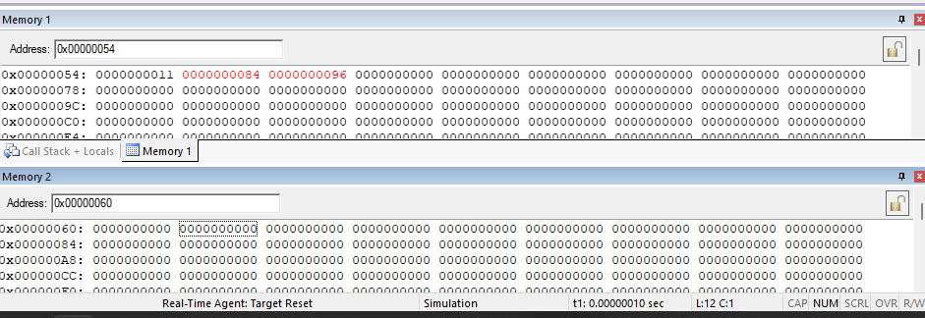

Setup:

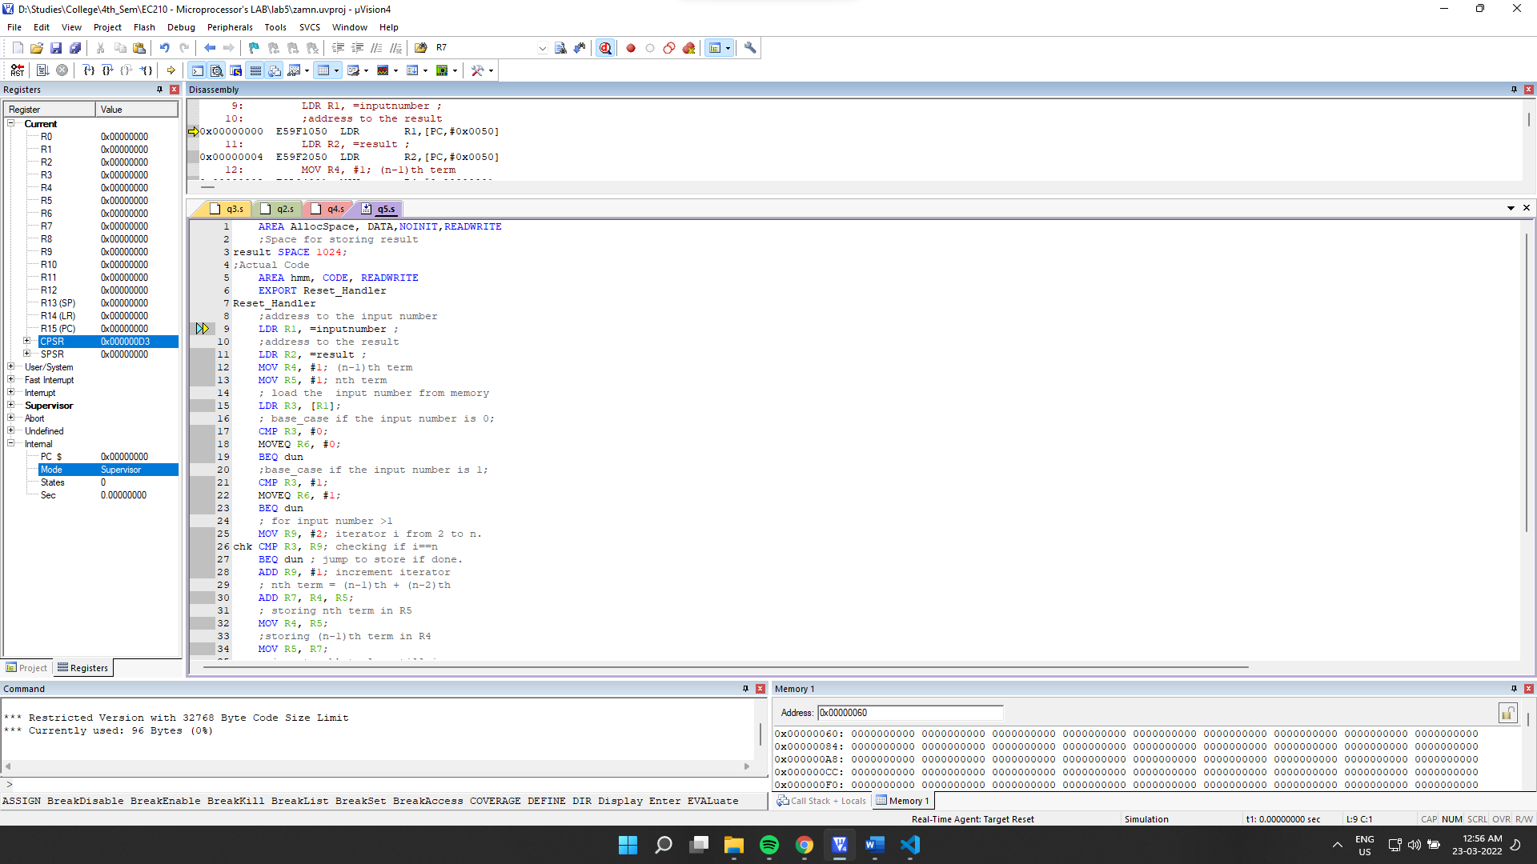

Final Output:

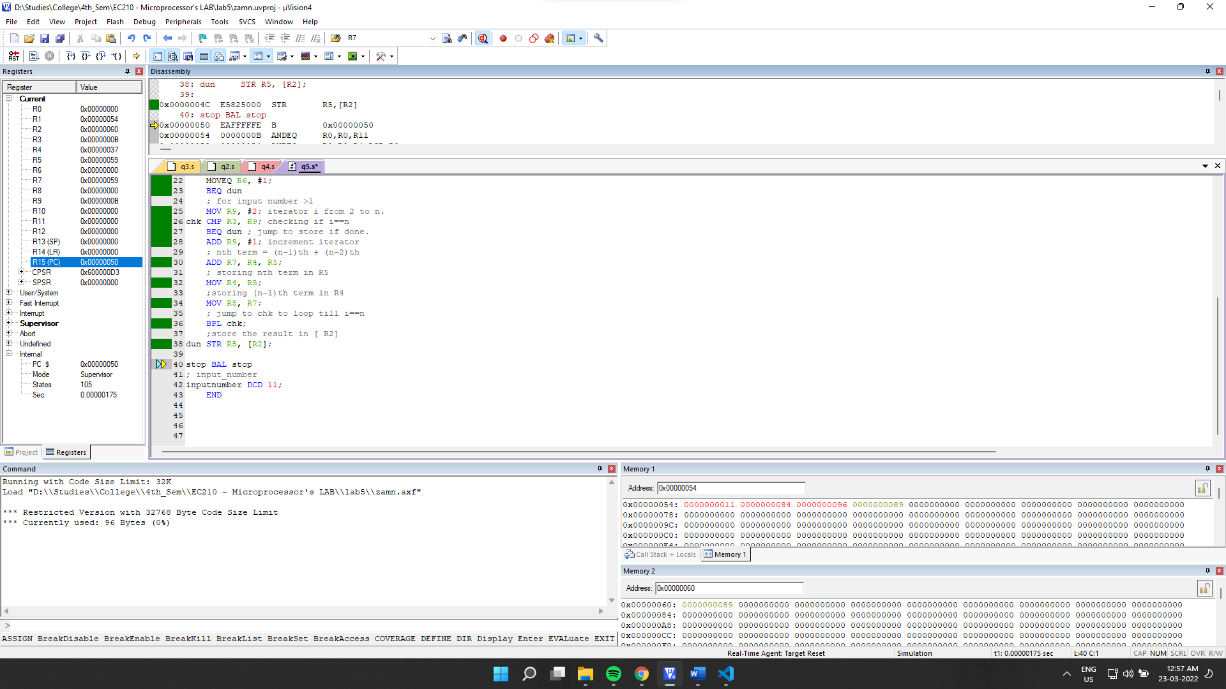

Final Memory:

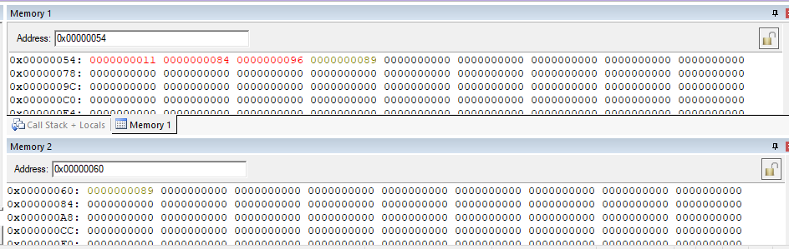

**Observation**: We can see that the output stored in result memory location 89 is correct as 11th Fibonacci no is 89.