**EC-210**

**Microprocessors Lab**

**LAB-6**



Utkarsh Mahajan 201EC164

ARNAV RAJ 201EC109

Objective: To understand and use the multiplication instructions effectively.

**Exercise:**

**6.2]** Write an assembly program to perform multiplication c = a * b where

(a) a and b are both unsigned 32 bit numbers.

->

Source Code:

    AREA AllocSpace, DATA,NOINIT,READWRITE

*;Space for storing result*

*;Utkarsh && Arnav Lab6*

c SPACE 8*;*

*;Actual Code*

    AREA hmm, CODE, READWRITE

*EXPORT* Reset_Handler

Reset_Handler

*;address to the input number*

    LDR R1, =a*;*

    LDR R2, =bi*;*

*;address to the result*

    LDR R3, =c *;*

    LDR R4, [R1]*; load a*

    LDR R5, [R2]*; load b*

    UMULL R6, R7, R5, R4*; unsigned mult*

    STR R6, [R3]*; storing low*

    STR R7, [R3, #4]*; storing high*

stop BAL *stop*

*; input_number*

a   DCD 0x7A120*;*

bi  DCD 0xCF850*;*

*END*

Debugging:

Initial Memory: (after getting the address through register)

Memory 1 shows input and memory 2 will store output

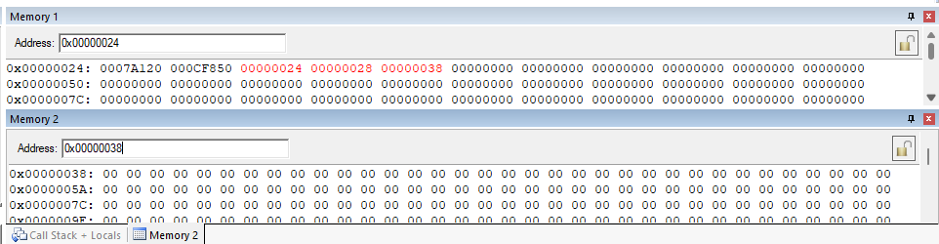

Setup:

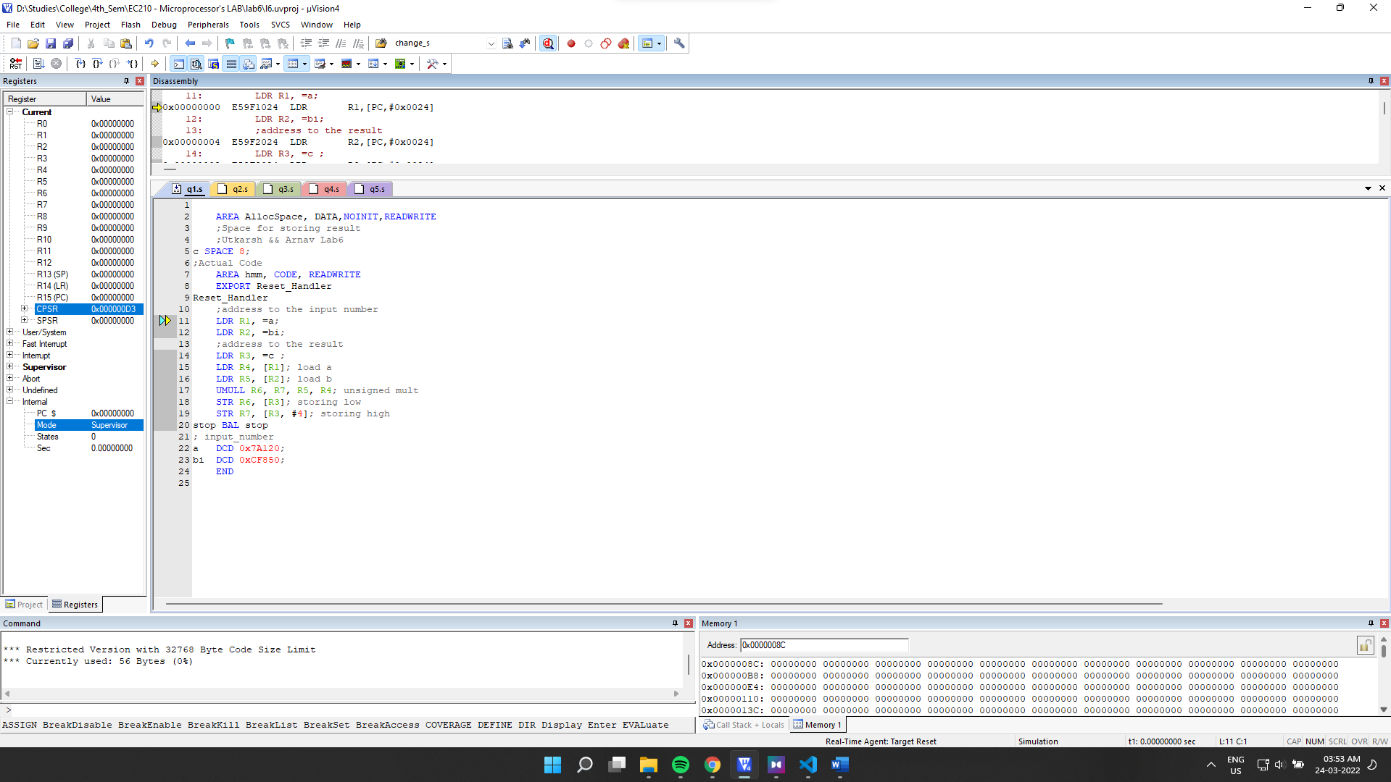

Final Output:

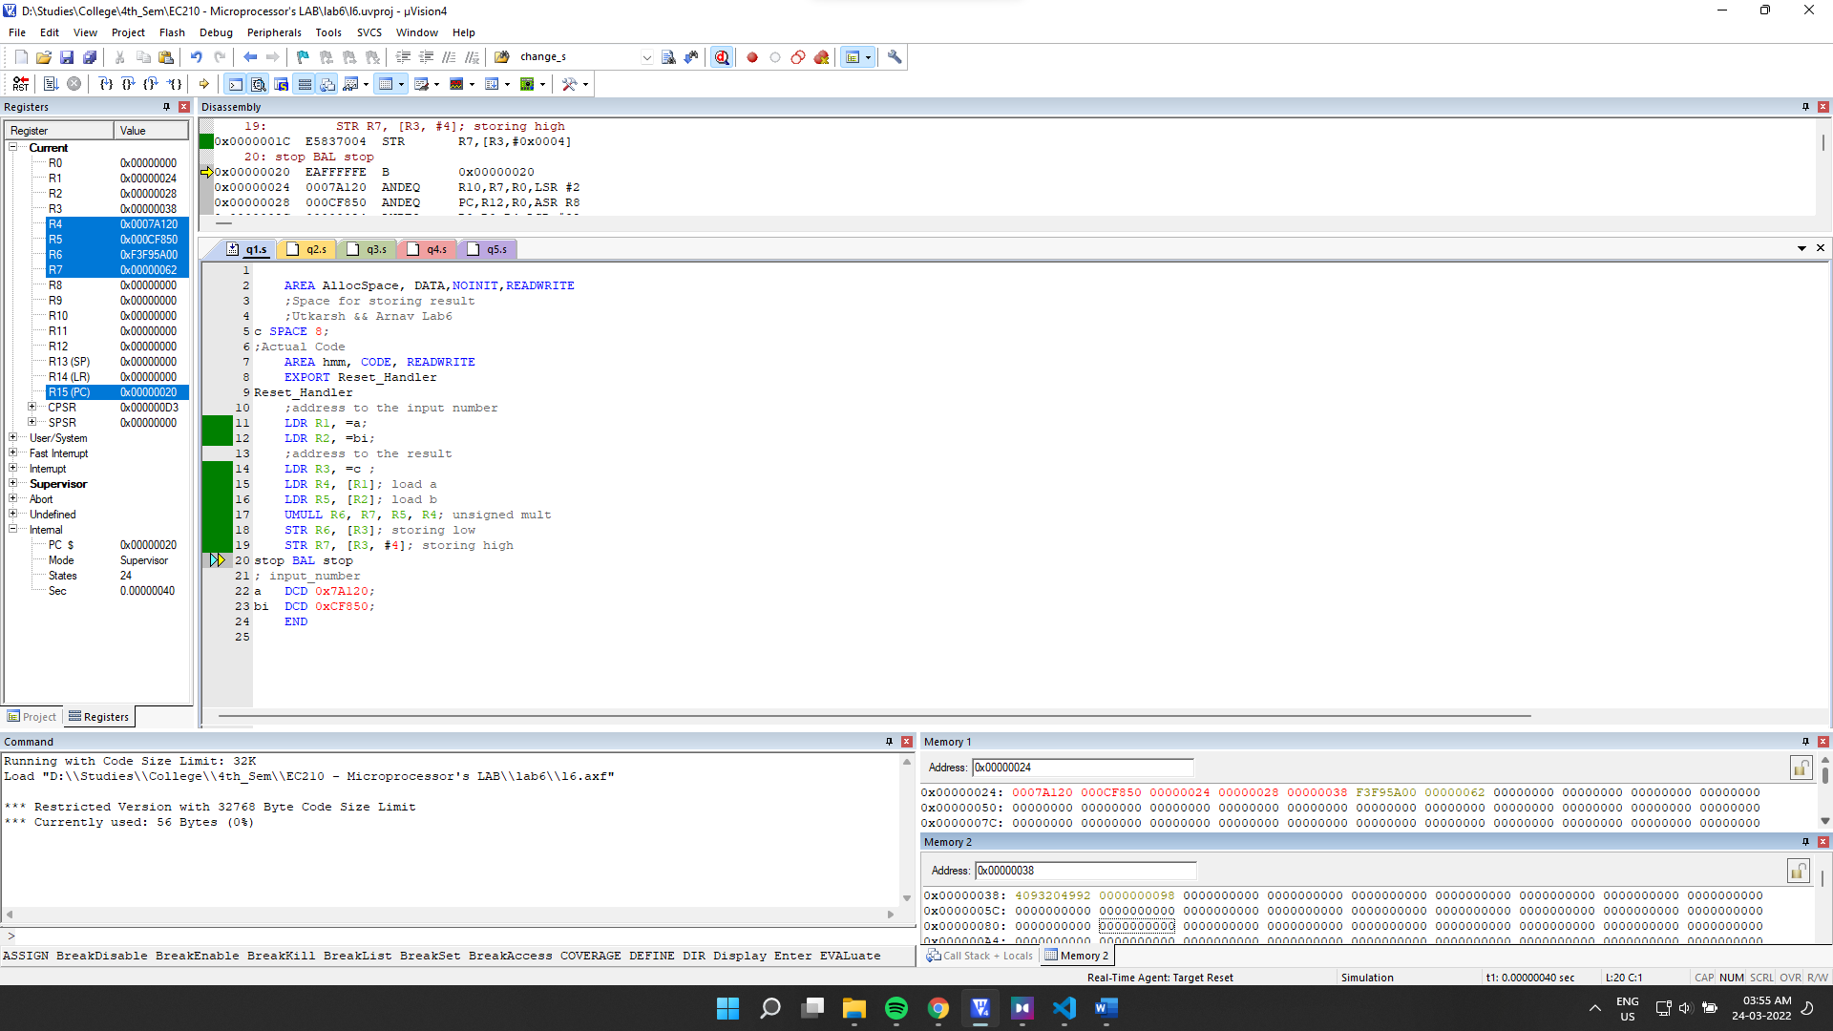

Final Memory:

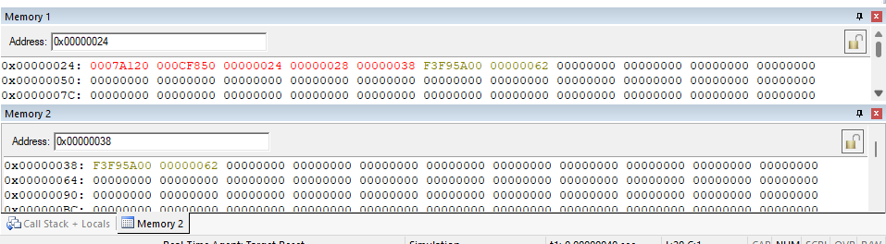

(b) a and b are both signed 32 bit numbers.

->

Source Code:

    AREA AllocSpace, DATA,NOINIT,READWRITE

*;Space for storing result*

*;Utkarsh && Arnav Lab6*

c SPACE 8*;*

*;Actual Code*

    AREA hmm, CODE, READWRITE

*EXPORT* Reset_Handler

Reset_Handler

*;address to the input number*

    LDR R1, =a*;*

    LDR R2, =bi*;*

*;address to the result*

    LDR R3, =c *;*

    LDR R4, [R1]*; a*

    LDR R5, [R2]*; b*

    SMULL R6, R7, R5, R4*; multiply*

    STR R6, [R3]*; low*

    STR R7, [R3, #4]*; high*

stop BAL *stop*

*; input_number*

a   DCD 0xFF7A0120*;*

bi  DCD 0xCF850*;*

*END*

Debugging:

Initial Memory: (after getting the address through register)

Memory 1 shows input number and memory 2 output

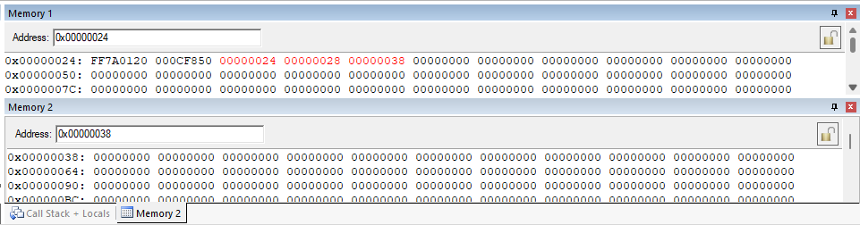

Setup:

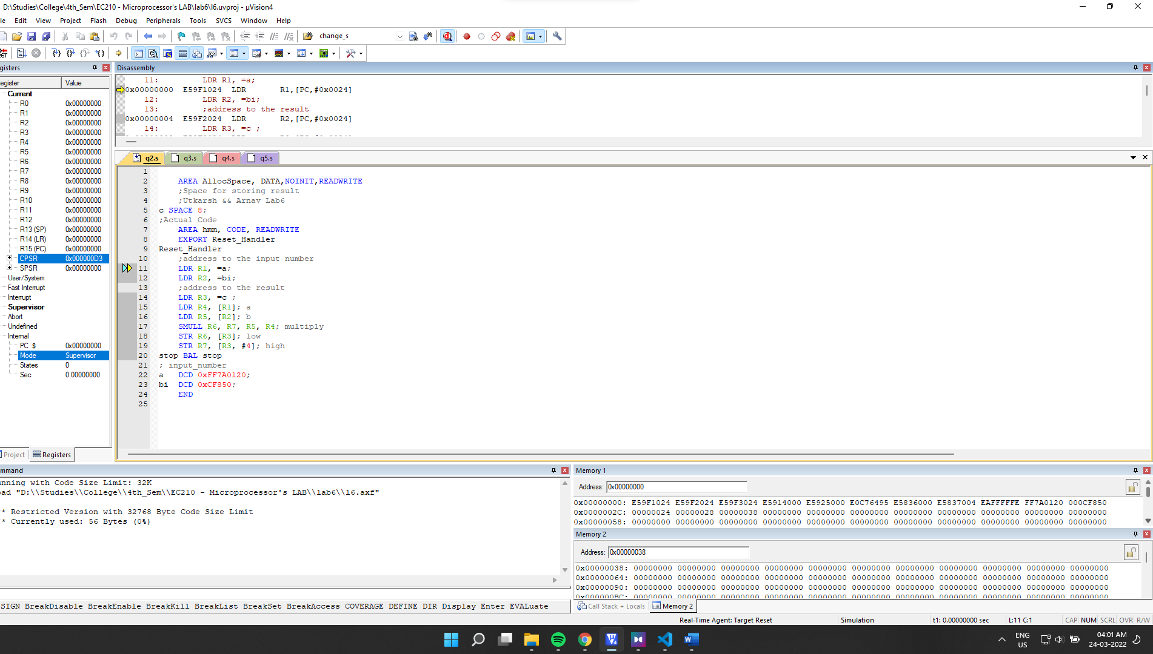

Final Output:

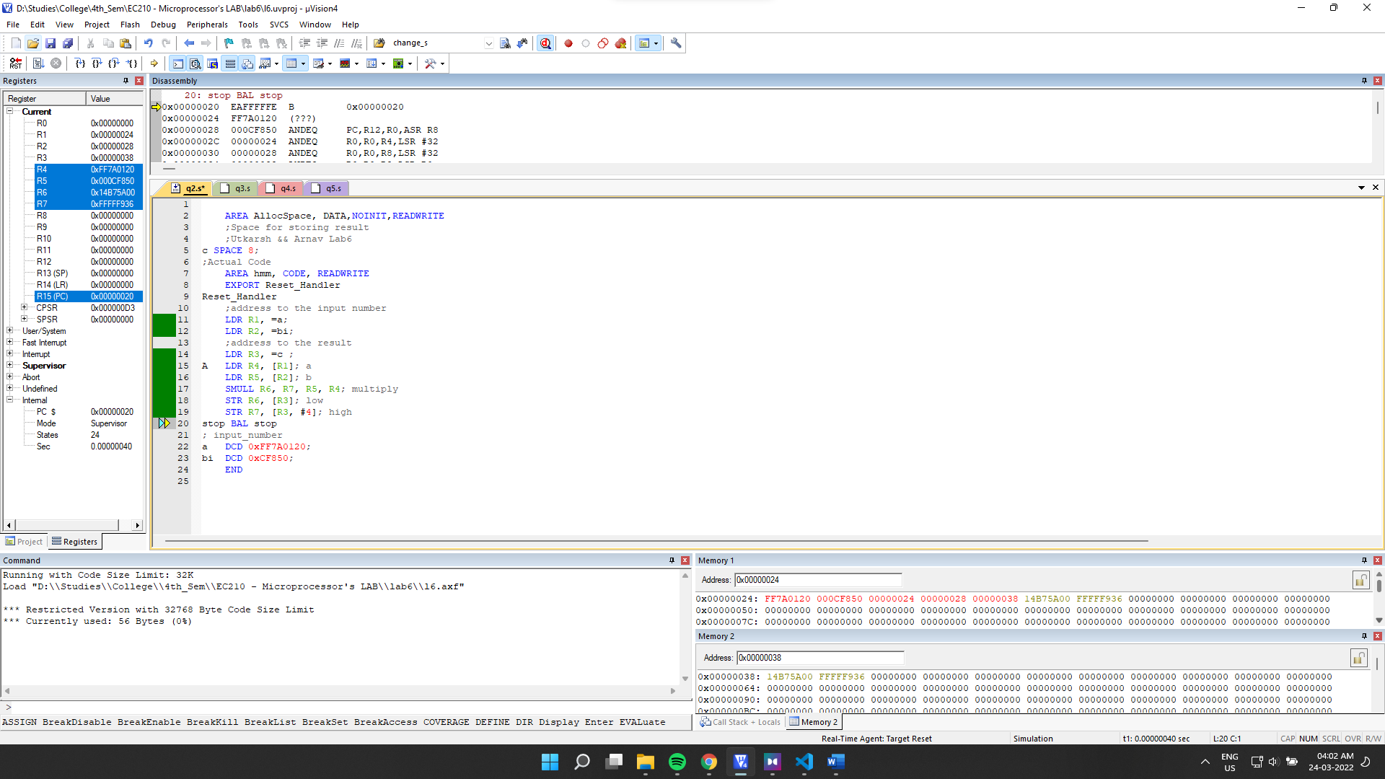

Final Memory:

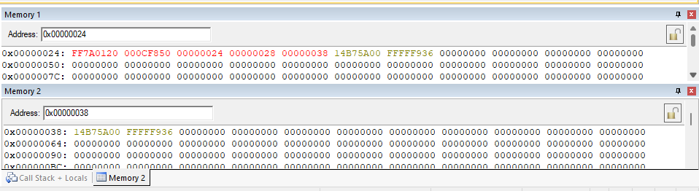

**(c) a and b are both unsigned 64 bit numbers.**

->Source Code:

    AREA AllocSpace, DATA,NOINIT,READWRITE

*;Space for storing result*

*;Utkarsh 164 && Arnav 109 Lab6*

c SPACE 16*;*

*;Actual Code*

    AREA hmm, CODE, READWRITE

*EXPORT* Reset_Handler

Reset_Handler

*;address to the input number*

    LDR R0, =a*;*

    LDR R1, =bi*;*

*; clearing registers used for calculation*

    MOV R7, #0*;*

    MOV R8, #0*;*

    MOV R9, #0*;*

    MOV R10, #0*;*

*;address to the result*

    LDR R2, =c *;*

    LDR R3, [R0]*;*

    LDR R4, [R0, #4]*;*

    LDR R5, [R1]*;*

    LDR R6, [R1, #4]

    UMULLS R7, R8, R5, R3*; a_low * b_low*

    UMULL R11, R12, R6, R3*; a_high * b_low*

    ADCS R8, R11, #0*;*

    ADCS R9, R12, #0*;*

    ADC R10, R10, #0*;*

    UMULLS R11, R12, R5, R4*; a_low* b_high*

    ADDS R8, R8, R11*;*

    ADCS R9, R9, R12*;*

    ADC R10, R10, #0*;*

    UMULL R11, R12, R6, R4*; a_high * b_high*

    ADDS R9, R9, R11*;*

    ADCS R10, R10, R12*;*

    ADC R10, R10, #0*;*

    STMIA R2, {R7-R10}*;*

stop BAL *stop*

*; input_number*

a   DCD 0x7A124AD0, 0x4A35D*;*

bi  DCD 0xCF850D00, 0x84DE3FF7*;*

*END*

Debugging:

Setup:

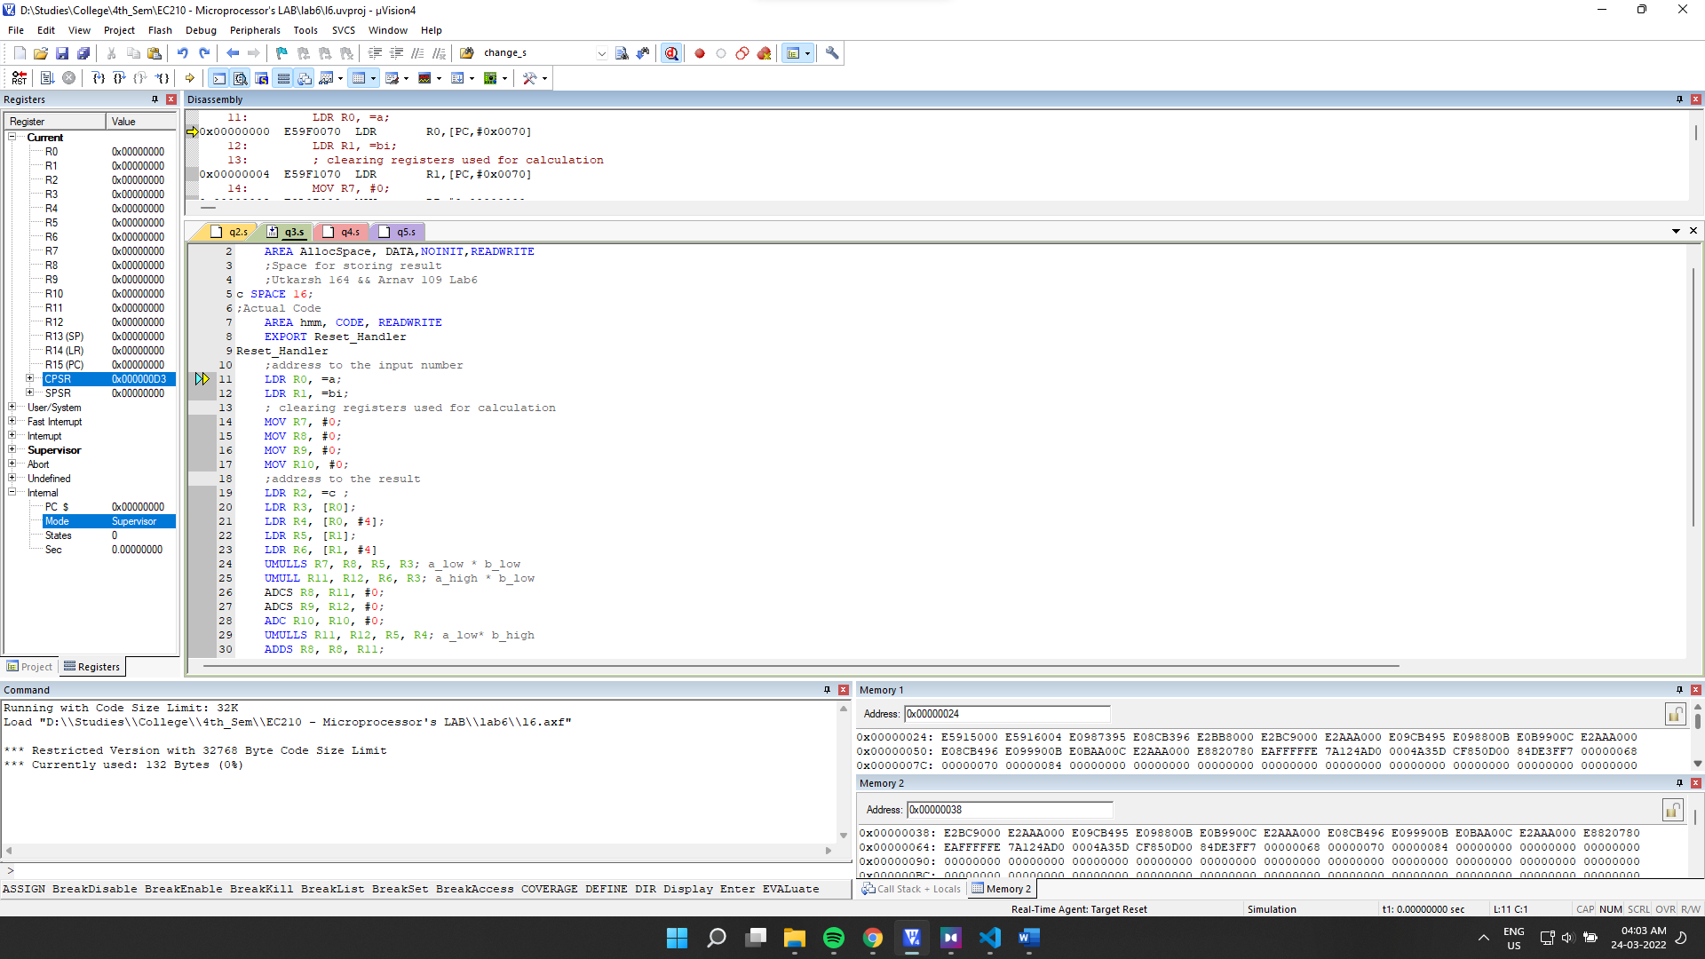

Initial Memory: (after getting the address through register)

Memory 1 shows input number and memory 2 will hold output.

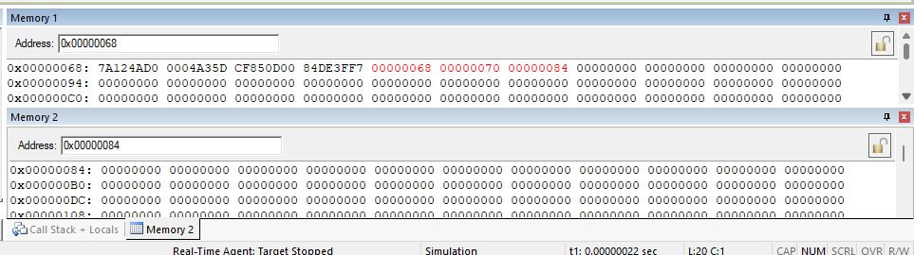

Final Output:

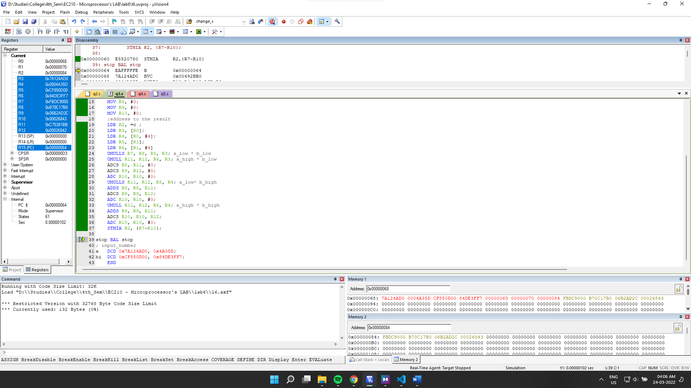

Final Memory Values:

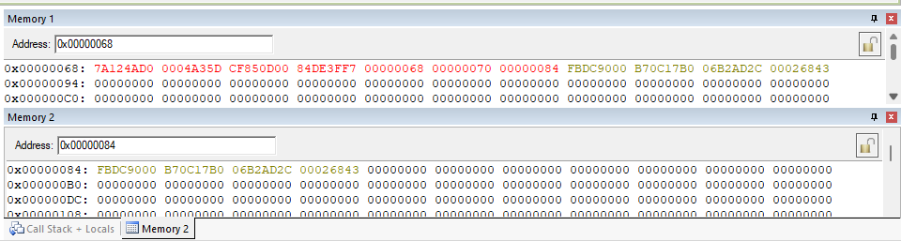

(d) a and b are both signed 64 bit numbers.

->

Source Code:

    AREA AllocSpace, DATA,NOINIT,READWRITE

*;Space for storing result*

*;Utkarsh 164 && Arnav 109 Lab6*

c SPACE 16*;*

*;Actual Code*

    AREA hmm, CODE, READWRITE

*EXPORT* Reset_Handler

Reset_Handler

*;address to the input number*

    LDR R0, =a*;*

    LDR R1, =bi*;*

*; clearing registers used for calculation*

    MOV R7, #0*;*

    MOV R8, #0*;*

    MOV R9, #0*;*

    MOV R10, #0*;*

*;address to the result*

    LDR R2, =c *;*

    LDR R3, [R0]*;*

    LDR R4, [R0, #4]*;*

    LDR R5, [R1]*;*

    LDR R6, [R1, #4]

    UMULL R7, R8, R5, R3*; unsigned a_low * b_low*

    SMLALS R8, R9, R3, R6*; signed a_low * b_high*

    ADC R10, R10, #0*; adding carry if any.*

    SMLALS R8, R9, R4, R5*; signed a_high * b_low*

    ADC R10, R10, #0*; adding carry if any.*

    SMLAL R9, R10, R4, R6*; signed a_high * b_high*

    STMIA R2, {R7-R10}*;*

stop BAL *stop*

*; input_number*

a   DCD 0x7A124AD0, 0x4A35D*; 0x4A35D7A124AD0*

bi  DCD 0xCF850D00, 0x84DE3FF7*; 0x84DE3FF7CF850D00*

*END*

Debugging:

Initial Memory: (after getting the address through register)

Memory 1 shows input, memory 2 will hold output.

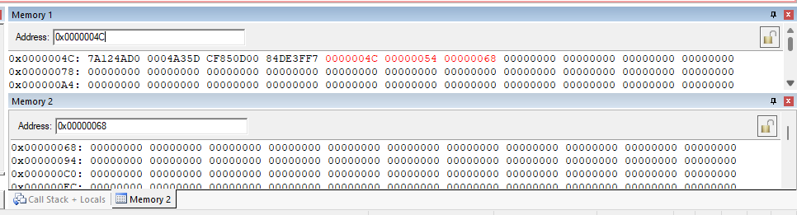

Setup:

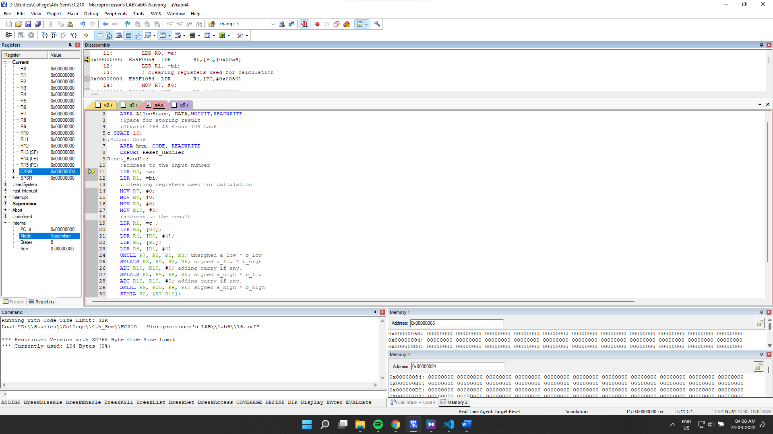

Final Output:

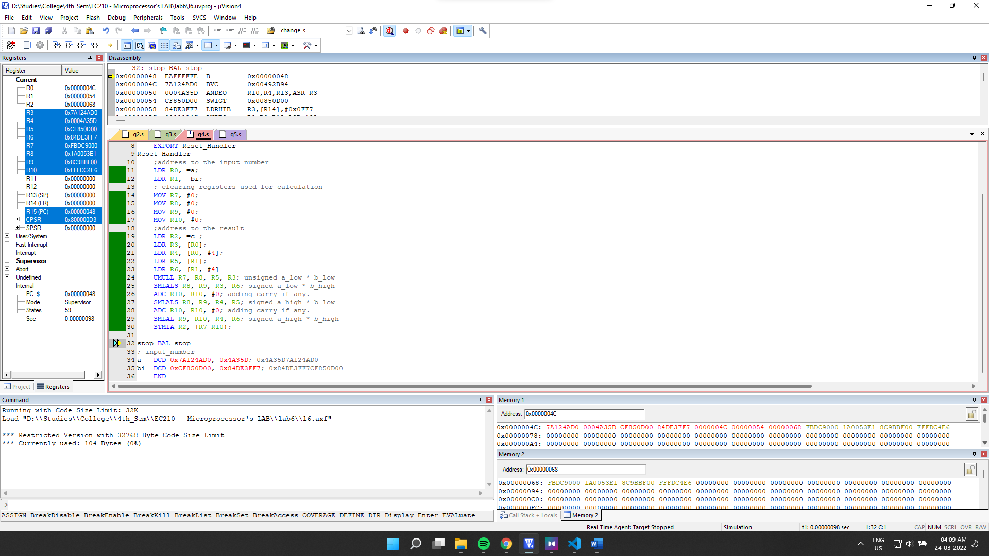

Final Memory:

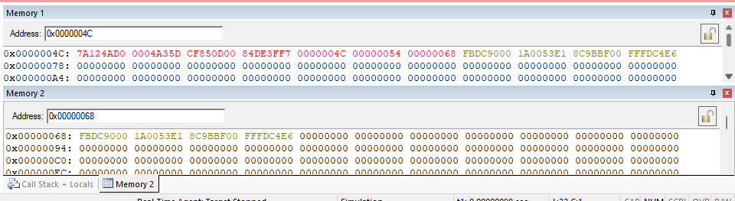

**6.2]** Assume that a signed long multiplication instruction is not available. Write a program that performs long multiplications, producing 64 bits of result. Use only the UMULL instruction and logical operations such as MVN to invert EOR and ORR

->

Source Code:

    AREA AllocSpace, DATA,NOINIT,READWRITE

*;Space for storing result*

*;Utkarsh 164 && Arnav 109 Lab6*

c SPACE 8*;*

*;Actual Code*

    AREA hmm, CODE, READWRITE

*EXPORT* Reset_Handler

Reset_Handler

*;address to the input number*

    LDR R11, =a*;*

    LDR R12, =bi*;*

*;address to the result*

    LDR R0, =c *;*

    LDR R1, [R11]*;*

    LDR R2, [R12]*;*

    LSR R3, R1, #31*;*

    LSR R4, R2, #31*;*

comp_1 CMP R3, #1*;*

    BEQ fn

comp_2 CMP R4, #1*;*

    BEQ sn

    B mult

fn MVN R5, R5*;*

    MVN R1, R1*;*

    ADD R1, R1, #1*;*

    B comp_2

sn MVN R5, R5*;*

    MVN R2, R2*;*

    ADD R2, R2, #1*;*

mult UMULL R6, R7, R1, R2*;*

    CMP R5, #0xFFFFFFFF*;*

    BEQ cs*;*

    B store*;*

cs MVN R6, R6*;*

    ADDS R6, R6, #1*;*

    MVN R7, R7*;*

    ADC R7, R7, #0*;*

store   *STR* R7, [R0]*;*

    STR R2, [R0, #4]*;*

stop BAL *stop;*

*; input_number*

a   DCD 0x7A124AD0*; 0x7A124AD0*

bi  DCD 0xCF850D00*; 0xCF850D00*

*END*

Initial Memory: (after getting the address through register and loading the value into the reserved space)

Memory 1 has the input no and memory 2 will hold result.

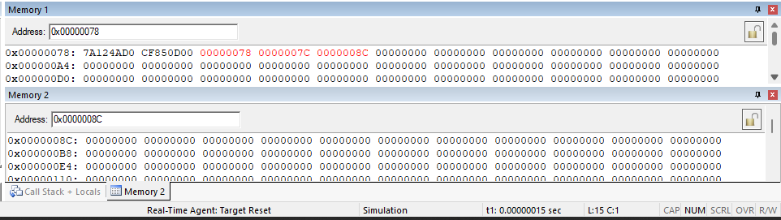

Setup:

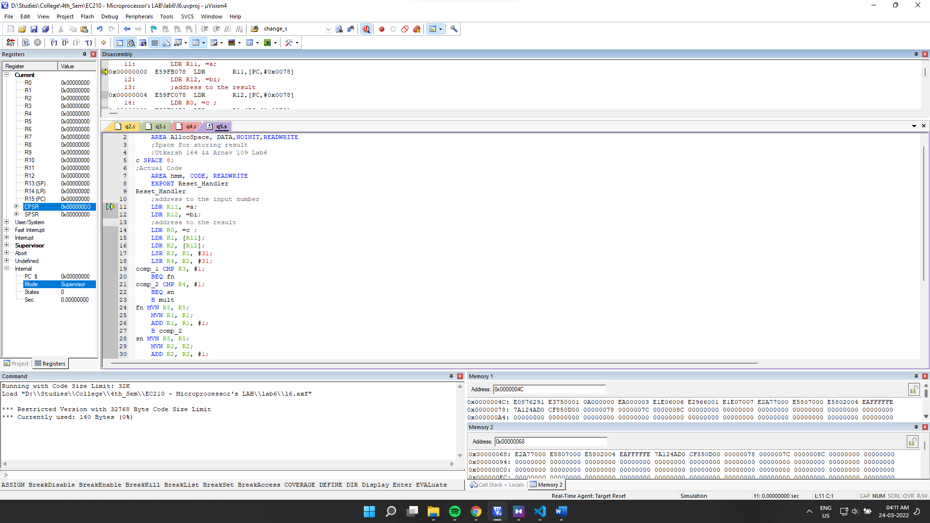

Final Output:

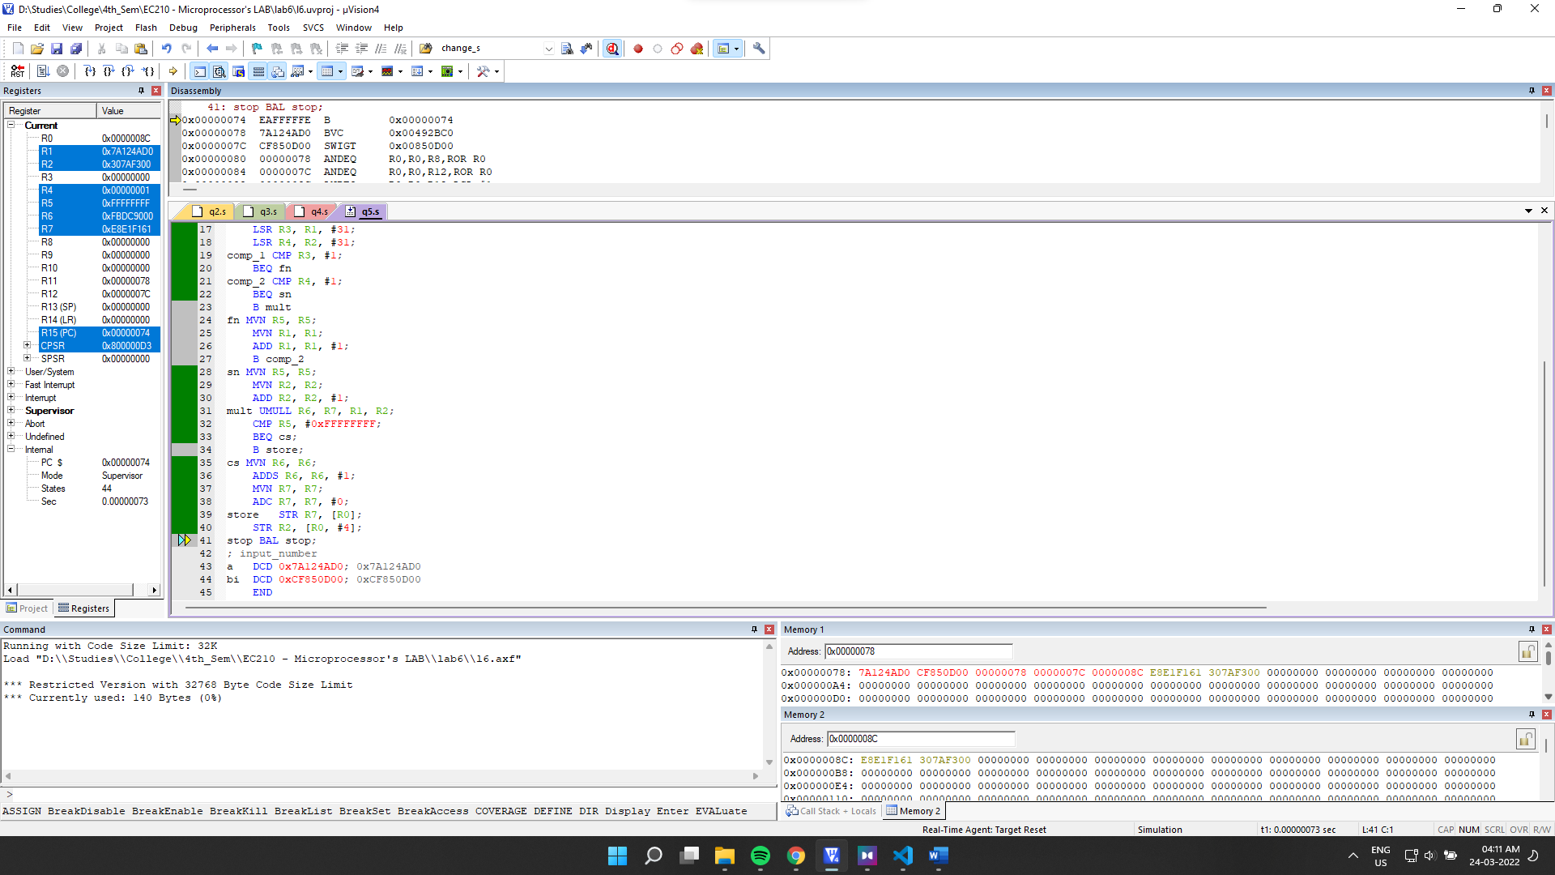

Final Memory:

