**Project-Title**: CareerCraft: ATS-Optimized Resume Analyzer using Gemini Model.

**Team / Developed By:** Utkarsh Trivedi.

**Email-ID :** utkarshtrivedi12d@gmail.com

**Mentor(s) Name**: Moses.

**Project-Report**

**Abstract**

The **ATS Resume Analyzer** is a web-based application designed to assist job seekers in optimizing their resumes for Applicant Tracking Systems (ATS). Leveraging advanced generative AI technology, the application evaluates a candidate's resume against specified job descriptions, providing actionable insights and alignment assessments. Users can upload their resumes in PDF format and input the desired job description, enabling the tool to conduct a thorough analysis of the resume’s content.

The analyzer generates two key outputs: a qualitative evaluation by simulating a human resources manager's perspective, highlighting the strengths and weaknesses of the applicant's profile, and a quantitative match percentage based on ATS algorithms, indicating how well the resume aligns with job requirements. By incorporating image processing capabilities to extract information from uploaded PDFs, the tool ensures a seamless user experience.

This project not only enhances the candidate's chances of passing through automated screening processes but also fosters a deeper understanding of the essential skills and keywords relevant to specific job roles. The ATS Resume Analyzer serves as a valuable resource for job seekers aiming to refine their applications in an increasingly competitive job market.

## Introduction

The ATS Resume Analyzer is an AI-driven tool designed to assist job applicants and HR professionals in evaluating how well a resume aligns with a specific job description. Using Google’s generative AI model 'gemini-1.5-flash', it provides insights into the strengths and weaknesses of a candidate’s profile, calculates a percentage match with the job requirements, and offers improvement suggestions. This tool is especially useful for organizations with high volumes of applications, ensuring efficient and accurate candidate screening.

## Technologies Used

1. **Programming Language**: Python  
2. **Framework**: Streamlit (for creating the web application)  
3. **AI Model**: Google Generative AI (gemini-1.5-flash)  
4. **PDF Processing**: pdf2image (for converting PDF resumes into images)

## Project Workflow

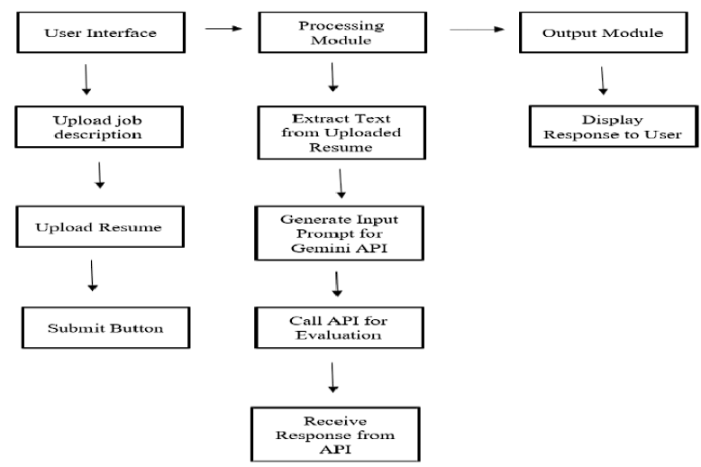

1. The user uploads their resume in PDF format.  
2. The PDF is converted to an image of the first page using the pdf2image library.  
3. The image is then converted to base64 format for processing by the AI model.  
4. Users provide a job description via a text area.  
5. The AI model (gemini-1.5-flash) evaluates the resume against the provided job description.  
6. Two options are provided:  
 - Tell Me About the Resume: A detailed analysis of the resume, including strengths and weaknesses.  
 - Percentage Match: A percentage score indicating alignment with the job description, including missing keywords and overall feedback.

## Implementation Guide

1. Software and Libraries:  
- Python: Version 3.8 or higher.  
- Conda: For environment management.  
- Libraries: Listed in requirements.txt:  
 - streamlit  
 - google-generativeai  
 - python-dotenv  
 - pdf2image  
  
2. Environment File (.env): Store the Google API key as:  
 GOOGLE_API_KEY="YOUR_API_KEY"  
  
3. Installation:  
- Setting up the Environment:  
 conda create -n myenv python=3.8  
 conda activate myenv  
 pip install -r requirements.txt  
- Run the Streamlit Application:  
 streamlit run app.py

## Methodology

## Code Overview

The following key functions are used in the project:  
  
1. get_gemini_response(input, pdf_content, prompt):  
 - Uses the gemini-1.5-flash model to generate content analysis of the resume.  
  
2. input_pdf_setup(uploaded_file):  
 - Converts the uploaded PDF into an image and encodes it in base64 for analysis by the AI model.

## Sample Outputs

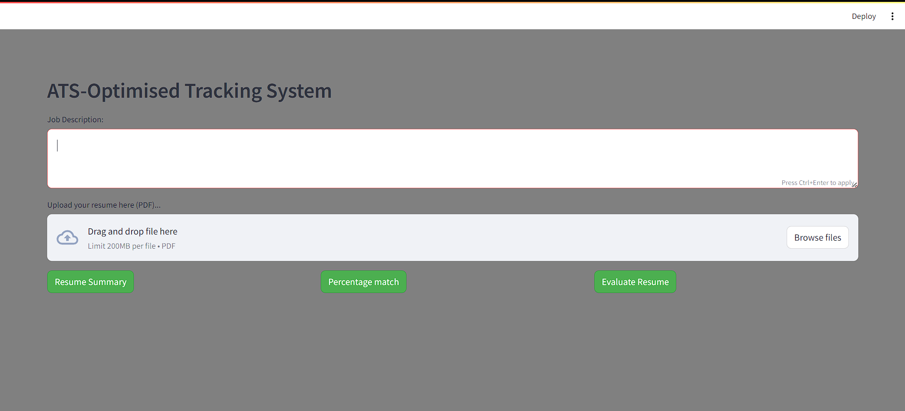

1. Detailed summary of the resume.  
2. A percentage score indicating the resume's alignment with the job description.

3. Evaluation of the resume with detailed feedback.

## Conclusion

The **ATS Resume Analyzer** project represents a significant advancement in the intersection of technology and job application processes. By utilizing generative AI and image processing, this application empowers job seekers to enhance their resumes for better compatibility with Applicant Tracking Systems. The dual output—qualitative feedback from a simulated HR perspective and a quantitative match percentage—provides users with a comprehensive understanding of their resume's effectiveness against specific job descriptions.

Through its user-friendly interface, the application not only streamlines the evaluation process but also encourages users to identify and rectify gaps in their resumes, ultimately increasing their chances of securing interviews. As the job market becomes increasingly competitive, tools like the ATS Resume Analyzer play a crucial role in equipping candidates with the insights needed to navigate automated screening processes successfully.

Future enhancements could include integrating more advanced analytics, personalized resume-building tips, and real-time feedback mechanisms. Overall, this project underscores the importance of leveraging technology to empower individuals in their job search, facilitating a more efficient and informed approach to career advancement.

## References

* Google Cloud. (n.d.). *Google Generative AI Documentation*. <https://cloud.google.com/generative-ai/docs>
* Streamlit. (n.d.). *Streamlit Documentation*. <https://docs.streamlit.io/>
* pdf2image. (n.d.). *pdf2image Documentation*. <https://pdf2image.readthedocs.io/en/latest/>
* Python Imaging Library (PIL). (n.d.). *Pillow Documentation*. <https://pillow.readthedocs.io/en/stable/>
* dotenv. (n.d.). *python-dotenv Documentation*. <https://pypi.org/project/python-dotenv/>