Python Training: Week 2 Day 2 (31st March,2020)  
TASK TWO: OPERATORS AND DECISION-MAKING STATEMENT

By: Utkarsh Dandwate

**Q1** **Write a program in Python to perform the following operation:**

* **If a number is divisible by 3 it should print “Consultadd” as a string**
* **If a number is divisible by 5 it should print “c” as a string**
* **If a number is divisible by both 3 and 5 it should print “Consultadd Python Training” as a string.**

**🡪** x = int(input("Please enter a number"))

if x%3==0:

print("Consultadd")

if x%5==0:

print("c")

if x%3==0 and x%5==0:

print("Consultadd Python Training")

**Q2. Write a program in Python to perform the following operator based task:**

* **Ask user to choose the following option first:**
  + **If User Enter 1 - Addition**
  + **If User Enter 2 - Subtraction**
  + **If User Enter 3 - Division**
  + **If USer Enter 4 - Multiplication**
  + **If User Enter 5 - Average**
* **Ask user to enter the 2 numbers in a variable for first and second for the first 4 options mentioned above.**
* **Ask user to enter two more numbers as first1 and second2 for calculating the average as soon as user choose an option 5.**
* **At the end if the answer of any operation is Negative print a statement saying “zsa”**
* **NOTE: At a time user can perform one action at a time.**

**🡪** x=eval(input("Please choose one of the following options \n 1. Addition \n 2. Subtraction\n 3. Division \n 4. Multiplication\n 5. Average\n "))

first = eval(input("Enter 1st number: "))

second = eval(input("Enter 2nd number: "))

if x==1:

result = first + second

print(result)

if result < 0:

print("zsa")

if x==2:

result = first - second

print(result)

if result < 0:

print("zsa")

if x==3:

result = first / second

print(result)

if result < 0:

print("zsa")

if x==4:

result = first * second

print(result)

if result < 0:

print("zsa")

if x==5:

first1 = eval(input("Enter 3rd number: "))

second1 = eval(input("Enter 4th number: "))

result = (first + second + first1 + second1 ) / 4

print(result)

if result < 0:

print("zsa")

**Q3. Write a program in python to implement the given flowchart**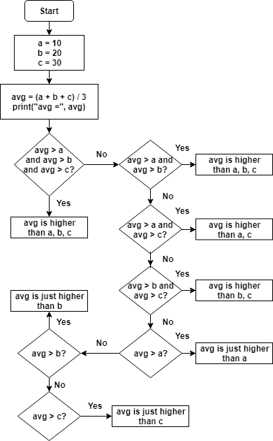

**🡪**

print("Please Enter three numbers")

a = eval(input("Enter first number: "))

b = eval(input("Enter second number: "))

c = eval(input("Enter third number: "))

avg = (a + b + c )/ 3

print("avg= ", avg)

if avg > a and avg > b and avg > c:

print("Average is higher than a,b and c")

elif avg > a and avg > b:

print("Average is higher than a and b")

elif avg > a and avg > c:

print("Average is higher than a and c")

elif avg > b and avg > c:

print("Average is higher than b and c")

elif avg > a:

print("Average is just higher than a")

elif avg > b:

print("Average is just higher than b")

elif avg > c:

print("Average is just higher than c")

**Q4. Write a program in Python to break and continue if the following cases occurs:**

* **If user enters a negative number just break the loop and print “It’s Over”**
* **If user enters a positive number just continue in the loop and print “Good Going”**

**🡪**

while True:

a = eval(input("Enter first number: "))

if a<0:

break

if a>0:

print("Good going")

continue

print("Its over!")

**Q5. Write a program in Python which will find all such numbers which are divisible by 7 but are not a multiple of 5, between 2000 and 3200.   
🡪** for x in range(2000,3200):

if x%7==0 and x%5!=0:

print(x)

**Q6.** **What is the output of the following code examples?**

* **x=123**

**for i in x:**

**print(i)**

* It should show an error as we cant use index functionality on integer
* **i = 0**

**while i < 5:**

**print(i)**

**i += 1**

**if i == 3:**

**break**

**else:**

**print(“error”)**

* 0

1

2

* **count = 0**

**while True:**

**print(count)**

**count += 1**

**if count >= 5:**

**Break  
🡪** 0  
 1  
 2  
 3  
 4

**Q7.**  **Write a program that prints all the numbers from 0 to 6 except 3 and 6.**

**Expected output: 0 1 2 4 5**

**Note: Use ‘continue’ statement**

**🡪** x=0

for x in range(0,7):

if x==3 or x==6:

continue

print(x)

x+=1

**Q8. Write a program that accepts a string as an input from user and calculate the number of digits and letters.**

**Expected output: consul12**

**Letters 6**

**Digits 2**

**🡪** x = input("Please enter a your username: ")  
digit=0

alphabet=0

for i in x :

if i.isalpha()==True:

alphabet+=1

if i.isnumeric()==True:

digit+=1

print("Total number of letters is: ", alphabet)

print("Total number of numbers is: ", digit)

**Q9.** **Read the two parts of the question below:**

* **Write a program such that it asks users to “guess the lucky number”. If the correct number is guessed the program stops, otherwise it continues forever.**
* **Modify the program so that it asks users whether they want to guess again each time. Use two variables, ‘number’ for the number and ‘answer’ for the answer to the question whether they want to continue guessing. The program stops if the user guesses the correct number or answers “no”. ( The program continues as long as a user has not answered “no” and has not guessed the correct number)**

🡪 Pat1:

lucky_number = 16

while True:

x = int(input("Guess the lucky number"))

if x != lucky_number:

continue

if x == lucky_number:

break

🡪 Part2:

lucky_number = 16

while True:

number = int(input("Guess the lucky number"))

if number != lucky_number:

answer = input("Would you like to guess again?")

if answer == "Yes" or answer == "YES" or answer == "yes":

continue

if number == lucky_number or answer == "NO" or answer == "No" or answer == "no":

break

**Q10. Write a program that asks five times to guess the lucky number. Use a while loop and a counter, such as**

**counter=1**

**While counter <= 5:**

**print(“Type in the”, counter, “number”**

**counter=counter+1**

**The program asks for five guesses (no matter whether the correct number was guessed or not). If the correct number is guessed, the program outputs “Good guess!”, otherwise it outputs “Try again!”. After the fifth guess it stops and prints “Game over!”.**

**🡪** lucky_number = 16

counter = 1

while counter <= 5:

x = int(input("Guess the number: \n"))

if x == lucky_number:

print("Good guess!")

if x != lucky_number:

print("Try again!")

counter += 1

print("Game over!")

**Q11.** **In the previous question, insert “break” after the “Good guess!” print statement. “break” will terminate the while loop so that users do not have to continue guessing after they found the number. If the user does not guess the number at all, print “Sorry but that was not very successful”.**

**🡪** lucky_number = 16

counter = 1

while counter <= 5:

x = int(input("Guess the number: \n"))

if x == lucky_number:

print("Good guess!")

break

if x != lucky_number:

print("Try again!")

counter += 1

if counter == 6:

print("Sorry but that was not very successful")