Fraud Detection in Online Transactions Using Advanced Behavioral Analysis

Utkarsh Prasad Dhekale
Bachelor of Technology in Computer Science Engineering,
VIT University, Chennai, Tamil Nadu, India,
E-mail: utkarshprasad.dhekale2021@vitstudent.ac.in,

Abstract

This study explores the ways to implement fraud detection in online transactions using behavioural and cognitive analysis. The application of clickstream and telemetry data can be leveraged to identify whether a user is fraudulent or legitimate. The following paper gives a detailed proof of concept on the technical implementation of this idea. It uses machine learning algorithms like XGBoost, Random Forest and SVM to analyse data from over 100K+ users to create a robust model that predicts the presence of fraudulent activity. This methodology stresses the role of clickstream data in improving fraud detection systems by giving insights and solutions to real-world financial security issues.

Keywords- Clickstream data analysis, Machine learning for Fraud detection, Financial Transaction Security, Real-time Fraud prediction, Behavioural and Cognitive analysis.

1. Introduction
Detection of fraudulent activity consists of taking various parameters into consideration. Starting with checking the transaction details, attributes like transaction type, time, amount, address of origin and destination, initial and final balances of both, etc. The dataset¹ on which this model is trained consists of data having over 6.3M different transactions with the above-mentioned attributes mapped over the course of 30 days of simulation. For clickstream data, we consider attributes like key pressed/released, input box, text changed, timestamp, etc.

The required Python libraries for this project are imported as below:
import pandas as pd
import numpy as np
import tensorflow as tf
import matplotlib.pyplot as plt
from sklearn import preprocessing
from sklearn.model_selection import train_test_split
from sklearn.ensemble import RandomForestClassifier
from xgboost import XGBClassifier
from sklearn.svm import SVC
from sklearn.metrics import accuracy_score, classification_report
import json
import gradio as gr
The code utilizes “pandas” and “numpy” for data manipulation, “TensorFlow” for potential deep learning models, “matplotlib” for data visualization, “scikit-learn” for preprocessing, model selection and evaluation, “XGBoost” and “RandomForestClassifier” for ensemble learning, “SVC” for support vector classification, “json” for data handling, and “gradio” for building interactive interfaces.

2. Data Preprocessing
The dataset taken into consideration has all the above-mentioned favourable attributes of both transaction details(Fig. 2.1) and clickstream data(Fig. 2.2).

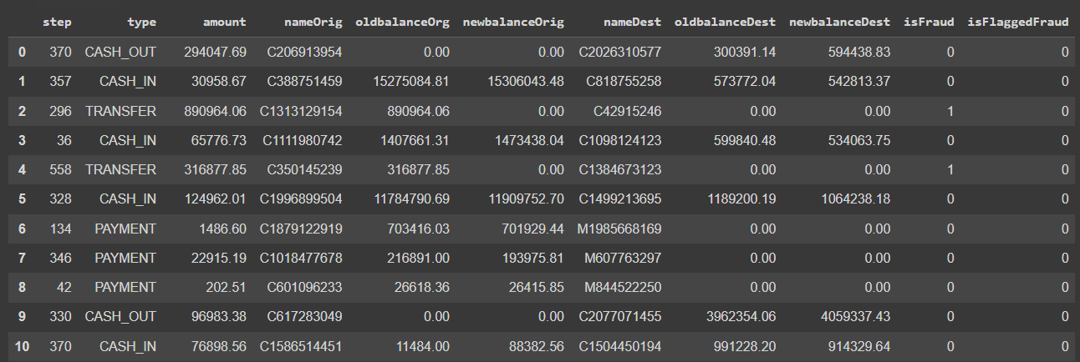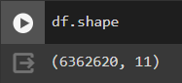
Fig. 2.1 Transaction Details Dataset

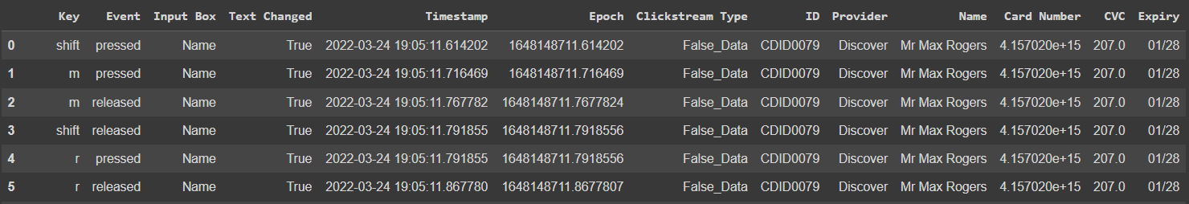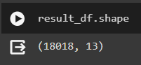
Fig. 2.2 Clickstream Dataset

This is a very raw form of dataset and needs to be cleaned and preprocessed. Hence first, we detect the presence of null values and remove them by using .dropna() method of Pandas Dataframe. Then we detect for the outliers in the dataset using boxplot graphs.

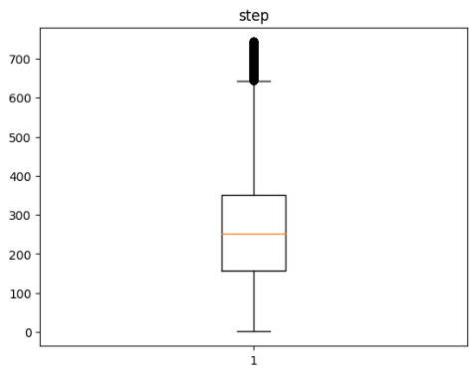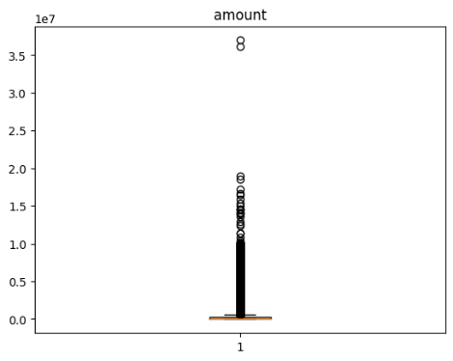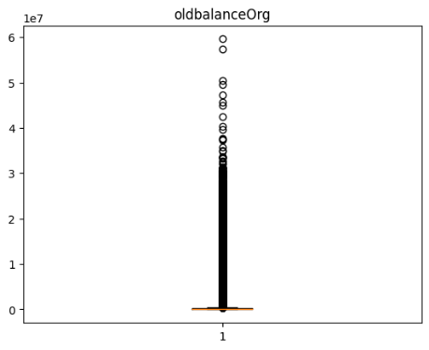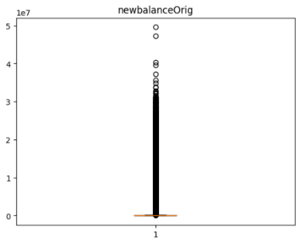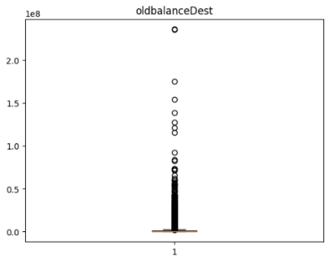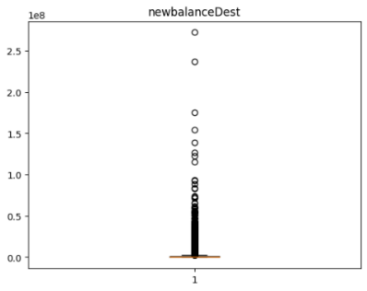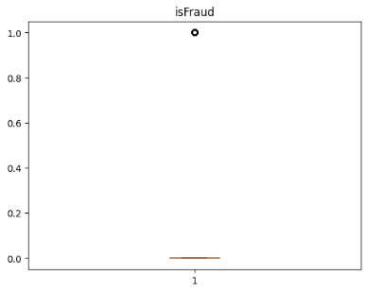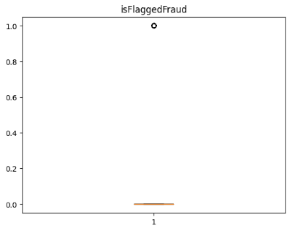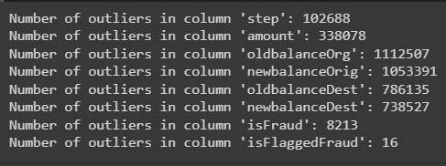
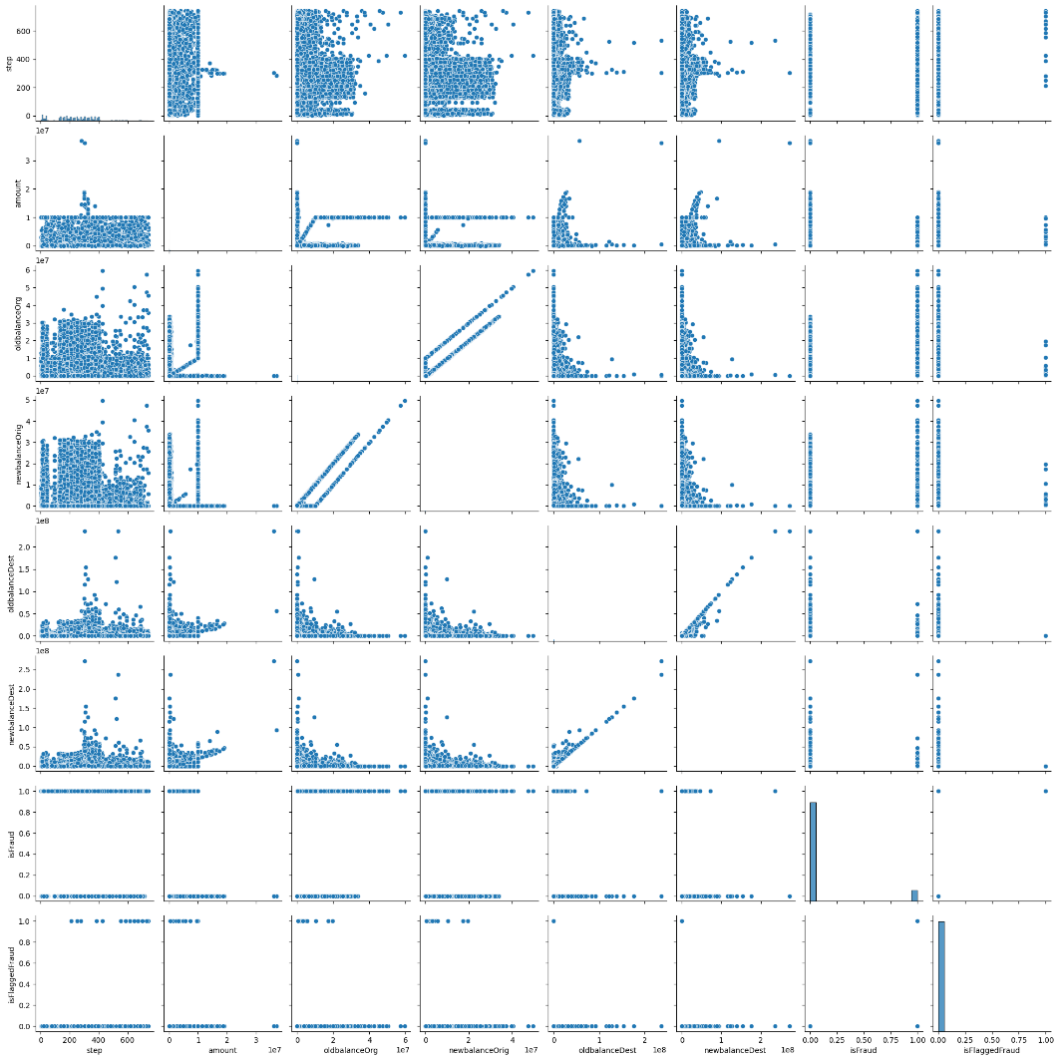
As we can see from the above boxplots, there are a significant number of outliers. Therefore we use algorithms like XGBoost which includes several features to make it robust to outliers. Scatterplot, or pair plot, is another visualisation for this dataset to get an idea of correlations between the attributes.
Preprocessing also involves deleting of insignificant columns to reduce the dimensionality of the data. Instead of having the columns ‘oldbalanceOrg’, ‘newbalanceOrig’, ‘oldbalanceDest’ and ‘newbalanceDest’, we insert ‘Original diff’ and ‘destination diff’ which are the difference of the respective accounts in the transaction dataset. And reducing the clickstream dataset’s dimensionality by deleting the ‘Timestamp’ column.

We find the correlation and generate a heatmap.
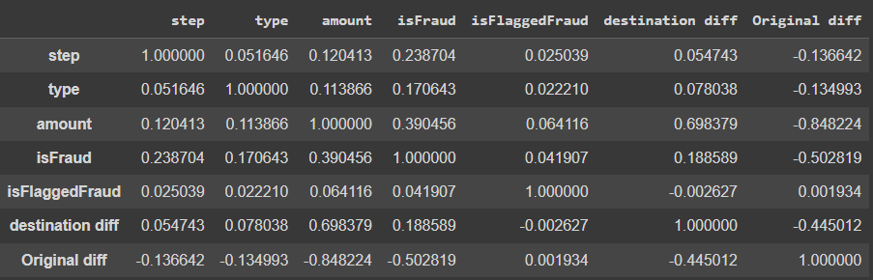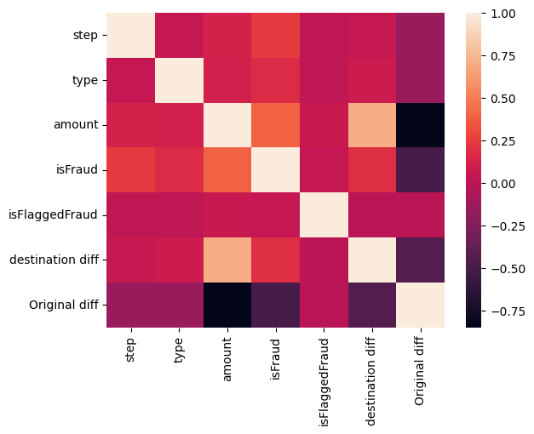

The new dataset contains the following columns: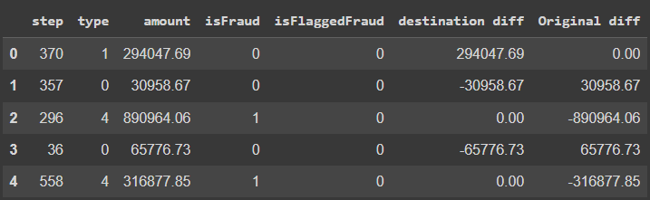 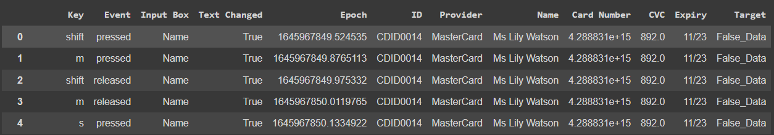
By using ‘LabelEncoder’ from ‘sklearn.preprocessing’ library we encode the data into ‘int’ type for the algorithm to understand the values.

3. Appling ML Algorithms
In order to find the most optimal solution, we try and test out multiple algorithms to compare the results with higher accuracy.
For the transaction dataset, ‘type’, ‘amount’, ‘destination diff’ and ‘Original diff’ have been declared independent variables and ‘isFraud’ as the dependent target variable.
For the clickstream dataset, 'Key', 'Event', 'Input Box', 'Text Changed', 'Epoch', 'ID', 'Provider', 'Name', 'Card Number', 'CVC' and 'Expiry' have been declared as independent variables and “Target” as the dependent variable.
Multiple algorithms have been used using the above data. Random Forest, XGBoost and SVM are most suitable for both datasets.
The following are their classification reports for the transaction dataset:
- Random Forest:
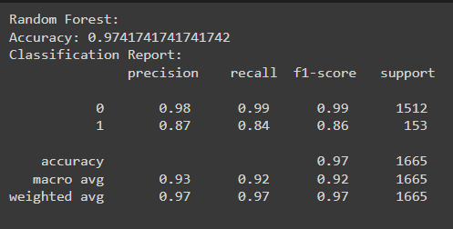
- XGBoost:
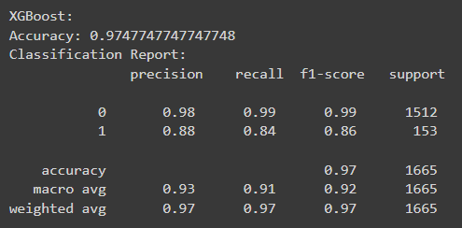
- SVM:
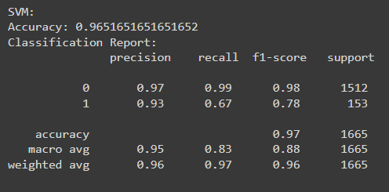
The following are their classification reports for clickstream dataset:
- Random Forest:
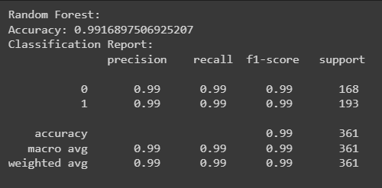
- XGBoost:
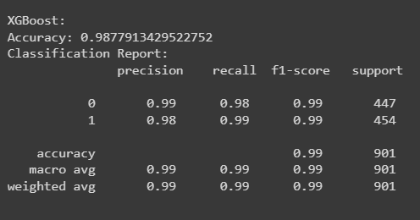
- SVM:
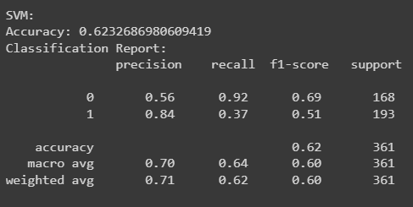

As XGBoost gives a better result for the transaction dataset and Random Forest for the clickstream dataset, we train the models using those algorithms. Training and deploying multiple models for different datasets enables parallel and distributive computing, providing better and accurate results.

4. Web Interface
A robust web interface is an integral part of a machine-learning project. We use Gradio to build an interface to take inputs for the transaction dataset. This is a prototype-based frontend hosted on a local system.

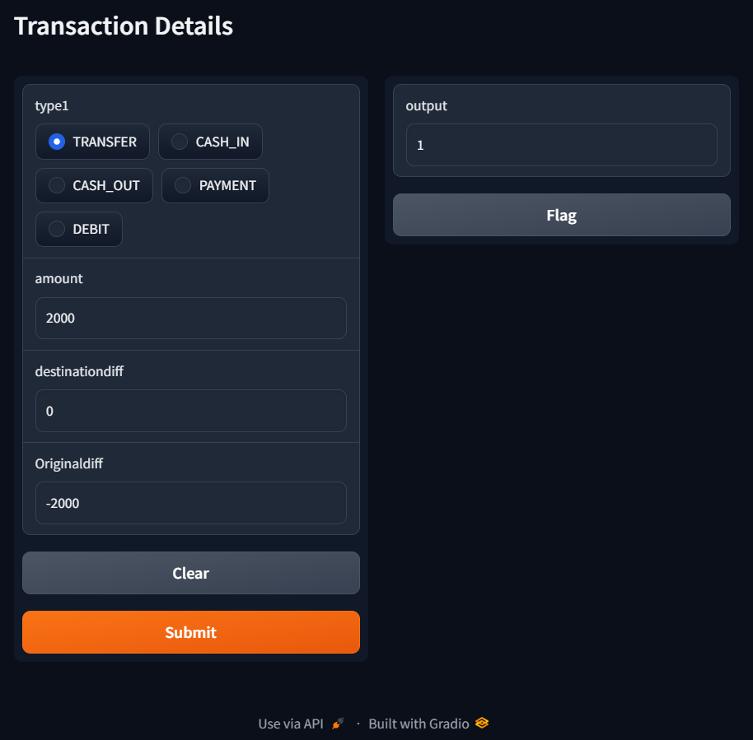

While this seems favourable to take in inputs for transaction details, clickstream data can be collected live over a period of time during a session to analyze fraudulent/bot-like behaviour. We put this in the future scope of this project.

5. Conclusion & Future Scope

This paper introduces a new way to fight against online transaction fraud by using behavioural and cognitive analysis techniques. The research shows effective fraud detection capabilities by integrating machine learning algorithms such as Random Forest and XGBoost with strong data preprocessing methods. The importance of enhancing data quality and feature engineering is highlighted in this article as it greatly contributes to accurate results through thorough data preparation. Moreover, the study applies Gradio for creating a web interface that is easy to use for end users which demonstrates how these findings can be practically implemented. Moreover, “Email and User Profiling” can also be taken into consideration while determining fraudulent activities. We include this in the future scope of this project. In summary, not only does this paper provide proof-of-concept but also sets the stage for future developments in fraud detection systems. It helps create a safer environment for electronic commerce by utilizing cutting-edge technologies and inventive approaches, benefiting businesses and consumers alike.

References
[1] https://www.kaggle.com/datasets/chitwanmanchanda/fraudulent-transactions-data
[2] https://data.mendeley.com/datasets/fnf8b85kr6/1
[3] https://dl.acm.org/doi/fullHtml/10.1145/3184558.3186569
[4]https://www.researchgate.net/publication/228722329_Analysing_clickstream_data_From_anomaly_detection_to_visitor_profiling
[5] https://aclanthology.org/2020.lrec-1.167.pdf

